Contents

[REVERENT 2](#_Toc511247667)

[CORE VALUES 2](#_Toc511247668)

[BELIEVE IT – LIVE IT 3](#_Toc511247669)

[FEBRUARY - ADVENTURES with a CHARACTER COMPASS pointing to REVERENT: 3](#_Toc511247670)

[MONTHS WITH THEMES FOR REVERENT 4](#_Toc511247671)

[THE FOUNDER'S PRAYER 4](#_Toc511247672)

[Duty to God Statements by Lord Baden-Powell 4](#_Toc511247673)

[More Quotes from Baden-Powell on Faith 5](#_Toc511247674)

[REVERENT QUOTES 5](#_Toc511247675)

[Faith Quotations 5](#_Toc511247676)

[REVERENT / REVERENCE QUOTATIONS 6](#_Toc511247677)

[THE GOLDEN RULE 7](#_Toc511247678)

[Trees & Faith for Scouters 8](#_Toc511247679)

[SCOUT SUNDAY / SABBATH 9](#_Toc511247680)

[SCOUTER’S PRAYER 11](#_Toc511247681)

[Monday Evening Prayer 11](#_Toc511247682)

[Pack Meeting Ideas for Reverent 11](#_Toc511247683)

[Gathering Activities 11](#_Toc511247684)

[**OPENING PRAYERS** 12](#_Toc511247685)

[**OPENING CEREMONIES** 12](#_Toc511247686)

[Songs 13](#_Toc511247687)

[**AUDIENCE PARTICIPATIONS** 15](#_Toc511247688)

[**ADVANCEMENT CEREMONIES** 16](#_Toc511247689)

[GAMES 17](#_Toc511247690)

[CUBMASTER’S MINUTES 17](#_Toc511247691)

[More Ideas for - Reverent 18](#_Toc511247692)

[Teachable Moments 18](#_Toc511247693)

[Religious Awards for Scouts 18](#_Toc511247694)

[Web Resources 19](#_Toc511247695)

[TRAINING TOPIC 19](#_Toc511247696)

[An Introduction to the Scouts Own 19](#_Toc511247697)

[FAITH AND SCOUTING 22](#_Toc511247698)

[Overview of Chartered Organizations 22](#_Toc511247699)

[Responsibilities of chartered organizations: 22](#_Toc511247700)

[Faith-Based Scouting Groups: 22](#_Toc511247701)

[Top 25 Charter Organizations 23](#_Toc511247702)

[SPECIAL OPPORTUNITIES 23](#_Toc511247703)

[Youth Religious Emblems 23](#_Toc511247704)

[FAQs about Religious Emblems 24](#_Toc511247705)

[Adult Religious Recognitions 26](#_Toc511247706)

[DUTY TO GOD PUZZLE PATCH 27](#_Toc511247707)

[Religious Emblems Coordinators 28](#_Toc511247708)

[BIOGRAPHY – 30](#_Toc511247709)

[Native American Spirituality 30](#_Toc511247710)

[James Earl "Jimmy" Carter, Jr 34](#_Toc511247711)

[GEORGE WASHINGTON 35](#_Toc511247712)

[**Washington on a proposed third term and political parties, 1799** 37](#_Toc511247713)

[Other Men of Faith 38](#_Toc511247714)

[LAST THOUGHTS 39](#_Toc511247715)

# REVERENT

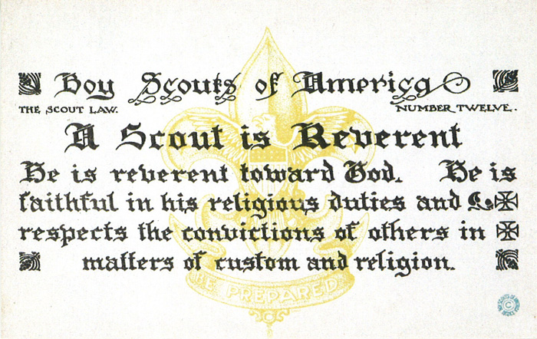

# CORE VALUES

**The Cub Scout Core Values are the  
 12 Points of the Scout Law.**

**Per our Founder, Lord Baden-Powell**

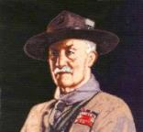

***Note –*** *Although Duty to God was part of B-P’s program, Reverent was not part of his Scout Law. The original Scout Law published in 1908 had nine points. In 1910, the BSA added Brave, Clean, and* ***Reverent****. In 1911 B-P added* ***Clean*** *to his list.*

**A SCOUT'S DUTY TO GOD**   
"No man is much good unless he believes in God and obeys His laws. So, every Scout should have a religion.... Religion seems a very simple thing: **First:** Love and Serve God.   
**Second:** Love and serve your neighbour." -   
(Scouting For Boys, 1908)

**Be a player on God's team.**

*Lord Robert Baden-Powell, Rovering to Success, 1922*

[**“Winter Wonderland,”**](https://filestore.scouting.org/filestore/cubscouts/pdf/YEAR1/310-842(15)_December%20Reverent_WEB.pdf) the December 2015 theme, used the Core Value Reverent. The Pack Meeting agenda is at –

<https://filestore.scouting.org/filestore/cubscouts/pdf/YEAR1/310-842(15)_December%20Reverent_WEB.pdf>

**The core value highlighted this month is:**

December's point of the Scout Law, **REVERENT,** will use the theme, **WINTER WONDERLAND**

**A SCOUT IS REVERENT**A Scout is reverent toward God. He is faithful in his religious duties. He respects the beliefs of others.

**HOW DOES “WINTER WONDERLAND” RELATE TO THIS POINT OF THE SCOUT LAW?**

As winter comes, it brings with it a wonderland of snow, peace, beauty, and holidays. Many of us come from different backgrounds and celebrate different traditions; each of our traditions gives us an identity, a sense of belonging. When we share our traditions and accept the traditions of others, we expand our circle so that everyone feels that they belong. Whether we celebrate Christmas, Hanukkah, Kwanzaa, or none of these, sharing valued traditions and holding true to what they stand for will help us understand others. But no matter who we are or how we celebrate, everyone in Scouting is part of a great organization that has taught us to show reverence for others and their beliefs.

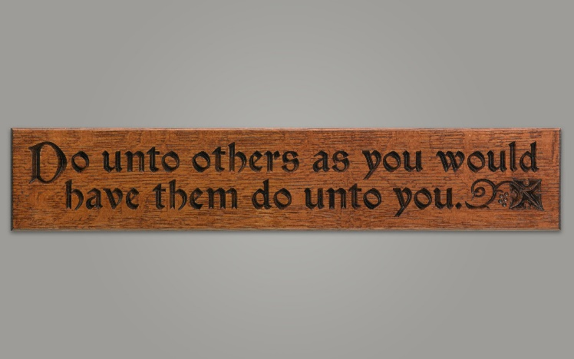[**“Passport to Other Lands,**](https://filestore.scouting.org/filestore/cubscouts/pdf/YEAR2/310-842(15)_February%20Reverent_WEB.pdf)**”** the February 2017 theme, used the Core Value Reverent. The Pack Meeting agenda is at –

<https://filestore.scouting.org/filestore/cubscouts/pdf/YEAR2/310-842(15)_February%20Reverent_WEB.pdf>

**The core value highlighted this month is:**

February's point of the Scout Law, **REVERENT,** will use the theme, **PASSPORT TO OTHER LANDS**

**A SCOUT IS REVERENT**A Scout is reverent toward God. He is faithful in his religious duties. He respects the beliefs of others.

**HOW DOES “PASSPORT TO OTHER LANDS” RELATE TO THIS POINT OF THE SCOUT LAW?**

Today we recognize that people of many different nationalities live in our communities. Learning about the ways of others helps lead to understanding. A Scout is reverent when he shows respect for the beliefs of others. This month we focus on experiencing the customs, religions, foods, and traditions of our friends from other countries.

[**“Cubs Give Thanks,**](https://filestore.scouting.org/filestore/cubscouts/pdf/YEAR2/310-842(15)_February%20Reverent_WEB.pdf)**”** the November 2017 theme, used the Core Value Reverent. The Pack Meeting agenda is at –

<https://filestore.scouting.org/filestore/cubscouts/pdf/YEAR2/310-842(15)_February%20Reverent_WEB.pdf>

A Scout is **REVERENT.**  The theme **CUBS GIVE THANKS** is used to help Cubs understand being **KIND.**

**A SCOUT IS REVERENT**A Scout knows there is strength in being gentle. He treats others as he wants to be treated. Without good reason, he does not harm or kill any living thing.

**HOW DOES “CUBS GIVE THANKS” RELATE TO THIS SCOUT LAW POINT?**

At this pack meeting, Cub Scouts will learn the importance of treating others as they want to be treated. Although it is nice when someone does something kind for you, it is even more rewarding to do something kind for someone else—without expecting anything in return.

## BELIEVE IT – LIVE IT

**[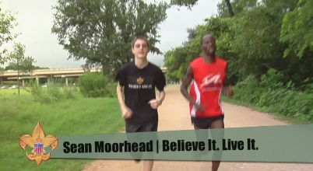](https://vimeo.com/24863948)**

**** In this video, the “Believe It Live It” team interviews a Gilbert, a runner who survived a horrific attack by rebels in Burundi, Africa. This video relates his reverence to God to the Scout Law <https://vimeo.com/24863948>

## FEBRUARY - ADVENTURES with a CHARACTER COMPASS pointing to REVERENT:

**TIGER –**

* My Family’s Duty to God (Core)
* Sky Is the Limit (Elec)

**WOLF –**

* Duty to God Footsteps (Core)

**BEAR –**

* Fellowship & Duty to God (Core)

**WEBELOS CORE –**

* Duty to God and You (Core)

**ARROW OF LIGHT CORE –**

* Duty to God in Action (Core)

**WEBELOS & AOL ELECTIVES –**

* Into the Woods (Elec)

## MONTHS WITH THEMES FOR REVERENT

|  |  |  |
| --- | --- | --- |
| **Month** | **Year** | **Theme** |
| **REVERENT** (Themes for former CV Faith are listed here) | | |
| November | 1942 | Thanksgiving |
| November | 1952 | Faith of his Fathers |
| December | 1960 | Guiding Stars |
| November | 1974 | Pilgrims |
| November | 1980 | Thanksgiving-Living & Sharing |
| November | 1984 | Turkey Day |
| November | 1992 | Turkey Day |
| November | 2003 | Pilgrims of Plymouth Rock |
| December | 2005 | Faith, Hope & Charity |
| December | 2007 | Celebrations Around the World |
| April | 2011 | Faith |
| April | 2012 | Faith |
| April | 2013 | Cub Scouts Give Thanks |
| April | 2014 | My Family Tree |
| April | 2015 | Soaring the Skies |
| December | 2015 | Winter Wonderland |
| February | 2017 | Passports to Other Lands |
| November | 2017 | Cubs Give Thanks |

# THE FOUNDER'S PRAYER

*Written by Baden-Powell for use in international events.*

Father of us all, we meet before Thee here today, numerous in the lands we come from and in the races we represent, but one in our Brotherhood under Thy Divine Fatherhood.

We come before Thee with hearts grateful and gladdened by the many blessings Thou hast granted us and thankful that our Movement has prospered as acceptable in Thy sight. In return we would lay on Thine Altar, as our humble thank-offering, such sacrifice as we can make of self in service to others. We ask that during our communion here together we may, under Thy Divine Inspiration, gain a widened outlook, a clearer vision of all that lies open before us and of our opportunity. Thus we may then go forth with strengthened faith to carry on our mission of heightening the ideals and powers of manhood, and of helping through closer understanding to bring about Thy happier Rule of Peace and Goodwill upon Earth.

# Duty to God Statements by Lord Baden-Powell

* "The Scout, in his promise, undertakes to do his duty to his king and country only in the second place; his first duty is to God. It is with this idea before us and recognizing that God is the one Father of us all, that we Scouts count ourselves a brotherhood despite the difference among us of country, creed, or class. We realize that in addition to the interests of our particular country, there is a higher mission before us, namely the promotion of the Kingdom of God; that is, the rule of Peace and Goodwill on earth. In the Scouts each form of religion is respected and its active practice encouraged and through the spread of our brotherhood in all countries, we have the opportunity in developing the spirit of mutual good will and understanding.
* "There is no religious "side" of the movement. The whole of it is based on religion, that is, on the realization and service of God.
* "Let us, therefore, in training our Scouts, keep the higher aims in the forefront, not let ourselves get too absorbed in the steps. Don't let the technical outweigh the moral. Field efficiency, back woodsmanship, camping, hiking, Good Turns, jamboree comradeship are all means, not the end. The end is CHARACTER with a purpose.
* "The atheists....maintain that a religion that has to be learnt from books written by men cannot be a true one. But they don't seem to see that besides printed books....God has given us as one step the great Book of Nature to read; and they cannot say that there is untruth there - the facts stand before them....I do not suggest Nature Study as a form of worship or as a substitute for religion, but I advocate the understanding of Nature as a step, in certain cases, towards gaining religion." - (Rovering To Success, 1930) day.
* "Our objective in the Scouting movement is to give such help as we can in bringing about God's Kingdom on earth by including among youth the spirit and the daily practice in their lives of unselfish goodwill and cooperation."

## http://www.scouting.org/scoutsource/Media/Relationships/ScoutSabbathServices/~/media/Images/relationships/15-208/bp.gif.ashx?w=184&h=225&as=1More Quotes from Baden-Powell on Faith

*Alice, Golden Empire Council*

"No man can be really good, if he doesn't believe in God and he doesn't follow His laws. This is why all Scouts must have a religion". *(Scouting for Boys, 1908)*

"Scouting has been described as "a new religion". It's not, of course, a new religion: it's just the application to religious formation of the principle now accepted in non-religious formation, i.e. to point out a precise aim to the boy and give him the way to learn and practice by himself" *[Quoted in Taccuino, a collection of B-P's writings and essays published in Italy. Dated January 1912]*

***From Aids to Scoutmastership, 1919:***

"Love of God, love of your neighbour and respect of oneself as God's servant are the basis for any form of religion"

"Many difficulties may arise while defining religious formation in a Movement such as ours, where many religions coexist; so, the details of the various forms of expressing the duty to God must be left to those responsible of each single association. We insist however on observance and practice of that form of religion the boys profess"

"Nowadays the actions of a large part of youths are guided just in a small part by religious convictions. That can be attributed for the most to the fact that in the boy's religious formation the worry was on teaching instead of educating".

"If you really wish to find the way towards success, i.e. your happiness, you must give a religious base to your life. It's not simply attending church or knowing history or comprehend theology. Many men are sincerely religious almost without knowing it or having studied these things. Religion, briefly explained, means: First: know who God is; Second: use to the best the life He gave us, and do what He expects from us. This means mostly doing something for the others."

***From Rovering to Success, 1922***

The method of expression of reverence to God varies with every sect and denomination. What sect or denomination a boy belongs to depends, as a rule, on his parents' wishes. It is they who decide. It is our business to respect their wishes and to second their efforts to inculcate reverence, whatever form of religion the boy professes.

****

# REVERENT QUOTES

*Quotations contain the wisdom of the ages, and are a great source of inspiration for Cubmaster’s minutes, material for an advancement ceremony or an insightful addition to a Pack Meeting program cover.*

PlatoLet parents then bequeath to their children not riches but the spirit of reverence. Plato

## Faith Quotations

Faith is not without worry or care, but faith is fear that has said a prayer. Author Unknown

Faith is spiritualized imagination. Henry Ward Beecher

Faith is courage; it is creative while despair is always destructive. David S. Muzzey

Faith is a passionate intuition. William Wordsworth

Faith is putting all your eggs in God's basket, then counting your blessings before they hatch.   
Ramona C. Carroll

Faith is what makes life bearable, with all its tragedies and ambiguities and sudden, startling joys. Madeleine L'Engle

Be like the bird that, passing on her flight awhile on boughs too slight, feels them give way beneath her, and yet sings, knowing that she hath wings. Victor Hugo

Faith is raising the sail of our little boat until it is caught up in the soft winds above and picks up speed, not from anything within itself, but from the vast resources of the universe around us. W. Ralph Ward

As your faith is strengthened you will find that there is no longer the need to have a sense of control, that things will flow as they will, and that you will flow with them, to your great delight and benefit. Emmanuel

A little faith will bring your soul to heaven, but a lot of faith will bring heaven to your soul. Author Unknown

Faith is believing that the outcome will be what it should be, no matter what it is. Colette Baron-Reid

Faith can move mountains, but don't be surprised if God hands you a shovel. Author Unknown

Faith is believing in things when common sense tells you not to. George Seaton

Faith is taking the first step even when you don't see the whole staircase. Martin Luther King, Jr.

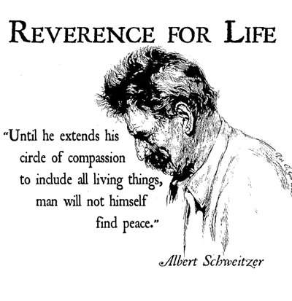

## REVERENT / REVERENCE QUOTATIONS

***Pursue some path, however narrow and crooked, in which you can walk with love and reverence.   
Henry David Thoreau***

Reverence is an emotion that we can nurture in our very young children, respect is an attitude that we instill in our children as they become school-agers, and responsibility is an act that we inspire in our children as they grow through the middle years and become adolescents.― Zoe Weil, Above All, Be Kind: Raising a Humane Child in Challenging Times

Authentic faith leads us to treat others with unconditional seriousness and to a loving reverence for the mystery of the human personality. Authentic Christianity should lead to maturity, personality, and reality. It should fashion whole men and women living lives of love and communion. False, manhandled religion produces the opposite effect. Whenever religion shows contempt or disregards the rights of persons, even under the noblest pretexts, it draws us away from reality and God.― Brennan Manning, The Ragamuffin Gospel: Good News for the Bedraggled, Beat-Up, and Burnt Out

Abba is not Hebrew, the language of liturgy, but Aramaic, the language of home and everyday life … We need to be wary of the suggestion … that the correct translation of Abba is ‘Daddy.’ Abba is the intimate word of a family circle where that obedient reverence was at the heart of the relationship, whereas Daddy is the familiar word of a family circle from which all thoughts of reverence and obedience have largely disappeared … The best English translation of Abba is simply ‘Dear Father.”― Thomas Allan Smail, The Forgotten Father

He’d never really given religion much thought himself. It was just there, one of the basic fundamentals of life and living; Heaven is generally good and one should aspire to end up there, and Hell is decidedly foul and one should generally direct their enemies there.  
― T.A. Miles, Raventide

The sympathy which is reverent with what it cannot understand is worth its weight in gold.   
― Oswald Chambers, Baffled to Fight Better

Bond is stronger than blood. The family grows stronger by bond.― Itohan Eghide, Master of Maxims

Carrying little Kunta in his strong arms, he walked to the edge of the village, lifted his baby up with his face to the heavens, and said softly, “Fend kiling dorong leh warrata ka iteh tee.” (Behold—the only thing greater than yourself.)” ― Alex Haley, Roots

Each of us experiences the perpetual revival of the self. We constantly recast our connate emotional index by perceiving each encounter in life as a marvel, impedance, problem, disaster, or nothing at all. Living in the moment allows us to escape the lonely landscape of self-interest and be part of a larger world filled with beauty, reverence, and adoration.   
― Kilroy J. Oldster, Dead Toad Scrolls

Faith in God, reverence of a Creator!  
― [Lailah Gifty Akita](http://www.goodreads.com/author/show/8297615.Lailah_Gifty_Akita), [Pearls of Wisdom](http://www.goodreads.com/work/quotes/45089802)

An enlightened person strives to live a meaningful life, defined by their personal humility joy, passion, and profound reverence for life.”   
― Kilroy J. Oldster, Dead Toad Scrolls

Ernest Thompson Seton, one of the Founders of the BSA once said, **“Many years ago in Montana, I heard a missionary severely rebuke an Indian for driving his team on Sunday. The Indian looked puzzled, as he was merely minding his business and caring for his family. The missionary reiterated that this was the Lord’s Day. At last a light dawned on the Indian. He glanced up with a gleam in his eye and answered, “Oh, I see. Your God comes only one day a week; my God is with me every day and all the time.”**

## THE GOLDEN RULE



**The Golden Rule Around   
the World**

* **Christianity** All things whatsoever ye would that men should do to you, do ye so to them; for this is the law and the prophets. Matthew 7:1
* **Confucianism** Do not do to others what you would not like yourself. Then there will be no resentment against you, either in the family or in the state. Analects 12:2
* **Buddhism** Hurt not others in ways that you yourself would find hurtful. Udana-Varga 5,1
* **Hinduism** This is the sum of duty; do naught onto others what you would not have them do unto you. Mahabharata 5,1517
* **Islam** No one of you is a believer until he desires for his brother that which he desires for himself. Sunnah
* **Judaism** What is hateful to you, do not do to your fellowman. This is the entire Law; all the rest is commentary. Talmud, Shabbat 3id
* **Taoism** Regard your neighbor’s gain as your gain, and your neighbor’s loss as your own loss. Tai Shang Kan Yin P’ien
* **Zoroastrianism** That nature alone is good which refrains from doing another whatsoever is not good for itself. Dadisten-I-dinik, 94,5

Or as Baden Powell said:   
**“The real way to get happiness is by giving out happiness to other people.”**

## Trees & Faith for Scouters

****

***Thoughts from Alice: Planting a tree is really a testament of faith – faith in the future and in God, as this first poem demonstrates – to share with scouts, you might just read the underlined verses – although there are good thoughts in every verse. (OR You can use the second poem by Kilmer - CD)***

**Why Does an Old Man Plant a Tree?***by Robert H Mealey*

My friends quite often ask of me,  
Why does an old man plant a tree?  
It grows so slow it will not pay  
A profit for YOU anyway.  
Then why in storm and winter cold,  
Do you plant when you are so old?

The answer seems hard to define,  
When muscles ache and they are mine.  
But I just cannot stand to see,  
A space where there should be a tree.  
So that in part as years unfold,  
Is why I plant when I'm so old.

I know that animals, bugs and things,  
Love trees, and so do such as go on wings.  
So creatures wild that benefit,  
Is one more reason I can't quit  
From planting trees while I can hold,  
My planting hoe, though I'm so old.

They say that those retired from labor,  
Should fish and play and talk to neighbor.  
They say also that folks in leisure,  
Should do the things which give them pleasure.  
And so the thought on which I'm sold,  
I'll plant some trees though I'm so old.

As time goes on my trees will grow.  
So tall and clean and row on row.  
The furry folk will have a home,  
The birds can nest, and kids can roam.  
And all of this as I have told,  
I planted trees though I'm so old.

And then there is my family,  
Young folks who will follow me.  
I'd like to leave them with some land,  
Stocked with trees and looking grand.  
These gifts I value more than gold,  
So I plant some trees though I'm so old.

And taxes too for schools and roads,  
With jobs and lumber for abodes.  
I won't see these things, I won't be here.  
But to my mind it's very clear.  
The words of some who could be polled,  
Might thank a man who is so old.

Man should be proud of what's his own,  
And how he's managed what he's grown.  
But management must be begun,  
By planting seedlings one by one.  
And so my pride I shall uphold,  
I'll plant some trees though I'm so old.

So, when my friends ask of me,  
Why does and old man plant a tree?  
Perhaps the lines above explain,  
How aching back and limbs in pain,  
May by commitment be controlled,  
To plant my trees though I'm so old.

***Here’s a second famous poem –I am a native of New Jersey, so I am very well acquainted with Kilmer. Don’t be fooled by appearances! Joyce is actually an honorable male name in Great Britain, along with Kip and Evelyn, pronounced Eve-A-Lyn) CD***

**Trees**

*By Joyce Kilmer (1886-1918)*

I think that I shall never see   
A poem lovely as a tree.

A tree whose hungry mouth is prest   
Against the earth's sweet flowing breast;

A tree that looks at God all day,   
And lifts her leafy arms to pray;

A tree that may in Summer wear   
A nest of robins in her hair;

Upon whose bosom snow has lain;   
Who intimately lives with rain.

Poems are made by fools like me,   
But only God can make a tree

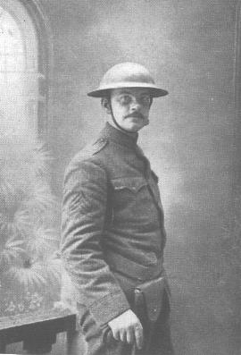

Alfred Joyce Kilmer (1886-1918), the noted American poet killed in action during World War I, was born in New Brunswick, New Jersey, on 6 December 1886. Educated at Rutgers College and Columbia University. In June 1908 Kilmer married Aline; they had five children. In 1911 Kilmer's first volume of poetry, entitled *A Summer of Love*, was published to acclaim.

Kilmer's best-known poem today is *Trees*, written in 1913.  In it he demonstrated his deeply-held affinity for nature and God.

## SCOUT SUNDAY / SABBATH

Sunday before February 10th   
Saturday after February 10th

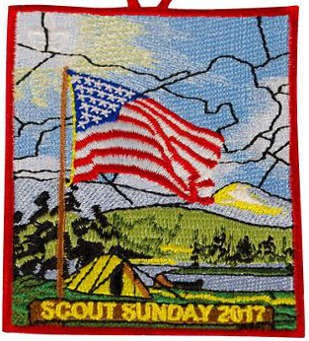  
*Each year BSA issues a patch for Scout Sunday and one for Scout Sabbath. They are available at Scout Shops and* [*www.scoutstuff.org*](http://www.scoutstuff.org)*. There are, also, matching neckerchiefs and pins.*

The Boy Scouts of America annually celebrates its founding on February 8, 1910, based on the program started by Lord Baden Powell in England on August 1, 1907.

Scout units and religious-based chartered organizations share a special bond that lasts all year.

But on certain days each year — namely Scout Sunday and Scout Sabbath — we set aside time to celebrate a partnership that benefits all parties involved: the religious institution, Scouts, Scouters and the communities they serve.

Scout Sunday is designated by BSA’s National Council as the Sunday preceding February 8th (Scouting’s Anniversary Date), unless the 8th is a Sunday, in which case the 8th would be Scout Sunday. The Saturday following February 8th is Scout Sabbath. Scout Sunday & Scout Sabbath celebrations began in 1940s. This is the primary date to recognize the contributions of young people and adults to Scouting. However, chartered organization and local congregations can use other options to celebrate this special day. (e.g. The United Methodist Church celebrates Scout Sunday on the second Sunday in February). A local church may celebrate on the Sunday most acceptable to the Pastor and congregation. Depending on the year, the date may be shifted to avoid conflict with Lenten and other religious observances.

The Scout units are urged to participate in the religious services. [Scout Sunday](http://www.scouting.org/scoutsource/Media/Relationships/ascoutisreverent.aspx) is an opportunity for units can attend services in uniform, conduct a flag ceremony, speak about Scouting, present [religious awards](http://www.scouting.org/scoutsource/Awards/ReligiousAwards.aspx) and/or formally thank the chartering organization for their support throughout the year.

**Elements of participation may include:**

* Reserving a section of pews so the unit(s) may sit together.
* Taking an active part in the service by having youth perform such acts as leading a prayer, reading from the Bible, ushering, taking the offering,
* A notice in the church bulletin. It could simply be a mention that today is Scout Sunday, or it may include information about Scouting and a Scout’s Duty to God. Perhaps the Scout Oath and Law showing “Duty to God” and Reverent.
* Hosting a Fellowship Hour and having an information (and recruiting) table in the foyer or hospitality area.

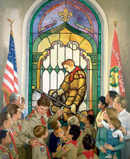  
A Scout is Reverent.

**Bryan’s Blog has an issue almost every year devoted to Scout Sunday.** Here is a link to the January 2016 article. That article has links to three of his previous Scout Sunday issues.

[**Scout Sunday 2016 and Scout Sabbath 2016: Your complete guide**](http://blog.scoutingmagazine.org/2016/01/20/scout-sunday-2016-scout-sabbath-2016-complete-guide/)

[](http://blog.scoutingmagazine.org/2016/01/20/scout-sunday-2016-scout-sabbath-2016-complete-guide/)On Scout Sunday 2016 and Scout Sabbath 2016, we set aside time to celebrate a partnership that benefits religious institutions and Scout units alike. 

**National’s website has lots of information:**

* **Scout Sunday -** <http://www.scouting.org/scoutsource/Media/Relationships/ascoutisreverent.aspx> It includes a suggested Order of Worship, recommended readings, and lots of resources.
* **Scout Sabbath -** <http://www.scouting.org/scoutsource/Media/Relationships/ScoutSabbathServices.aspx>

**US Scouts (the host for Baloo’s Bugle) has a whole section devoted to “A Scout is Reverent.” Find it at** [**http://usscouts.org/Reverent.asp**](http://usscouts.org/Reverent.asp)

There are links to:

* [*A Scout's Duty to God and Country*](http://usscouts.org/scoutduty/)
* [Big Book of Scout Worship Services](http://usscouts.org/reverent/BigBookScoutRev.doc)
* [Meditations for the Trail](http://usscouts.org/scoutduty/Meditations_for_the_Trail.rtf) (RTF)
* [Meditations for the Trail](http://usscouts.org/scoutduty/Meditations_for_the_Trail.doc) (DOC)
* [Prayers](http://usscouts.org/reverent/prayers.asp)
* [Retreat](http://usscouts.org/reverent/retreat.asp)
* [Training/Information Packet for Chaplains and Chaplain Aides by Andrew McCreight](http://usscouts.org/reverent/ChaplainBasics.doc)
* [Scouts Own Resources](http://www.macscouter.com/ScoutsOwn) (this one has several versions of responsive readings based on the **Scout Law**. Some use a Bible Verse to illustrate each of the 12 points. ***I love these!! CD***

**Several churches have put out guidance for their members and churches on observing Scout Sunday:**

* The Catholic Committee on Scouting - <http://www.nccs-bsa.org/pdf/ScoutSunday.pdf>
* The United Methodist Church - <https://www.umcdiscipleship.org/resources/scouting-sunday>

## SCOUTER’S PRAYER

Dear Lord, from your judgment seat on high,  
Look down on a Scoutmaster such as I.  
Search me through and find me whole,  
Then help me, Lord, to reach my goal.  
Help me, Lord, to work for Thee,  
Guard my homeland—keep it free.  
Help me to work with others and be kind,  
Helpful with my hands and mind.  
Keep me, Lord, both well and strong,  
To help growing boys along.  
Control my thoughts, keep them right,  
Sound, clean weapons for life's fight.  
Protect my morals, keep them high,  
Grant this to a Scouter such as I.  
*—Author Unknown*

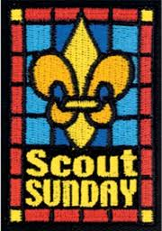

## Monday Evening Prayer

George Washington 1752, Age 20

Most Gracious Lord God, from whom proceedeth every good and perfect gift, I offer to thy divine majesty my unfeigned praise & thanksgiving for all thy mercies towards me. . . . Bless our rulers in church and state. Bless O Lord the whole race of mankind, and let the world be filled with the knowledge of Thee and thy son Jesus Christ. Pity the sick, the poor, the weak, the needy, the widows and fatherless, and all that morn or are broken in heart, and be merciful to them according to their several necessities. Bless my friends and grant me grace to forgive my enemies as heartily as I desire forgiveness of Thee my heavenly Father. I beseech thee to defend me this night from all evil, and do more for me than I can think or ask, for Jesus Christ sake, in whose most holy name & words, I continue to pray, Our Father. **Amen**

*From William J. Johnson,   
George Washington, The Christian   
(New York: The Abingdon Press, 1919).*

# Pack Meeting Ideas for Reverent

## Gathering Activities

**A Scout is Reverent Puzzles**

*Commissioner Dave*

**Materials:** Pictures of Religious Awards printed on card stock or pasted to thin cardboard..

* Cut the pictures into puzzle pieces - 4 or 6 per card.
* Give the boys puzzle pieces as they arrive.
* Have them try and complete the puzzle by talking with others and finding the others pieces.

During Icebreaker have them show the completed puzzle and read the back. *(Have tape available)*

**Faith Bingo**

*Commissioner Dave*

Give each person a Board. They go around and meet people. After meeting someone and learning their name, they are to ask them to sign a box. Each person can only sign 1 box!!! This is not a speed contest; there should be interaction!! Here is a sample board- boxes may be changed to suit your group

**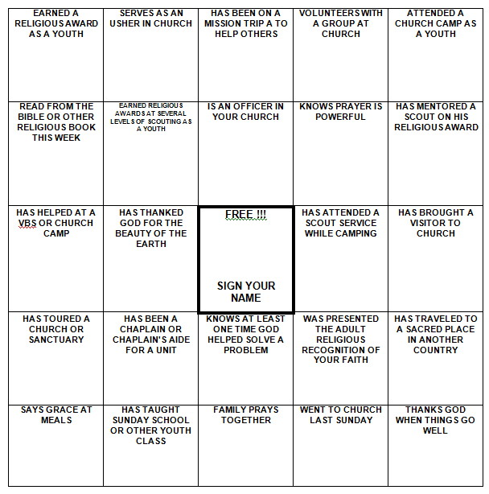**

Be sure to enlarge the BINGO Board to fill a sheet of paper and put some directions on the sheet, too.

**Search for Reverent**

*Alice, Golden Empire Council*

Words in this search all pertain to belief in God – words may be in any direction.

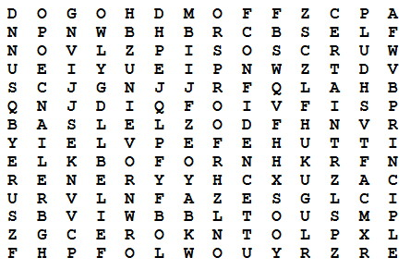

**Here are the words:**

Belief Principle Certain

Proof Confidence Reliance

Friends Religion God

Self Hope Sure

Loyalty Trust

**OPENING PRAYERS**

**The Scout Prayer**

*Scouting Ireland*

Dearest Father, teach me to be generous,  
Teach me to love and serve as you deserve;  
To give and not to count the cost;  
To fight and not to heed the wounds;  
To toil and not to seek for rest;  
To labor and to look for no reward  
Save that of knowing that I do Thy Holy Will. **Amen.**

**Cub Scout Prayer**

*Scouting Ireland*

Lord, in this evening hour I pray,  
For strength to do my best each day.  
Draw near to me that I may see,  
The kind of Cub Scout that I should be.  
In serving others, let me see,  
That I am only serving Thee.  
Bless me, oh Lord, in Thy great love,  
That I may be a better Cub. **Amen.**

**OPENING CEREMONIES**

**Where Faith is Found Opening**

*Alice, Golden Empire Council*

**Materials:** Have each boy make a sign to hold with the letter he has been assigned. Alternately, you can simply download images or make letter signs. Write each boy’s part on the back of the sign in large letters.

**Narrator:** This month we have been learning all about Faith – see if you recognize these examples of where Faith is Found.

|  |  |
| --- | --- |
| letter-f | **Cub #1:** *(holding up letter or posting on the wall)*  **F**ollow the example of your religious leaders, your grandparents, or others who have great faith – it will help you find your own Faith. |
| the+letter+a+copy | **Cub #2:** *(holding up letter or posting on the wall)*  **A**lways look for examples of faith as you enjoy the outdoors – like the breeze, faith cannot be seen – but you can feel its presence. |
| ANd9GcTTHYD9ANw_kTr3f6FQPTFWE5bSU1qSw_6ox5AKMF_6-yoRCT76&t=1 | **Cub #3:** *(holding up letter or posting on the wall)*  **I**f you want to have faith, learn to serve others – without complaining. |
| Letter-T | **Cub #4:** *(holding up letter or posting on the wall)*  **T**rust in your God, your Country and Yourself – And always be a person that can BE trusted if you want to find Faith. |
| 73369_letter-H_lg | **Cub #5:** *(holding up letter or posting on the wall)*  **H**ow you ACT will show what you really believe.  *(All boys return and hold up their letters)*  **All:** SHOW YOUR FAITH! |

**Narrator:** As you can see, the boys have learned some important ways to really SHOW their faith. And we’d like you to join us in Showing how we feel about our Country – where every person can follow their own faith, and worship as they please…..

*(Lead into the Flag Ceremony)*

## Songs

**Cub Scout Garden**

*Commissioner Dave*

*Tune*: She'll Be Coming Round the Mountain.

***Gardening is a great example of reverence and faith in God. I wrote this one a few years ago. It has many more verses.*** *(Too many for Cub Scout attention spans!!)*

***Be sure to create some good motions   
for the verses!***

We will plant our Cub Scout Garden in the spring

We will plant our Cub Scout Garden in the spring

We will plant our Cub Scout Garden

We will plant our Cub Scout Garden

We will plant our Cub Scout Garden in the spring

We will pray to God to watch our crop each day

We will pray to God to watch our crop each day

We will pray to God to watch

We will pray to God to watch

We will pray to God to watch our crop each day

We will reap our harvest early in the fall

We will reap our harvest early in the fall

We will reap our harvest early

We will reap our harvest early

We will reap our harvest early in the fall

Then we’ll Thank God for his help with our garden

Then we’ll Thank God for his help with our garden

Then we’ll Thank God for his help

Then we’ll Thank God for his help

Then we’ll Thank God for his help with our garden

**Cub Scout Taps**

*Catalina Council*

Tune: Taps

*Can be sung or sung to the tune or*

*spoken in a solemn manner*

Sun of gold, sky of blue

Both are gone from our sight,

Day is through,

Do your best, then to rest,

Peace to you.

**It's a Small World***(With Scouting Verses)*

*San Gabriel Valley, Verdugo Hills, Long Beach Area*

It's a world of laughter, a world of tears  
It's a world of hopes and a world of fears  
There's so much that we share  
That it's time we're aware  
It's a small world after all

**Chorus:**It's a small world after all  
It's a small world after all  
It's a small world after all  
It's a small, small world

There is just one moon and one golden sun  
And a smile means friendship to everyone  
Though the mountains divide  
And the oceans are wide  
It's a small world after all

**Chorus:**

It's a world of Scouting, a world of fun  
It's a world of aims, but we work as one  
There's so much that we share  
That it's time we're aware  
It's a small world after all.

**Chorus:**

You can go to China or go to Spain  
And the Guiding Handshake will be the same  
We have friends in Japan,  
Mexico, Pakistan,  
It's a small world after all.

**Extra Verses:**

It's a world of color, a pretty sight,  
Red and yellow and brown and black and white  
And yet under our skin,  
We are all kith & kin  
It's a small world after all

Some may live in houses, in tents in shacks  
And what one man has yet another lacks  
There's so much that we share,  
That it's time we're aware  
It's a small world after all

How we live our lives we must each decide,  
Every Cub & Scout & Leader Guide  
Throughout Scouting we find,  
Both in body & mind  
It's a small world after all

**It’s A Cub World**

*Santa Clara County Council*

(Tune: It’s a Small World)

**CHORUS**

It’s a Cub’s world, after all,   
It’s a Cub’s world, after all,   
It’s a Cub’s world, after all,   
It’s a Cub’s world, after all.

There’s a world of Scouting, a world of fun,  
There’s a world of sharing for ev’ryone,  
From Tibet to Peru, Mozambique, Timbuktu,   
It’s a Cub’s world after all!

**CHORUS**

The Cub Scouts promise to help and to care,  
In our homes, our country, and ev’rywhere,  
In Brazil, Turkey, Spain, Liechtenstein, Ukraine,   
It’s a Cub’s world after all!

**CHORUS**

Though Cubs may be diff’rent around the earth,  
By the Scout Oath and Law they prove their worth,  
Bhutan to Japan, Pakistan, Newfoundland,  
It’s a Cub’s world after all!

**CHORUS**

There are Cubs in England and Italy,  
There are Cubs in France and Germany,  
When the Cub flag’s unfurled, All around the world,  
It’s a Cub’s world, after all.

**CHORUS**

**I'd Like to Teach the World to Sing**

*Great Salt Lake Council*

I'd like to build the world a home   
and furnish it with love.  
Grow apple trees and honey bees   
and snow-white turtle doves.

I'd like to teach the world to sing   
in perfect harmony.  
I'd like to hold them in my arms   
and keep them company.

I'd like to see the world, for once,   
all standing hand in hand,  
And hear them echo through the hills   
for peace throughout the land.

That's the song I hear,   
let the world sing today.  
A song of peace that echoes on   
and never goes away.

**Cub Scout Harmony**

*Santa Clara County Council*

(Tune: I’d like to Teach the World to Sing)

I’d like to teach the world to sing,   
In Cub Scout harmony.  
The Blue and Gold would be the thing,   
That everyone would see.

Each Tiger, Wolf and Bear ‘n’ Webelos,   
Is doing all he can,  
To “Do His Best” with all the rest,   
Of Cub Scouts in the land.

We’re the Cub Scouts!   
Let the whole world see.   
They’ll see you and me,   
In the Cub Scouts

**Pharaoh, Pharaoh**

*Tune – Louie, Louie*

Hear it sung at - <https://www.youtube.com/watch?v=ZmeguN_5nJU>  
*One of over a dozen videos on Youtube for this.*

Well the burnin' bush told me just the other day  
That I should go to Egypt and say  
It’s time to let my people be free  
Listen to God if you won’t listen to me

**Chorus**Pharaoh, Pharaoh  
Whoa baby, let my people go!  
Pharaoh, Pharaoh  
Whoa baby, Let my people go!

Well, me and my people goin’ to the Red Sea  
With Pharaoh's best army comin' after me  
I took my staff, put it in the sand  
And all of God's people walked on dry land singin’

**Chorus**

Well Pharaoh's Army was a comin' too  
So whattaya think that God did do?  
Had me take my staff, and clear my throat  
And all of Pharaoh's Army did the "dead man's float  
**Chorus**

Well that’s the story the stubborn goat  
Pharaoh should have known that chariots don’t float  
The answer is simple, it’d easy to find  
When God says, “GO!” you had better mind

**Scouting Around The World**

*Santa Clara County Council*

(Tune: Battle Hymn of the Republic)

Around the world as far away   
As England or Peru,   
Wherever there are kids who   
Like to play a game or two,  
You’ll find some boys who do their best   
In everything they do,  
The best in all the world!

**CHORUS**

Scouts are having fun all over!   
Scouts are having fun all over!   
Scouts are having fun all over!   
The best in all the world!

These boys all hike and fish and camp   
Wherever they may be.  
They ride their bikes and sing fun songs   
The same as you and me.  
We’re each a tiny parcel   
Of the Scouting family   
The best in all the world

**CHORUS**

**AUDIENCE PARTICIPATIONS**

**Faith Based Stories**

[*http://scouts.org.uk/documents/Magazine/decjan\_09/beavdecjan09.pdf*](http://scouts.org.uk/documents/Magazine/decjan_09/beavdecjan09.pdf)

There are many stories that relate to the Beaver ***Scout (US - Cub Scout)*** Promise, and which come from the many faiths that make up our nation’s identity. Here is a snapshot:

* + - The Good Samaritan (Christianity). The classic tale of the man from Samaria who, unlike the others who passed by, helped a man in desperate need. [www.tinyurl.com/l9rdd8](http://www.tinyurl.com/l9rdd8)
    - The snake in the wall (Judaism). A tale about a girl who was especially kind and helpful and who was rewarded with her life. [www.tinyurl.com/l3oqju](http://www.tinyurl.com/l3oqju)
    - A brother like that (Islam). A modern parable about thinking of others and being kind. [www.tinyurl.com/lofm36](http://www.tinyurl.com/lofm36)
    - Six blind men and the elephant (Hinduism) A great poem about how you shouldn’t make decisions based on one piece of evidence. [www.tinyurl.com/ly89f5](http://www.tinyurl.com/ly89f5)

Read some of these stories to the Beaver Scouts ***(US - Cub Scouts)*** and they can then act them out in small groups or draw the story for themselves in cartoon form.



**Make a Pretzel of Faith Tie Slide**

*Alice, Golden Empire Council*

Prayer is an important part of faith – and here’s an interesting way to “wear” your faith on your neckerchief – make a pretzel tie slide!

Really simple – just mount a “perfect” pretzel on a piece of fun foam, or cardboard, or heavy duty paper. Background can be any color. Add a backing.

Be prepared to explain what the pretzel really means. Here’s the story:

A few weeks before Christmas in 610 AD, Brother Bachman was kneading bread dough while he watched the village children play in the snow. “Too bad they aren’t as interested in their prayers,” he thought to himself.

"If only there was some way to get them back to saying their prayers and coming to church," he said to himself. As he was finishing up the last loaves of bread, Brother Bachman was suddenly struck with a most original idea. He thoughtfully gathered up the leftover dough and began to form pencil-like strips, which he then twisted into a shape that looked like a child's arms folded in prayer. "Ah! A Pretiola!" he declared, which in Latin meant little reward.

He opened the bakery window and called out to the children. "Come in, come in say your prayers, and I will give you a Pretiola!" It didn't take much convincing. Soon each child had learned a prayer and proudly received a "little reward." Rushing home, the children excitedly told their parents. Word of Brother Bachman's idea soon spread through the village, and children and parents alike visited the chapel to receive a Pretiola.

The Christmas Prayer Service that year was especially festive and bright. The church was filled with families once again. And as the cheerful voices rose in prayer and song together, Brother Bachman smiled joyfully and thanked the Lord for little rewards.

The Pretiola soon found its way into Germany and Austria. It became a symbol of excellence used to reward worthy accomplishments as the church and youth programs flourished.

Through the centuries, Pretiola became known as "Pretzel" as we know it today. If you make a Pretzel Tie Slide, you can tell the story, too!

**ADVANCEMENT CEREMONIES**

**Reverent Advancement**

*Alice, Golden Empire Council*

Gather gardening, fire building, cooking materials to use as props. You could either use just one type of material, or you could use gardening materials for the Tigers and Wolf den boys, Cooking materials for Bears and Fire Building materials for Webelos/Arrow of Light boys.

Each boy’s advancement items should be placed under (or in) an item, then brought out as the boys and their parents are called up. For example:

**Cubmaster:** (*pointing to gardening equipment)* The boys in the Tiger den have been learning all about Faith this month -They planted some seeds – and watched them grow. I’d like to call up *(Say Scouts name)* and his parents. *(holds up seed packet and removes advancements – gives parent pin to boy to present, and advancement to parents to present to boy) ….*

*Continue calling up and presenting awards –*

*For* ***Gardening Equipment,*** *you could also use refer to the planting directions (scriptures), trowel (to prepare the soil), watering can (need to nourish faith), etc.*

*If using* ***Cooking materials****, use Recipe as Scriptures, Baking Powder or yeast as the way to raise the dough, mixing or kneading as the way to practice faith, etc.*

*With* ***Fire Building materials,*** *Shovel to prepare the area, tinder as first stirrings of faith, then kindling and fuel; you could also include a match as the “spark” that activates, and the need for air to keep fire going.*

You get the idea – and you may have much better examples than mine! Alice

## GAMES

**Reverent Runaround**

*Commissioner Dave*

***This is a takeoff of the classic "Four Corners" game***

**Materials:**

* Four (or more) signs.
* Each sign to have an emblem of a different Faith - Cross (Christian), Star of David (Jewish), ...
* Label the four corners of the hall with a different sign depending on theme you are using.
* Have a stack of cards, each with a word or saying related to one of the four pictures you posted in the corners
* Take the top card and call out the fact written on it.
* Tell the Scouts to go to the corner with the emblem to which the fact relates.
* The Scouts then run to the corner of the room they think is correct. Scouts that do not pick the correct corner are eliminated. Last person left is the winner.

**Note:**After writing your cards, you may wish to review some things before beginning the game to make sure everyone has a fair chance at the game

Ideas for cards - Such as:

* **Religious Leaders -** Brahmins (Hindu), Imams (Islam), Rabbis (Jewish), Pastors, Priests, vicars (Christianity)
* **Clothing -** Kacch, white shorts (Sikhs), Yarmulkes, a little cap that covers the crown of the head, as a mark of respect for God (Jewish).
* **Festivals -** Pesach or Passover, a festival held in March or April (Jewish), Pentecost (Christian), Ramadan (Islam), Eid Al-Adha (Muslim)
* **Places of Worship** - Mosques (Muslims), Temples (Jewish), Churches (Christian)
* **Important Cities** - Jerusalem (Jewish, Christian, Islam, Muslim). Mecca (Islam), Rome (Catholic)

**CLOSING CEREMONIES**

**Baden-Powell and Religion**

*Alice, Golden Empire Council*

**Cubmaster:** As we prepare to close this meeting, I’d like to quote something Baden-Powell had to say about religion and faith.

“Religion, briefly explained, means: First: know who God is; Second: use to the best the life He gave us, and do what He expects from us. This means mostly doing something for the others."

1. In our families we should spend time learning to know who God is.
2. And in Scouting, we need to “Do Our Best” with what God gave each of us.
3. We need to spend most of our time doing something for others.
4. Our flag is a symbol of men and women who have sacrificed for others – and some who have given their lives.
5. Will the audience please rise…. *(Go into the flag retrieval ceremony)*

## CUBMASTER’S MINUTES

**A Scout is Reverent**<https://johnscout.wordpress.com/2010/10/17/sm-minute%E2%80%94a-scout-is-reverent/>

***A Scout is reverent. A Scout is reverent toward God. He is faithful in his religious duties. He respects the beliefs of others.***

Sometimes we overlook the 12th and final point of the Scout Law. How a Scout is reverent is between him, his family and his relationship with God. My relationship with God is different than yours. Some of us attend church every week. Some of us celebrate God’s grace in the great outdoors. What is important is that every Scout is reverent towards God, in his own way.

When we go camping, we have a Scout’s Own service like we did at last weekend’s Camporee. This is not meant to replace your church duties. It simply recognizes that a Scout is reverent and shares our different religious traditions.

A Scout is reverent, yet we also respect the many different ways each of us is reverent all around the world.

**Scout is Reverent.**<https://scoutmastercg.com/a-scout-is-reverent-scoutmaster-minute/>

***A Scout is reverent. A Scout is reverent toward God. He is faithful in his religious duties. He respects the beliefs of others.***

Scouting’s founders recognized spirituality as an central element of the movement. As scouting expanded throughout the world so did the way Scouting defined duty to God. Scouting would fail in its mission if it was limited to the adherents of a certain brand of religious thought. If a world brotherhood is to survive it must be based on a mutual respect for differing concepts of God.

Reverence in America has deep roots as does the concepts of political and religious freedom. A continuous, lively and often strident debate of these freedoms has been a part of our national conversation since its founding. Mutual respect for differences is one point on which almost all of us accept though we will argue as to what and who is due what degree of respect.

Tibetan Buddhist master Atisha tells us that, “All dharma (teaching, thinking, belief) agrees at one point.”. I take this to understand that there is a thread of common humanity that inspires reverence that brings forward the best and highest in us. When we take the hand of a fellow Scout we transcend the constructs culture, background, and religion to something much deeper and broader; that elemental, indefinable common point where we stand as brothers.

***These are here as examples of the fine Scoutmaster Minutes that John Scout and Scoutmaster CG have available on their sites. Please go check out their sites for Scoutmaster Minutes and other program elements. CD***

# More Ideas for - Reverent

Universal Youth Religiuos Emblem Square Knot

## Teachable Moments

* Consider taking a field trip to an historic place of worship. Visit an early church or mission and learn about the history and faith of people who lived in your area earlier.
* As you work on the new Cub Scout Adventures, remind boys that their abilities be they mental for the STEM type badges or physical for sports and athletic badges are all gifts from God. Reinforce in a positive way that they should be thankful for these gifts.

## Religious Awards for Scouts

~~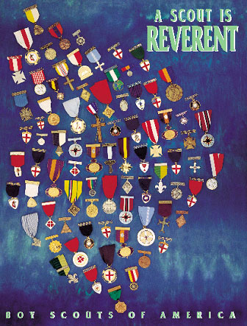~~  
Chart of all Religious Awards at <https://filestore.scouting.org/filestore/pdf/512-879_WB.pdf>

## Web Resources

**Activities for your Den for Reverent  
Based on the British Beaver Scout Faith Badge**

*Commissioner Dave*

The December 2009 issue of Beaver Magazine published by the Scouting in England for Leaders of their youngest boys *(British Beavers are equivalent to our younger Cub Scouts),* has an article on their non-denominational Faith badge with many great activities your dens could do. Multi-cultural activities include Christian, Judaism, and Islam.

***[](http://scouts.org.uk/documents/Magazine/decjan_09/beavdecjan09.pdf)***

<http://scouts.org.uk/documents/Magazine/decjan_09/beavdecjan09.pdf>

***I checked the link is good - CD, October 29, 2015***

# TRAINING TOPIC

## An Introduction to the Scouts Own

*With Pack Family Camping strongly encouraged and promoted, Packs should be holding a Scout’s Own Service every camping trip, whether it on a traditional day of worship or not. I am sure some are doing very well, some are not, and some are simply ignoring a Scout’s Duty to God and getting home earlier. Here is a brief presentation by Kyna Hendra, “Mrs. MacScouter,” clearing up what is and is not a Scout’s Own Service. Her book that you can see on* [*www.macscouter.com*](http://www.macscouter.com) *is over a 100 pages of excellent tip s and ideas for building your own Scout’s Own. CD*

***From the MacScouter’s   
“A Scout is Reverent” Book***[*http://www.macscouter.com/ScoutsOwn*](http://www.macscouter.com/ScoutsOwn/index.html)

The founder of Scouting, Robert Baden-Powell, believed that Reverence and Duty to God should be an important part of the Scout Movement and of every Scout and Scouter. He originated the notion of Scout's Own ..."a gathering the Scouts for the worship of God and to promote fuller realization of the Scout Law and Oath (or Promise), but supplementary to, and not in substitution for, regular religious observances." (Aids to Scoutmastership, p.38)

Let us first consider what Scouts' Owns are not.

* They are not Church Services, nor are they meant to be a substitute for them.
* They are not a structured liturgy like the Book of Common Order, etc.
* They are not a good opportunity for the Leader to bang home some truths with a little bit of God added for effect.
* They are not necessarily the Chaplains or Leaders' department or duty.

Given those guidelines, let's define what Scouts' Owns are. This is not what they ought to be - this is what they are; and if they do not fulfill one or more of these categories, they are not Scouts' Owns.

* They are an acknowledgment of God and his creation and ourselves as part of it, expressed in a way that all the faiths that Scouting embraces can share together.
* They are a pause in our activity to discover something deeper and more permanent in the things we are trying to achieve or learn or enjoy.
* They are a response to the Creator for the gift of life.

Which means, of course, they can be almost everything from a time of silence through a single sentence right up to a kind of service of worship that might include music and singing and stories and readings and prayers. In other words, although the next few paragraphs and pages suggest some material that could be useful for a Scouts' Own and end with a couple of outlines that might be useful for a colony/pack/troop/unit evening or in camp, there really is no "proper form."

For example, a group of Venture Scouts [older Scouts or high adventure group] may get to the summit of a mountain after a difficult or challenging rock climb and as they stand or sit down to recover and enjoy the view, one of them says, with feeling, "Thank God we made it!" and the others respond "Too right" (in context, another word for "Amen"), conscious or not, they have experienced a Scouts' Own, because they have recognized both their achievement and their growing because of it. The glory of a sunset and the breaking of the dawn; the sky at night, the hills by day and the flickering friendship round a camp-fire are absolutely natural settings for thinking -- sometimes silently, sometimes aloud -- about the power that is the beginning and end of everything and our human place in the complex order of the universe. And that's a Scouts' Own, without the need, even, for a mention of God by name -- only by implication. You see the point? A Scout's Own is really a spiritual experience that happens.

But sometimes, especially at the younger ages, it has to be underlined. So a game or an activity that has demanded effort in body or mind or in tolerance and team-work can, on the spot, be turned into a Scouts' Own with a thought and a "thank-you" for God -- no necessity for hymns or uniforms or readings. Of course, there is a place for a Scouts' Own with songs and readings -- when a time is set aside for God. Then it can be good to tell a story of adventure or challenge, where the people have relied on their faith -- whatever their faith -- in the Creator God to achieve their goal; and sing a campfire song or two about sharing and caring and serving. The song "Allelu, alleluia, praise ye the Lord" can be fun, because, divided into two groups, one does the 'Alleluias' and the other the 'Praise ye the Lord' and whenever they are singing they stand and when not they sit. This is praise that is ordered chaos and fun. Maybe that's a good description of a true Scouts' Own.

And prayers. A lot of young folk today find prayer difficult, yet the best prayers come from them. The young Cub Scout who prays "Thank you God for making me" has hit the nail on the head that's a Scouts' Own in a sentence. So it is far better to let the young people make up their own prayers - maybe creating a Group book of prayers and use it, updating it year by year. As a Leader you will never quite match, for them, the depth of their own thinking.

Finally, having, hopefully, done away with the mystique surrounding and the necessity of formality or a formal structure for Scouts' Owns, we suggest you go and get on with them - and enjoy them!

**Some Ideas on Scouts' Owns**By Baden Powell  
Printed in "The Scouter”, November 1928

For an open Troop, or for Troops in camp, I think the Scouts' Own should be open to all denominations, and carried on in such manner as to offend none. There should not be any special form, but it should abound in the right spirit, and should be conducted not from any ecclesiastical point of view, but from that of the boy. Everything likely to make an artificial atmosphere should be avoided. We do not want a kind of imposed Church Parade, but a voluntary uplifting of their hearts by the boys in thanksgiving for the joys of life, and a desire on their part to seek inspiration and strength for greater love and service for others.

A Scouts' Own should have as big an effect on the boys as any service in Church, if in conducting the Scouts' Own we remember that boys are not grown men, and if we go by the pace of the youngest and most uneducated of those present. Boredom is not reverence, nor will it breed religion.

To interest the boys, the Scouts' Own must be a cheery and varied function. Short hymns (three verses are as a rule quite enough-never more than four); understandable prayers; a good address from a man who really understands boys (a homily "talk" rather than an address), which grips the boys, and in which they may laugh or applaud as the spirit moves them, so that they take a real interest in what is said. If a man cannot make his point to keen boys in ten minutes he ought to be shot! If he has not got them keen, it would be better not to hold a Scouts' Own at all.

**Basic Concepts for Planning a Scout's Own (Interfaith Worship) Service**

* Choose a setting that lends itself to the occasion and promotes reverence –
  + - A grove of trees,
    - A site with a view of a lake, pond, brook, etc.
    - For small groups, sitting in a circle can be a very effective arrangement.
* Everything must be in good taste.
* The service should be planned, timed, and rehearsed.  
  (Generally 30 minutes maximum.)
* It should go without saying that those attending an interfaith worship service will be courteous, kind, and reverent. They should respect the rights and feelings of others even if their beliefs and religious practices differ from their own.
* Everyone in attendance should have opportunities to participate, if they wish, through responsive readings, silent and group prayer, singing, etc.

**Recognizing Diversity in a Scout's Own (Interfaith Worship) Service**

* Scouts practice many faiths, and many units are composed of Scouts from a variety of faiths. When this is the case during a Scout outing, ask them to suggest materials, to participate in the planning, and to assist in leading the service. If the group represents a mixture of religions, you may choose to use inspirational passages instead of particular religious materials.
* Because different faiths observe different religious practices and have a variety of holy days, it is not always possible to conduct an interfaith service in a time frame that fully recognizes individual religious obligations. This should be acknowledged and explained. Other time may need to be built into the schedule to allow individuals to meet their obligations.
* "Interfaith" means a service that all Scouts and Scouters may attend. Therefore, much attention must be paid to recognize the universality of beliefs in God and reverence.
* Encourage Scouts and Scouters to participate in religious services. Let them know ahead of time the nature of a service so that those anticipating a multi-faith experience do not find themselves surprised by a service that espouses the beliefs of a particular faith or religious tradition.

# FAITH AND SCOUTING

*Scouter Jim, Bountiful UT*

The history of the Boy Scouts of America (BSA) begins with a legend. It is said that Chicago newspaperman William Boyce was traveling in London and had become lost in a thick fog when a boy appeared and helped Boyce find his way. Boyce attempted to give a tip, but the boy refused because he was doing his duty as a Boy Scout. Soon after, Boyce sought the Scouting for Boys handbook and, upon returning to the States, formed the Boy Scouts of America in 1910.

As Baden-Powell’s model of Scouting became more popular, groups across Europe and the United States sprang up and began using the title “Scouts.” The Church of Jesus Christ of Latter-day Saints noticed the movement as well and, using the structure of the YMMIA, Anthony W. Ivins, general superintendent, organized the MIA. Scouts in 1911. The Church organized patrols and developed lessons for boys similar to those in official Scouting.

In 1913, the Boy Scouts of America invited the Church to be an official part of their program. Bryant S. Hinckley — father of Gordon B. Hinckley — and Oscar A. Kirkham traveled to New York City and, after hearing about BSA’s focus on honor, service, and duty to God, returned with a favorable opinion. At a meeting with the YMMIA committee, Hinckley moved to officially adopt the BSA program. The First Presidency and Quorum of the Twelve approved the decision.

The Boy Scouts issued a charter on May 21, 1913, to the MIA Scouts, and The Church of Jesus Christ of Latter-day Saints became the first institution to be officially affiliated with the Boy Scouts of America program.

From that first charter, faith based groups hold a large number of the Charters for the Boy Scouts of America. Four of the top five charter holders are faith based groups. Scouting and faith based groups are closely affiliated to train young men and boys in America.

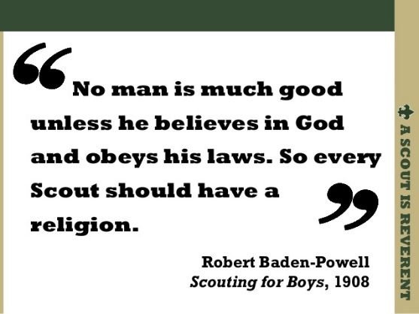

## Overview of Chartered Organizations

* Civic, faith-based, and educational organizations operate Scouting units to deliver the programs to their youth members and the community at large.
* Approximately 120,000 Scouting units are owned and operated by chartered organizations. Of these:
  + 66.9% of units are chartered to faith-based organizations
  + 24.4% of units are chartered to civic organizations
  + 8.7% of units are chartered to educational organizations

## Responsibilities of chartered organizations:

* Providing adequate meeting facilities.
* Providing quality leadership for the Scouting unit.
* Appointing a chartered organization representative to coordinate all Scouting unit operations within the organization.

## Faith-Based Scouting Groups:

*(List is incomplete. Send me others you know about we can have a longer list.   
Thank you CD)*

<http://www.nlas.org/>  
National Lutheran Association on Scouting

<http://www.ldsbsa.org/>  
Church of Jesus Christ of Latter-Day Saints BSA Relations Office

<http://www.presbyterianscouters.org/>  
Presbyterian Church

<http://www.jewishboyscouts.com/>  
Jewish Boy Scouts

<http://www.nccs-bsa.org/>   
Nat’l Catholic Committee on Scouting

<http://nycatholicscouts.com/>  
New York Catholic Scouts

<http://www.naums.org/>  
Nat’l Assoc of United Methodist Scouters

<http://baptistscouters.org/>   
Association of Baptists for Scouting

Top 25 Charter Organizations *(2010 Data)*



# SPECIAL OPPORTUNITIES

## Youth Religious Emblems

[*www.USScouts.org*](http://www.USScouts.org)

 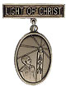 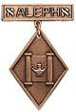

**"A Scout is Reverent."** All Scouts show this by being faithful in their duty to God. Some go further and give special service. This can qualify them for a religious emblem. Such an emblem is not a Scouting award. It is conferred on a Scout by his religious leader. Each faith has its own requirements for earning the emblem for members of its Faith. Listed at <http://usscouts.org/advance/cubscout/religious.asp#Chart> on the [www.USScouts.org](http://www.USScouts.org) website are the TIGER CUB, CUB SCOUT, AND WEBELOS SCOUT emblems and where to find out about them. Before writing or visiting your local council service center, check with your religious leader. (Unless indicated otherwise below, awards listed may be earned by both Cub Scouts and Webelos Scouts, but not by Tiger Cubs)

These groups (and others) also offer religious emblems for older youth. For information on the awards available to Boy Scouts, Varsity Scouts, Venturers, and/or Explorers, [Click here](http://usscouts.org/advance/boyscout/religious.asp).

Most of the awards consist of bar pins, ribbons, and pendants, and are worn on the uniform above the left pocket on formal occasions. In addition, the Religious Emblem Square knot, shown at the top of this page, may be worn on the uniform over the left pocket by youth or adults who earned any of the religious awards.

One or more miniature devices are affixed to the knot to indicate which level(s) of the award was earned. The youth religious emblem knot may be worn on the uniform by itself or with one or more devices to indicate the program phase(s) where the award was earned. A Scout that earns a sequence of religious emblems wears one youth religious emblem knot and up to four devices, as described below.

* The **CUB SCOUT** device for the first level (God & Me, Maccabee, etc.) earned as a Tiger Cub or Cub Scout;
* **WEBELOS** device for the second level (God & Family, Parvuli Dei, Aleph, etc.) earned as a Cub Scout or Webelos Scout;
* **BOY SCOUT** device for the first level (God & Church, Ad Altare Dei, Ner Tamid, etc.) earned as a Boy Scout;
* **VENTURING** device for the second level emblem (God & Life, Pope Pius XII, Etz Chaim, etc.) earned as an older Boy Scout, Varsity Scout, Sea Scout, or Venturer. ***Note*** *that Webelos Scout and Venturing devices are used to designate the second level emblems, even if the youth isn't a Webelos Scout or Venturer when the religious emblem was earned.*

For more information on the Youth Religious Emblem square knot patch, go to (<http://usscouts.org/awards/religyouth.asp>)

For information on the devices which are attached to the knot, go to <http://usscouts.org/awards/devices.asp>.

## FAQs about Religious Emblems

[*www.scouting.org*](http://www.scouting.org)

**What are the religious emblems programs?**The religious emblems programs are programs created by the various religious groups to encourage youth to grow stronger in their faith. The religious groups—not the Boy Scouts of America—have created the religious emblems programs themselves. The Boy Scouts of America has approved of these programs and allows the recognition to be worn on the official uniform, but each religious organization develops and administers its own program.

**I have a unit with children of all different faiths. How can I include the religious emblems programs for my unit?**The religious emblems programs should be presented to youth members and their families as an optional program for them to complete through their religious organization. Religious instruction should always come from the religious organization, not from the unit leader. Parents need to be informed of these programs and told where to get the information for their particular faith. Interested in making a presentation on the religious awards? Find sample scripts at www.praypub.org.

**Do boys and girls participate in the same program?**It depends on the religion. Some religions have created programs that are used by both boys and girls. Other religions have created programs for members of separate youth agencies (i.e., Boy Scouts of America, Girl Scouts of the U.S.A., and Camp Fire). Please check the specific eligibility requirements for each religious emblems program.

**Do the youth have to belong to a religious institution?**It depends on the religion. Please check the eligibility requirements for your particular religious program.

**Why doesn't my religious institution know about the religious emblems programs?**Although the religious bodies at the national level created the religious emblems programs, the local religious institution may not be aware of these programs. It may be helpful to write for more information or even obtain a copy of the curriculum to give to your religious leader.

**If the religious emblems program for my faith has more than one level (for the different grade levels), may my child earn all of these recognitions?**Yes. Members can earn all levels of their religious emblems program. However, they must be in the appropriate program guidelines when they start and complete each level (they may not go backward and earn younger programs).

**How is the emblem presented?**The emblem should be presented in a meaningful ceremony, preferably in the youth member's religious institution. Some emblems come with a sample presentation ceremony.

**How long does it take to complete a program?**It depends on the program. Some programs may take three or four months, others longer.

**Where is the emblem worn on the uniform?**The universal religious square knot is worn over the left shirt pocket of the Scout uniform. The medallion is pinned over the square knot for full uniform occasions.

**How do we get started on these programs?**

1. Youth members must obtain the specific booklet for their religion. This booklet will contain information on all the lessons and service projects that they will need to complete. Each member needs to have his or her own booklet to document progress. Some religions also provide adult manuals for counselors and mentors. Check with your local council to see if it stocks these booklets in its store, or contact the religious organization directly (addresses and phone numbers are provided at <http://www.scouting.org/scoutsource/Awards/ReligiousAwards/~/link.aspx?_id=9D5FA10AEB254061A248D13D459424FE&_z=z>).
2. Parents must review the specific guidelines for their particular program; age/grade requirements vary from program to program. Some programs require that the youth be an official "member" of the local religious institution, others may not. Each program determines who may serve as counselor (some require clergy, others allow parents or other family members). Be sure to look at specific eligibility guidelines!
3. Families should talk to their religious leaders and show them the booklet before beginning any program. Most of the religious emblems programs require that they be completed under the auspices of that religious organization, and many require the signature of the local religious leader. Again, check the specific eligibility requirements for your religious program.
4. The member needs to complete the requirements, obtain the proper signatures, and follow the instructions to order the emblem/award. (These emblems are not available in your local council.) The emblem can be presented at any time of the year and should be presented in a meaningful ceremony, preferably in the member's religious institution.

**Who may serve as counselor?**It depends on the program. Some programs require clergy to serve as counselor, others allow a parent or family member. Please check the specific guidelines for your religious program.

**How do I order the recognition items?**Each religious program has its own emblem. Follow the instructions in your recognition guidelines. These emblems will not be available in your local council!

**What is the adult religious recognition program?**An adult religious recognition award is presented by nomination only. The recognition is presented to worthy adults for their outstanding service to youth both through their religious institution and one of the national youth agencies. Recipients of these awards are unaware that they are being nominated. They are nominated to receive an award by submitting the required application, letters of recommendation, and resume. Please check eligibility requirements for specific awards.

**Which religious emblem square knot should I wear?**

Cloth, silver knot on purple, No. 05007, may be worn by youth or adult members who earned the knot as a youth, above left pocket.

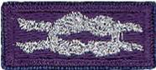 

Cloth, purple on silver, No. 05014, may be worn by adult members presented with the adult recognition of a faith, above the left pocket. Adults may wear both knots if they satisfy qualifying criteria. (See the *Insignia Guide,* No. 33066D.)

***NOTE: - Since the programs are similar or the same (as in the case of the PRAY Awards) for girls and boys in Boy Scouting, 4H, Girl Scouting, Campfire, etc., a female Venturer or Adult Leader who earned her religious award as a youth may wear the purple square knot on her uniform even though it was not earned as a member of the BSA. (My Philmont staffer daughter Dr. Darby does this!!)***

***Per Mike Walton of*** [***www.USScouts.org***](http://www.USScouts.org)***, this applies to BOTH MALES AND FEMALES, youth and adult.  If you earned a youth religious emblem as a youth member, whether it was earned or received as a BSA member or not does not matter. The youth religious emblem square knot represents ANY AWARD which youth members earned or received -- period.***

***So yes, a Girl Scout, 4Her, or Royal Ranger/Missionette who earned a youth religious emblem in one of those programs and then either becomes an adult or youth member of the BSA (to include Venturing/Sea Scouting) may wear that emblem on their BSA field uniform; and informally wear the square knot insignia without device on the uniform shirt.***

The 2015 printing of the ***"Guide to Awards and Insignia,"*** states in the Special regulations section (page 9), "The Boy Scouts of America recognizes the religious emblems programs that belong to each faith group. Anyone (youth or adult) who, as a member of another youth agency (e.g., Girl Scouts of the USA, Camp Fire USA, a Sunday school class, etc.), has earned the religious emblem of their faith is eligible to wear the approved religious emblem on their respective uniform. Individuals would also be eligible to wear the religious square knot, without any device."

## Adult Religious Recognitions

*Baloo's Archives*

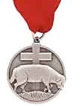 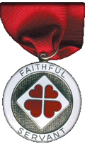

****

**What is the adult religious recognition program?**   
An adult religious recognition award is presented by nomination only. The recognition is presented to worthy adults for their outstanding service to youth both through their religious institution and one of the national youth agencies. Recipients of these awards are sometimes unaware that they are being nominated. They are nominated to receive an award by submitting the required application, letters of recommendation, and resume. Please check eligibility requirements for specific awards. Self and spousal nominations are usually not allowed.

Essentially every denomination that has Youth Awards has at least one Adult Award. The award on the left is **the** [**Lutheran Lamb Award**](https://www.praypub.org/pdf_docs/lamb2014.PDF). Presented to acknowledge at least 10 years of distinguished service of a Lutheran adult in fostering the spiritual growth of youth through church and civic youth serving agency programs and to increase the use and quality of the civic agency programs in Lutheran congregations as a part of their ministries with youth. (Commissioner Dave has been presented this honor). The recipient may wear the Adult Religious Emblem Square Knot. The Lutherans also have the [**Servant of Youth**](https://www.praypub.org/pdf_docs/youth2014.pdf) Award to acknowledge distinguished volunteer service by adults in ministry to young people through one or more civic youth agency programs. This award may be presented to a non-Lutheran SM of a troop chartered to a Lutheran Church. (or vice versa – a Lutheran Scoutmaster of a troop at a Baptist (or other) Church)

The award on the right is the [**Churches of Christ Faithful Servant award**.](http://goodservant.org/wp/request-curricula/faithful-servant-information/) There is a minimum ten year tenure requirement for nomination. The recipient may wear the Adult Religious Emblem Square Knot.

For complete listings of Adult Religious Recognitions for BSA Leaders go to National’s site at <http://www.scouting.org/scoutsource/Awards/ReligiousAwards.aspx>

or US Scouts site at <http://www.usscouts.org/awards/religadult.asp>

Many of these awards are coordinated by P.R.A.Y. Check their website for info, too [www.praypub.org](http://www.praypub.org/)

Only one Adult Religious Award square knot is worn regardless of how many awards have been received. It is possible, for example, to receive two or three levels of awards in some faiths or to receive awards from more than one faith.

***So, if you know someone who is deserving of receiving the Adult Award from his faith – check it out and begin the nomination process.***

## DUTY TO GOD PUZZLE PATCH

*P.R.A.Y. at* [www.praypub.org](http://www.praypub.org)

***Consider making a Duty to God promotion at your RT (or Pack Meeting) and having patches available to all who commit to promote or earn a Duty to God award. CD***

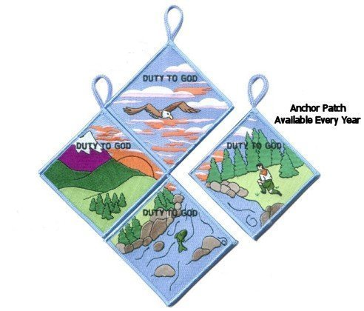

To order patches - <https://store.praypub.org/puzzle-patches>

“Duty to God” is at the heart of the Scouting movement. Religious emblems reinforce this spiritual component and promote many of the values found in the Scouting program. The purpose of this “Duty to God Promotion Patch” is to encourage youth and adults to learn about and promote the religious emblems programs.

**Requirements** –

Youth and adults must:

1. Attend or coordinate a presentation or information seminar on religious emblems (Resources and suggestions are available at [www.praypub.org](http://www.praypub.org)).
2. Make a commitment to fulfill their “Duty to God.”

*Here are some examples:*

* Adults can commit to leading a religious emblems program at their unit, nominating a worthy adult to be recognized with an adult religious award, or serving as counselor for the awards, etc.
* Youth can commit to earning the religious emblem of their faith, making a presentation on religious emblems to another unit, or helping younger Scouts earn their religious emblem, etc.

**The Patch**

* The Duty to God Puzzle Patch has four segments.
* Only one segment is presented at a time (a year).
* Participants are encouraged to earn all four segments over a four-year span.
* Visit [www.praypub.org](http://www.praypub.org) to see and order patches.
* Patches may be pre-ordered for distribution at the presentation/ information seminar.

**The DVD**The Duty to God Promotion DVD contains the resources to make a presentation on the religious emblems programs. These resources include the video “Promoting Duty to God (Religious Emblems),” Duty to God brochure/chart listing all religious emblems (No. 05-879), scripts (for presentations to Cub Scouts, Boy Scouts, and Venturers), and Parent Handout.

**Making a Presentation**

* Find scripts, videos, handouts, and other resources at [www.praypub.org](http://www.praypub.org)
* Invite parents
* Provide information on emblems of ALL faiths
* Encourage Scouts to make a commitment to earn their religious emblem
* Present the Duty to God Promotion Patch to participants

**Call and talk to the "Religious Emblems People" today! 1-800-933-7729 or visit** [**www.praypub.org**](http://www.praypub.org)

**Confused??**

***Need help to figure out these awards??***

**Here is with whom you can talk –**

## Religious Emblems Coordinators

They support the Duty to God (religious Emblems) Program, Promote Growth, & Retention in Units

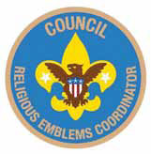

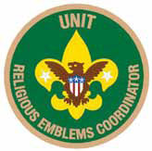

**Purpose:**There are three purposes for having Religious Emblems Coordinators at the council, district, and unit levels:

* Encourage all youth to earn the emblem of their faith
* Promote religious emblems usage the way the BSA promotes other youth advancement
* Establish goals and track the number of religious emblems earned each year

**Why?**Baden-Powell stated, "Religion seems a very simple thing: First, love and serve God. Second, love and serve your neighbor." (*Scouting for Boys*, 1908) Here are three reasons to have Religious Emblems Coordinators:

* Reinforce BSA values through religious emblems
* Improve relationships with religious chartered organizations
* Establish relationships with potential religious chartered organizations

**Responsibilities -**

**Unit Religious Emblems Coordinator**

* After appointment by the unit committee chair, serves on the unit committee
* Acquaints all youth with the religious emblems program and emblems available for their faith
* Provides Scout families and clergy with an orientation to the religious emblems program and encourages their involvement
* Urges all youth to earn the religious emblem(s) of their faith
* Disseminates information about any district or council religious emblems activities, retreats, camps, or classes
* Promotes religious emblems usage the way the BSA promotes other youth advancement
* Serves as the unit's liaison to the district religious emblems coordinator

**District Religious Emblems Coordinator**

* After appointment by the district program chair, attends district meetings and with district program chair, sets district goals for religious emblems.
* Encourages every unit to appoint a unit religious emblems coordinator
* Disseminates information to units through charter renewal packets, roundtables, and camporees
* Helps unit religious emblems coordinators recruit presenters to make presentations on religious emblems, including clergy of chartered organizations, unit leaders who promote religious emblems, chaplains, etc.

**Council Religious Emblems Coordinator**

After appointment by the council vice president of program, works with the Religious Relationships Committee. The religious emblems coordinator focuses specifically on raising awareness of religious emblems and increasing usage. The Religious Relationships Committee works directly with the faith community to recruit chaplains, coordinate the council calendar with religious holidays, sponsor religious emblems retreats, identify religious representatives from the various faith groups, and strengthen ties with local congregations and chartered organizations.

Disseminates information to district religious emblems coordinators.

Provides information for dissemination at Trainings (e.g. Colleges of Commissioner Science, Universities of Scouting, New leader trainings) and summer camp (resident and day) programs. Provides information for dissemination to Professional staff and volunteers.

Learns through the Religious Relationships Committee which faith committees are sponsoring religious emblems retreats and which congregations are offering religious emblems classes.

**To learn more:**Go to National's Web Page at <http://www.scouting.org/Home/Commissioners/newsletter/spotlight/10_2013_religious.aspx> and "read all about it."

Then, go to Roundtable and find out who your District Religious Emblems Coordinator is and call them up for help.

# BIOGRAPHY –

## Native American Spirituality

**An integral part of their cultures -   
Living your beliefs 24 - 7**



**Native Americans saw their beliefs (spirituality, religions) as an integral part of their culture.***In other words - they lived their beliefs every hours of every day. Not just a few hours a week on a perceived Sabbath Day.* Most adherents to traditional American Indian ways do not see their spiritual beliefs and practices as a "religion"; rather, they see their whole culture and social structure as infused with 'spirituality' - an integral part of their lives and culture.

Native American religion is very closely connected to the land in which Native Americans dwelt and the supernatural. Native American spirituality is often characterized by a strong emphasis on the importance of personal spirituality and its inter-connectivity with one's own daily life, and a deep connection between the natural and spiritual 'worlds'. Native Americans did not practice religion as we do today. They lived it with spirituality penetrating every aspect of their lives. Most adherents to traditional American Indian ways do not see their spiritual beliefs and practices as a "religion"; rather, they see their whole culture and social structure as infused with 'spirituality' - an integral part of their lives and culture.

Spiritual power, they believed, suffused the world, and sacred spirits could be found in all kinds of living and inanimate things-animals, plants, trees, water, and wind. Through religious ceremonies, they aimed to harness the aid of powerful supernatural forces to serve the interests of man. In some tribes, hunters performed rituals to placate the spirits of animals they had killed.



**What were their Basic Beliefs and Practices**While recognizing that there is great diversity in the religious practice of the various Native American religious traditions, we can also see that they do share worldview similarities that allow us to make a few general observations.

* **First, in every case, all of creation is seen to be interrelated.** These systems all believe that it is the responsibility of humans to oversee and protect the material world.
* **Secondly, there is a basic belief that all of life is of equal value.** They understand there to be a spark of life in all humans, animals and plants. This life force is considered to be sacred and connects all living things together. All life forms have as much right to existence as human beings, and should not be damaged or destroyed. They believe that plants and animals may be used for food, medicine and to take care of other needs, but there are limitations on that use.
* **A third common characteristic relates to a long term concern for life.** They are willing to forego short-term expediency in order to assure the long-term viability of the natural world.
* **Finally, there is a deep gratitude to the Creator for life and for the things it makes possible.** This gratitude is expressed by both public and private worship traditions.

The basic Native American view of deity is dualistic – there is believed to be good and bad in the spiritual world. Most believe in a creator God who was responsible for creating the world. They acknowledge him in their worship practices and pray to him. They also believe that there are other spirits which are able to interact in the material world. These spirits have control over such things as the weather and other circumstances which affect humans.

**Native American Prayer**

*For that solemn moment towards the end of Den or Pack meeting, try this Native American Prayer:*

Morning Star wake us, filled with joy.  
To new days of growing to man from boy.  
Sun, with your power, give us light.  
That we can tell wrong and do what is right.  
South Wind, we ask, in your gentle way.  
Blow us the willingness of obey.  
North Wind, we ask, live up to thy name.  
Send us the strength to always be game.  
East Wind, we ask, with your breath so snappy.  
Fill us with knowledge of how to be happy.  
West Wind, we ask, blow all that is fair.  
To us, that we may always be square.  
Moon, that fills the night with red light.  
Guard us well while we sleep in the night.  
Akela, please guide us in every way.  
We'll follow your trail in work or play.

**Should not we all strive to live our Faith 24 - 7   
as did the Native Americans??**

Failure is a reality; we all fail at times, and it's painful when we do. But it's better to fail while striving for something wonderful, challenging, adventurous, and uncertain than to say, I don't want to try because I may not succeed completely*.* Sources of Strength: Meditations on Scripture for a Living Faith

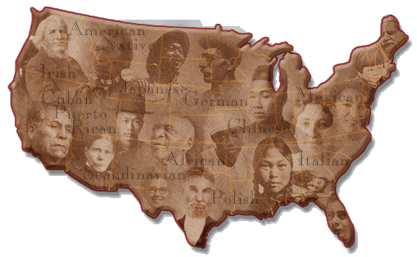

As Mankind becomes more liberal, they will be more apt to allow that all those who conduct themselves as worthy members of the community are equally entitled to the protections of civil government. I hope ever to see America among the foremost nations of justice and liberality." -   
George Washington

Only when the last tree has died  
and the last river has been poisoned  
and the last fish has been caught  
will we realize we cannot eat money.   
Cree Indian Expression

**Do you remember the crying Indian commercials??**



To see the associated PSA go to [http://www.youtube.com/watch?v=j7OHG7tHrNM](http://www.youtube.com/watch?v=j7OHG7tHrNM%20)

or for a later version - <https://www.youtube.com/watch?v=DH0U2AsyoWU>

or Google "Crying Indian Chief"

The actor is "Iron Eyes" Cody. Although he was not a Native American, he did a lot of good for the Native Americans who readily accepted him.

**More information**Gospel of the Redman

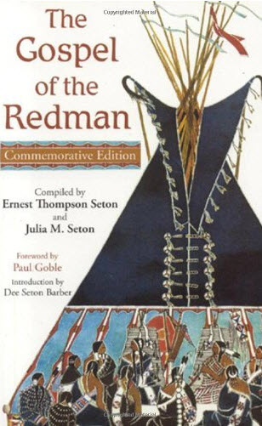

Gospel of the Redman,  
by Ernest Thompson Seton, the creator of   
“Woodcraft Indians,” a youth group he merged into the BSA, and one of the founders of the BSA

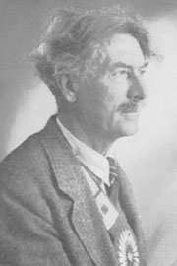***The Gospel of the Redman*** was first compiled in 1937 by E.T. Seton and his wife Julia. The current edition has an Introduction by their daughter Dee Seton Barber, a Foreword by renowned children’s book illustrator, Paul Goble as well as Ernest Thompson Seton's American Indian sketches and photographs from throughout his life.

Ernest Thompson Seton greatly respected the “Redman,” a common term which was used to refer to First Peoples. In recent years there is a tendency to think that this expression carries a racial connotation, but to Seton and his American Indian friends this word showed admiration and respect. Seton wrote this book to help the Whiteman realize the value of the doctrines by which the Redman lived in the days of his unspoiled grandeur.

"My lifelong dream and hope is that I may be the instrument of giving to the Whiteman’s world the inspiring teachings of the American Indian, in all and the full measure of their values.

“There is no Indian Bible written by an Indian, just as there was no Pentateuch written by Moses, no Tripitika by Buddha, no Dialogues by Socrates, no Gospels written by Christ. All these records were made long after by those who knew their Master in his lifetime, or at least received the traditions of his teachings from those who were privileged to hear his voice. I have never yet had an Indian tell me fully and frankly the details of his faith; but by respectfully questioning the old men, by assembling their traditions, by noting their customs, by observing their lives, by gathering the records of their prophets, by consulting living White men who knew the Indian in primitive days, and especially by conferring with Indians who were educated as Whites after spending their youth in the ancient way of their people, we have achieved something like a comprehension of the Indian’s creed, of his unwritten laws, of his sense of relationship and duty to the Great Oversoul, the Creator and Ruler, as well as to his neighbor and to himself.” E.T. Seton

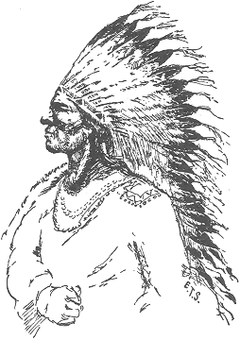

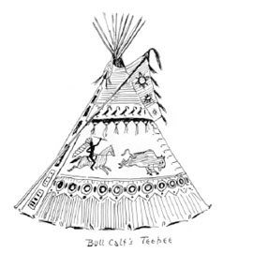

Quotes From   
***The Gospel of the Redman:”***

Be hospitable. Be kind. Always assume that your guest is tired, cold, and hungry. If even a hungry dog enters your lodge, you must feed him. Always give your guest the place of honor in the lodge, and at the feast, and serve him in reasonable ways. Never sit while your guest stands. Go hungry rather than stint your guest. If he refuses certain food, say nothing; he may be under vow. Protect your guest as one of the family; feed his horse and beat your dogs if they harm his dog. Do not trouble your guest with many questions about himself; he will tell you what he wishes you to know.

"And still I held my vision of the perfect man, athletic, fearless, kind, picturesque, wise in the ways of the woods, and without reproach of life. And by a long, long trail, with ample knowledge of histories and of persons, I was led, as many before have been, to choose the ideal American Indian. By all the evidence at hand, his was a better system, a better thought, because it produced far nobler, better men. He, more than any type I know, is the stuff that fires our highest dreams of manhood, realized complete. Him, therefore, I proclaim as the model for an outdoor life, our travel guide on the fourfold way that leads to perfect manhood.”

“There was no stronger impulse in the Indian than the deep abiding love of his country and the soil on which he and his people had lived for generations. Their most desperate fights were those in which the bravest gladly gave their lives to hold their own country for their own people.”

“The honor of their tribe, and the welfare of their nation is the first and most predominant emotion of their hearts; and from hence proceed in a great measure all their virtues and their vices. Actuated by this, they brave every danger, endure the most exquisite torments, and expire triumphing in their fortitude, not as a personal qualification, but as a national characteristic.”

**In Summary -**Throughout, The Gospel of Redman, Ernest Thompson Seton has demonstrated his deep admiration for the “Redman,” and out of respect for them incorporated many of their traditions and beliefs into the Boy Scouts of America, including a deep respect for nature, profound respect for God, and a love of vigorous outdoor living.

**Indian Prayers from   
“Gospel of the Redman”**

“O Great Spirit of my fathers, this is my prayer.  
Help me to feel Thine urge and Thy message.  
Help me to be just even to those who hate me;   
and at all times help me to be kind.

If mine enemy is weak and faltering,   
help me to the good thought that I forgive him.  
If he surrender,   
move me to help him   
as a weak and needy brother.”

“O Great Spirit of my fathers,   
help me to wholly void my heart of fear.  
And above all things,   
O God of my people and of my soul,   
help me to be a man.”

“O God, show me the way of wisdom,   
and give me strength to follow it without fear.”

“O Great Spirit, this is my prayer!   
Grant that fear may never enter into my heart   
to be the guide of my feet.”

“Help me to win, if win I may, but—  
and this especially,   
O Great Spirit—if it be not ordained   
that I may win,   
make me at least a good loser.”

## James Earl "Jimmy" Carter, Jr

**39th American President  
A REVERENT Man**

**President Jimmy Carter is 93 this (2018) year and he is still out their demonstrating his   
FAITH and COMPASSION.**

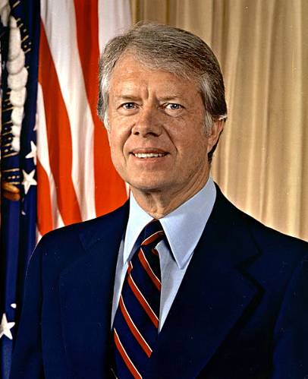

James Earl Carter Jr. was born 1 October 1924 in Plains Georgia. Jimmy Carter was the first United States President born in a hospital. He was the oldest of four children of James Earl Carter and Bessie Lillian Gordy. His father was a prominent business owner and his mother was a nurse. Jimmy Carter was a gifted student and active socially. In High School, he was Secretary of the Plains Future Farmers of America Chapter and a star baseball player.

After High School, Jimmy Carter enrolled in Georgia Southwestern College and applied for the United States Naval Academy. After taking some additional Math courses at Georgia Tech, he was admitted to the Naval Academy in 1943. After graduating 59th in his class of 820 midshipmen, he served on surface ships and on diesel-electric submarines in the Atlantic and Pacific Fleet. As a junior officer he completed the qualifications for command of a diesel-electric submarine. He applied for the US Navy’s new nuclear submarine program run by then Captain Hyman G Rickover. Carter was assigned to Schenectady, New York and worked on developing training materials for the prototype of a new submarine.

From a young age, Carter showed a deep commitment to Christianity. He served as a Sunday School teacher throughout his life. Even as president, Carter prayed several times a day, and professed that Jesus Christ was the driving force in his life. Carter had been greatly influenced by a sermon he had heard as a young man. It asked, "If you were arrested for being a Christian, would there be enough evidence to convict you?"

Jimmy Carter had intended to make the Navy his career, but the death of his father in July 1953, led him to resign his commission on 9 October 1953 and return to Georgia to run the family business. Though James Earl Carter Sr. died a relatively wealthy man, his forgiveness of debt and division of his estate between his heirs, left little for his oldest son to inherit. Jimmy Carter was forced to move his family into public housing while he struggled to revive the family business. He grew this business from those humble straights to a successful business, with the help of his wife Rosalyn who studied accounting to manage the business funds.

In 1976, Jimmy Carter defeated then President Gerald R. Ford to become the 39th President of the United States. His administration was plagued by the Energy Crisis and the hostage crisis in Iran at the United State Embassy.

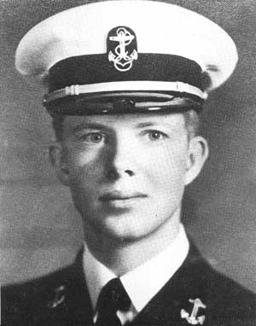

Jimmy Carter was defeated for re-election in 1980 by Governor Ronald Regan. He and his vice president Walter Mondale are the longest living post presidential team in American History, now over 32 year out of office. They surpassed second place, President John Adams and Vice President Thomas Jefferson. In 1978 Jimmy Carter was awarded the Silver Buffalo Award by the Boy Scouts of America. In 2002 he received the Nobel Peace Prize for this work after his Presidency.

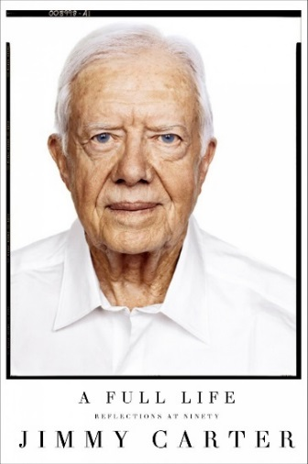

After leaving office he created the Carter Center, a non-profit partnership with Emory University committed to human rights and alleviating human suffering. He and his wife Rosalyn lead the Jimmy and Rosalynn Carter Work Project for Habitat for Humanity International one week each year. Not only do the Carters lead this week of work, they jump in and swing hammers to make it happen. Their first involvement was in 1984 when they helped renovate a six-story building with 19 families, planting the seed for their Work Project. The Carters have truly planted seeds of compassion that have yielded the Fruits of Human Kindness.

## GEORGE WASHINGTON

**A Man of Faith**

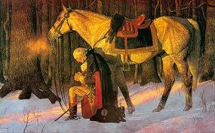

*February 22 is George Washington's real birthday (along with Lord Robert Baden Powell’s), an appropriate time to consider the faith of America's most important founding father.*

At age 13 George transcribed "110 Rules for Young Gentlemen," written by Ignatius of Loyola, founder of the Jesuits in the 1590's. George memorized them. They teach that man is God's servant who lives not for self, but for others. They became part of his character:

"Let your conversation be without malice or envy...

"When you speak of God or His attributes, be serious and speak with words of reverence.

"Let your recreations be manful, and not sinful.

At age 20, he wrote prayers to say each morning and evening. On Sunday mornings he prayed: "...pardon, I beseech Thee, my sins; remove them from Thy presence, as far as the east is from the west, and accept me for the merits of Thy son, Jesus Christ..."

At 23 Captain Washington was caught in a surprise ambush by the French and Indians near what is now Pittsburgh. Every British and American officer was shot but Washington though he rode back and forth across the battlefield. George later wrote to his brother, "By the all-powerful dispensations of Providence, I have been protected beyond all human probability or expectation, for I had four bullets through my coat, and two horses shot under me, yet escaped unhurt, although death was leveling my companions on every side of me."

On July 2, 1776 he told his troops: "The fate of unborn millions will now depend, under God, on the courage of this army. Our cruel and unrelenting enemy leaves us only the choice of brave resistance or the most abject submission. We have therefore to resolve to conquer or die."

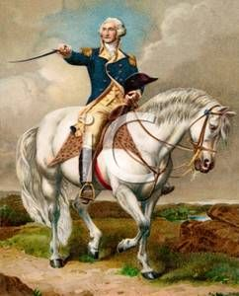

Seven weeks later British General Howe had trapped Washington and his 8,000 troops on Brooklyn Heights, ready to crush them the next morning. Washington gathered every vessel from fishing to row boats and spent all night ferrying his army across the East River. By morning many troops were still exposed to the British.

"In a most unusual change in weather, the fog did not lift from the river. It stayed thick, covering Washington's retreat until the entire army had evacuated and escaped," writes William Federer in his inspiring book, "America's God and Country." Never again did the British have such a rare chance to win the war.

During the freezing winter of 1777 at Valley Forge, a dozen soldiers died a day, with many not having blankets or shoes. "Feet and legs froze till they became black," and were amputated wrote a Committee from Congress. A Quaker named Isaac Potts came upon Washington upon his knees in the snow, praying aloud for his beloved country. He thanked God for exalting him to the head of a great nation which was fighting at fearful odds.

The Quaker told his wife of the sight: "Till now I have thought that a Christian and a solider were characters incompatible, but if George Washington not be a man of God I am mistaken, and still more I shall be disappointed in God does not through him perform some great thing for this country."

On May 5, 1778 Washington learned that the French would join America as allies. The General told his troops, "It having pleased the Almighty Ruler of the universe to defend the cause of the United American States, and finally to raise up a powerful friend among the princes of the earth, to establish our liberty, and independence upon a lasting foundation, it becomes us to set apart a day for gratefully acknowledging the divine goodness..."

In 1781 Washington's southern army defeated a detachment of British troops. Lord Cornwallis was infuriated and began pursuing the outnumbered Americans. He waited the night at the Catawba River, which the U.S. troops had crossed just two hours earlier. Miraculously, a storm arose during the night causing the river to be uncrossable for five days. Cornwallis nearly overtook Americans at the Yadkin River, but another flood arose, allowing Americans to escape.

The French navy seized control of the Chesapeake Aug. 30, 1781, driving out British ships. Washington rejoiced and besieged Cornwallis' stronghold at Yorktown. With no ships to escape upon, Cornwallis surrendered.

Washington wrote Congress, "I take a particular pleasure in acknowledging that the interposing Hand of Heaven...has been most conspicuous and remarkable."

After victory had been finalized in 1783, Washington resigned as commander-in-chief rather than seize power, proving his opposition to dictatorship and his commitment to American republicanism.[6] Washington presided over the Constitutional Convention in 1787, which devised a new form of federal government for the United States.

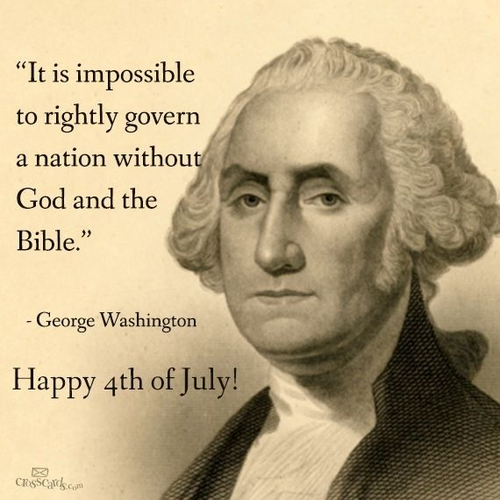

Following his election as president in 1789, he worked to unify rival factions in the fledgling nation. He supported Alexander Hamilton's programs to satisfy all debts, federal and state, established a permanent seat of government, implemented an effective tax system, and created a national bank. In avoiding war with Great Britain, he guaranteed a decade of peace and profitable trade by securing the Jay Treaty in 1795, despite intense opposition from the Jeffersonians. He remained non-partisan, never joining the Federalist Party, although he largely supported its policies. Washington's Farewell Address was an influential primer on civic virtue, warning against partisanship, sectionalism, and involvement in foreign wars. He retired from the presidency in 1797, returning to his home and plantation at Mount Vernon.

Upon his death, Washington was eulogized as "first in war, first in peace, and first in the hearts of his countrymen" by Henry Lee. He was revered in life and in death; scholarly and public polling consistently ranks him among the top three presidents in American history. He has been depicted and remembered in monuments, currency, and other dedications to the present day.

***Think about it -*** Washington had more near escapes than victories. Would God have protected him from bullets, and saved his troops with fog and floods - had he not been a praying man?

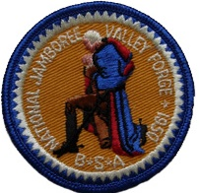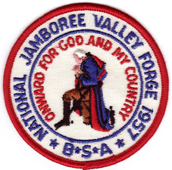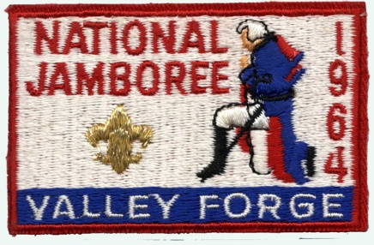

**Washington on a proposed third term and political parties, 1799**

By 1798, George Washington had led America to victory in the Revolution, helped create the American government, and served two terms as the nation’s first president (1789–1797). He was called back to service, though, by President John Adams, who offered Washington a commission as chief officer of the US Army in July 1798 to help plan for possible conflict with the French. Washington reluctantly accepted.

A year later, in June 1799, Jonathan Trumbull Jr., the governor of Connecticut who had served as Washington’s military secretary during the Revolution, wrote to urge him to run for a third term as president. “Election of a President is near at hand,” Trumbull wrote, “and I have confidence in believing, that, should your Name again be brought up, you will not disappoint the hopes & Desires of the Wise & Good in every State, by refusing to come forward once more to the relief & support of your injured Country.” Trumbull continued, writing that unless Washington sought the presidency, “the next Election of President, I fear, will have a very ill-fated Issue.”

Washington had several reasons for not running again. There was his promise not to seek unfair power as a government official and his desire to avoid being, as he wrote to Trumbull, “charged with concealed ambition.” There was also his “ardent wishes to pass through the vale of life in retirement, undisturbed in the remnant of the days I have to sojourn here.” Washington’s early promise and the lure of retirement were reasons for his declining to seek a third term.

Perhaps even stronger than those factors were Washington’s feelings about the country’s heated political climate. “The line between Parties,” Washington wrote Trumbull, had become “so clearly drawn” that politicians would “regard neither truth nor decency; attacking every character, without respect to persons – Public or Private, – who happen to differ from themselves in Politics.” Washington wrote that, even if he were willing to run for president again, as a Federalist, “I am thoroughly convinced I should not draw a single vote from the Anti-federal side.” For Washington, the nation’s political parties had soured discourse and created a climate in which, as he predicted in his 1796 farewell address, “unprincipled men will be enabled to subvert the power of the people and to usurp for themselves the reins of government.” Referring to the Democratic-Republicans, Washington wrote, “Let that party set up a broomstick, and call it a true son of Liberty, a Democrat, or give it any other epithet that will suit their purpose, and it will command their votes in toto!”

George Washington was never a man to shirk responsibility. Though he might have liked nothing better than to retire to Mount Vernon after the Revolution, he was, as he wrote Trumbull, always ready to “render any essential service to my Country,” having served, after the American Revolution, in the Constitutional Convention, two terms as president, and again as commander in chief of the Army. By 1799, though, Washington was through with elected office despite the urging of those who knew him. “Prudence on my part,” he told Trumbull, “must arrest any attempt of the well-meant, but mistaken views of my friends, to introduce me again into the Chair of Government.”

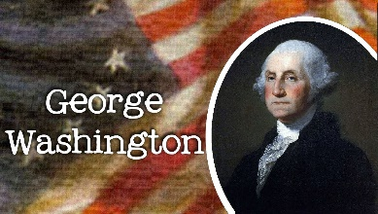

## Other Men of Faith

**William Penn Adair Roger (Will Rogers)**

[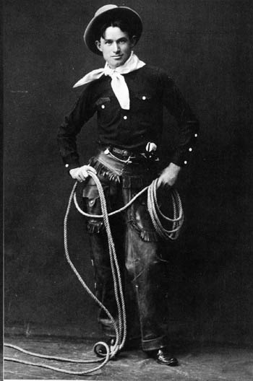](http://upload.wikimedia.org/wikipedia/commons/1/1b/WillRogers.jpeg)

Will is a great choice for a biography of a Reverent person. I usually use him Friendly, Cheerful, and Positive Attitude.

"I never met a man I didn't like,"  
was his signature line.

Go to [http://usscouts.org/bbugle/bb1112P.pdf](http://usscouts.org/bbugle/bb1112P.pdf%20)   
to read about Will Rogers

Charles Pomeroy Stone, Chief Engineer of the Statue of Liberty base. -

**Charles Pomeroy Stone  
Chief Engineer for The Statue of Liberty**

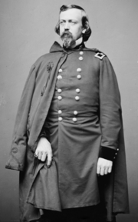

Charles Pomeroy Stone was born 30 September 1824 in Greenfield, Massachusetts. He graduated 7th in the West Point Class of 1845. He is best known as the Chief Engineer for the base of the Statue of Liberty. The job was so properly done, that many have suggested that the island would have to be turned upside down to dislodge the statue from the base. Stone resigned his Commission in November 1856 shortly after the birth of his son. The child died 5 months later.

In December 1860 while working in Washington DC, Stone was asked by General Scott to return to the army and organize the DC militia of the defense of the capital in the war which Scott felt was inevitable. Stone organized some 30 companies of militia and oversaw the security arrangements for President Abraham Lincoln’s Election.

He was named Brigadier General of volunteers in August 1861 and given command of the right flank division of the Army of the Potomac along the line of the river opposite Leesburg, Virginia. On October 21 came the disastrous battle of Ball’s Bluff, which resulted in his eventual arrest and the end of his military career. Stone was arrested in February, 1862 and spent six months in a military prison at Fort Lafayette and Hamilton in New York Harbor. He was never charged with any crime, but appears to have been imprisoned because he made political enemies in the US Senate. Contrary to U.S. Army regulations as well, no charges were ever filed against Stone nor did he stand trial. While he was in solitary confinement at Fort Lafayette, he could not exercise, and consequently Stone's health began to degrade. His physicians protested heavily to Stanton, who ordered him transferred to the military prison at Fort Hamilton. There Stone was allowed to exercise and his condition improved. He stayed at Fort Lafayette for fifty days, and would spend another 139 in Fort Hamilton. Stone was finally released without explanation or apology on August 16, 1862.

Stone’s imprisonment is a blight on the service of Abraham Lincoln and he seems partly if not whole responsible for this unjust act. Despite his illegal and unjust imprisonment in New York Harbor, he was willing to serve as Chief Engineer on the Statue of Liberty Base in the same harbor. Shortly after finishing the base of the Statue of Liberty, he died 24 January 1887 and was buried at West Point National Cemetery with full military honors.

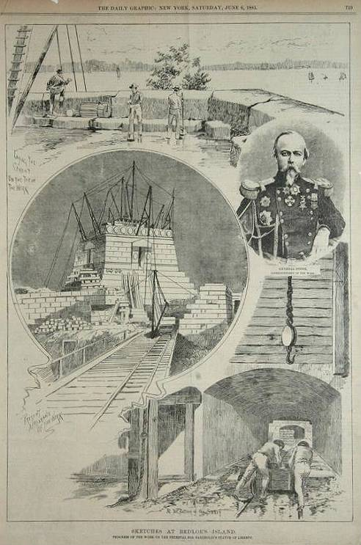

## LAST THOUGHTS

**Beatitudes for Cub Scouts***Capital Area Council*

Blessed are the Cub Scouts   
who are taught to see beauty in all things around them.  
For their world will be a place of grace and wonder.

Blessed are the Cub Scouts   
who are led with patience and understanding  
For they will learn the strength of endurance and gift of tolerance.

Blessed are the Cub Scouts   
who are provided a home where family members dwell in harmony and close communion  
For they shall become the peacemakers of the world.

Blessed are the Cub Scouts   
who are taught the value and power of truth,  
For they shall search for knowledge and use it with wisdom and discernment.

Blessed are the Cub Scouts   
who are guided by those with faith in a loving God  
For they will find Him early and will walk with him through life.

Blessed are the Cub Scouts   
who are loved and know that they are loved  
For they shall sow seeds of love in the world and reap joy for themselves and others.

**Beatitudes for Those Who Care**

*Sam Houston area Council*

Blessed are you who take the time to listen to difficult speech for you help me know that, if I persevere, I can be understood.

Blessed are you who never bid me to "Hurry up," or take my tasks from me and do them for me. For I often need time rather than help.

Blessed are you who stand beside me as I enter new and untried ventures. For my failures will be outweighed by the times I surprise myself and you.

Blessed are you who understand that it is difficult for me to put my thoughts into words

Blessed are you who, with a smile, encourage me to try one more.

Blessed are you who never remind me that today I asked the same question twice.

Blessed are you who respect me and love me just as I am.

**The Five Finger Prayer**

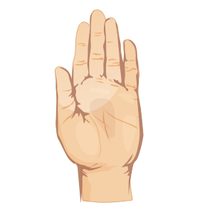

* Your thumb is nearest you. So begin your prayers by praying for those closest to you. They are the easiest to remember To pray for our loved ones is, as C. S. Lewis once said, a "sweet duty."
* The next finger is the pointing finger. Pray for those who teach, instruct and heal. This includes teachers, doctors, and ministers. They need support and wisdom in pointing others in the right direction. Keep them in your prayers.
* The next finger is the tallest finger. It reminds us of our leaders. Pray for the president, leaders in business and industry, and administrators. These people shape our nation and guide public opinion. They need God's guidance.
* The fourth finger is our ring finger. Surprising to many is the fact that this is our weakest finger, as any piano teacher will testify. It should remind us to pray for those who are weak, in trouble or in pain. They need your prayers day and night. You cannot pray too much for them.
* And lastly comes our little finger the smallest finger of all which is where we should place ourselves in relation to God and others. As the Bible says, "The least shall be the greatest among you." Your pinkie should remind you to pray for yourself. By the time you have prayed for the other four groups, your own needs will be put into proper perspective and you will be able to pray for yourself more effectively.

