Contents

LOYAL 2

CORE VALUES 2

BELIEVE IT – LIVE IT 3

ADVENTURES with a CHARACTER COMPASS pointing to LOYAL: 3

CUBMASTER’S MINUTES 6

BIOGRAPHY 8

**ABRAHAM LINCOLN** 8

**DAVY CROCKETT** 9

**DAVY CROCKETT QUOTES** 10

**THE BALLAD OF DAVY CROCKETT** 11

# LOYAL

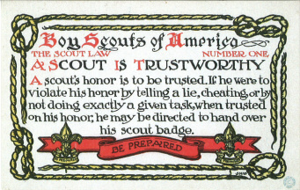

# CORE VALUES

**The Cub Scout Core Values are the  
 12 Points of the Scout Law.**

**Per our Founder, Lord Baden-Powell**

[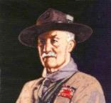](https://en.wikipedia.org/wiki/Scout_Law)

***Note –*** *The original Scout Law published in 1908 had nine points. In 1910, the BSA added Brave, Clean, and Reverent. In 1911 B-P added* ***Clean*** *to his original list.*

**A SCOUT IS LOYAL***Baden Powell said -* **A SCOUT IS LOYAL** to the King, and to his officers, and to his country, and to his employers. He must stick to them through thick and thin against anyone who is their enemy, or who even talks badly of them.   
*(Scouting for Boys, 1908)*

Loyalty is a feature in a boy’s character that inspires   
boundless hope.  
 *– Lord Robert Baden-Powell*

**[“Scout Salute,”](https://filestore.scouting.org/filestore/cubscouts/pdf/YEAR1/310-842(15)_July%20Loyal_WEB.pdf)** the theme for July 2016, used the Core Value Loyal. The Pack Meeting agenda is at - <https://filestore.scouting.org/filestore/cubscouts/pdf/YEAR1/310-842(15)_July%20Loyal_WEB.pdf>

**The Core Value highlighted this month is:**

A Scout is **LOYAL.**  The theme **SCOUT SALUTE** is used to help Cubs understand being **LOYAL.**

**A SCOUT IS LOYAL**A Scout is true to his family, friends, Scout leaders, school, and nation.

**HOW DOES “SCOUT SALUTE” RELATE TO THIS POINT OF THE SCOUT LAW?**

A Scout is true to his family, friends, Scout leaders, school, and nation. Cub Scouts will show their loyalty during this meeting by participating in several activities such as honoring the American flag, creating a pack banner, and hearing about loyalty from a guest speaker or demonstrating loyalty to a team through a pack game.

~~~~

[**“Our National Treasures,”**](https://filestore.scouting.org/filestore/cubscouts/pdf/YEAR2/310-842(15)_March%20Loyal_WEB.pdf) the March 2017 theme, used the Core Value Loyal. The Pack Meeting agenda is at: <https://filestore.scouting.org/filestore/cubscouts/pdf/YEAR2/310-842(15)_March%20Loyal_WEB.pdf>

**The core value highlighted this month is:**

A Scout is **LOYAL.**  The theme **OUR NATIONAL TREASURES** is used to help Cubs understand being **LOYAL.**

**A SCOUT IS LOYAL**A Scout is true to his family, friends, Scout leaders, school, and nation.

**HOW DOES “OUR NATIONAL TREASURES” RELATE TO THE FIRST POINT OF THE SCOUT LAW, TRUSTWORTHY??**

A Scout is loyal. A Scout is true to his nation. America is blessed with many national treasures both manmade and natural. The Washington Monument and the Grand Canyon are only two examples. Explore the importance of the treasures around you.

[**“Cubs In the Future,”**](http://www.scouting.org/filestore/cubscouts/pdf/2017/310-842(17)_March_Trustworthy.pdf) the April 2018 theme, used the Core Value Loyal. The Pack Meeting agenda is at –

<https://filestore.scouting.org/filestore/cubscouts/pdf/2017/310-842(17)_March_Trustworthy.pdf>

**The core value highlighted this month is:**

A Scout is **LOYAL.**  The theme **CUBS IN THE FUTURE** is used to help Cubs understand being **LOYAL.**

**A SCOUT IS LOYAL**A Scout is true to his family, friends, Scout leaders, school, and nation.

**HOW DOES “CUBS IN THE FUTURE” RELATE TO THE FIRST POINT OF THE SCOUT LAW, TRUSTWORTHY??**

What happened to the cookie from the cookie jar? Everyone loves a mystery. This month, solve mysteries and become Cub Scout Investigators—the most dependable detectives!

## BELIEVE IT – LIVE IT

[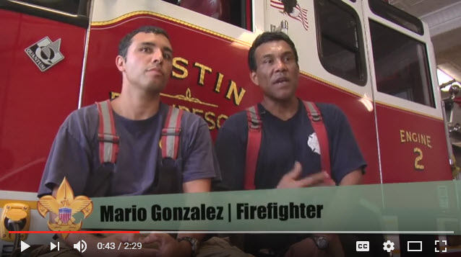](https://www.youtube.com/watch?v=ssIC6YrlWOY)

 In this video, the "Believe It Live It" team speaks with Austin, Texas, Fipe Fighters. Fire Fighters truly exemplify Trustworthy, as they are trusted to respond at any time. And they must trust each other to leave the equipment in operable condition. Go to URL: <https://www.youtube.com/watch?v=ssIC6YrlWOY>

## ADVENTURES with a CHARACTER COMPASS pointing to LOYAL:

**ADVENTURES** with a **CHARACTER COMPASS** pointing to **LOYAL:**

**TIGER –**

* Team Tiger (Core)
* Earning Your Stripes

**WOLF –**

* Council Fire (Core)
* Spirit of the Water (Elec)

**BEAR –**

* Grin and Bear It (Core)
* Forensics (Elec)

**WEBELOS CORE –**

* **None** (Core)

**ARROW OF LIGHT CORE –**

* Scouting Adventure (Core)

**WEBELOS & AOL ELECTIVES –**

* Project Family (Elec)

**MONTHS WITH THEMES FOR TRUSTWORTHY**

|  |  |  |
| --- | --- | --- |
| **Month** | **Year** | **Theme** |
| **TRUSTWORTHY** (Themes for former CV's Honesty & Responsibility) | | |
| October | 2010 | Responsibility |
| August | 2011 | Honesty |
| October | 2011 | Responsibility |
| August | 2012 | Honesty |
| October | 2012 | Jungle of Fun |
| August | 2013 | Kids Against Crime |
| October | 2013 | Down on the Farm |
| August | 2014 | Heroes of History |
| October | 2014 | Dollars and Sense |
| January | 2016 | The Great Race |

**TRUSTWORTHY QUOTES**

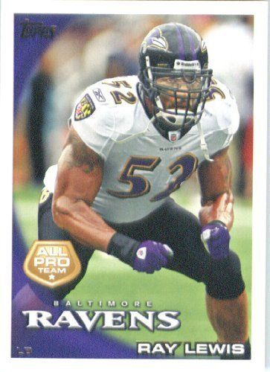*Quotations contain the wisdom of the ages, and are a great source of inspiration for Cubmaster’s minutes, material for an advancement ceremony or an insightful addition to a Pack Meeting program cover.*

**I like to see honesty out of people.   
People who are trustworthy.   
I like to see people who are involved with The Lord.   
Ray Lewis,**

Just trust yourself, then you will know how to live.   
--Johann Wolfgang von Goethe

Leadership requires five ingredients--brains, energy, determination, trust, and ethics. The key challenges today are in terms of the last two--trust and ethics.   
--Fred Hilmer

The best way to find out if you can trust somebody is to trust them. --Ernest Hemingway

The only way to make a man trustworthy is to trust him. Henry L. Stimson

You further develop trust by consistently delivering on your promise ― Sharon Macaluso

Trust, but verify. --Ronald Reagan

The United States established itself as a trustworthy new nation in its first two decades after the Revolutionary War by paying its debts, even when many in the country believed it had no obligation to do so. Alexander Hamilton, the founder of this newspaper, insisted on it. John Podhoretz

If the Lord says to give more than you think you are able to give, know that He will provide for you. Whether things are sailing smoothly or the bottom has dropped out, He is always trustworthy. You can count on Almighty God to keep His everlasting Word.   
Charles Stanley

God has never made a mistake. Ever. Ray Lewis

Depend upon yourself. Make your judgement trustworthy by trusting it. You can develop good judgement as you do the muscles of your body - by judicious, daily exercise. To be known as a man of sound judgement will be much in your favor.   
Grantland Rice

It gives me immense pleasure to be trustworthy, faithful, and true - to have the kind of romantic bond that inspires this. Kate Christensen

The Bible gives a true and trustworthy account of creation, and that account in no way conflicts with or contradicts an old-Earth view, and vice versa.   
Hugh Ross

The glue that holds all relationships together -- including the relationship between the leader and the led is trust, and trust is based on integrity.   
--Brian Tracy

Better to trust the man who is frequently in error than the one who is never in doubt. --Eric Sevareid

The greatness of a man is not in how much wealth he acquires, but in his integrity and his ability to affect those around him positively. -Bob Marley

When people honor each other, there is a trust established that leads to synergy, interdependence, and deep respect. Both parties make decisions and choices based on what is right, what is best, what is valued most highly. --Blaine Lee

We need people in our lives with whom we can be as open as possible. To have real conversation with people may seem like such a simple, obvious suggestion, but it involves courage and risk. --  
Thomas Moore

We're never so vulnerable than when we trust someone--but paradoxically, if we cannot trust, neither can we find love or joy. --Walter Anderson

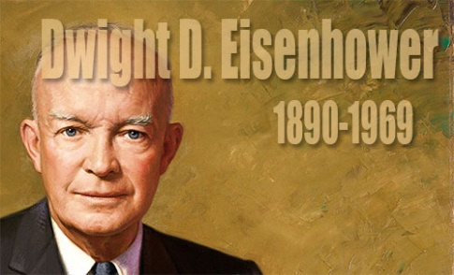

The supreme quality for leadership is unquestionably integrity. Without it, no real success is possible, no matter whether it is on a section gang, a football field, in an army, or in an office. --Dwight D. Eisenhower

If we aren't trustworthy to our own words and values, why should we expect others to trust us with their resources, let alone with their lives?  
― Assegid Habtewold

The leaders who work most effectively, it seems to me, never say I. And that's not because they have trained themselves not to say I. They don't think I. They think we; they think team. They understand their job to be to make the team function. They accept responsibility and don't sidestep it, but we get the credit…. This is what creates trust, what enables you to get the task done.   
--Peter Drucker

Let me define a leader. He must have vision and passion and not be afraid of any problem. Instead, he should know how to defeat it. Most importantly, he must work with integrity.-A. P. J. Abdul Kalam

As soon as you trust yourself, you will know how to live. --Johann Wolfgang von Goethe

Self-trust is the first secret of success.   
--Ralph Waldo Emerson

The chief lesson I have learned in a long life is that the only way to make a man trustworthy is to trust him; and the surest way to make him untrustworthy is to distrust him and show your distrust.   
--Henry L. Stimson

Trust each other again and again. When the trust level gets high enough, people transcend apparent limits, discovering new and awesome abilities for which they were previously unaware. --David Armistead

Achievement of your happiness is the only moral purpose of your life, and that happiness, not pain or mindless self-indulgence, is the proof of your moral integrity, since it is the proof and the result of your loyalty to the achievement of your values. --Ayn Rand

Building trust takes long- years, sometimes decades.   
It only takes a second, a word, or a misstep to lose it.   
Regaining trust takes even longer.”   
― Assegid Habtewold

# CUBMASTER’S MINUTES

**Scoutmaster Minute—A Scout is Trustworthy  
Paul Bunyan and Babe the Blue Ox**

<https://johnscout.wordpress.com/2010/02/14/scoutmaster-minute—a-scout-is-trustworthy/>

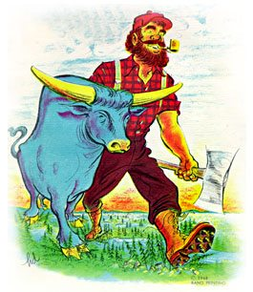

The Scout Law says:

*A Scout is trustworthy. A Scout tells the truth. He is honest, and he keeps his promises. People can depend on him.*

We all know the story of Pinocchio, the little boy whose nose grew every time he told a lie. It’s a good thing our noses don’t grow whenever we fib, or it would be a lot more difficult to move around in a crowded room.

It’s not our nose that grows when we don’t tell the truth. It’s our honor that shrinks when we are not honest, when we don’t keep our promises.

It’s not always easy to keep your word. It takes a big man to get up early to help out your fellow Scouts on a service project, or go out in the cold to compete in the Klondike Derby.

But eventually people will figure out if you are somebody they can rely on. Who would you rather trust? A guy who’s honor is the size of Paul Bunyan, or Pinnochio?

***This is one example of the fine Scoutmaster Minutes that John Scout has available on his site. Please go check it out for Scoutmaster Minutes and other program elements. CD***

**A Scout is Trustworthy**

<http://www.macscouter.com/scoutmaster>

***This is one example of the fine Scoutmaster Minutes that MacScouter has available on his site. Please go check it out for Scoutmaster Minutes and other program elements. CD***

An architect who had just finished college was trying to get his business established and was having a hard time doing it. He still owed money for some of his college expenses and saw his debts piling up. Each day he became more and more worried, until he was looking around desperately for a solution.

Then a wealthy man, who had been a good friend of his father, came to him one day. "I want you to build me a house," he said. "Build it of the finest materials. Spare no expense. Build it as if it were for yourself and you had all the money in the world. Here is an advance on your fee. I will be gone for some months, so take full charge. "

It was like a dream to the young architect. The advance enabled him to wipe out all his debts, and he knew that he could be married soon. For when the house was finished, he could expect other good commissions. Then his reputation would be established solidly. So he set to work with great joy.

As the building progressed, the architect was struck with an idea. The owner would not be back for months. No one was keeping check on the building. He could build the house just as he pleased. So he began to use second-rate materials where they wouldn't show. As he went on this way, he figured he would make an extra ten thousand dollars for himself, because, of course, he would charge the owner for the best materials throughout.

Well, the house finally was finished and the owner came back. The man was pleased. "It's beautiful," he said. "But, unfortunately I will never live in it. While I was traveling, I made some investments in Europe that will keep me there perhaps permanently. And I want you to have this house as a wedding present from me. It's so beautiful! It's a true picture of your own character, true and loyal all the way through!

Imagine how the young architect felt! Yes, the house was a picture of his own character, and would be there to remind him of his cheating for as long as he lived.

**A SCOUT IS TRUSTWORTHY**

<https://thescoutmasterminute.wordpress.com/>

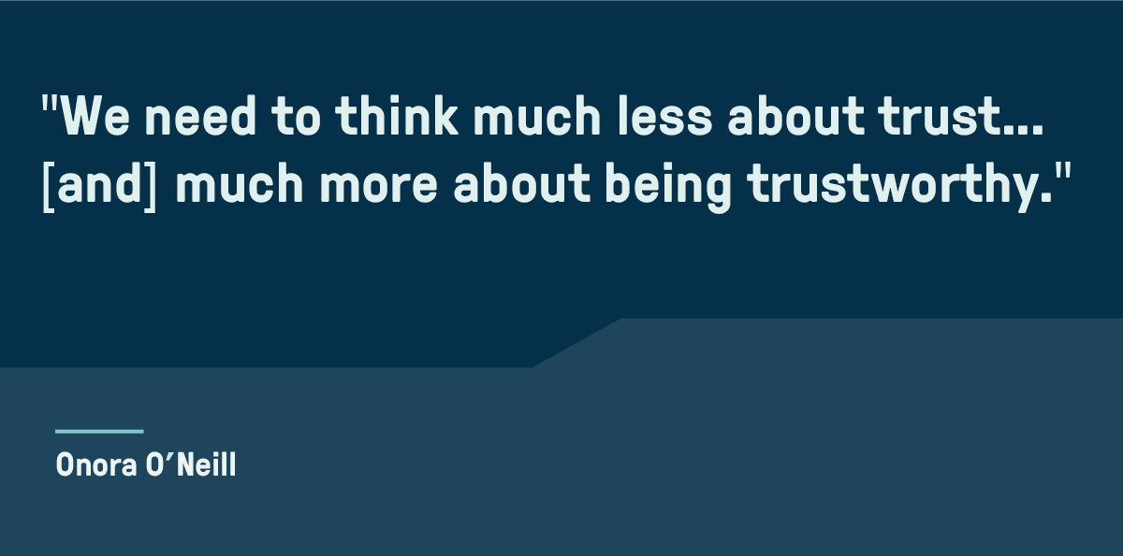

It is bad form to define a term or word by using the word or term. When we ask a Scout what is meant by being Trustworthy it is almost a cop out for the Scout to answer “One that is worthy of Trust” or someone worthy of being Trusted.

Merriam-Webster defines Trustworthy as worthy of confidence: dependable. Words that describe the actions or attitudes of someone deemed to be Trustworthy.

Reliable, Dependable, Honest, Deserving of Trust are a few more words that I think of when we talk about being Trustworthy.

For me it all comes down to actions. Those tangible things that we can see and feel or read and process in our minds that lead us to put our Trust in someone or an organization.

We had an interesting discussion a few days ago with a Scout. The discussion led to Character and how we judge the character of a person or group, in particular the discussion was about the Media.

How do we know what we can trust? The Scout asked me. What is credible and honest in today’s media? How do we define in today’s media what is true or as they now say “Fake News”. This young man explained that they were having this discussion in School that day and felt as though the teacher obviously had a certain bias for one side of the media.

Again, I led the conversation to what we believe character looks like. What is the expectation of a Scout in our community. Does he tell the truth? Does he demonstrate leadership? Does the Scout stay out of trouble? When he makes a commitment does he follow through and complete the task? Does he treat others with respect and dignity?

I am sure that we can go on and on. the bottom line is simply this, are we dependable, worthy of people’s confidence, honest and deserving of trust.

So how do apply that standard to the media or society in general. It appears that it depends on how you define character. One side is “Fair and Balanced” while the other side is “First and Accurate”. So who is right?

What is “Fake News”? What are “alternate facts”. The issue has become so clouded that we are getting to a point where we are hard pressed to accurately determine who is being Trustworthy.

This is a great lesson for our Scouts. No matter which side of the spectrum you find yourself politically or socially. The fact that no matter what you claim to believe the one thing that we can agree on is that the media is perceived as suspect. In the discussion of Trust and Trustworthiness, we can agree that it is hard to believe either side because they are creating doubt in their character. Both side make the argument that “They are right”, but we all know that the truth must be somewhere in the middle. Gone is the idea of a clear “right and wrong” when it comes to some social issues and media influence.

I am not sure what the fix is, but I do know that when I discuss this with Scouts it is a great case study in what we look for in defining “Trustworthy”.

A Scout is Trustworthy. so yeah… Worthy of Trust. We must do everything not to take that away from how people view us as Scouts.

Drop us a note - what do you think.

# BIOGRAPHY

**ABRAHAM LINCOLN**

**Abraham Lincoln's great laws of truth, integrity:  
A long career ruled by honesty**

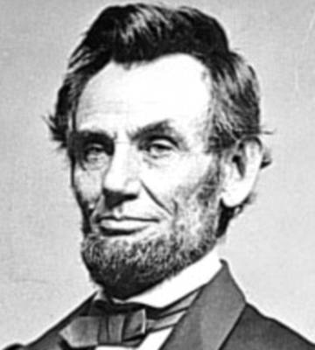

***Mr. Lincoln . . . is almost monomaniac   
on the subject of honesty.***Mary Todd Lincoln, letter to a friend

The future president was first called Honest Abe when he was working as a young store clerk in New Salem, Ill. According to one story, whenever he realized he had shortchanged a customer by a few pennies, he would close the shop and deliver the correct change-regardless of how far he had to walk.

People recognized his trustworthiness (integrity) and were soon asking him to act as judge or mediator in various contests, fights, and arguments. According to Robert Rutledge of New Salem, Lincoln's judgment was final in all that region of country. People relied implicitly upon his honesty, integrity, and impartiality.

As a member of the Illinois legislature and later in his law practice, he took advantage of his reputation for trustworthiness and fairness to help broaden his constituency. His good name helped win him four consecutive terms in the legislature.

Lincoln soon moved to Springfield, Ill, and began his law practice, a profession at which he admitted there was a popular belief that lawyers are necessarily dishonest. His advice to potential lawyers was: Resolve to be honest at all events; and if in your judgment you cannot be an honest lawyer, resolve to be honest without being a lawyer. Choose some other occupation, rather than one in the choosing of which you do, in advance, consent to be a knave.

According to Judge David Davis, in whose court Lincoln practiced for many years, The framework for [Lincoln's] mental and moral being was honesty, and a wrong cause was poorly defended by him. Another judge who had worked with Lincoln agreed, saying Such was the transparent candor and integrity of his nature that he could not well or strongly argue a side or a cause he thought wrong.

Lincoln was trustworthy and ethical not only in his legal dealings with clients, but with his personal relationships.

Always comfortable telling jokes and stories around the men of Springfield, he usually was awkward and self-conscious around women. In Lincoln's early political years, he wrote I want in all cases to do right, and most particularly so in all cases with women. This was a principle to which he remained true all of his life. Today, historians tell us there is not a single credible story of Lincoln's being unfaithful to his wife.

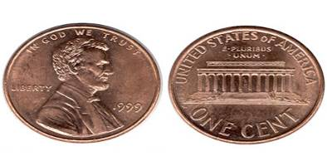

The Reverend Albert Hale of Springfield's First Presbyterian Church said, Abraham Lincoln has been here all the time, consulting and consulted by all classes, all parties, and on all subjects of political interest, with men of every degree of corruption, and yet I have never heard even an enemy accuse him of intentional dishonesty or corruption.

An example of an enemy's respect came in 1858, during Lincoln's Senate race against the powerful incumbent, Stephen A. Douglas. The senator, having competed with Lincoln in the legislature and many Illinois courtrooms, knew his opponent well.

Responding to the news that Lincoln was to be his adversary, Douglas said: I shall have my hands full. He is the strong man of his party-full of wit, facts, dates-and the best stump speaker, with his droll ways and dry jokes, in the West. He is as honest as he is shrewd, and if I beat him my victory will be hardly won.

Lincoln lost his Senate bid to Douglas. Two years later, however, he found himself running against the same man for the presidency. When Douglas was told of Lincoln's victory, he unselfishly told his informants: You have nominated a very able and very honest man.

By the time Lincoln was president, statements he had made previously, such as I have never tried to conceal my opinions, nor tried to deceive anyone in reference to them, and I am glad of all the support I can get anywhere, if I can get it without practicing any deception to obtain it had become a source of strength for him as a leader.

Everyone, even his bitterest political opponents, knew exactly where they stood with Lincoln. Because he didn't have to waste time convincing his opponents of his sincerity, he was able to devote his energies to solving political issues and winning the war.

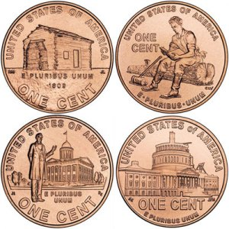Lincoln as commander in chief was honest and straightforward with his generals, always telling them directly what he did and did not appreciate about them. An example of his candor is the following excerpt from a letter to Major General Joseph Hooker in early 1863:

I have placed you at the head of the Army of the Potomac. Of course, I have done this upon what appear to me to be sufficient reasons, and yet I think it best for you to know that there are some things in regard to which I am not quite satisfied with you. I believe you to be a brave and a skillful soldier, which of course I like. I have heard, in such a way as to believe it, of your recently saying that both the army and the government needed a dictator. Of course, it was not for this, but in spite of it, that I have given you the command. Only those generals who gain successes can set up dictators. What I now ask of you is military success, and I will risk the dictatorship.

Finally, in search for the reason Lincoln was so adamant about honesty, a quote by one of his closest friends, Leonard Swett, is revealing:

He believed in the great laws of truth, the right discharge of duty, his accountability to God, the ultimate triumph of the right, and the overthrow of wrong.

**For further reading:**

[http://www.greatamericanhistory.net](http://www.greatamericanhistory.net/)   
*Please go to Great American History and check it out. Consider leaving them a donation to thank them for all their hard work on Lincoln and the Civil war and other parts of our history.* ***CD***

Abraham Lincoln: Quotes, Quips, and Speeches   
by Gordon Leidner or

The Inner World of Abraham Lincoln   
by Michael Burlingame.

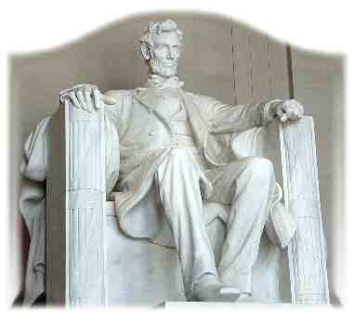

**DAVY CROCKETT**

**Proving He Was Trustworthy**

**"Make sure you are right –   
then go ahead"**

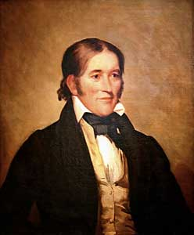

Davy Crockett was born to a large family that lived in the American wilderness where there were no stores, schools, or churches. The family finally settled on the Holston River and opened a tavern where travelers stopped on their way from Virginia to the West. Davy was only 8 when he started working in the tavern – he was excited by the stories visitors told, and wanted to see the world.

When Davy was only 12 years old, his father agreed to let him work for a Dutchman driving a herd of cattle over the mountains to Virginia – he offered to let Davy stay, but homesickness brought him home. He was excited to learn that a new school had opened, but on his fourth day, Davy was bullied by another boy, and finally fought the boy and won – but he was afraid the boy and his friends would be waiting for him the next day, so he stayed in the woods till school would have been out and then went home. The schoolmaster sent a note to Davy’s father after a few days, and the angry father headed off with a hickory stick to find Davy. When Davy saw his father coming, he ran away and joined a drover taking cattle hundreds of miles away.

For two years, Davy worked at odd jobs, earning about 25 cents a day, but finally his fear of his father faded, and he headed home. There was a great celebration. Davy was bound by customs of the time to stay with his father till he reached 21 – but his father offered to give Davy his freedom early if he would work for six months to earn off a debt his father owed. Davy developed a sense of what it meant to be honest as he worked, and discovered he could earn another $40 if he worked an extra six months. So six months later, he returned home and presented his father with a cancelled note for two debts – a total of almost $80.

Davy was now 16, and knew he should learn how to read and write. He took a job working two days a week for board, and went to school the other four days. He married, built a log cabin, and became an outstanding shot with his musket. He moved several times, settling in Tennessee, and was one of the best riflemen in Andrew Jackson’s army. His skill in hunting kept the troops from starving. He learned to write in order to serve as a magistrate, and became very popular, being a great storyteller. He was asked to run for the legislature, and his jokes and stories, and his wonderful memory helped him get elected.

There was nothing he liked more than a good bear hunt, and his skill was legendary – twice he brought down a bear weighing more than 600 pounds, and he once killed 105 bears in one year. The meat was considered a delicacy, their fur was used for coats, and their skins were used for beds and bedding.

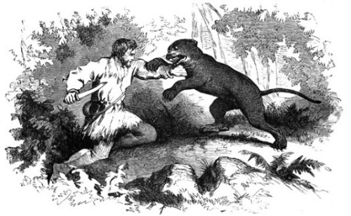

In 1827 he was elected to Congress, and introduced himself by saying, “I am …fresh from the backwoods, half horse, half alligator, a little touched with snapping turtle…I can ship my weight in wildcats.” He made quite a stir in Washington, but was always well liked. As a Congressman, Crockett’s service was outstanding – he was honest and conscientious, never took a bribe or voted for something he didn’t believe in – he was called the “Honest Congressman.” He also wrote an autobiography which he called “a plain, honest, homespun account of my life.”

In 1846, Crockett and his “Tennessee boys” went to the Alamo to help the Texans in their battle against a far larger Mexican force of 5,000 men. The Texans and Crockett’s men numbered only about 108. But the determined defenders inside the Alamo forced the Mexicans back twice. Out of ammunition, Crockett and the Texans were finally killed as the Mexicans stormed a short wall. On the day he died, Crockett wrote a letter to his daughter telling her not to worry, that he was among friends. His youngest daughter later wrote she remembered him leaving for Texas, “dressed in his hunting suit, wearing a coonskin cap, and carrying a fine rifle presented to him by friends in Philadelphia.”

He was a real-life hero, an honest man, and became a legend while he was still alive.

**DAVY CROCKETT QUOTES**

**"Let your tongue speak what your heart thinks"**[Davy Crockett](http://www.goodreads.com/author/show/219075.Franklin_D_Roosevelt)

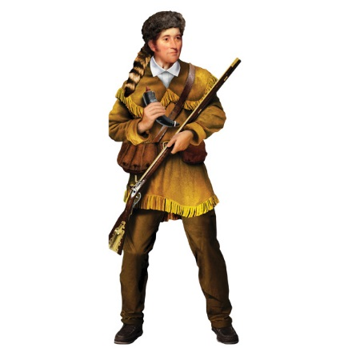

* I am at liberty to vote as my conscience and judgment dictates to be right, without the yoke of any party on me... Look at my arms, you will find no party hand-cuff on them.
* We have the right as individuals to give away as much of our own money as we please in charity; but as members of Congress we have no right to appropriate a dollar of the public money.
* It is [better to keep a good conscience with an empty purse, than to get a bad opinion of myself, with a full one.](http://www.quotationspage.com/quote/3254.html)
* Although our great man at the head of the nation (Andrew Jackson), has changed his course, I will not change mine.
* It was expected of me that I was to bow to the name of Andrew Jackson... even at the expense of my conscience and judgement. such a thing was new to me, and a total stranger to my principles.
* Pop, pop, pop! Boom, boom, boom!   
  Throughout the day  
  No time for memorandums now.  
  Go ahead! Liberty and independence forever.
* [I have suffered myself to be politically sacrificed to save my country from ruin and disgrace and if I am never again elected I will have the gratification to know that I have done my duty.](http://www.quotationspage.com/quote/2545.html)
* I would rather be politically dead than hypocritically immortalized.
* I have always supported measures and principles and not men.
* I would rather be beaten and be a man than to be elected and be a little puppy dog.

**"Fame is like a shaved pig with a greased tail, and it is only after it has slipped through the hands of some thousands, that some fellow, by mere chance, holds on to it!"** [Davy Crockett](http://www.goodreads.com/author/show/219075.Franklin_D_Roosevelt)

**THE BALLAD OF   
DAVY CROCKETT**

Music by George Bruns and   
Lyrics by Thomas W. Blackburn.

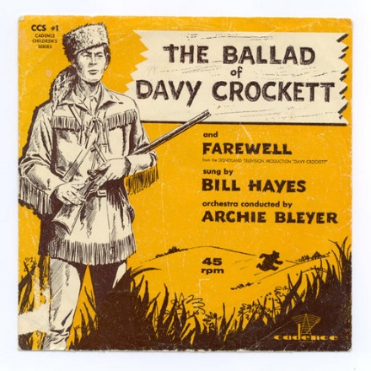

Born on a mountain top in Tennessee  
Greenest state in the Land of the Free  
Raised in the woods so's he knew every tree  
Kilt him a b'ar when he was only three.  
Davy, Davy Crockett, King of the wild frontier!

In eighteen thirteen the Creeks uprose  
Addin' redskin arrows to the country's woes  
Now, Injun fightin' is somethin' he knows  
So he shoulders his rifle an' off he goes.  
Davy, Davy Crockett, The man who don't know fear!

Off through the woods he's a marchin' along  
Makin' up yarns an' a singin' a song  
Itchin' for fightin' and rightin' a wrong  
He's ringy as a b'ar and twice as strong.  
Davy, Davy Crockett, The buckskin buccaneer!

Andy Jackson is our general's name  
His reg'lar soldiers we'll put to shame  
Them redskin varmints us volunteers'll tame  
'Cause we got the guns with the sure-fire aim.  
Davy, Davy Crockett, The champion of us all!

Headed back to war from the ol' home place  
But Red Stick was leadin' a merry chase  
Fightin' and burnin' at a devil's pace  
South to the swamps on the Florida Trace.  
Davy, Davy Crockett, Trackin' the redskins down!

Fought single-handed through the Injun War  
Till the Creeks was whipped an' peace was in store  
And while he was handlin' this risky chore  
Made hisself a legend for evermore.  
Davy, Davy Crockett, King of the wild frontier!

He give his word and he give his hand  
That his Injun friends could keep their land  
And the rest of his life he took the stand  
That justice was due every redskin band.  
Davy, Davy Crockett, Holdin' his promise dear!

Home fer the winter with his family,  
Happy as squirrels in the ol' gum tree,  
Bein' the father he wanted to be,  
Close to his boys as the pod and the pea.  
Davy, Davy Crockett, Holdin' his young 'uns dear!

But the ice went out and the warm winds came  
And the meltin' snow showed tracks of game  
And the flowers of Spring filled the woods with flame  
And all of a sudden life got too tame.  
Davy, Davy Crockett, Headin' on West again!

Off through the woods we're ridin' along  
Makin' up yarns and singin' a song  
He's ringy as a b'ar and twice as strong  
And knows he's right 'cause he ain't often wrong.  
Davy, Davy Crockett, The man who don't know fear!

Lookin' fer a place where the air smells clean  
Where the trees is tall and the grass is green  
Where the fish is fat in an untouched stream  
And the teamin' woods is a hunter's dream.  
Davy, Davy Crockett, Lookin' fer Paradise!

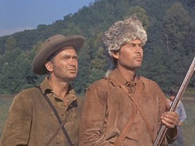

*Fess Parker as Davy, and   
Buddy Ebsen as Georgie*

*in Walt Disney's Production*

Now he'd lost his love an his grief was gall  
In his heart he wanted to leave it all  
And lose himself in the forests tall  
But he answered instead his country's call.  
Davy, Davy Crockett, Beginnin' his campaign!

Needin' his help they didn't vote blind  
They put in Davy 'cause he was their kind  
Sent up to Nashville the best they could find  
A fightin' Spirit and a thinkin' mind.  
Davy, Davy Crockett, The man who don't know fear!

The votes were counted and he won hands down  
So they sent him off to Washin'ton town  
With his best dress suit still his buckskins brown  
A livin' legend of growin' reknown.  
Davy, Davy Crockett, The Canebrake Congressman!

He went off to Congress and served a spell  
Fixin' up the Gover'ment and laws as well  
Took over Washin'ton so we heared tell  
And patched up the crack in the Liberty Bell.  
Davy, Davy Crockett, Seein' his duty clear!

Him and his jokes travelled all through the land  
And his speeches made him friends to beat the band  
His politickin' was their favorite brand  
And everyone wanted to shake his hand.  
Davy, Davy Crockett, Helpin' his legend grow!

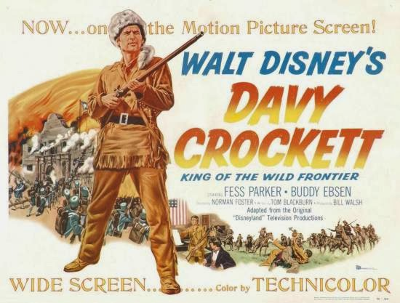

He knew when he spoke he sounded the knell  
Of his hopes for White House and fame as well  
But he spoke out strong so hist'ry books tell  
And patched up the crack In the liberty Bell.  
Davy, Davy Crockett, Seein' his duty clear!

When he come home his politickin' done  
The western march had just begun  
So he packed his gear and his trusty gun  
And lit out grinnin' to follow the sun.  
Davy, Davy Crockett, Leadin' the pioneer!

He heard of Houston and Austin and so  
To the Texas plains he jest had to go  
Where freedom was fightin' another foe  
And they needed him at the Alamo.  
Davy, Davy Crockett, The man who don't know fear!

His land is biggest and his land is best  
From grassy plains to the mountain crest  
He's ahead of us all meetin' the test  
Followin' his legend into the West.  
Davy Davy Crockett, King of the wild frontier!

Hear Fess Parker sing it at - <https://www.youtube.com/watch?v=txcRQedoEyY>

