Cub Scout Roundtable Planning Sheet – 60 minute Format
Topic: Tour and Activity Plan Planning Safely – The Sweet Sixteen of BSA Safety/ BSA Safety Moments/BSA Accident Insurance/Safety Checklists
Scout Law: Trustworthy, Obedient
Adventures:
Tiger – Floats and Boats
Wolf – Call of the Wild
Bear – A Bear Goes Fishing
Webelos/Arrow of Light – Webelos Walkabout, Castaway

Take Away: Unit leaders to know and understand when to complete and file a tour and activity plan, as well as any additional requirements their local council may have. Protect your youth by planning safely. Units can learn about BSA Safety Moments, how to present them, and incorporate them into their monthly meetings. They can also use The Sweet Sixteen of BSA Safety, the Safety PAUSE and safety checklists to plan safely. Unit leaders to have an understanding of how the local council’s BSA Accident Insurance for activities is handled.

Pack Meeting Themes that work with this topic:
March – Trustworthy – Cub Scout Investigators
June – Obedient – Wheel In To Summer

Time Allotted | Activity | Assigned To | Content Ideas | Notes for Media Team
5 min | Ceremony/Skit/Song/Game | Cub RT Staff or participants | Emergency Broadcast System Skit. See resource page.
15 min | Tips for Pack Activity | Cub RT Staff or participants | Proper planning for all Scouting Activities is important, not just when a Tour and Activity Plan is required. and planning safely will help ensure a fun, exciting and safe activity for the youth participating.  BSA has introduced a new series, Safety Moments, which allows leaders to choose a topic and learn about it.  Share a different Safety Moment Topic with your pack monthly via a pack newsletter, social media, or a hands-on activity at a pack meeting.  Topics of the series include incident reporting helps, safe use of medication in Scouting, the tour and activity plan, weather-related safety, winter activity, and winter sports.  And here is how you can present a Safety Moment on You Tube:  https://video.search.yahoo.com/search/video?fr=aaplw&p=BSA+Safety+memonts+on+you+tube#id=1&vid=2119669c07266694af72ec860bb7b83b&action=click  or BSA Safety Moment Website:  http://www.scouting.org/scoutsource/HealthandSafety/Safety_Moments.aspx  Using the information shared in the you tube video or website, present the BSA Safety Moment on Family Camping. Have a copy for each participant.  Link for topics located in the resource information.  The Scout motto is Be Prepared!
25 min | General Session Option | Cub RT Staff, District and Council professional staff | Prior review and understanding of the Tour and Activity Plan The Sweet Sixteen of BSA Safety and Safety PAUSE and safety checklists is suggested.  Review the video for completing a tour plan. Video may be part of the presentation to the group. (Video link is in the resource section.)  District or council professional staff may present this session.  Be aware of and include any additional requirements your council may have for Tour Permits Plans. for following these safety procedures.  Questions to invoke discussion:  - What is a Tour and Activity Plan? What tools are available to help leaders plan events, campouts and activities safely?  - The Sweet Sixteen of BSA Safety  - Safety Moments (as shared above)  - Checklists such as: Campout Safety Checklist, Event Safety Checklist  Take time to review. May want to give each participant a copy so that they can follow along.  - What is Safety PAUSE? Have cards printed – one for each participant.  - Why should a Tour and Activity Plan be filed? Why should leaders be aware of The Sweet Sixteen of BSA Safety?  - Who is responsible for filing the plan? making sure these safety procedures are followed?  - Does a Pack have to file one? A den?  - When is a Tour and Activity Plan needed?  - Benefits to filing a Tour and Activity Plan following The Sweet Sixteen of BSA Safety and Safety PAUSE.  - Council requirements for filing a Tour and Activity Plan incorporating these procedures in outings?  - Insurance/liability concerns  - Is there training available in completing the form?  Check with your Council to see what other information is derived from the filing of Tour and Activity Plans – outing statistics, camping statistics, etc. Share this information with the group.  It is always great to share tools that our units can use, but providing them an activity to use the tools will help them see the importance and encourage their use.  Activity –  Ask for a volunteer to share with the group an upcoming camping event or outdoor activity. Depending on the size of your group, either 1) Have the volunteer tell about his/her event and then using the Sweet Sixteen of BSA Safety, review to see if they have considered safety or planned safely when planning their event; or 2) As the volunteer discusses their activity, have the group raise their hand as they hear something in the Sweet Sixteen of BSA Safety. Do not let the volunteer have a copy of The Sweet Sixteen of BSA Safety close by when telling about the event.  In closing, remind the leaders that there are many resources and tools available to them to make a plan. Being attentive to safety concerns when planning their activities will ensure fun and safety for those attending.  End the session with a PAUSE for safety! Hand out the PASUE for Safety handout (if not done earlier) and have the leaders read along with you.  If your council takes part in the BSA accident insurance program, share information on the program.
10 min | Q & A | Cub Scout RT Staff | Opportunity to answer any additional Tour and Activity Plan The Sweet Sixteen of BSA Safety/Safety PAUSE/Safety Checklists/Insurance questions.
5 min | Closing | Cub Scout RTC | Perform the Be Prepared Skit. See Resource page.

Resource Information
Ceremony/Skit/Song/Game
Emergency Broadcast System Skit

One Cub Scout or leader stands to the side or in front. All other Scouts stand in line.
Leader: “For the next ten seconds, we will conduct a test of the emergency broadcast system.”
Cub Scouts: “Beeeeeeeeeeeppppp” for 10 seconds until Leader raises his hand.
Leader: “Thank you. This concludes the test of the emergency broadcast system. Had this been an actual emergency, you would have heard…”
Cub Scouts scream in panic and run around waving their hands.
[Source - http://cubscoutideas.com/3985/cub-scout-skits-for-campfires/. This skit is located in multiple places on the web]
Tips for Pack Activities
[Insert this graphic from the Safety Moments link shown below
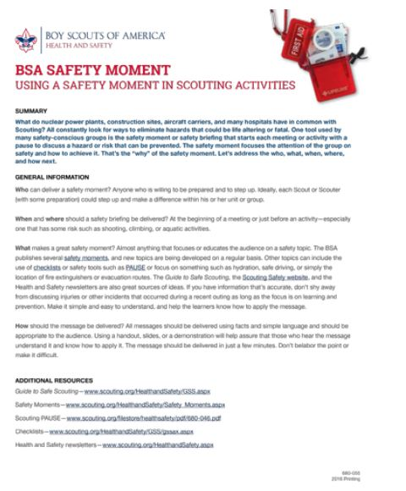
General Session – Tour and Activity Plan The Sweet Sixteen of BSA Safety/ Safety PAUSE/Safety Checklists
The links below provide information on The Sweet Sixteen of BSA Safety, Safety PAUSE and Safety Moments
The Sweet Sixteen of BSA Safety: http://www.scouting.org/scoutsource/HealthandSafety/Resources/sweet16.aspx
Safety PAUSE: http://www.scouting.org/filestore/healthsafety/pdf/680-046.pdf
Safety – Moments and How to Present a Safety Moment: http://www.scouting.org/scoutsource/HealthandSafety/Safety_Moments.aspx
You Tube – Presenting a Safety Moment
https://video.search.yahoo.com/search/video?fr=aaplw&p=BSA+Safety+memonts+on+you+tube#id=1&vid=2119669c07266694af72ec860bb7b83b&action=click
Checklists for Assessing Risks:
http://www.scouting.org/scoutsource/HealthandSafety/GSS/gssax.aspx
Event Safety Checklist:
www.scouting.org/filestore/HealthSafety/pdf/event_checklist.pdf
Campout Safety Checklist:
www.scouting.org/filestore/HealthSafety/pdf/campout_checklist.pdf
This link provides information on the Tour and Activity Plan and a link to the Tour and Activity Plan FAQs. In the FAQ document, you will find many links including one to the actual Tour and Activity Plan Form.
http://www.scouting.org/scoutsource/HealthandSafety/TourPlanFAQ.aspx
Video link for completing Tour Plan
http://www.scouting.org/scoutsource/HealthandSafety/DemoTourPlanVideo.aspx
[Insert copy of the tour plan]
How to present a safety moment: http://www.scouting.org/scoutsource/HealthandSafety/Safety_Moments.aspx or
Closing:

Be Prepared
First scout walks to center of stage, stands to attention, salutes and says, "BE PREPARED." This is repeated by three other scouts. When they are all standing side by side, a loud motor horn or explosion is let off behind the audience.
The scouts then all say, 'WE TOLD YOU TO BE PREPARED'
[Source http://www.macscouter.com/skits/BBSkits_A-B.asp]

