# PACK MEETING THOUGHTS

The Point of the Scout Law being highlighted for Cub Scouts in December is: **A Scout is Helpful.**  A Scout cares about other people. He willingly volunteers to help others without expecting payment or reward.



**HOW DOES “JOBS! JOBS! JOBS!” RELATE TO THIS SCOUT LAW POINT?**

There are many ways that people can be helpful. One way is by volunteering time to help others. Cub Scouts, Scout leaders, and coaches are examples of volunteers. Another way people help is by doing jobs that provide a service. This month we celebrate those who help out in their homes, schools, and communities.

# FOCUS

*Adapted from 2009-10 CS Roundtable Leaders’ Guide*

Cub Scouts salute those volunteer heroes who help keep us safe and secure, those who are always there to help in both small and large ways, and those who provide needed services for all every day. Can only adults be heroes? Heroes can be ordinary kids who do something out of the ordinary. Do you read Boys' Life? Every issue features Scout heroes. Invite your hometown heroes to a den or pack meeting. Your den can become "silent heroes" by performing service for others without seeking any recognition. Visit a veterans' hospital, fire station, or police station and give a "Cub Scout salute" for their heroism.

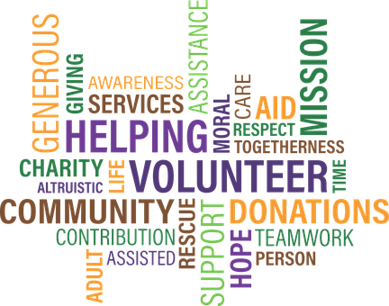

TABLE OF CONTENTS

PACK MEETING THOUGHTS 1

FOCUS 1

GATHERING ACTIVITIES 3

OPENING CEREMONIES 8

AUDIENCE PARTICIPATIONS 10

ADVANCEMENT CEREMONIES 13

LEADER RECOGNITION 17

Over the Top 17

SONGS 17

STUNTS AND APPLAUSES 20

APPLAUSES & CHEERS 20

RUN-ONS 22

JOKES & RIDDLES 22

SKITS 24

CLOSING CEREMONIES 28

CUBMASTER’S MINUTES 29

GAMES 33

PACK ACTIVITIES 38

HELPFUL PACK AND DEN ACTIVITIES 38

Fun Facts About Being Helpful 39



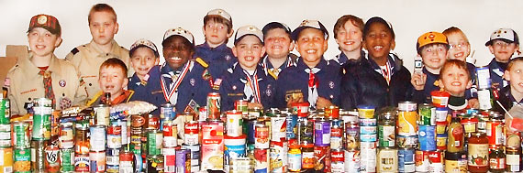

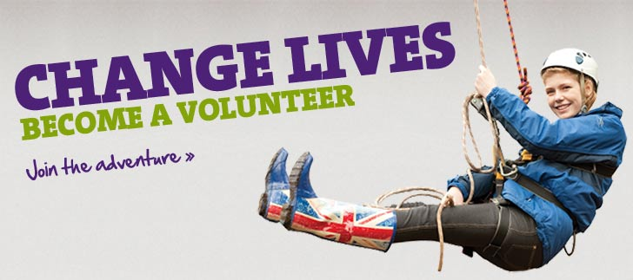

***Months with Cubs being Helpful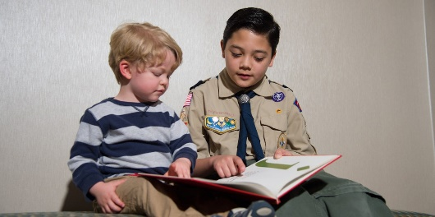 and volunteering and saluting volunteers.***

|  |  |  |
| --- | --- | --- |
| **Month** | **Year** | **Theme** |
| **HELPFUL Months** in Adventure Program | | |
| November | 2015 | Cubs In Action |
| September | 2016 | To The Rescue |
| **Potential HELPFUL Months** | | |
| October | 1941 | Live and Help Live |
| December | 1945 | Follows - Helps - Gives |
| December | 1947 | Helps and Gives |
| December | 1950 | Helps |
| December | 1951 | F-H-G |
| December | 1961 | Follows, Helps, and Gives |
| December | 1972 | Follows, Helps, Gives |
| December | 1984 | Do a Good Turn |
| December | 1985 | Follows, Helps, Gives |
| December | 1991 | Follows, Helps, Gives |
| December | 1992 | To Help Other People |
| December | 1995 | Do a Good Turn |
| December | 1996 | Helping Others |
| December | 1997 | The Golden Rule |
| November | 2008 | Spreading Seeds Of Kindness |

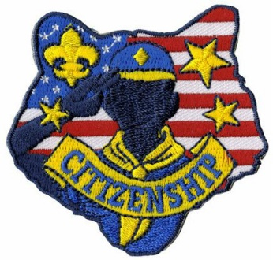

|  |  |  |
| --- | --- | --- |
| **Jobs, Jobs, Jobs  Providing Service** | | |
| September | 1951 | Barn Raisin' |
| September | 1965 | Barn Raising |
| December | 1969 | The Cub Scout Gives Good Will |
| December | 1971 | Cub Scout Gives Good Will |
| December | 1975 | Cub Scout Gives Good Will |
| April | 1999 | Pollution Solution |
| April | 2001 | Save It For Us |
| November | 2001 | Hometown Heroes |
| November | 2002 | Kids Against Crime |
| February | 2003 | Uncle Sam Depends on You |
| December | 2003 | A Cub Scout Gives Good Will |
| January | 2004 | Home Alone |
| October | 2005 | To The Rescue |
| December | 2005 | Faith, Hope & Charity |
| November | 2009 | Scout Salute |
| April | 2010 | Spring into Action |
| November | 2010 | Citizenship |
| November | 2011 | Citizenship |
| September | 2012 | Hometown Heroes |
| March | 2013 | Planting Seeds of Kindness |
| April | 2013 | Cub Scouts Give Thanks |
| August | 2013 | Kids Against Crime |
| November | 2014 | Give Goodwill |
| March | 2015 | Aware and Care |
| September | 2015 | Cubservation |
| July | 2016 | Scout Salute |

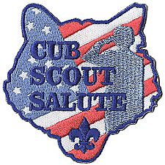

# GATHERING ACTIVITIES

**Why Have Pack Gathering Activities.**

*2011-2012 CS RT Planning Guide*

A successful, planned gathering activity will get a pack meeting off to a good start. A good gathering activity has pack members and parents interacting with each other. They should require minimal preparation, be fun for the boys, and can be enjoyed by the entire family. Since the Cubmaster is busy preparing for the pack meeting, other members of the pack should lead the activity. This is a great opportunity to begin involving parents who are not in a formal leadership position to help with something. Gathering activities may be found in the Den & Pack Meeting Resource Guide, the Den Chief Handbook, the Cub Scout Leader How-To Book, Group Meeting Sparklers, and Boys’ Life. Plus the monthly Cub Scout roundtables.

***Note on Word Searches, Word Games, Mazes and such –*** *In order to make these items fit in the two column format of Baloo’s Bugle they are shrunk to a width of about 3 inches. Your Cubs probably need bigger pictures. You can get these by copying and pasting the picture from the Word version or clipping the picture in the Adobe (.pdf) version and then enlarging to page width.* ***CD***

**From Super Hero to Super Scout**

*Alice, Golden Empire Council*

Give each boy a piece of regular white paper and have them fold the paper into four squares.

In the first square, each boy can draw their favorite superhero, or write something about that hero.

In the second square, each boy can feature their favorite well-know “real” hero – you may want to talk about some examples, such as Mother Teresa or Martin Luther King.

In the third square, have them choose a favorite community hero – it could be a teacher, a firefighter, or even a parent.

In the last square have them draw or write about themselves.

Later in the meeting, talk about the boy’s hero squares – let each boy explain who they included and why they are heroes.

***I also did a project like this using T-shirts one time. The boys drew out their ideas and we transferred them to a Hero shirt – today, that would work with the transfer sheets you can print off your computer. -Alice***

**Graham Cracker Flags**

*Sam Houston Area Council*

**Ingredients**

A few packages of graham crackers,

White frosting,

Ice cream sticks,

Small paper cups, and

Red, white, and blue food coloring.

**Directions:**

* Give each Scout 3 paper cups with a tablespoon of frosting inside each cup.
* Drop the food coloring in each cup – 1 red, 1 blue, 1 white.
* Give each Scout an ice cream stick and
* Instruct him to mix the food coloring in each cup.
* Then ask him to draw the US flag on the cracker using the frosting.

**Hero’s Award**

*Great Salt Lake Council*

Provide materials for the boys to create an award or a card for their parents, leaders, teachers, etc.

**First Aid**

*Great Salt Lake Council*

Man people view a hero as someone who saves another’s life. Provide first aid supplies for the boys to practice safely on each other. Bandages (long and triangular) and splints (sticks) can provide fun practice implements for the boys.

**Calling for Help Cryptogram**

*San Gabriel, Long Beach, & Verdugo Hills Councils*

You must discover what number is assigned to each letter, then fill in the blanks to complete the message. Four letters have been identified for you. Have the boys work together to get started. If they have trouble, give them another letter such as L.



**Solution Calling for Help Cryptogram**



**Good Turn**

*Great Salt Lake Council*

Have the boys make a list of either the good things they have done for someone else or what has been done for them.

**Jobs - Jobs - Jobs Word Search**

*San Gabriel, Long Beach, & Verdugo Hills Councils*

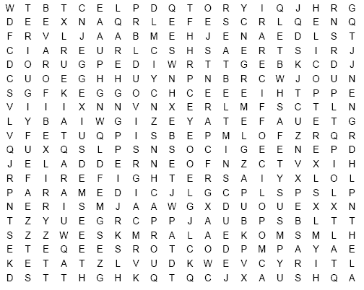

Find words that describe rescue workers, their tools and safety items printed in the word search above. They can be upside down, backwards, forwards or diagonal.

AMBULANCE CAR SEAT CPR

CROSSING GUARD DOCTORS

EMERGENCY EXTINGUISHER FIRE ENGINE

FIREFIGHTERS HELICOPTER HELMET

HELP HOSES HYDRANT

LADDER LIFEGUARD LIFEJACKET

PARAMEDIC PARENTS POLICE OFFICER

RESCUE SAFETY SEATBELT

SIREN SMOKE ALARM TELEPHONE

**Heroes in Our Community**

*Alice, Golden Empire Council*

Have each boy, den or family bring in a display of a favorite hero – it could be someone from the community or even a family member. Have families talk about their picture with others as they gather.

**Definitions**

*Alice, Golden Empire Council*

Give each person a strip of colored paper when they arrive and ask them to write one word describing an attribute a hero would have. Post the strips on the wall for everyone to see.

**American Hero Word Scramble**

*Alice, Golden Empire Council*

Unscramble the following words to find the words associated with heroes.

1. HTEIGRIEFF
2. OPIELC
3. RAMY
4. VNYA
5. MIIRTAYL
6. OIRAFREC
7. SNUER
8. COTORD
9. MIRAANEC
10. EROH
11. VEARB
12. CUAROEG

*Answers – A – Fire Fighter, B – Police, C – Army, D – Navy, E – Military, F – Air Force, G – Nurse, H – Doctor,   
I – American, J – Hero, K – Brave, L - Courage*

**FAMOUS PAIRS**

*Santa Clara County Council*

Make up stickies for people’s backs with names of famous pairs. (e.g – Abbott on one, Costello on another. Or Aldrin on one, Armstrong on another.). As each person enters the room, he has a stickie pinned to his back. The object of the game is to learn the identity of the person on your back and then find his partner. Each player is allowed to ask one or two (or more, you set limit) yes or no question(s) of each other player. At the same time, the two people introduce themselves (their real names) and shake hands. Once you find your identify, find your partner by reading tag.

**Veteran’s Word Search**

*Alice, Golden Empire Council*



ADMIRATION AIR FORCE AMERICA

ARMY CELEBRATE MARINE

NAVY PARADE PATRIOT

REMEMBER SERVED TRIBUTE

**America Hero Word Search**

*Alice, Golden Empire Council*



AMERICAN BLUE BRAVE

COAST GUARD COURAGE COURAGE

FIRE FIGHTER HEROES HONOR

POLICE RED SOLDIERS

WHITE

**Hero Match-Up**

*Great Salt Lake Council*

Heroes do many different things for us. Match-up the hero with what they have done to help others

|  |  |
| --- | --- |
| 1. __ Clara Barton 2. __ Martin Luther King Jr. 3. __ Benjamin Franklin 4. __ George Washington 5. __ George Washington Carver 6. __ John Glenn 7. __ Jackie Robinson 8. __ Philo T Farnsworth | A. Astronaut  B. Athlete  C. Civil Rights Advocate  D. Inventor –Peanut Butter  E. Inventor - TV  F. Red Cross  G. US Founding Father  H. US President |

*Answers: 1F, 2C, 3G, 4H, 5D, 6A, 7B, 8E*

**WHO’S A SCOUT?**

*Great Salt Lake Council*

Let the boys guess which notable person is a Scout.   
Note: All listed below were Scouts.

1. Henry “Hank” Aaron (Baseball Player)
2. Neil Armstrong (First Man on Moon)
3. Philo t. Farnsworth (TV Inventor)
4. Gerald Ford (US President)
5. JW Marriott J. (Marriott Hotels)
6. Steven Spielberg (Movie Director/Producer)
7. Walter Cronkite (Journalist)
8. Harrison Ford (Actor)
9. William Sessions (Former FBI Director)
10. Bill Gates (Computer Company CEO)
11. John F. Kennedy (US President)
12. Sandra Day O’Connor - Associate Justice, US
13. Supreme Court
14. Jimmy Buffet (Musician)
15. Mary Tyler Moore (Actress)
16. Richard Gere (Actor) ***(Richard was born August 31, 1949, same date and year as CD)***

**Hero Bingo**

*Alice, Golden Empire Council*

Print off bingo cards with 9 squares labeled with descriptions such as: Favorite Superhero, Sports Hero, Favorite Teacher Hero, Family Hero, Military Hero, Eco Hero, Community Hero or Project, Hero Quality. Use the center square for “Be A Hero” – and have a space or line inside each square. Give each person or family a bingo card as they come in. They must go around the room and find a different person to fill in each square. You could share some of the entries, or give a prize to the person who has a filled-out card first.

**Hometown Hero Matching Game**

*Santa Clara County Council*

Hang up pictures of famous “hometown Americans” with their names below their pictures. (These can be US heroes, locals, etc.) Have their heroic deeds listed out on a sheet that is handed out to everyone and have folks match the people with the actions.

**WHAT IS THAT SONG?**

*Santa Clara County Council*

1. Country Between Canada and Mexico the Good-Looking
2. Heavy Iron Hooks Lifted Off the Bottom of the Sea
3. Short Fight of Cajun Town
4. Higher Being Sanctify United States
5. Creator Consecrate Country Begun in 1776
6. Majestic Not Born Yesterday Colors
7. First Person Singular is Northern Inhabitant Scribble Gentleman
8. One of a Few Good Men Prayer Song
9. We Leave into Untamed, Sapphire “Out There”
10. Celestial Object Glittery Standard
11. Other Suns and Streaks Not Ending
12. Spigots
13. Short Skirmish Chant of the Democracy
14. The Wagons with Canons Move Forward on Wheels
15. This Area of Ground Belongs to Second Person Singular or Plural
16. Secure a Satin Strip of Golden Material With a Knot
17. The Time Jack’s Other Nickname Walks Sharply Back to His House
18. Heavenly Souls Enter Walking In Straight Lines

*“****WHAT IS THAT SONG?” ANSWERS***

1. *America the Beautiful;*
2. *Anchors Aweigh;*
3. *Battle of New Orleans;*
4. *God Bless America;*
5. *God Bless the USA;*
6. *Grand Ole Flag;*
7. *I'm a Yankee Doodle Dandy;*
8. *Marine's Hymn;*
9. *Off We Go Into the Wild Blue Yonder;*
10. *Star Spangled Banner;*
11. *Stars and Stripes Forever;*
12. *Taps;*
13. *The Battle Hymn Of The Republic;*
14. *The Caissons Go Rolling Along;*
15. *This Land Is Your Land;*
16. *Tie a Yellow Ribbon;*
17. *When Johnny Comes Marching Home;*
18. *The Saints Go Marching In*

**Fire Safety Quiz**

*Timucua District, North Florida Council*

Use this at a den meeting by reading the questions and asking the boys to write down the letter of the correct answer, or by making copies and giving one to each boy.

1. What should you do to be ready if fire should strike your home?
   1. Keep pails of water handy.
   2. Have an escape plan and rehearse it often.
   3. Be ready to carry out furniture.
   4. Have a suitcase already packed.
2. In making your escape plan, why should you know two ways out of every room?
   1. So I can see different parts of the house when I practice.
   2. In case fire or smoke blocks one escape route.
   3. To keep people guessing.
   4. To make home fire drills more fun.
3. If your clothing catches fire, what do you do?
   1. Run for help.
   2. Look for water to throw on yourself.
   3. Roll on the floor or ground, wrapping yourself in a coat, blanket, or rug, if possible.
   4. Try to blow out the fire.
4. What should you use for light in a dark closet where there is no light bulb?
   1. A match.
   2. A candle.
   3. A cigarette lighter.
   4. A flashlight.
5. When you check extension cords in your home for fire hazards, what should you look for? Choose two.
   1. Frayed, broken insulation.
   2. Whether the color matches the woodwork.
   3. Whether they run under rugs.
   4. Whether the plug is brown or white.
6. If there are small children in your home, you should be especially careful that they cannot play with which of these?
   1. Pile of blankets
   2. Matches
   3. Tennis Balls
   4. Pots and Pans
7. In checking around a furnace for fire hazards, you should remove which of these?
   1. Fishing rods and reels.
   2. Table.
   3. Garden Tools
   4. Gasoline can, greasy rags, newspapers
8. Stairways in your home should be:
   1. A great place to play.
   2. A good place to keep your toys when you aren’t playing with them.
   3. Kept clear of obstructions at all times.
   4. A place to pile your laundry until you can take it to your room.

*Answers: 1-b, 2-b, 3-c, 4-d, 5-a-c, 6-b, 7-d, 8-c*

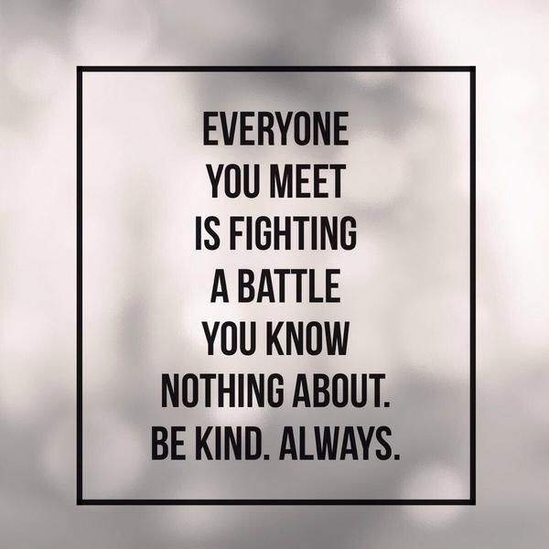

# OPENING CEREMONIES

**We Salute You**

*Greater St. Louis Area Council*

You will need 6 Cub Scouts. Have each Cub make up a card with a picture illustrating what the words on his card say or anything he wants related to the theme. Make sure the words are in LARGE print

1. Some who we salute are obvious, local heroes who like a police officer risks life to protect us from violence or the fireman who pulls people out of burning buildings.
2. Other we salute are the ambulance drivers, paramedics, doctors and nurses who save lives everyday.
3. Some people around us seem like regular people, but they we salute them because they were soldiers in the military and served our country to keep us free.
4. A hero is someone who does the right thing even when they are afraid of failure. They do it because it should be done. And we salute them.
5. Some who should be saluted are harder to spot, but they are still there. These include blood donors, teachers who spend their time and energy helping kids, and kids who say “No” to drugs.
6. Heroes are all around us. Please join in saluting all the heroes of our country, by repeating with me the Pledge of Allegiance to the Flag.

**Heroes Flag Ceremony**

*Great Salt Lake Council*

**Setting:** The Colors advance in the normal manner. A spotlight is shined on the flag while the narrator speaks.

**Narrator** (Hidden): Heroes, with help from God, have kept me flying in the face of threat and challenge to the democratic way of life I represent. I symbolize all the achievements of a great nation founded for freedom. I am the last hope of peace on earth. I am the American Flag.

**Cubmaster:** Audience arise and join me in the Pledge of Allegiance to be followed by singing "God Bless America."

**Hometown Heroes**

*Greater St. Louis Area Council*

You will need 6 Cub Scouts. Have each Cub make up a card with a picture illustrating what the words on his card say or anything he wants related to the theme. Make sure the words are in LARGE print

1. Sometimes a local hero is obvious, the policeman who risks his life to protect us from violence or the fireman who pulls people out of burning buildings.
2. Other heroes that come to mind are the ambulance drivers, paramedics, doctors and nurses who save lives everyday.
3. Some people around us seem like regular people, but they are heroes because they used to be soldiers in the military and served our country to keep us free.
4. A hero is someone who does the right thing even when they are afraid of failure. They do it because it should be done.
5. Some heroes are harder to spot, but they are still there. My heroes include the people who donate blood, teachers who spend their time and energy helping kids, and kids who say “No” to drugs.
6. Heroes are all around us. Please join in saluting all the heroes of our country, by repeating with me the Pledge of Allegiance to the Flag.

**Fire Safety Opening**

*Timucua District, North Florida Council*

**Setting:** The room lights are turned off. The Cubmaster lights a candle.

**Cubmaster:** Cub Scouts, this candlelight represents the spirit of Cub Scouting, lighting our way through life. This flame also represents danger. As fire detectives, you have learned about the danger of fire and how to prevent it. Let’s remember what we have learned so we will always use fire wisely and safely, not only today but the rest of your life.

This light of Cub Scouting gives us warmth and good cheer. Make sure it is never allowed to run wild and destroy lives and property. Let’s always be fire detectives. (Lights on. Have a Webelos den post the U.S. flag and lead in the Pledge of Allegiance.)

***I think this would make a great Cubmaster’s Minute Closing, too. Your choice. CD***

**Cub Crime Prevention Tips**

*San Gabriel, Long Beach Area, Verdugo Hills Councils*

Have six Cubs with cards depicting various rescue items – police cars, fire trucks, .. And words on back in LARGE letters. Have another Cub or a leader lead the Pledge of Allegiance when Cubs are done.

1. To help make things safer, we offer these tips, On everything from school to going on trips.
2. Make sure that you know your full name and phone number, So if you should need them you don’t stop and wonder.
3. Learn from your parents where you’re safe to go. That way if you’re walking, which way they will know.
4. Be alert in your neighborhood and note what you see. Tell an adult if you think “It didn’t look good to me.”
5. Don’t let your feelings get you in a fight,  
   Make friends or walk away whether you’re wrong or right.
6. And finally, remember, put safety number one so no one gets hurt and all will have fun.

**How to Dial 911**

*San Gabriel, Long Beach Area, Verdugo Hills Councils*

**Narrator:** It is important to know how and when to Dial 911. Our Cub Scouts want to share what they have learned about using 911.

1. Always be prepared for an emergency. Know where the closest phone is.
2. To Dial 911, pay phones are free.
3. Know what is wrong, what’s the emergency.
4. Know where you are, the address and street.
5. Say who you are and
6. Tell them who needs help.
7. Speak clearly and answer questions.
8. Stay on the line until help arrives.

**All:** Dial 911 only for an emergency.

**When to Dial 911**

*San Gabriel, Long Beach Area, Verdugo Hills Councils*

Cub Scouts enter one by one with signs reading Dial 911.

1. Our Den Leader taught us to “Do our best” and know when to *(holds sign up)* Dial 911.
2. When someone's hurt in an emergency *(holds up sign).* Dial 911.
3. A house on fire is an emergency *(holds up sign).* Dial 911.
4. Smell gas or smoke, it’s an emergency *(holds up sign)*. Dial 911.
5. Need an ambulance, that’s an emergency *(holds up sign)*. Dial 911.
6. Power line is down - it’s an emergency *(holds up sign)*. Dial 911.
7. Choking on food or not breathing is an emergency *(holds up sign).*Dial 911.
8. Fallen in the water and cannot swim can be an emergency *(holds up sign)*. Dial 911

**All:** Join all of us to ‘Do your Best’ - Dial 911 in an emergency.

**Cub Scout Opening**

*Sam Houston Area Council*

**Setting –** Each letter of C-U-B S-C-O-U-T should be cut out from poster board or printed on large pieces of paper or card stock. Write the lines on the back in LARGE print and line up the Scouts so they can read the lines in order.

1. C – is for Comradeship. We learn to get along.
2. U – is for Unity. Together we are strong.
3. B – is for Boys! Sometimes they’re wild, but mostly they’re nice.
4. S – is for Socials! You don’t have to ask twice.
5. C – is for Courtesy. Of this we know.
6. O – is for Outings. We can’t wait to go!
7. U – is for Universal. Scouts are known in every land.
8. T – is for Teamwork. We’ll lend you a helping hand.

(All the Scouts say together)

**ALL:** We Will Do Our Best!!

**CM:** Will you please rise for the Pledge of Allegiance?



**The Circle of Life**

*Sam Houston Area Council*

**Setting –** Narrator, 4 Scouts, 4 posters showing the sun, the moon, the wind, and the earth

**Scene –** Scouts are in a line.

**Emcee:** Everything in life has a cycle, normally represented by a circle, like the circle of life. The power of the world always works in circles and forces try to take a round shape.

1. (holding the poster of the sun) The sun is round; it warms all living things and allows us to grow.
2. (holding the poster of the moon) The moon is round; it gives us light at night.
3. (holding a poster of wind) The winds, in their great power, swirl, giving coolness and strength.
4. (holding a poster of the earth) The earth is round; it provides a home and nourishment for all living things.

**Emcee:** The life of a person is a circle from childhood to childhood. We teach our children, as they will teach their children. Please stand and join in the Pledge of Allegiance.

**Fire Brigade Opening**

*Baltimore Area Council*

A brigade of Cub Scouts dressed as fire fighters come running out on stage as if responding to a three-alarm fire. On stage is a ladder and taped to the sides are flames and billowing puffs of smoke cut from poster board or cardboard. On the reverse side of each flame and cloud of smoke is text describing a particular household fire hazard and means for preventing it. One by one, the Cub Scouts mount the ladder, remove a card, climb back down and read the text to the audience. Follow with a flag ceremony.

[](http://www.google.com/imgres?q=old+cub+scout+image&start=299&hl=en&sa=X&rls=com.microsoft:en-us:IE-Address&biw=1920&bih=934&tbm=isch&prmd=imvns&tbnid=NgYIqZMp5bVJMM:&imgrefurl=http://centralnccouncilbsa.com/openrosters/ViewOrgPageLink.aspx?LinkKey=34931&orgkey=2390&docid=5FHNMQ4F6BHOdM&imgurl=http://centralnccouncilbsa.com/OrgHeaders/2390/CS.JPG&w=1198&h=368&ei=ZpYUUKDNMILmqgHbwICADg&zoom=1&iact=hc&vpx=910&vpy=639&dur=202&hovh=124&hovw=405&tx=223&ty=86&sig=101063524714094760578&page=6&tbnh=55&tbnw=179&ndsp=60&ved=1t:429,r:14,s:299,i:49)

# AUDIENCE PARTICIPATIONS

Traditionally, Audience Participation means giving speaking parts to the members of the audience, based on a keyword they’ll hear in the story. Separating the audience can be done in several ways, like by seating section, age, den, etc. You instruct them that when their word is heard, they shout out their part, which may be a phrase or sound effect.

**Clancy To the Rescue**

*San Gabriel, Long Beach, & Verdugo Hills Councils*

Divide audience up into six groups. Assign each group a response to do whenever their word is spoken in the story. Practice as you assign parts. If your group is small, have everyone react to the last two items. If group is larger, divide into seven groups and assign STEAM. ASLEEP only occurs once at the very end.

**CLANCY:** Feel your muscles, like a strong man

**HORSES:** Slap Thighs

**YELL:** Use your hand over your mouth

**FIRE ENGINE:** High-pitched siren sound

**BELL:** Swing arm like a clapper saying,  
 “Clang, clang, clang!”

**HOSE:** Shh-sh-sh sound like water from a hose

**STEAM: *Everyone*** makes high pitched Sssss sound

**ASLEEP: *Everyone*** snores

If you like **HORSES**, you would have enjoyed living back in the 1800's when they had old-fashioned **STEAM** type **FIRE ENGINES** pulled by **HORSES**. One of the **FIRE ENGINES** was driven by the greatest hero ever, **CLANCY**! Yes, Sir! **CLANCY** was a real hero. Every day when there was no fire, he would take the **HORSES** out for exercise, trotting them gently up and down the streets. If there were children along the way, **CLANCY** would always stop and let them pet the **HORSES**.

Sometimes the alarms were in the daytime, but sometimes they were at night. When the alarm sounded at night, one man would **YELL** up to the firemen above, and the men would run to the **FIRE ENGINE** where the **STEAM** was started up, and away they would go to the fire, clanging the **BELL**, with **CLANCY** driving the **HORSES**.

One night most of the men were in bed and the others were playing checkers when the alarm sounded. Where was the fire? At the mayor's big two-story house! The **YELL** was given and quick as a flash the firemen were up and on their way. **CLANCY** stopped the **HORSES** and **YELLED**,

"Keep the **STEAM** up men." They started the fire **HOSE** and began to squirt water on the fire. **CLANCY** strained to see upstairs where the mayor's wife was trapped. Flames were everywhere! **CLANCY YELLED**, "You'll have to jump!" The mayor's wife was afraid, so **CLANCY** threw her a rope and she came right down into the middle of the net.

The firemen kept fighting the fire. They got the **HOSE** on it and kept up the **STEAM** in the **FIRE ENGINE**. Before long, the fire was out, so they turned off the **HOSE**, got back on the **FIRE ENGINE** and went back to the fire house, clanging the **BELL**. To **CLANCY** and the other firemen, it was all in a day's work. The tired firemen went back upstairs and soon were sound **ASLEEP**.

**Cub Scout Heroes**

*Sam Houston Area Council*

Divide the audience into four groups. Assign each group their words for the story. Each time their word is mentioned in the story, the assigned group enthusiastically says the designated sound words. Practice as you make assignments and have a practice session before starting the story

FOLLOW: A Cub Scout Follows Akela (Give sign)

HELP: The Pack Helps the Cub Scout Grow (Give sign)

GIVE (GAVE): A Cub Scout Gives Goodwill (Give sign)

PACK: A Cub Scout Helps the Pack Go (Give sign)

HERO (HEROES): **ALL ADULTS** cheer “Hip, hip hooray!”

CUB SCOUT: **ALL CUBS** give the Cub Scout sign   
 and say, “Do Your Best.”

This is the story of Gary, a CUB SCOUT who wanted to do something to HELP his elderly neighbor, Mrs. Green. This CUB SCOUT wanted to FOLLOW the advice of his PACK leaders, who asked every CUB SCOUT to find some way they could GIVE HELP to someone else. Gary thought that his neighborhood would be the best place to start.

One way Gary could think of to HELP his neighbor was to rake up the leaves in her yard for her. It was such a big yard, though, and he was such a little CUB SCOUT. Gary needed some HELP. So he thought some more and decided to talk to his PACK leaders and see if they could GIVE him some suggestions. The PACK leaders said they would ask if any other CUB SCOUTS would like to FOLLOW Gary’s example and HELP rake the leaves for Mrs. Green.

What started with only one CUB SCOUT helping Mrs. Green soon grew to two CUB SCOUTS, then three CUB SCOUTS, then four CUB SCOUTS, then five CUB SCOUTS... (Continue adding CUB SCOUTS while the audience gives the Cub Scout sign each time and says “Do Your Best!” until everyone starts to laugh. Then finish reading the story.)

Mrs. Green told everyone about Gary and his CUB SCOUT PACK. She called the CUB SCOUTS her HEROES because of all the help they GAVE her.

The moral of this story is: If you FOLLOW the advice of your PACK leaders, and GIVE HELP to those around you, you will be a great CUB SCOUT, and maybe someone’s HERO, too.

**Smokey Bear (A true story)**

*Santa Clara County Council*

Divide the audience into six groups. Assign each group their words for the story. Each time their word is mentioned in the story, the assigned group enthusiastically says the designated sound words. Practice as you make assignments and have a practice session before starting the story.

Big Tree - I am so big!

Middle-Sized Tree - See my pretty leaves

Baby Tree - I'm just a bush

Camper - I love this beautiful forest

Fire - Crackle, crackle

Smokey - Only you can prevent forest fires

Babbling Brook - Assign one person,   
they get up and run through the group, babbling

*The distribution of the words in this story is not close to even. There are FIRE appears 8 times, Middle Sized Tree and Camper twice. Watch your assignments.*

One upon a time in a beautiful lush green forest, there stood three trees, the **BIG TREE**, the **MIDDLE-SIZED TREE** and the **BABY TREE**. A **BABBLING BROOK** coursed its way through the forest. A **CAMPER** made a **FIRE** for his breakfast without clearing the area for 10 feet and then went for a hike without making sure the **FIRE** was dead out. The **FIRE** threw some sparks into some dried grass. It started smoldering. The **BABBLING BROOK** was not close enough to put out the sparks. In a short time, the dry forest was ablaze. The animals heard the sounds of the **FIRE**. smelled the smoke, and tried to flee. A bear cub couldn't see where his mother had gone so he did what she had taught him when there was danger. He climbed the **BIG TREE**. The **FIRE** roared by. It burned up the **BABY TREE** and **MIDDLE-SIZED TREE**. It singed the **BIG TREE** with the bear cub clinging to the top. After the **FIRE**, a ranger found the bear cub still in the top of the **BIG TREE** and got him down. He was singed and scared. The ranger healed his burns and raised him. He called him **SMOKEY**. He became the symbol to remind **CAMPERS** and hikers to be careful with **FIRE** and protect the **BIG TREES**, the **MIDDLE-SIZED TREES** and the **BABY TREES** so we can enjoy the forest with the **BABBLING BROOKS** running through them. Remember, "Only you can prevent forest **FIRES**!" the one who says that is **SMOKEY** Bear.

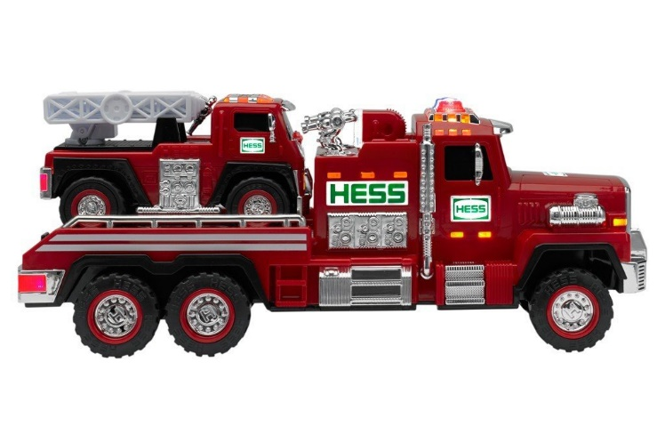

**The Spark Watcher**

*Timucua District, North Florida Council*

Divide audience into 6 groups. Assign each group a response to said when their word is read in the story. Practice as you assign the parts. Encourage VOLUME

Little Fire Engine: “Ding ding”

Big Fire Engine: “Clang clang”

Pumper: “Pump pump”

Fire Chief: (Siren sound)

Fire: “Crackle crackle”

Toys: “Ha-ha, ho-ho”

Once there was a LITTLE RED FIRE ENGINE who lived in a toyshop. “I’d like to go to a real FIRE just once,” said the LITTLE RED FIRE ENGINE to the other TOYS. “ I could watch the FIRE CHIEF, the BIG FIRE ENGINES and the PUMPERS shoot streams of water all over, and maybe then they would let me help put out the FIRE.”

“Pooh,” said the TOYS. “You’re only a LITTLE TOY FIRE ENGINE, you wouldn’t be any help at a big FIRE.” All the TOYS laughed at him. “You’ve never even seen a FIRE,” said the TOYS. “How would you know what to do? You’d only be in the way.”

The LITTLE FIRE ENGINE rumbled off to a corner by himself. He thought that he might be in the way, but he might be good at fighting FIRES. “I’ll never know until I try. I’ll have to go to a FIRE and see.” So, the LITTLE FIRE ENGINE decided to go to a FIRE.

That very afternoon, he heard the siren blow. Out the open toyshop door he dashed, and stood at the curb panting. The BIG RED FIRE ENGINE, the PUMPER, and the FIRE

CHIEF went tearing by. “Wow!” said the LITTLE FIRE ENGINE, “I didn’t know real fire engines were so very, very big!” But, he hurried down the street anyway. He did his best to keep up, but the BIG FIRE ENGINE got to the FIRE first. When the LITTLE FIRE ENGINE got there, the BIG FIRE ENGINES were already at work. The long hoses were twisting and winding all around. The LITTLE FIRE ENGINE could hardly get through. He puffed and panted over one hose and then another. At last, he was close to the FIRE, and he looked around for a job to do.

“I’ll shoot water,” thought the LITTLE FIRE ENGINE, but his hose was too short. In spite of all he did, the FIRE burned brighter. “I wish someone would tell me what to do,” the LITTLE FIRE ENGINE said.

The PUMPER was busy shooting water and the BIG FIRE ENGINE was running up ladders for the fire fighters, while the FIRE CHIEF ran around giving orders. They had plenty to do, and they didn’t even notice the LITTLE FIRE ENGINE was there. They pushed him to one side, out of the way. He had to be very careful that he wasn’t run over.

“I guess I don’t belong here,” the LITTLE FIRE ENGINE thought sadly. “I’m too little for such a big FIRE. I better go back with the rest of the TOYS.” But, just as he started to leave, he saw a spark fly from the burning building. It landed right beside him, and started to burn.

“Here,” said the LITTLE FIRE ENGINE, “This will never do.” He turned his hose on the little FIRE; his hose was just the right size. In an instant, the FIRE was out. He had an idea. He’d be a spark watcher. So he raced around looking for flying sparks. Whenever the LITTLE FIRE ENGINE saw one, he rushed to put it out.

He got all hot and smoky, just like the BIG FIRE ENGINE. He was so successful that the FIRE CHIEF’S car, the PUMPER and the BIG FIRE ENGINE called to him, “Why don’t you stay with us in the fire house, LITTLE FIRE ENGINE? We could use you.” He was delighted. And so, the LITTLE FIRE ENGINE lived from then on with the BIG FIRE ENGINES and became the best spark watcher in town!

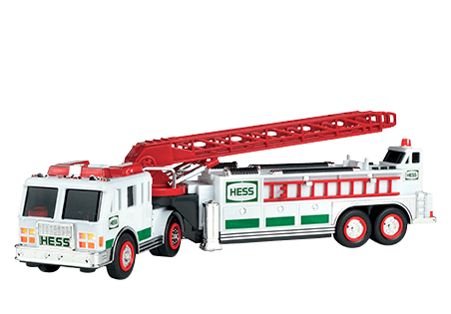

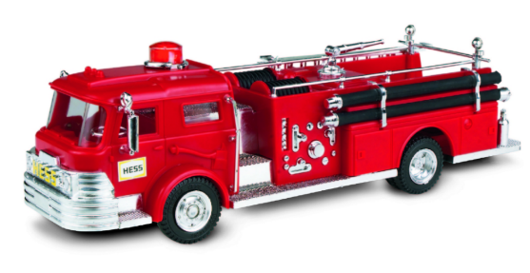**LEFT, RIGHT, WRIGHT**

*Santa Clara County Council*

Divide the audience into LEFT and RIGHT and have them stand up and sit down when they heard their word. You could also divide the audience into LEFT, RIGHT and WRIGHT.

Johnny WRIGHT was very excited as he talked to his parents. "I want to become a Cub Scout," he said. "I am the only boy LEFT in the neighborhood that isn't one. Peter invited me to his Blue & Gold banquet tonight to see if scouting is RIGHT for me. Can we go?"

Mr. WRIGHT called Peter's dad to get directions. When he got off the phone he told everyone, "It's at First Baptist Church. We go south on 125, take a LEFT on Cherry St. then our first LEFT into the parking lot…let's go! Johnny ran RIGHT out and got into the car. At the church they went in and had a great time. The Cub Scouts got great awards, put on skits, sang songs and had a ball. The Cubmaster came over and talked to Johnny. "Why do you want to be a Cub Scout…"Because at school all the kids talk about the fun they have here, and I feel LEFT out, and my friend LEFT his Cub Scout cap at my house, right on my desk so I tried it on, I look cool in it." Johnny replied. One of the leaders looked at Johnny's parents. "Would you like to help out? It's fun and rewarding". Mr. WRIGHT looked at Mrs. WRIGHT they both fidgeted nervously…"We thought parents brought their boys, then LEFT. We didn't know we had to help." "Oh, you don't have to" explained one of the leaders, "but if no one is willing to give of their time, soon there will be no scouting LEFT. The more parents that help…the less work for us all. You could be den leaders and help boys to stay on the RIGHT track, or you could be on the committee and attend a meeting once a month to help make the RIGHT decisions for our Pack. There are many positions with different levels of time commitment, I'm sure we could find one that's just RIGHT for you…I hope I haven't LEFT out any information…so, would you like to help?"

RIGHT on, exclaimed Johnny's folks. Johnny just beamed. He knew he had made the RIGHT decision by coming to the Blue & Gold.

# ADVANCEMENT CEREMONIES

**Award Presentation Idea:**

**Can the Awards!**

*Pamela, North Florida Council*

Use one of those new safety can openers that removes the whole lid. Prepare in advance by saving cans for each boy and washing out. If you save the original label on the can the boys will be even more surprised when the first can is opened. Fill a can with awards for each boy. Replace the lid. Let each boy open their award can.

**Do Your Best in an Emergency**

*San Gabriel, LB Area, Verdugo Hills Councils*

**Cubmaster:** In Cub Scouting, the boys learn how to take care of themselves and how to issue first aid. They also learn what to do in case of a vehicle accident, family illness, or how to stop, drop and roll if they are on fire.

**Asst CM:** This month we have been learning about the people who help us in an emergency. Like the Cub Scouts, they do their best. The Cub Scout motto is: "Do Your Best." This is one of the things the Cub Scouts are always trying to do. We cannot ask more of someone.

**Cubmaster:** Would *(name)* please come forward with his parents? This Cub Scout has worked hard to do his best in earning the rank of _______.  
We present this badge to his parents to pin on him *(parents pin badge on).* We will honor him by giving him a Grand Howl.

**Fire Safety Advancement Ceremony:**

*Baltimore Area Council*

As Cub Scouts we must be aware of being fire safe. As we develop in Scouting, our knowledge increases, our awareness of safety protects ourselves and those who live, play and work with us. Our responsibility to be fire safe and guide others increases as time goes on.

Entering into this beginning class are our new Bobcats, ___________. Will these boys and their parents come forward? These boys are receiving the Bobcat award. This award is the beginning of their experiences in Cub Scouting. A part of this experience involves fire safety. The parents will present this bobcat award to their son. Congratulations and welcome to the Pack. LEAD CHEER

Advancing forward as a Tiger are __________. One of the adventures a Tiger may earn is Tiger: Safe and Smart. They learn how to Stop, Drop and Roll, plan an escape route from their home, and check the smoke detectors. This award is presented to the boys by their parents. Congratulations. LEAD CHEER

Advancing in knowledge as a Wolf are __________. One of the Adventures required for the Wolf Badge is Call of the Wild. They learn about outdoor fire safety for a campfire. This award is presented to the boys by his parents. Congratulations. LEAD CHEER

Another achievement in Cub Scouting is the earning of the Bear award. Tonight several boys have earned this award. Will the following Cubs and their parents come forward? __________. While attaining skills in several areas, one of the adventures a Bear may earn is Bear Picnic Basket. They learn about cooking and cooking safety, what to do for burns, and how to safely cook a foil pack over a fire. The parents will present the bear award to their sons. Congratulations. LEAD CHEER

Receiving the Webelos badge tonight are __________. Will __________ and their parents come forward? The knowledge initiated in the Webelos Cast Iron Chef, Camper, and Castaway adventures increased their knowledge of fires and fire safety. They learned more outdoor fire safety. They built fires, maintained them safely, and, maybe, used them for cooking. They learned what to do if a fire is in their campsite. And how to light a fire without matches. The Webelos leader will present the award to the parents and __________ congratulations on your success in Scouting. LEAD CHEER

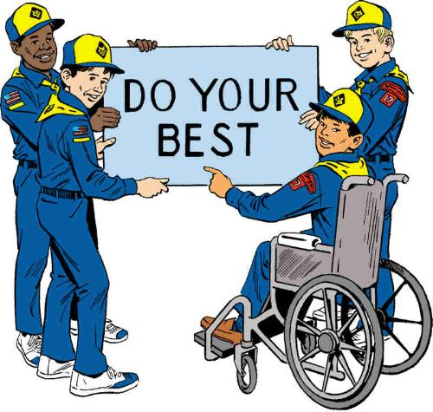

**To Help Other People At All Times-**

*Greater St. Louis Area Council*

**Props:** A small taper candle for each Scout, A candelabra with three candles either all white or one red, one blue, and one white.

***Note –*** *add in the actual award names to personalize this ceremony. Have more Scouts, use a Scout to light the other candle.*

**Cubmaster: “**To help other people at all times,” is the second of the three duties of a Scout expressed in the Scout Oath. Helping other people is part of what it means to be a good neighbor. We have to help and look out for each other. I will light the second candle to represent our duty to others. Tonight, would like to recognize several Scouts who with the help of their mothers, fathers, den leaders, and others have met the requirements for advancement to the next rank.

**Assistant CM:** Will Cub Scouts_________ and _________ please come forward with their parents? Will one of the parents please light the first candle, which represents a Scout's Duty to God and his Country? Duty to God and Country is the first duty of a Scout expressed in the Scout Oath.

**CM:** Will Cub Scouts_________ and _________ please come forward with their parents? Will one of the parents please light the third candle, which represents a Scout's Duty to himself? This duty is expressed in the words, "Keep myself physically strong, mentally awake, and morally straight." This is the third duty of a Scout expressed in the Scout Oath.

**Cubmaster:** I will now present these patches which represent your sons' accomplishments to you, the parents, to present to your sons. I do this because you have helped him the most to earn this award and deserve the honor of presentation more than I do.

Now, you may present the award to your son.

**Assistant CM:** Lead a Cheer

**Bobcat Badge Ceremony**

*Sam Houston Area Council*

**Setting – 6** Webelos Scouts (WS), all Scouts earning the Bobcat badge; Cubmaster (CM), den leaders (DL).

**Scene –** Cubmaster invites the Scouts earning their Bobcat badges to stand in front of the group with their parents behind them. Webelos Scouts are standing to the side of the group.

**CM:** Den leaders, please step forward. For what purpose do these Scouts stand before us tonight?

**DL #1:** Akela, these Scouts are ready to receive their Bobcat rank.

**CM:** What leads you to believe they are worthy of this honor?

**DL #2:** They have completed the requirements for the Bobcat rank by learning the Scout Oath and Law, the Cub Scout Sign, Salute, Handshake, and Motto.

**CM:** Are they ready to be tested by their brothers, the Webelos Scouts?

**DL #2:** Yes, they are.

*(Den leaders return to previous spot.)*

**WS #1:** Show us the Cub Scout Sign. (Hold the sign until the Cubmaster inspects all the candidates and then returns to the audience and says, “Very Good!”)

**WS #2:** Repeat the Scout Oath with me. Cub Scout Sign! (Raise the sign and say the Oath with the candidates. Then say) Good job!

**WS #3:** Show us the Cub Scout Salute. (Hold the salute as the Cubmaster inspects each candidate. Then say) Two. Well done!

**WS #4:** Repeat the Scout Law with me. Cub Scout Sign! (Raise the sign and say the Scout Law with the candidates. Then say) Good job!

**WS #5:** Show us the Cub Scout Handshake. (Several of the Webelos Scouts perform the handshake with various candidates in the line and return. Say) Well done!

**WS #6:** What is the Cub Scout Motto? (The candidates say the Motto.) Ok, now let’s hear it with a little spirit! (Candidates say the Motto again.) Great – now louder! (The Bobcats yell the Motto. Then say loudly) That was great!

**CM:** Webelos Scouts, is your testing complete?

**WS #1:** It is, Akela.

**CM:** Are these Scouts ready to become Bobcats and to begin work on their next rank?

**WS #3:** They have all performed well and are ready, Akela.

**CM:** Thank you Webelos Scouts. You may be seated.

**CM:** Congratulations Scouts! You have completed the rank of Bobcat and have demonstrated your ability for all of us. I’m now going to give you your rank award to acknowledge your hard work. Make sure you thank your parents for helping you on this journey. They will journey with you on your adventure through Cub Scouts!

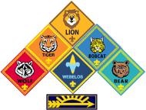

**Salute to our Heroes Advancement Ceremony**

*Sam Houston Area Council*

**Materials –** “Medals of Honor” made from construction paper and attached to loops of crepe streamer to be hung around the Cub Scouts’ necks. Label the medals “HERO.”

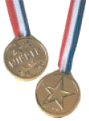

**Cubmaster:** Often we hear of professional athletes being called “sports heroes.” That’s a colorful description, but all they are really doing is playing a game to entertain us. Some of these people really are heroes, but that comes from things they do off the playing field to help their communities.

We salute those heroes that are not afraid to do what they believe is right. They are people who want to make things better for others. They are usually prepared and trained to do the job. And they will do their best even if they are afraid because it is important to them to do what is right.

The following Scouts are the heroes that we salute today. They have chosen to work hard and prepare themselves in life by learning Cub Scouting ideals. They are learning to be independent and successful and happen to have a lot of fun along the way. Please join me in congratulating the heroes who have earned their (name award) (call out names of Scouts and their parents, present rank awards, and place medals around the Scouts’ necks. Continue in a similar manner for each additional award.)

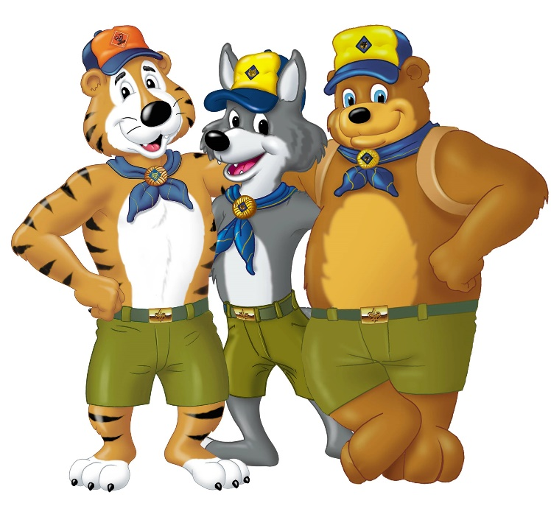

**Hear Ye, Hear Ye**

*Santa Clara County Council*

**Props:** This can be as simple or as fancy as desired. The setting is at a campaign speech for city mayor.

**Characters:** The Cubmaster (CM) will need to have four people help with the awards. The candidates as Mr. (or Miss or Mrs.) Tiger, Wolf, and Bear and Mayor Scout.

**Cubmaster:** Ladies and gentlemen, we have come here tonight to hear the members of our (town council) express their views. Normally, we would salute these upstanding citizens but tonight they wish to salute our Cub Scouts.

*Introduce Mr. (or Miss or Mrs.) Tiger, Wolf, and Bear  
 and Mayor Scout.*

**Mr. (or Mrs. Or Miss) Tiger:** I enjoy talking with the youngest citizens of our fair city. It is great that we can provide so many places for them to adventure forth. These Tiger Cubs have earned awards for doing just that –adventuring into the world. And I salute you. Would these Tiger Cubs and their Adult Partners please come forward and receive their awards. (Call out boys' names that are receiving their Tiger badges. The Cubmaster assists in presenting the awards to the parents to present to the Tigers.). After presentation CM leads a cheer.

**Mr. (or Mrs. Or Miss) Wolf:** I would like to talk to the next group of young people about our fair city, to say we need to improve on our quality of life. We have Cub Scouts present who have completed seven Adventures to improve both their mind and body and their religious beliefs. I salute you for a job well done. Would these Cub Scouts and their parents please come forward and receive their awards. (Call out boys' names that are getting their Wolf and arrow points. The Cubmaster assists in presenting the awards to the parents to present to the Wolfs.). After presentation CM leads a cheer.

**Mr. (or Mrs. Or Miss) Bear:** I would like to address the middle-aged group of your fair Pack. You have been working for some time and have achieved much. I salute you and feel honored that I will be helping in the presentation of your Bear award. Would these Cub Scouts and their parents please come forward and receive their awards. (Call out boys' names that are getting their Bear and arrow points. The Cubmaster assists in presenting the awards to the parents to present to the Bears.). After presentation CM leads a cheer.

**Mayor Scout:** I would like to talk to the old timers of this our golden town. You have each given unselfishly of yourselves and for your loyal support all these years I have a special award that is called the Webelos Badge . Webelos stands for We'll Be Loyal Scouts and I salute you for your continued loyalty to Scouting. Pretty soon you will be moving up to Boy Scouting and I know you will be just as loyal there. Would these Webelos Scouts and their parents please come forward and receive their awards. (Call out boys' names that are getting Activity Awards and Webelos Badges. The Cubmaster assists in presenting the awards to the parents to present to the Webelos.). After presentation CM leads a cheer.

**Cubmaster:** As sponsor for these campaign speeches I would like to add my personal salute and many thanks for jobs well done.

**Badges of Cloth**

*Greater St. Louis Area Council*

This will make a great start to your first advancement ceremony. Although no awards are made during this it does a good job of explaining the advancement program.

You will need six cards in the shape of a badge, with one letter of the word BADGE on each card, the explanation for each letter on the reverse side.

1. B: stands for badges given today. What is a badge? A scrap of colored material is not nearly so important as the job that was done to earn it.
2. A: stands for Akela. Your family and leaders who have helped you earn your badge.
3. D: stands for Deeds. Good deeds to be done now and in the future for family, friends, and the community. Good deeds done with the knowledge and skills acquired through the badges.
4. G: stands for Growth. The Pack helps the Cub Scout grow.
5. E: stands for Eagerness and Energy. Both are necessary to earn badges. Badges do not come easily and they should not or their value would be small. Badges present challenges, difficulties, and satisfaction in accomplishment.
6. S: stands for Service. Service to others is one of our aims in life. Our badges help up to bring service to others.

# LEADER RECOGNITION

## Over the Top

*Sam Houston Area Council*

**Materials –** smiley face pin OR neckerchief slide OR mounted on a display with the words – Thank you for your Cooperation and Positive Attitude! (OR – thank you for giving 100%, OR something you feel is appropriate.)

**Emcee, Presenter, or Cubmaster   
(Someone not getting a presentation):**

If A=1, B=2, C=3, and so forth to X=24, Y=25, and Z=26

Then,

*(You will probably want to display the numbers so people can see what you are doing.   
Chalkboard, Dry Erase Board, Flip Chart, …   
Maybe solicit the numbers from the audience)*

H+A+R+D+W+O+R+K is  
8 +1+18+4+23+15+18+11= 98% ONLY

And   
K+N+O+W+L+E+D+G+E is   
11+14+15+23+12+5+4+7+5=96% ONLY

But  
A+T+T+I+T+U+D+E is   
1+20+20+9+20+21+4+5=100%

And  
C+O+O+P+E+R+A+T+I+O+N is  
3+15+15+16+5+18+1+20+9+15+14 = 131%   
**WITH COOPERATION WE ARE OVER THE TOP!!**

**Cubmaster –** There are some incredible parents and leaders with us tonight who consistently Cooperate and maintain a Positive Attitude as they play the game of life. They are always cheerful and ready to cooperate whatever the need when they are asked (and sometimes even before they are asked). Tonight we are presenting them with the Cooperation and Positive Attitude awards, and we thank them for the tremendous help they have provided our pack. (Call adults forward and present award.)



# SONGS

**I Am Proud-**

*Greater St. Louis Area Council*

Tune “Yankee Doodle Dandy”

I am proud to be a Cub Scout  
It makes me want to sing and shout  
I wear a uniform of blue and gold,  
It’s really a sight to behold  
You would like to be a Cub Scout  
I know without a single doubt  
I do my best to do my duty  
That’s what Cub Scouting is about.

**9-1-1 HELP**

*Greater St. Louis Area Council*

Tune “My Bonnie”

Emergencies they will answer,  
They’re always a phone call away  
They come when they’re needed most promptly  
And for you they will most surely stay

**Chorus:**Nine-one-one  
Nine-one-one  
We call on them when we need HE…LP

Medics are your friends and my friends  
They answer their calls so fast  
They come when they are needed so greatly  
And always will stay to the last.

**Chorus:**

The firemen too answer calls  
A fire is scary to see  
But when they come oh so quickly  
They put out the fire with glee

**Chorus:**

We often need a policeman  
And 9-1-1 will get one there  
Be sure that you know your address  
Of this you should always be aware

**Chorus:**

**America, My Homeland**

*Sam Houston Area Council*

Tune – You are my Sunshine

You are my homeland,   
You are a great land.  
You make me happy,   
You make me free.  
Your flag I’ll honor,   
I’ll pledge allegiance.  
The USA is good to me.

**I’ve Got That Cub Scout Spirit**

*Great Salt Lake Council*

A Classic Cub Scout Tune

I’ve got that Cub Scout spirit up in my head  
*(Point to head each time you say it)*Up in my head, Up in my head  
I’ve got that Cub Scout spirit up in my head  
Up in my head to stay

Repeat verse above and sing in turn:

Deep in my heart *(Point to your heart)*

Down in my feet *(Touch your toes)*

All over me *(Make big circles with your arms)*

**Last Verse**I’ve got that Cub Scout spirit   
Up in my head *(Point to head)*  
Deep in my heart, *(Point to heart)*  
down in my feet, *(Touch your toes)*  
I’ve got that Cub Scout spirit all over me *(Circle arms)*  
All over me to stay.  *(Circle arms)*

**Pack Meeting**

*Sam Houston Area Council*

Tune – Clementine

When our Cub Pack is outside at dusk  
And our camp fire’s all aglow,  
We will form a friendship circle,  
As we sing so sweet and low.  
We’re brave Tiger Scouts, and Wolf and Bear Scouts,  
And trusty Webelos we’ll be.  
To the Scout Oath and the Scout Law  
We will pledge our loyalty.

**The Yankee Doodle Scout Law**

*Sam Houston Area Council*

Tune – Yankee Doodle

Trusty Tommy was a Scout  
Loyal to his mother  
Helpful to the friends about, and  
Friendly to his brother  
Courteous to all about  
Kind unto the rabbits  
Obedient to his father, too, and  
Cheerful in his habits  
Thrifty saving for a need  
Brave, and not a faker  
Clean in thought and word and deed, and  
Reverent to his Maker.

**I’M A YANKEE DOODLE DANDY**

by George M. Cohan

*Santa Clara County Council*

I'm a Yankee Doodle Dandy  
A Yankee Doodle, do or die  
A real live nephew of my Uncle Sam  
Born on the Fourth of July  
I've got a Yankee Doodle sweetheart  
She's my Yankee Doodle joy  
Yankee Doodle came to London  
Just to ride the ponies  
I am the Yankee Doodle Boy

**TOMMY THE CUB SCOUT**

*Santa Clara County Council*

Tune: Frosty the Snowman

Tommy, the Cub Scout  
Was a very happy boy.  
With a uniform of blue and gold  
And a Den that gave him joy.

Tommy, the Cub Scout  
Earned his badges one by one.  
He did his best and met the test.  
A good citizen he's become.

He helps out other people when  
He sees they need a lot.  
He does his chores around the house  
And feeds his dog (named Spot).

Tommy, the Cub Scout  
Does his duty willingly.  
Someday he'll join a Boy Scout Troop  
And a fine man he will be.

**That's Why We Are In Cub Scouts**

*Cascade Pacific Council*

Tune: Deep In The Heart Of Texas

The fun things in life,   
Our family's delight!   
*(clap hands four times)*That's why we're in Cub Scouting.

We do our best,   
To pass each test   
*(clap hands four times)*That's why we're in Cub Scouting.

Just me and my son,   
Work, play and have fun,   
*(clap hands four times)*That's why we're in Cub Scouting.

We think our pack's great,   
We keep it first-rate;   
*(clap hands four times)*That's why we're in Cub Scouting!

**Catch the Scouting Spirit**

*Cascade Pacific Council*

(Tune: Catch a Falling Star)

Catch the Scouting spirit   
Put it in your heart   
Never let it fade away.   
Catch the Scouting spirit   
Put it in your heart   
Never let it fade away.

For someday soon you'll see   
What's been accomplished   
It will make you proud   
And don't forget the fun   
And fellowship there you'll   
Get rewards beyond compare.  
Catch the Scouting spirit   
Put in it your heart   
Never let it fade away.

***(Repeat first verse)***

**Cub Scout Friends**

*Cascade Pacific Council*

Tune: “It’s a Small World”

We all come in different shapes and size,  
We all come with different hair and eyes.  
Some are tall, some are short,  
But we’re proud to report,  
That we all are Cub Scout friends.

**Chorus:**We’re alike but different,  
All of us have different strengths.  
No matter what, we do our best,  
We all are Cub Scout friends.

**Dial 911**

*San Gabriel, LB Area, Verdugo Hills Councils*

Tune: Three Blind Mice

Dial 911

Dial 911

If you are hurt

If you need help

If someone has fallen and can't get up

Run to the phone and pick it up

Stay on the line and don't hang it up

Help will come.

5. say “the end”.

**Thinking Safety**

*San Gabriel, LB Area, Verdugo Hills Councils*

Tune: Clementine

In the kitchen, Dad was cooking,  
Frying chicken in some oil.  
Said he’d go out to do the shopping,  
Just as dinner tried to boil!

Thinking Safety, I remembered,  
Told him, “Dad! Turn off the heat!”  
Using caution is more important  
Than preparing supper meat.

At the table was a candle  
Mom had lit to cheer the room.  
Matches sitting on the counter  
Made me feel a sense of doom.

Thinking Safety, I remembered,  
Told her, “Mom, this I must teach,  
Keep the matches and the lighters  
Out of little sister’s reach!”

In the bedroom, brother studied,  
Working oh so diligently,  
Stereo, TV, heater, computer,  
All plugged in the same circuitry.

Thinking Safety, I remembered,  
Told him, “Bud, that’s not too wise!  
You should unplug some electronics  
Before that one connection fries!”

Fire prevention can be easy,  
Just have care at every turn.  
Use your good sense and some planning  
To prevent unwanted burn.

**I Wish I Were A Volunteer**

*Greater St. Louis Area Council*

Tune “Oscar Meyer Weiner”

Oh, I wish I were a volunteer fireman,  
That is what I’d really like to be.  
‘Cuz if I were a volunteer fireman,  
Everyone would look up to me.

I’d climb a ladder up high to save babies.  
I’d battle fire, smoke and burning steam.  
I’d wear my big, red fireman’s cap proudly,  
And polish my badge until it gleamed.

I’d rescue cats from limbs in very tall trees  
And do inspections very carefully,  
I’d teach the kids to all be fire detectives  
‘Cuz then my job would be so easy

**By the Blazing Council Fire Light**

*Greater St. Louis Area Council*

Tune “’Til We Meet Again”

By the blazing council fire’s light

We have met in comradeship tonight

Round about the whispering trees

Guard our golden memories

And so before we close our eyes in sleep

Let us pledge each other that we’ll keep

Scouting friendships strong and deep

‘Til We Meet Again

**Fireman’s Song**

*Timucua District, North Florida Council*

***(No tune was listed in either spot I found this song. So make one up or if you know – E-mail me. CD)***

Behold the noble Fireman, all dressed in red and black.

He climbs the tilted ladder with a rope upon his back.

An axe he carries by his side, a helmet on his head,

He goes to fight the fire, most powerful and dread.

He is our unsung hero, this man of brawn and might,

And to watch him fight a fire is a great and wondrous sight.

**Fire Prevention**

*Baltimore Area Council*

Tune: Clementine

Check your hallways, check your closets,   
And underneath the stairwell, too.   
For if you’ve piled lots of junk there,   
A big fire may call on you.

Dirty paint rags, piled up papers,   
Frayed extension cords won’t do.   
Fire prevention is the answer,   
All cub Scouts must follow through.

**Prevent Fires**

*Baltimore Area Council*

Tune: Are you Sleeping?

Prevent fires, prevent fires,   
Do your part, do your part,   
Check your house for hazards,   
Check your house for hazards,   
You’ll be smart. You’ll be smart.

Hunt for hazards, hunt for hazards,   
Clean them out, clean them out.   
Help protect your family,   
Help protect your family,   
Have no doubt, have no doubt.

# STUNTS AND APPLAUSES

## APPLAUSES & CHEERS

*Timucua District, North Florida Council*

**Fire Bucket Brigade Cheer:**Pretend to pass buckets of water, throw water on fire saying “SWWWOOOSSSHH.”

**Fire Engine Cheer:**Divide into four groups.

1. Bell… “ding, ding, ding.”
2. Horn… “honk, honk, honk.”
3. Siren… “rrr, rrr, rrr.”
4. Clanger… “clang, clang, clang.”

Have everyone yell at once.

**Fireman’s Applause:**

* Make sounds, “Crackle, crackle, pop” as you move your fingers over your head.
* Then make a sound like a fire engine.
* Grab your hose and spray on the fire and “hiss-s-s”
* Say “The fire is out.”

*San Gabriel, LB Area, Verdugo Hills Councils*

**Grand Howl Applause:**

* Cub Scouts form a circle around the person being honored.
* Each Cub Scout in the circle squats, makes the two-fingered Cub Scout sign and touches the fingers of both hands to the ground, between his feet.
* Then, like young wolves, the Cub Scouts raise their heads and give a long howl:
* “Ah-h-kay-y-la! Wee-e’ll do-o-o ou-u-u-ur best!”
* As the word “best’ is yelled, very sharply, everyone jumps to his feet, raises his hands high above his head, and gives the Cub Scout sign.

*Capital Area Council*

**Big Balloon Cheer**

Stick out your thumb and pretend to blow up your hand, keep opening your fingers until your hand opens up really big and yell "BANG!.

**Jet Plane Cheer**

Move your hand around yelling "Zoom, Zoom"

then add one big clap for the sonic boom.

**Lightning Cheer**

Shake your finger like jagged lightning yelling "Shhhhh, Shhhh" on each movement.

Throw in a "BOOM" every now and then.

*Great Salt Lake Council*

**DYBS yell -**DYBS means “ Do Your Best, Scouts”  
It is pronounced ‘dibs’.   
Leader raises his fist in the air and brings it down hard each time ‘DYBS’ is yelled.   
Number of DYBS given is according to accomplishment. I would set a max ***(e.g. Three How's is a perfect score on the HOW scale. And thanks to Jamie at National I can now get to 2 7/8 CD)***

**The Good Turn Cheer -** Stand up and turn around while clapping.

**Heart and Soul Cheer -** (For people who put their heart and soul into something.)  
Pat the palm of your hand on your heart and then on the sole of one shoe.

*Santa Clara County Council*

**Abe Lincoln Cheer:** That was great! HONEST!

**America:** A-M-E-R-I-C-A (3 times), Cub Scouts (or Boy Scouts), Cub Scouts, USA!

**Constitution Cheer:** We the people, APPROVE!

**George Washington Cheer:** That was great. I cannot tell a lie.

**Presidential Cheer:** Salute and say: "Hail to the Chief."

“**We Want You” Cheer:** Everyone yells “I Want You” and points their finger at the honoree (like in the Uncle Sam posters).

**Liberty Bell Yell:** Ding, Ding, Ding, Dong! Let freedom ring!

*Alice, Golden Empire Council*

**Superhero Applause -** Hold arms out in front and upwards and yell – “Fly Into Action, Superhero!”

**Hero Motto**

1. Divide the audience into two groups.
   1. First group puts their hands in front of the eyes as if looking through binoculars and says, “Find a Need!”
   2. Second group holds out the left hand as if a bowl, while the right hand “dumps” something in the bowl – while shouting, “And Fill It!”
2. Narrator starts by yelling – “What does a hero do?”
3. Leader can then point to first group several times, then to the second group, and can also control the sound level with his motions.

**Hero Definition Applause**

Group yells several times – “Brave and Loyal, Strong and True!” ***(A “Less Filling’, Tastes Great” type chant. CD)***

*Utah National Parks*

**Ocean Cheer**

Best done with a large group;

First row sways from side to side;

Second row sways in opposite direction;

Third row same as first, etc.

Then have them add sound effects:  
 SWOOSH, SWOOSH, SWOOSH!!

**Pole Vault Cheer**

* Hold one arm straight in front.
* Stand 2 fingers of the other hand on the outstretched arm, like legs, and have them “run” down the arm.
* When they get to the wrist, make them “leap” into the air.
* As you bring your hand back down, clap.

**Baseball Cheer**

* Pretend to throw a baseball in the air
* Then pretend to hit it with a bat.
* After you hit the ball, shout, “Home Run!!”

**Bowling Cheer**

Pretend to throw a bowling ball down an alley.

Then yell, “Strike!”

**Bicycle Cheer**

Say: “Pump, pump, pump!”

Make motions as if using a manual bicycle pump

**Long Hike Cheer**

Stomp your feet loudly three times,

Shuffle your feet softly three times

Then say “Boy, I’m tired.”

**Longer Hike Cheer**

Stomp your feet loudly six times,

Shuffle your feet softly six times

Then whine “Are we there yet?”

**End of Hike Cheer**

Throw hands up in the air and yell “We made it!” and collapse.

*Capital Area Council*

**Big Balloon Cheer**

Stick out your thumb and pretend to blow up your hand, keep opening your fingers until your hand opens up really big and yell "BANG!.

**Jet Plane Cheer**

Move your hand around yelling "Zoom, Zoom"

then add one big clap for the sonic boom.

**Lightning Cheer**

Shake your finger like jagged lightning yelling "Shhhhh, Shhhh" on each movement.

Throw in a "BOOM" every now and then.

## RUN-ONS

*San Gabriel, LB Area, Verdugo Hills Councils*

**1st Cub:** "Hey look over there, smoke signals."

**2nd Cub:** "Oh yes, what do they say?"

**1st Cub:** *(pretending to look away through binoculars says very slowly)* "Help... My... Blanket… is... On... Fire.

**1st Cub:** *(looking back at 2nd Cub)* "Help, my blanket is on fire?"

**1st Cub:** Who can hold up traffic with one hand?

**2nd Cub:** A policeman.

*Great Salt Lake Council*

1. Spell “we” using two letters other   
   than W or E.
2. U and I.
3. What can a person wear that is never   
   out of style?
4. A smile.

*Sam Houston Area Council*

Knock-Knock.  
Who’s there?  
Heaven.  
Heaven who?  
Heaven the time of my life in Cub Scouts!

Knock-Knock.  
Who’s there?  
Uniform.  
Uniform who?  
Uniform a straight line when we say the pledge!

**Veteran Heroes**

*Alice, Golden Empire Council*

Down at the Veteran's hospital, a trio of old timers ran out of tales of their own heroic exploits and started bragging about their ancestors. "My great grandfather, at age 13," one declared proudly, "was a drummer boy at Shiloh."

"Mine," boasted another, "went down with Custer at the Battle of Little Big Horn."

"I'm the only soldier in my family," confessed vet number three, "but if my great grandfather was living today he'd be the most famous man in the world."

"What'd he do?" his friends wanted to know.

"Nothing much. But he would be 165 years old."

*Greater St. Louis Area Council*

Knock, Knock

Who’s There?

Ella Mann

Ella Mann, who?

Ella Mann-terry my dear Watson

1. Just by looking at them I can tell where you got your shoes
2. Where?

**Cub #1** On your feet

1. Why is it that when you are looking for something it is always in the last place you look for it/
2. Because you stop looking when you find it!

*Baltimore Area Council*

**Cub #1:** Did you hear about the kid that always wore two different colors of socks?

**Cub #2:** Yeah, his mother told him to never touch matches!

## JOKES & RIDDLES

*Santa Clara County Council*

1. What did the turkey say before he was roasted?
2. Wow, I’m stuffed.

**Cub #1:** What are those holes in the trees?

**Cub #2:** They’re knotholes.

**Cub #1** Really? If they’re not holes, what are they?

**Cub #1:** I crossed a carrier pigeon with a woodpecker yesterday.

**Cub #2:** Really, what did you get?

**Cub #1:** I don’t know, buy when it delivers a message, it knocks.

**Cub #1:** What is the chemical formula for water?

**Cub #2:** H, I, H, K, L, M, N, O.

**Cub #1:** May I ask what that is?

**Cub #2** H to O.

**Cub #1:** (enters pet shop) Sir! I would like 25 cents worth of birdseed.

**Man:** 25 cents worth of birdseed? How many birds do you have?

**Cub #1:** I don’t have any birds, I want to grow some.

**Who’s the Hero?**

*Alice, Golden Empire Council*

**Q:** A hero says, "Brothers and sisters, have I none, but that man's father is my father's son." Who is he pointing at?

**A:** His own son – father’s son has to be himself, since he has no bothers, and since this is the father of the person he is pointing at, he is pointing at his son!

**Some Hero Riddles:**

*Alice, Golden Empire Council*

**Q:** What is light as a feather, but even the strongest hero can’t hold it more than a few seconds?

**A:** His breath!

**Q:** What is a policeman's favorite snack?

**A:** Copcakes (cupcakes).

**Q:** What kind of food do brave soldiers eat?

**A:** Hero sandwiches.

**Q:** When does a police dog not look like a police dog?

**A:** When it is an undercover agent.

**Running from Heroes**

*Alice, Golden Empire Council*

**Q:** A man left home running. He ran a distance and then turned left, ran the same distance and turned left again, ran the same distance and turned left again. When he got home there were two masked men. Who were they?

**A:** The catcher and umpire in a baseball game

**Calling a Superhero**

*Alice, Golden Empire Council*

**Q:** Imagine you are in a sinking rowboat surrounded by sharks. Which superhero would you need to survive?

**A:** You don’t need a superhero at all – Just stop imagining!

**A Real Riddle About a Real Hero:**

*Alice, Golden Empire Council*

**Q:** Why is George Washington's official birthday celebration held on February 22 when he was actually born on February 11?

**A:** We lost eleven days when we switched from the Julian to the Gregorian calendar during his lifetime. So Washington celebrated his birthday eleven days later to make it a year after his last birthday.

*Sam Houston Area Council*

Knock-Knock.  
Who’s there?  
Heaven.  
Heaven who?  
Heaven the time of my life in Cub Scouts!

Knock-Knock.  
Who’s there?  
Uniform.  
Uniform who?  
Uniform a straight line when we say the pledge!

**Veteran Heroes**

*Alice, Golden Empire Council*

Down at the Veteran's hospital, a trio of old timers ran out of tales of their own heroic exploits and started bragging about their ancestors. "My great grandfather, at age 13," one declared proudly, "was a drummer boy at Shiloh."

"Mine," boasted another, "went down with Custer at the Battle of Little Big Horn."

"I'm the only soldier in my family," confessed vet number three, "but if my great grandfather was living today he'd be the most famous man in the world."

"What'd he do?" his friends wanted to know.

"Nothing much. But he would be 165 years old."

*Timucua District, North Florida Council*

All the toilets at police HQ have been stolen.   
 Detectives say they have nothing to go on!

Did you hear about the girl who ran away with the circus? The police made her take it back!

What wears a coat all winter and pants in summer?   
 A police dog!

What does a desert doctor always carry?  
 A thirst aid kit.

Knock, Knock.

Who's there?

Police.

Police who?

Police let me in; I'm freezing out here!

Knock, Knock

Who’s there?

Dozen

Dozen who?

Dozen anyone answer the door?

*Great Salt Lake Council*

1. Spell “we” using two letters other   
   than W or E.
2. U and I.
3. What can a person wear that is never out of style?
4. A smile.

**Elephant Jokes in Honor of Horton***Alice, Golden Empire Council*

Q: What cheers you up when you are sick?  
A: A Get Wellephant card!

Q: What should you do to a blue elephant?  
A: Cheer it up!

Q: How can you tell when an elephant has been in   
 your refrigerator?  
A: Look for elephant tracks in the butter.

Q: [What has 6 legs, 3 ears, 4 tusks, and 2 trunks?](javascript:void(0))  
A: An elephant with spare parts.

Q: What is large and gray and goes around and   
 around in circles?  
A: An elephant stuck in a revolving door!

Q: How can you tell when an elephant is under   
 your bed?  
A: Your nose is squashed against the ceiling.

***And my personal favorite Elephant joke. I won a Silver Dollar on this from the Editor of the Westwood (NJ) Local (An old time weekly shopper that carried all the Scouting news, Little League and other news. Thank you Mr. Barblinado) when Elephant Jokes first came out. The joke is probably not completely politically correct any more. CD***

Q: Why do ducks have web feet?  
A: To stamp out forest fires.  
Q: Why do elephants have flat feet?  
A: To stomp out burning ducks!!

# SKITS

**C.P.R.**

*Greater St. Louis Area Council*

The first Scout comes out walking around, he suddenly grabs his chest and falls to the ground.

Two other Scouts come in talking about just completing their first aid merit badge and find the scout on the ground.

They rush to his aid and begin C.P.R. Adjust the head, listen, feel for pulse then begin fake compressions. The other Scout counts.

After about 3 sets, the other Scout yells “SWITCH”.

Suddenly, the scout on the ground gets up, one of the other two scouts lies down, and they begin again to administer C.P.R.

**Fire Safety Skit**

*Baltimore Area Council*

**Set Up:**

This skit needs at least five boys.

Mr. James and Narrator wear suits or shirt and ties.

Hose Man carries a garden hose,

Ladder Man carries a chair,

Chief wears a fireman’s hat and raincoat.

Other props are a candle and matches, and an offstage siren. ***(One of the boys can make the siren noise, as boys seem to do this so well.)***

**Narrator:** Now, this evening, folks, we have Mr. James to talk to us on fire safety. Let’s welcome Mr. James. (Narrator begins applause, audience follows.)

**Mr. James:** Hello, ladies and gentlemen. This evening I would like to discuss the hazards of an unwatched open flame. I shall light this candle now as the first part of my demonstration.

***Mr. James lights candle. Just as he is about to open his mouth to begin his talk a siren goes off.***

**Hose man:** (enters shouting) Fire! Fire! Fire!

***(Ladder man enters and sets up chair by Mr. James. Others may also enter, adding to the excitement,***

**All Firemen** ***(Shout)*** Chief! Chief! Chief! Fire! Fire! Fire!

***Chief enters and climbs chair, he ceremoniously blows out the candle. All firemen run off stage***

**Narrator:** That concludes our fire safety demonstration. Thank you, Mr. James. *(Shakes Mr. James’ hand.)* I’m sure we’ll all remember that an unwatched open flame can cause a lot of trouble!

***Narrator exits, Mr. James picks up candle and exits singing “Happy Birthday”.***

**Why Are Fire Engines Red?**

*Greater St. Louis Area Council*

You will need 7 Cub Scouts each with a picture of a fire engine to hold.

1. Why are fire engines red? Well. Roses are red too.
2. And two and two are four. Four and eight are twelve.
3. There are twelve inches in a ruler. Now Queen Mary was a ruler.
4. Queen Mary was also a ship. Ships sail on the sea.
5. Fish swim in the sea. Fish have fins.
6. The Finns fought the Russians. The Russians were red.
7. Fire engines are always rushin’. And that’s why fire engines are red.

**Doctor! Doctor!**

*San Gabriel, LBArea, Verdugo Hills Councils*

The secret to success with this series of quickies is to keep them moving along. You can have one doctor and different patients, but it may add greater rush and flurry if a different doctor and patient fly in and out for each quickie.

**Cub #1:** Doctor! Doctor! I feel like a set of drapes.

**Doc:** Pull yourself together!

**Cub #2:** Doctor! Doctor! Am I going to die?

**Doc:** That's the last thing you'll do.

**Cub #3:** Doctor! Doctor! Everyone is ignoring me.

**Doc:** Next!

**Cub #4:** Doctor! Doctor!   
My back feels like a deck of cards!

**Doc:** I'll deal with you later.

**Cub #4:** Doctor! Doctor! What's wrong with me?

**Doc:** Have you had this before?

**Cub #4:** Yes.

**Doc:** Well, you've got it again!

**Doc:** You'll live to be 80.

**Cub #5:** I am 80.

**Doc:** See!

**Cub #6:** Doctor! Doctor! I've got insomnia.

**Doc:** Don't lose any sleep over it!

**Cub #7:** Doctor! Doctor! My boy swallowed a pen!

**Doc:** Well, bring him to my office as soon as you can.

**Cub #7:** What should I do in the meantime?

**Doc:** Use a pencil.

**Doctor's Office**

*San Gabriel, LBArea, Verdugo Hills Councils*

First patient comes in hiccupping and asks to see the doctor. The second patient comes in cross-eyed, with a silly look on his face.

The third person can't control his muscles and is all jittery. They are all asked to sit down.

The first person is asked to go in. There is a real commotion and the patient comes out fine. The same thing happens to the second and third patients. The nurse tells the doctor it is time to go home. The doctor emerges with the symptoms of all his patients and goes offstage.

**FIRE STARTING**

*Sam Houston Area Council*

**Characters:** Eight boys

**Props:** See what each boy needs in the skit.

[Have each boy walk on stage with his prop, say his line, and build a fire.]

1. (holding wood shavings, pine needles, dry grasses, shredded bark, etc) I’m tinder! I’m quick to burn because I’m small and dry!
2. (holding pieces of firewood) I’m kindling! I’m dry dead twigs no thicker than a pencil.
3. (holding pieces of firewood) I’m fuel! I’m dry dead wood as thin as your finger and up to as thick as your arm.
4. (holding a big cardboard match) I’m a match! I create a spark which will ignite the tinder.
5. (holding a poster board picture of a small flame) I’m a flame! I start the kindling burning.
6. (holding a poster board picture of a medium fire) I’m a blaze! I burn the fuel and give off heat and light.
7. (holding a poster board picture of roaring fire) I’m a bonfire! I’m very dangerous. I can give off enough heat to make this whole pack hot.
8. (holding a pail with a small mist bottle of water hidden inside) I’m water. I can put out fires and cool you off. (Takes spray mist bottle out of pail and lightly sprays it into the air.)

**THE FIRE**

*Sam Houston Area Council*

You need two players and a behind-the-scenes person to move the fire (an artificial campfire with almost invisible strings attached).

The players sit by the fire, reading, doing a puzzle, etc.

The fire moves slightly. They don’t notice.

It moves again. They don’t notice.

This continues until the fire is pulled off stage.

At that point, the players looks at each other and say,  
“Looks like the fire’s gone out again!”

**Recipe for a Great Cub Scout Den**

*Sam Houston Area Council*

**Setting –** 3 to 10 Scouts. One Scout “reads” from a cook book; one Scout “stirs” the pot, and the other Scouts add the “ingredients.”

**Props -** Cover old cans or boxes or plastic containers with paper and label. Fill each can with some streamers so it looks like it’s spilling out when the Scout adds the “ingredient.”

**Scene –** Scouts are standing around a table with a large pot and the “ingredients” on top of the table.

**Cub #1:** (stands by the pot and stirs slowly as each ingredient is added)

**Cub #2:** (reads from the cook book) Here is a recipe for a great Cub Scout den. Hey guys, do we have everything? (He looks around as the other Cubs nod their heads.)

**Cub #2:** First we need three cups of enthusiasm.

**Cub #3:** Here it is (pours it in).

**Cub #2:** Next comes two cups of laughter.

**Cub #4:** I have that! (pours it in)

**Cub #2:** Two cups of courtesy are next.

**Cub #5:** I think this is the courtesy (pours it in).

**Cub #2:** Now, two cups of helpfulness.

**Cub #6:** I brought that (pours it in).

**Cub #2:** Next we need two adults to help.

**Cub #7:** I found two real good ones! (pours it in)

**Cub #1**: This is really looking good (peers inside the pot).

**Cub #2:** We need one cup of ability to follow instructions.

**Cub #8:** I brought that (pours it in).

**Cub #2:** Now we need one gallon of patience.

**Cub #9:** I had to look a long time for that, but I finally found it! (pours it in)

**Cub #2:** Last we need four cups of friendship.

**Cub #10:** I got that, and I added a little more than the recipe needed (pours it in).

**Cub #2:** Well that’s it. Now we need to mix it all together and store it somewhere safe so we can bring some back to every den meeting!

**Making A Cub Scout**

*Great Salt Lake Council*

**Characters:** Child, Narrator (MC), Two Leaders, Two Parents

**Props:**   
You will need a large table for the child to lie on during the “operation.”  
The “doctor” can carry a large cardboard knife.   
Props to be “removed” are tacked to the back of the table, out of sight.   
Those to be “put in” can be placed nearby. (Props are listed where used.)

**MC:** We are about to instruct you in the method of making a Cub Scout. To complete this project, you will need one small eager boy, two interested parents, one patient den leader, and one courageous Cubmaster.

*(Each character enters as his name is spoken. The boy wears his uniform under a large loose-fitting shirt and climbs up on the table. Others don surgical masks. As the MC continues, the operation proceeds, with the Cubmaster acting as doctor. The den leader and parents hand him the things to be put in and take the things removed. When the boy is hidden under a sheet, he removes his shirt.)*

**MC:** Cover him with fun and good times (Hold up posters labeled “FUN” and “GOOD TIMES” and cover boy)

**MC:**  We use laughing gas for anesthetic. (Use a tire pump labeled “Laughing Gas.”)

**MC:**  Take out hate and put in “Love.” (Hate - lump of paper, so labeled. Love - big paper heart, labeled).

**MC:**  Take out selfishness, put in cooperation. (Sign “I,” sign “WE).

**MC:**  Take out idle hands, put in busy fingers. (Idle - empty rubber gloves. Busy - glove full of flour.)

**MC:**  Take out laziness, put in ambition. (Laziness - rag; Ambition -blown up balloon.)

**MC:** After this pleasant operation, we have a   
“Cub Scout.”

*(Remove the sheet. Boy, in uniform, stands up and gives the Cub Scout sign.)*

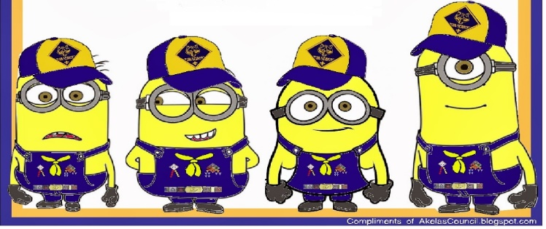

**Blue and Gold Spirit**

*Sam Houston Area Council*

**Setting –** 7 Scouts. One (Cub #1) is dressed as Lord Baden-Powell (or a den leader, or other Scout leader). Props for the items needed as noted below.

**Scene –** Lord Baden-Powell stands in front and the Scouts enter one at a time as they are described.

**Cub #1:** I represent the spirit of Lord Baden-Powell, the founder of Boy Scouting. I am also the spirit of Boy Scouting, past and present. Here is our future – the Cub Scouts of America.

*(Cub #2 enters in complete uniform.)*

**Cub #2:** The two colors of the Cub Scout uniform have special meaning. Blue stands for truth and loyalty. Gold stands for good cheer and happiness.

*(Cub #3 enters with Wolf book and   
Kipling’s Jungle Book.)*

**Cub #3:** Early Cub Scout ceremonies were based on Kipling’s Jungle Tales. When Cub Scouting was organized in America in 1930, Native American themes were used.

*(Cub #4 enters with a craft project made from wood.)*

**Cub #4:** Cub Scouting means fun. We have lots of fun. Most Scouts like making things – really good projects – things they can play with that usually follow a monthly theme.

*(Cub #5 enters carrying a collection from nature.)*

**Cub #5:** Cub Scouts like to go on hikes and collect things for their nature collections. They like the outdoors.

*(Cub #6 enters, carrying a spatula and a bowl.)*

**Cub #6:** Most Cub Scouts like to go on picnics. AND, it’s even more fun when they get to cook their own food.

*(Cub #7 enters, carrying the American flag.)*

**Cub #7:** Cub Scouts are proud to be Americans. They are proud of their flag. They are also very proud of their pack flag, because it reminds them they are part of 100 years of Scouting. They are part of both America and the Cub Scouts.

*(Pause)*

**Cub #8:** Yes, I represent the past and the present. These young Cub Scouts now are the men of the future. They will be the preservers of our American heritage.

**Harvest Celebration**

*Santa Clara County Council*

Boys are standing around talking. They can be attired in Colonial costumes.

1. We sure had a great time at the Harvest Celebration. When my Dad said we would have a big party I didn't know it would last for 3 days.
2. Yea! We invited 92 Indians, plus all our families. We helped our Moms cook for days. It was fun to play games, have shooting contests and relays during the celebration.
3. I liked the food we cooked, boiled eel, lobster, roasted pigeon, stuffed cod, journey cakes, corn meal bread with nuts and succotash.
4. The Indians brought food too, turkeys, pumpkins, sweet potatoes, cranberry sauce. And, they brought deer meat, too.
5. I liked the popcorn the best...I never ate popcorn before. I heard my Dad say Governor Bradford has decided to have a celebration again next year, in 1622. He wants to call it Thanksgiving Celebration!

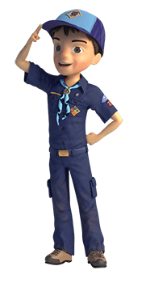

program updates banner

# CLOSING CEREMONIES

**Closing Ceremony**

*Timucua District, North Florida Council*

*(Light candle before starting ceremony)*

A group of boys rush into the room, imitating a fire brigade, circles the room and rush toward the fire.

One or two boys might be sirens, another ring bells, several could carry a hose, one a bucket.

They all rush toward the candle and just before they get there, the Cubmaster blows the candle out.

The boys look disgusted and walk away.

The Cubmaster says, “Good night everyone!”

**Top Ten Crime Prevention Tips**

*San Gabriel, LBArea, Verdugo Hills Councils*

1. Do NOT commit crimes or hang around with people who commit crimes.
2. Do NOT use illegal drugs or hang out with people who do.
3. Trust your gut instinct. If you get a weird “vibe,” you are probably right.
4. Be aware of your surroundings.
5. Be rude if you have to. It’s better to be rude than to be a victim.
6. Do not leave valuables in plain view.
7. Vary your daily routine.
8. Know your neighbors and keep you neighborhood clean.
9. Use common sense (lock your doors, don’t leave keys in the car, etc.).

**All Think!**

Have Cubmaster follow up with a Cubmaster’s Minute about being safe and then dismiss Pack

**Smoky Closing**

*Baltimore Area Council*

Each boy should hold up cards to spell “SMOKEY”

Words on back in LARGE print

1. **S**mokey the Bear has a message to tell.
2. **M**ake it a point to hear him well.
3. **O**nly you can prevent forest fires, Smokey says.
4. **K**eep yourself safe in being careful that way.
5. **E**verybody must do his part.
6. **Y**es, we can stop fires before they start

**When Accidents Happen...**

*San Gabriel, LBArea, Verdugo Hills Councils*

A leader may do Cub #5’s part.

**Cub # 5:** When accidents happen, we are told to call 911 using the telephone. But what if there is no phone available? What if we are out in the woods or on a boat? There are other ways that we can communicate that we need help. Let's have some of our Cub Scouts show us what we could do in such an emergency.

1. ***(carrying a flag upside down)***One distress signal is to fly the flag upside down and others will know that you need help.
2. ***(carrying a poster of 3 bonfires burning in a row****)* Build three fires equally spaced apart. Remember that a fire will be seen a long way during the night, but smoke is better for day.
3. ***(carrying a horn or whistle)***Remember the number three! Three blasts from a horn or a whistle at equal intervals should bring help. *(Blow whistle three times)*
4. ***(carrying a flashlight or two sticks)***Don't forget SOS. You can use a flashlight to signal 3 short, 3 long and 3 short; or you can beat out this Morse code with sticks or on a pipe. *(Make signal)*
5. Knowing how to communicate can save lives, those we love and even our own.

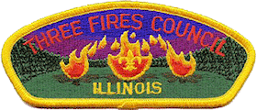

***HHHMMMmmm –*** *the three fires signal for help made me wonder about* ***Three Fires Council in Illinois****. So, I went to their website. The name honors Native Americans of the Ottawa, Potawatomi, and Chippewa tribes which banded together to form "The Three Fires," and who populated that area. It, also, symbolizes working together as one after a merger. See* [*http://www.threefirescouncil.org*](http://www.threefirescouncil.org/)

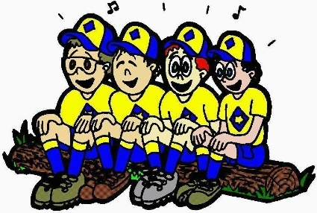

**Battery Check**

*Baltimore Area Council*

**Personnel:** 6 Cub Scouts

**Equipment:** Smoke Detector and new Batteries

1. Brings out the smoke detector and places on a table
2. Checks for a sound, pushing button - nothing happens.
3. Takes out the old batteries.
4. Brings out new batteries and puts them in.
5. Checks for a sound, pushing button - the smoke detector works.
6. “A message to our parents. Please remember to check the batteries in our home smoke detectors tonight. Goodnight.”

**HERO Closing**

*Greater St. Louis Area Council*

You will need large cards spelling out H-E-R-O, with lines on the back in LARGE print for boys to read

1. H is for Help. Help is on the way. A hero is someone who helps.
2. E is for Everyone. Everyone can be a hero. You just have to be prepared and know that you can make a difference.
3. R is for Remember. Remember that even brave people can be afraid. It is taking action even when you are scared that makes you brave.
4. O is for One Person One Person can make a difference. One person who helps can change someone’s world

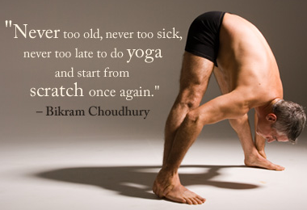

Same is true for Boy Scout Leaders!!

*program updates banner*

## **CUBMASTER’S MINUTES**

**Respect Life**

*Sam Houston Area Council*

(If possible, darken the room) What is life? It is the flash of a firefly in the night. It is the breath of a buffalo in the wintertime. It is the little shadow that runs across the grass and loses itself in the sunset. It is a circle. We will always return to the beginning and life will start again. It is very important to continue, through our participation in Cub Scouts, to teach respect for the earth, for each other, and for the simple and small things in our world.

**The Circle of Life**

*Sam Houston Area Council*

**Setting –** 4 Scouts holding posters from the Circle of Life opening ceremony

**Scene –** darkened room, if possible, as the CM speaks:

We must stand together – with these four circles. They are powerful forces in our lives, and yet without them, we are unable to sustain life. We must harness the strength and the energy these forces provide for peace in our world. We must find the spiritual power that enables the forces and use it to intensify our own struggle for peace. Each of us carries an energy, and combined with the energies of our friends, our family, our neighbors, our world, we can become one body and one heart striving for peace. And we must continue this path as the sun and the moon and the winds and the earth continue in their paths in the great circle of life.

**Cub Scout Benediction**

*Santa Clara County Council*

And now may the Great Master of all Cub Scouts  
Guide and guard our footsteps   
For today, for tomorrow,   
And for all the tomorrows to come.

**THE AMERICAN’S CREED**

*Santa Clara County Council*

I believe in the United States of America as a Government of the people, by the people, for the people; whose just powers are derived from the consent of the governed; a democracy in a republic; a sovereign Nation of many sovereign States; a perfect Union, one and inseparable; established upon those principles of freedom, equality, Justice and humanity for which American patriots sacrificed their lives and fortunes. I, therefore; believe it is my duty to my country to love it; respect its flag; and to defend it against all enemies.

**GIVE THEM THE CUB SCOUT SALUTE !!!**

*Great Salt Lake Council*

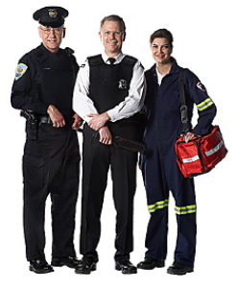

We will find many heroes within the community this month. Some of them will be the adults that we know. Some of them will be Cub Scouts or even the Boy Scouts. We will search throughout the neighborhood to find someone that would be interested in coming to share some of the things that helped them determine their own destiny. We will also look at our young friends that might be the future leaders of tomorrow, those that show leadership qualities that will put them in positions throughout their lives to become the president of a company or even the United States.

We have highlighted some of the heroes that we find in our neighborhood. Our policeman, the firefighters that risk their lives every time they suit up. The mail man is also trained to watch out for the emergencies that might come his way while delivering the mail. The neighbor that would open his door to a young child that might need some help out on the street could be a hero also. We also will be highlighting the women that will be in the lives of the Cub Scouts. They would be the den leaders and perhaps the Cubmaster. Then there is the one special person that is in most every boy’s life, his mother.

We are using the cardboard stand-ups and placing a familiar face by enlarging the photo and attaching it in place of the original. Now we have created the “Super Hero” that we want to present. It, of course, could be any one of many people in your area that you have noticed a silent act of heroism that has not been mentioned before. There are many people that just go about their business daily that often respond at a moments notice to help out someone in distress.

We often read in the “Boy’s Life” magazine about the young men that have been prepared in a time of need when the call for help arises and what they have done to save a life. We hope that you will be able to search out some of these people and highlight them for the month.

***WE GIVE THEM THE CUB SCOUT SALUTE !!!***

**THE AMERICAN’S CREED**

*Santa Clara County Council*

I believe in the United States of America as a Government of the people, by the people, for the people; whose just powers are derived from the consent of the governed; a democracy in a republic; a sovereign Nation of many sovereign States; a perfect Union, one and inseparable; established upon those principles of freedom, equality, Justice and humanity for which American patriots sacrificed their lives and fortunes. I, therefore; believe it is my duty to my country to love it; respect its flag; and to defend it against all enemies.

**A Boy**

*Santa Clara County Council*

* He is a person who is going to carry on what you have started. He is to sit right where you are sitting, and attend, when you are gone, to those things you think are so important.
* You may adopt all the policies you please, but how they will be carried out depends on him. Even if you have leagues and treaties, he will have to manage them.
* He will assume control of our cities, states and nation. He is going to move in and take over your churches, schools, universities, and nation.
* All your work is going to be judged and praised or condemned by him. Your reputation and your future are in his hands.
* All your work is for him; and the fate of the nation and of humanity lies in his hands. It is well that we pay him some attention.

**Fire Safety Closing**

*Baltimore Area Council*

Extinguish the room lights, shine a small spotlight of flashlight on the U.S. flag and ask all to join in singing “God Bless America.” Cubmaster then says, “Cub Scouts, all during our meeting the candle representing the Spirit of Cub Scouting has continued to burn. Now we’ll blow it out, reminding ourselves that a flame must never be left burning when no one is around, but let us keep the light of Cub Scouting burning in our hearts.”

**A Scout is Helpful**

[*https://johnscout.wordpress.com*](https://johnscout.wordpress.com)

**[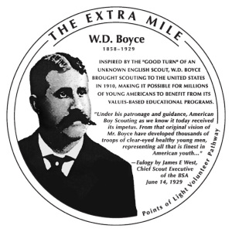](https://johnscout.files.wordpress.com/2010/03/wdboyce.jpg)**

***A Scout is helpful.*** *A Scout cares about other people. He helps others without expecting payment or reward. He fulfills his duties to his family by helping at home.*

Before Chicago publisher William D. Boyce made his fortune in the Windy City, he knew what it was like to live in the cold part of the country. In Winnipeg, Canada, he co-founded a newspaper. He worked as a reporter in Fargo, North Dakota. In Lisbon, North Dakota, he started the *Dakota Clipper*, a weekly newspaper specializing in political and business intrigues.

In 1909, Boyce was on his way home from an African safari, and lost his way in a dense London fog. A boy came to his aid and, after guiding the man, refused a tip, explaining that as a Scout he would not take a tip for doing a Good Turn. This gesture by an unknown Scout inspired a meeting with Robert Baden-Powell, the British founder of the Boy Scouts. As a result, William Boyce incorporated the Boy Scouts of America on February 8, 1910. He also created the Lone Scouts, which merged with the Boy Scouts of America in 1924.

No one knows what happened to the boy who guided Mr. Boyce through the London fog, but he was one Helpful Scout who will never be forgotten.

You can read more about the Unknown Scout in your *Boy Scout Handbook*.

(Adapted from BSA Speakers Bureau   
and the [Points of Light Institute](http://www.extramile.us/honorees/boyce.cfm))

**Be Prepared**

*Greater St. Louis Area Council*

Being a hero does not mean that you must risk your own life. It can mean getting help, or making a phone call to 911 to get the police, or fire department, or ambulance. The key is to use wisdom and judgment, but to do it quickly. Sometimes time is limited. You can save a drowning person by pulling them in with a life ring, and not become a victim yourself by jumping in after them. Many times an adult’s life has been saved because a child knew to call 911 in an emergency and get help right away.

You never know when or where emergencies will arise. Cub Scouting teaches us to handle these situations. We don’t expect to get hurt, and don’t expect to need first aid, but we are prepared just in case. Do Your Best!

**A Scout is Helpful**

*Bryant O’Tuel - Assistant Scoutmaster*

This month’s theme for the SM minute is the 3rd part of the Scout Law.

A Scout is Helpful. This is what the Boy Scout Handbook says about being Helpful:

A Scout cares about other people. He helps others without expecting payment or reward. He fulfills his duties to his family by helping at home.

It sounds pretty simple. You can be helpful at home, school, scouting events, the neighborhood, and church.

The most important thing is to be helpful when someone needs it. When you see the need! Don’t let peer pressure stop you from being helpful.

The scout movement in the United States was started because one scout helped a stranger cross the streetin the London fog.

I challenge you to be more helpful. Start by helping someone tomorrow.

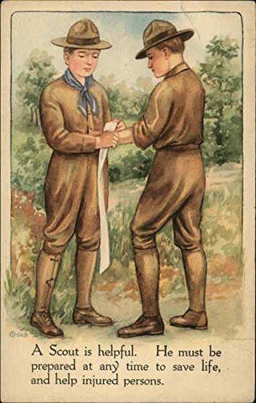

**A Scout is Helpful**

Troop 900, Livermore, CA  
<https://sites.google.com/site/troop900livermore/>

**Introduction:** According to Wikipedia, the Boy Scout Law for BSA was created in its present form August 1, 1911. The Law must be pretty important to remain unchanged for so long. Starting this week and every few weeks throughout the Scouting year, we will be looking at one point of the Scout Law. We all say the Scout law, but how often do we have a chance to reflect upon what it means?

This week: **Helpful.**

What does Helpful mean and how why should it apply to us? Helpful is defined as, “A Scout cares about other people. He willingly volunteers to help others without expecting payment or reward.” When someone is helpful, he does his best to make life easier for others and to ensure the world they live in is the best possible version of itself.

This last weekend was a good example of helpful. 20 people from Troop 900 volunteered their time to help the National Park Service restore a Yosemite Valley meadow to a more natural condition. More than 100 years of fire suppression, altering the water flows, and development (a golf course) turned the natural meadow into an overgrown thicket. We helped by removing extraneous undergrowth. The park service did not pay us by the hour, nor did they feed us. We supplied our own needs including transportation to the park.

The Scout Law reminds us to be helpful in our daily lives. Being helpful doesn’t need to be a lot of work or effort. Sometimes the little things make a big difference. Helping with dinner by setting the table can make mealtime an easier affair. If everyone helped by picking up one piece of litter, your local park would look more attractive. Practice every day by asking yourself, “what can I do to help someone?”

We hear stories about Boy Scouts helping little old ladies across the street. One of these stories is important to us. In 1909 William D. Boyce, a banker from America, was assisted by a Boy Scout. Mr. Boyce was impressed that the boy didn’t accept payment for his help. Later when returning to the United States, Mr. Boyce would go on to help found the Boy Scouts of America. One helpful task 100 years ago has had a big effect on many people’s lives, including yours.

Thank you for listening and Good Night Scouts

**A Scout is Helpful**

<http://boyscouttrail.com>   
**Note:** This website has a complete set of Scout Law Scoutmaster Minutes (One per each of the 12 points). This one is given as a sample.

**From the Scout Handbook -** "A Scout is helpful. A Scout cares about other people. He willingly volunteers to help others without expecting payment or reward."

From a baby's first cry of hunger, he continually looks out for himself with a self-centered view of things. Human nature is to preserve oneself. A Scout is challenged to put others first, possibly at odds with his own needs. This being helpful is an outward demonstration of the inner honor being developed in a Scout. Doing a Daily Good Turn takes real effort to search for need and then commitment to fulfill that need. A Scout that has not learned to care about other people and be willing to sacrifice some of his time can not live this part of the Scout Law. Guidance, explanation, continual modeling, and planned service opportunities in the troop give a Scout the learning moments to understand the importance of this law.

In order to be helpful, a Scout must be ready, able, and willing to help. Many things can be done to aid others, such as mowing a neighbor's yard, shoveling a sidewalk, or cleaning windows, by untrained boys. But, in order to help in many ways, a Scout needs special knowledge, skills, and abilities. To walk a dog, he needs to understand animals. To drive an elderly neighbor to the store, he needs a license. To prepare a meal for a family in grief, he needs cooking skills.

Many a Scout might use the excuse of "I don't know how" when faced with an opportunity to provide aid. He must be trained and confident so his attitude changes to "I'll give it a try". Without First Aid skills, how can he properly bandage a serious cut? Without Swimming and Lifesaving skills, how can he rescue a drowning swimmer? How can a Scout prevent panic? How can he direct traffic, extinguish fire, carry an unconscious person, or any of the dozens of tasks that may be required in an emergency? By participating in Scouting activities, that's how. Advancement through the ranks shows a Scout is participating and building skills. Merit badges give him reason to learn more skills. Leadership roles allow him to practice taking control in different situations.

Having skill and confidence is necessary for specific aid, but at least as important is the skill of being observant. In our society, making eye contact, especially in larger cities, can be dangerous. We are more and more becoming indrawn with minimal contact with strangers and that causes more and more people to become strangers. But, a Scout needs to be constantly observing what occurs around him so he is Ready and Prepared to act if needed. Knowing where fire exits, alarms, and phones are in school and other buildings he enters will make it easier for him to help in case of trouble. A person walking down the street having difficulty carrying groceries, or some kids worried to cross the busy street, or a person sitting on a park bench having problems breathing can only be recognized by an open-eyed, observant person. If a Scout walks down the street, head down, eyes ahead, like so many of the people around him, he misses life and misses opportunities to lend a hand.

To broaden the scope of being Helpful, a Scout is also helpful when he supports the leaders of his troop. It is a difficult position to be in when leading a group of peers. By obeying directions and supporting decisions, a Scout helps his Senior Patrol Leader or Patrol Leader. Being respectful of and caring for those leaders, a Scout strives to help them at all times.

I believe that Scouts today have a huge responsibility to emphasize being Helpful in their communities. Ask the average person what they envision when you say "Boy Scout" and they will still say something along the lines of a boy in uniform helping a little old lady. But, that is not what they actually see in their mind when they see a real, physical Scout at their door. They see someone wanting to sell them something - popcorn, wreaths, spaghetti dinner tickets, mulch, nuts, flower bulbs, or some such thing. That is not the image of Scouts that I want people to have.

A patrol of 8 scouts in our troop just spent a couple hours this weekend clearing snow from fire hydrants in the neighborhood. They knocked on the door of the house on whose property the hydrant sat and asked if it would be alright for them to clear the snow so the fire department could access it in case of an emergency. Of the 20 houses, every single one asked about giving a donation - everyone! No one thought, "Oh, the scouts are being helpful again." They all figured the Scouts were trying to raise funds in a new way. Now, after the next snow, when they do it again, these people will hopefully not expect to give a donation - they will just think, "Oh, the scouts are being helpful again", and that's how it should be.

A Scout is Helpful.

GAMES

**Fire, Police, Ambulance Game-**

*Greater St. Louis Area Council*

Three corners of the room are named “Fire Station”, “Police Station”, and “Ambulance”.

The leader calls out a situation in which a boy might find himself and the Scouts run to the correct “corner”

The last one home loses a point for his team.   
Suggested situations-

1. Smoke is seen coming from under the door of a house. (Fire Station.)
2. Your window cleaner falls from a ladder while cleaning an upstairs window (Ambulance.)
3. When out fishing you spot some bushes on fire. (Fire Station.)
4. You see some older boys cutting the wire to a telephone in a call box (Police Station)
5. Your friend falls from his bicycle while you are out for a ride, (Ambulance.)
6. You find a transistor radio on the pavement. (Police Station.)
7. Your bicycle is stolen. (Police Station.)
8. An older person who has rescued an unconscious, small girl from a river asks you to call for help (Ambulance)

**Scout Sign Puzzle**

*Sam Houston Area Council*

* Give each Scout a 3x5 card and instruct him to draw one of these features –   
   Scout sign,   
   hair on top of a head,   
   a pair of eyes,   
   two ears,   
   a nose,   
   a mouth,   
   a body with an arm down & 1 arm up,   
   legs and feet/shoes.
* Place the cards upside down on a table and shuffle them.
* Have each Scout take a turn turning up the cards and putting the Scout together IN THE RIGHT ORDER (start with the Scout sign, then the top of the head, then the eyes, ears, nose, mouth, body, and finally the legs).
* If a Scout turns up a card out of order, it is the next persons’ turn.
* Turn the cards back over for the next Scout.
* The first Scout to turn over the cards in the right order wins.

**Telephone Code**

*San Gabriel, LBArea, Verdugo Hills Councils*

This is a secret message game based on the telephone. Give each boy a pencil and paper and ask him to convert a very short message into code based on the dial numbers. Decoding can be tricky, since there is more than one letter for each number.

Here is a sample message:

DO: 36

YOUR: 9687

BEST: 2378

When each boy has encoded his message, exchange papers and have the boys decode other’s messages.

**First Aid Baseball-**

*Greater St. Louis Area Council*

For this game you will need push pins, a corkboard, permanent markers, and Rank Appropriate Handbooks

**Purpose:**

Everyone enjoys baseball, so why not test your Scouts knowledge of first aid in a fun manner!

Draw a baseball diamond on the corkboard (or a white (dri-erase) board with appropriate markers.

Divide your Scouts into two teams. Ask each team a question related to the first aid using their handbook as a reference.

Have each team designate one person as the spokesperson for the team. He will be the only person to give the team’s answer. All members of the team are to discuss answers and vote on the correct answer, but only the spokesman gives the answer.

For each correct answer, you are awarded 1 base.

If you ask a multiple part question, the team can be awarded multiple bases if they answer the entire question, award them 2 bases. You keep score just as at a baseball game. You can designate a time to quit or set a specific number of innings to play the game.

The team with the most runs wins the game. This is a great game to play if it rains at an outdoor event.

**Tug of Peace**

*Timucua District, North Florida Council*

A group of boys sit in a circle holding onto a rope placed inside the circle in front of their feet. The ends of the rope are tied together to make a huge loop. If everyone pulls at the same time, the entire group should be able to come to a standing position. The Tug of Peace can also be played by stretching the rope out straight and having boys sit on either side of it, facing each other in two lines. If both sides pull on the rope evenly, they can help each other up.

**X Marks the Spot**

*Timucua District, North Florida Council*

This is a simple game that can be used to choose “It” for another game. All the players stand on one side of the room touching the wall with their back. Have a Den Leader supervise this game.

The leader points out a spot on the ground, for example, a seam between two floor tiles. The players close their eyes and take turns walking slowly toward the spot, relying on their memory to judge its location.

When the player believes he is on the spot, he stops and sits down. Players must remain sitting until everyone has sat down.

Whoever is closest to the spot is the winner. For an added challenge, turn off the lights after the spot has been chosen.

**Missing Person**

*San Gabriel, LBArea, Verdugo Hills Councils*

The group should be seated in one area, where everyone can see everyone at a glance.

One person selected to be “it” faces away from the group and covers his or her eyes.

Another person is selected to leave the room while all the others quietly leave one seat and take another.

At a signal, “it” turns around and tries to guess who the missing person is while the group slowly counts to ten.

If “it” guesses who is missing before the group finishes counting, then he can have another turn. Otherwise, another (the missing person?) now becomes “it”.

**Where's the Fire Alarm?**

*San Gabriel, LBArea, Verdugo Hills Councils*

One boy stands with his eyes blindfolded in the center of a circle formed by the other boys.

The center counts aloud to 20. At the same time the other boys pass a small bell around the circle, ringing it as it travels.

When the counter reaches 20, all the boys in the circle put their hands behind their backs.

The boy in the center takes off the blindfold and tries to guess who has the alarm - the bell.

The boy in the center has 3 guesses; if he is correct, the boy who held the alarm comes into the center.

If not, the counter is blindfolded again, counts to 20 and the game continues as before. *No boy should be permitted to remain in the center of the circle for more than 2 or 3 turns.* ***Remember:*** *The boy in the center can turn as the bell rings so he should listen carefully.*

**Dial 911**

*Baltimore Area Council*

Pieces of paper are handed out to the captain of each team. Each paper contains emergency situations, i.e. house on fire, car wreck, cat up a tree. Each captain puts back the paper then goes back to his team and whispers what was written on the paper. Each team member must receive the message to the end. The last person raises his hand then when all the teams are done let each team’s final member repeat the message and compare it to the original. Parents can judge to see which team came the closest.

**Rescue Relay**

*Timucua District, North Florida Council*

Divide den into 2 equal teams. Supple each Cub Scout with a piece of rope about 2 feet long. One cub from each team sits on a piece of cardboard some distance from the rest of his team. Each Cub must tie rope to his neighbors using a square knot. When all ropes are tied, one end is thrown to the Cub on the cardboard and his team pulls him to safety (pass a line on the ground). First team to pull in Cub is the winner.

**Fireman, Save My Child**

*San Gabriel, LBArea, Verdugo Hills Councils*

* You will need a drinking straw for each player.
* Cut paper (the children) into squares of various sizes (2” to 4” square).
* The players are divided into two teams.
* Scatter paper squares on a table, about 15 to 20 feet away from the start line.
* Place a container for each team about 10-15 feet from the table (the course is like a triangle).
* On signal, the first player from each team runs to the table with his straw and picks up a square by sucking up the paper against his straw.
* While holding the square this way, each player runs to his respective container and deposits his paper in it.
* If he drops the square on his way, he must stop and pick it up by sucking it up with his straw.
* Run this relay style or set a time limit and let everyone play at the same time. When done count the square pieces in the containers.

**Fireman Relay**

*San Gabriel, LBArea, Verdugo Hills Councils*

* You will need a set of Dad’s old clothes (or big boots, pants, and suspenders), a bucket and a log for each team.
* Put blue or white crepe paper streamers 2 to 3 feet long in each fire bucket.
* Players form two teams.
* First player puts on a “fireman’s suit” (old clothes) on top of his own.
* He picks up a bucket and runs to a spot about twenty feet away where a log represents a “fire.”
* He pours the “water” (streamers) on the fire, refills the bucket (replaces streamers), and runs back to his team.
* He takes off his “fireman’s suit” and gives it to the next player. The team that finishes first is the winner.

**Spinning Wheel**

*Timucua District, North Florida Council*

Players sit in a circle on the floor with their legs stretched out in front of them and their feet touching. Players lean back on their hands, which they have placed behind them, and wait until the leader says, “Turn!” Then everyone moves to the right at the same time. To keep the wheel intact, everyone must turn together. If a player moves too slowly or too quickly, a pileup may happen and someone can yell: “Flat!” Players try to make the most consecutive turns as possible, although the fun is in the effort, not the outcome.

**Who Done It? Round Robin**

*Timucua District, North Florida Council*

This is an activity that the kids love.  Set up a “Who Done It” mystery scenario and then have different “tables.”

The Cubs visit the tables to gather clues to solve the mystery.

For the event, try to also arrange for a local police officer to come in at the end of the activity to ask the Pack for help in solving the crime.

Of course, the event is set up so that all clues point to the Cubmaster.

The officer hand-cuffs him/her and then the Pack could take up a collection to make bail.  (Donate proceeds to a worthy cause or use for a Service Project for your Chartered Org)

***I am not sure on the rules for collecting money; you should check them out before you do this. CD***

**Who Dunnit?**

*Timucua District, North Florida Council*

Before starting the game, explain the way it is played to all the boys.  Each boy will have a turn at playing the Detective.  That boy will leave the room and another boy will be selected as the one “Who Dunnit.”  All of the boys left in the den area (including Who Dunnit) will come up with a one-phrase clue to give the Detective when he returns.  The clues should not be so obvious, as the boy’s name, but should be fairly unique to Who Dunnit.  For example, it might be the boy’s street name (Oakmont Road) or his color of eyes (blue eyes) or his family (three sisters).  Based on the clues, the Detective tries to guess Who Dunnit.  To identify Who Dunnit, the Den Leader should select one boy randomly (so there’s no order to who is selected for each turn).

**Who Is Missing?**

*Timucua District, North Florida Council*

**Equipment**: None

**Formation**: Circle

The Cubs walk round in a circle.  When the leader gives a signal they all cover their eyes with their caps or their hands.  The leader touches one of the Cubs on the shoulder and he leaves the room as quickly and as quietly as possible, while the others still walk with their eyes closed.

When the leader calls 'STOP!', the Cubs stop walking and uncover their eyes. The first one to give the name of the Cub who is missing, is the winner.  Note: The Cubs should not walk round for too long a time, as they will become dizzy.  Watch out for any Cubs who are cheating by peeping through their fingers!

**Snowball Roll**

*Santa Clara County Council*

We did this game during Easter time using Styrofoam shaped Easter eggs. At Halloween with pumpkins. This is a simple race but since snowballs are not always nice smooth balls, they may refuse to roll in nice straight lines, you will need wandering room.

* You will need two large Styrofoam (or other material) ball shaped objects (Irregularities encouraged) and two sturdy sticks. If you need to play inside, use smaller balls.
* The racers line up on the starting line with the snowballs turned on their sides.
* On signal, the racers use the stick to roll the snowballs to the finish line.
* Younger players may want to use their hands instead of the stick.
* Can also be played as a relay race.

**Mixed Cubs**

*Great Salt Lake Council*

***(Musical chairs without music)***

* You need enough chairs for everyone in the group except for one person.
* Put the chairs in a circle.
* Then go around the circle and tell each person a Scout name like “Tiger, Wolf, Bear, Webelos.”
* The person in the center can then call out one of the names of the Scouts (Tiger, Wolf, Bear, Webelos) or “Mixed Cubs.”
* The object of the game is to always have a chair.
* When the person in the center calls out a Scout name (e.g. Bear), those people who are representing Bears must get up and find a new chair, and the person in the middle finds a chair.
* Whoever is left without a chair is the new “caller.”
* If “Mixed Cubs” is called, everyone in the game must find a new chair.
* After you are in a new seat, you must make the Cub Scout salute until the new caller shouts out one of the Scout names.
* If you do not make the Cub Scout salute and the caller catches you, then you lose your seat and must switch places with the caller.

**Crossing the Delaware**

*Santa Clara County Council*

**Needed:** balloons

* Give each player a balloon and have them blow it up and tie it.
* When the contestants are ready, have them stand against the wall.
* At the given signal, they are to cross the room, keeping the balloons in the air by hitting them only with their heads. No hands are allowed.
* The one who succeeds in crossing the room first with his balloon untouched except by his head, wins the game.

**Hiking Game**

*Santa Clara County Council*

While hiking, the leader stops and says, "I spot a ______________ to naming a familiar object. Everyone who sees the object raises his hand, until everyone sees it.

**Cub Scout Salute Relay Race**

*Great Salt Lake Council*

* For this relay race, divide the boys up into teams. You can have however many teams you want, but 2 to 4 is probably best.
* Everyone starts at certain point, and each team is lined up in their own line.
* At the go signal, the first person runs to the first station area, makes the Cub Scout sign and repeats the Scout Oath. You may want to post a copy of the Scout Oath for those who do not know it.

On my Honor, I will do my best.  
To do my duty to God and my country   
and to obey the Scout Law;   
To help other people at all times;   
To keep myself physically strong, mentally awake   
and morally straight.

* Then he runs to the next station, gets a licorice rope off the table and ties a square knot. (Show all the boys how to tie square knots before the race begins.)
* He keeps his licorice rope with him to eat later.
* Then he runs to the last station where an American Flag is posted.
* He stops, salutes the flag, and repeats the Pledge of Allegiance.
* Then, he turns around and runs back to his team.
* When he gets there, he must use the Cub Scout handshake with the next boy in line before that boy can start his turn. The first team (make sure the teams are equal in size or have a boy go twice) to have all the boys finish is the winning team.

**Hello Neighbor**

*Santa Clara County Council*

* Have boys form a circle, pick someone to be '"it".
* "It" walks counterclockwise around the circle.
* "It" tags someone on the back and starts running.
* The one tagged also starts running but clockwise.
* When the two of them meet while running around the circle, they must stop, shake hands and say "Hello, Neighbor".
* Then they must race to the open spot in the circle that was left open by the player that was tagged.
* The first one to get in the open spot stays in the circle, and the one left out starts to walk counter clockwise and continues the game by tagging another player.

**Help Lead Me Home**

*Santa Clara County Council*

**Supplies:** Pencil and paper

* Ask each of the boys to think about the walk from the den meeting place to their home.
* Have them count the number of streetlights, bridges, trees, cross walks, fire hydrant, police stations, fire stations and neighbors houses they pass.
* Have them write down as many as they can remember.

**Treasure Hunt Game**

*Santa Clara County Council*

**Supplies:** pencil and paper

Have the boys make a list of things that can be seen in their town. You might help by making suggestions like, large oak trees on Main Street, bridge, library, county office building, historical marker, and city park. After the boys have made their list take them on a 30 minute walk around town.

**Capture the Flag**

*Santa Clara County Council*

**Needed:** 2 large (at least l foot square) cloth "flags" in different colors, one for each team; a smaller flag for each team's player.

* Pick 2 teams.
* Designate outer boundaries of playing area. Include a line to divide field in half, as well as small areas in each territory for a "jail.”
* Each player receives a small flag in the teams color, which is tucked not tied) into the players belt.
* Each team's large flag is hidden somewhere in the opponent's area.
* The object of the game is to be the first team to bring its flag "home".
* Players must enter the other team's territory to look for their flag.
* While they're looking their opponents can steal their small flags.
* When a players flag is stolen, he goes to "jail" where his small flag is returned.
* A player can free jailed teammates by sneaking into the jail area (without losing his small flag) and calling "jailbreak".
* The game ends when a player finds the large flag and gets it back to his side without losing his small flag.

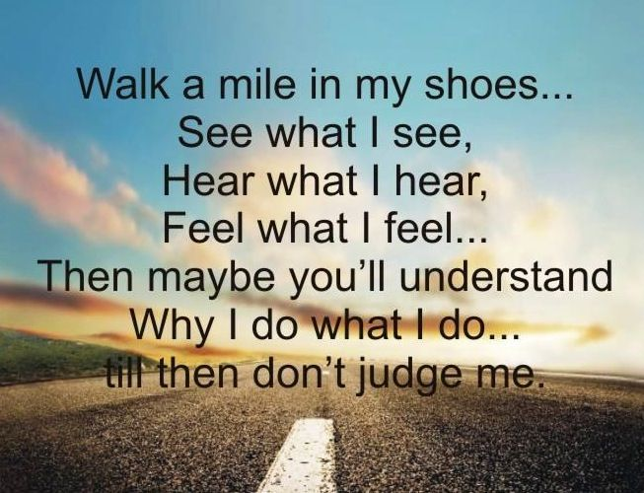

# PACK ACTIVITIES

## HELPFUL PACK AND DEN ACTIVITIES

*Alice, Golden Empire Council*

* Explore different kinds of heroes – include Strategic Air Command, DART, Civil Air Patrol, CERT (Community Emergency Response Team), National Guard, Firemen and Policemen, Regular Military, Teachers, Doctors.
* Have each scout or family make a list of some everyday heroes – make a list of categories and have each person or team fill in a real name that fits the category. Some ideas are: volunteer firefighters, musicians or artists, parents that volunteer at school, people that bake for a benefit sale, people that help the elderly, people that plan celebrations that everyone can enjoy, first responders, people who teach Sunday School, Scout leaders, kids who help younger kids learn something new (like Venturing Scouts or the Den Chief), people who help their neighbors, people who coach sports for kids.
* If you have a school garden or community garden in your area, invite a volunteer to share how it got started, how it helps families in the community. Learn about school gardens in your communities and the “heroes” who keep them going. Go to[www.kidsgardening.com/school/searchform.asp](http://www.kidsgardening.com/school/searchform.asp) for information and stories, as well as links to other great project ideas and garden projects in specific areas.
* Talk to a local librarian – they may need volunteers, can connect you with community organizations, speakers, or sometimes even sponsor programs such as Adult Literacy.
* Check with Habitat for Humanity, Christmas in April, Humanitarian Aid Projects or local Senior Gleaners for service project ideas or to find some wonderful local heroes.
* If there is a teacher’s resource center in your area, volunteer to put together kits for local teachers – they are all heroes!
* Check with your local Volunteer Center – every city or county has one. They can connect you with volunteer opportunities, and sometimes have programs to honor volunteers – an easy way to find someone to honor or come visit your den or pack!
* Ask families in your pack to share stories about everyday heroes – ways that people can help their communities – examples of one-person projects that make a difference. Feature these stories at your pack meeting.
* Challenge all members of your pack or den to “Pay It Forward” by volunteer to do something good!
* Invite a speaker to talk about Veteran’s Day or heroes – see the VA website information
* To locate a National Cemetery, go to: <http://www.cem.va.gov>.
* Check out the “Make a Difference Day” stories from Parade magazine – you might find the perfect one-person or den service project
* Work on the adventures that prepare scouts to be heroes –first aid training, plumbing, fix it, carpentry skills – boys or families can be a “hero” by helping an elderly neighbor or relative who can’t afford regular maintenance – and in the future, as men with these skills, today’s scouts will be a hero to their own families.
* Obtain or print out a map of the local community – (Thomas Bros. maps also show schools, fire stations, community centers) –talk about the places where help is available and where good citizenship is practiced.
* Take a Thomas Bros. or other map of the local neighborhood, mount it on cardboard, laminate, and cut into puzzle pieces to use for a family or den game to learn about community resources.
* Contact a local VFW or local cemeteries to get flags for putting on graves of Veteran’s. Flags are flown on every holiday and whenever there is a funeral for active military. You can arrange to come and distribute flags on graves or raise full size flags as a way to honor veterans.
* Invite a CERT (Community Emergency Response Team) member to come and share information with your den or pack families.
* Visit a museum and look for heroes – people who have done something heroic or started a service project, saved a building from demolition, worked with youth in the community, overcome challenges
* Visit with older people, especially family members, and learn about them, their work, their service, how they spent their time – identify ways that they were heroes, overcame challenges, helped others get educated, or made a difference in their communities
* Choose a service project to honor heroes – one idea is Operation Military Kids, which provides hero packs to children who are sacrificing time with their deployed parents – See web sites
* Give local Venturing Scouts the opportunity to teach skills to your scouts – Venturing crews can fulfill their requirements and be a “hero” to your Cubs/Webelos.
* Check out the book The Children’s Book of Heroes by William Bennett and read the story "How the Animals Got Sunlight." Then talk about who the hero is, why and what they did. Or choose one of the other hero stories in the book – you might even use a story as the plot of a skit for the pack meeting!
* Brainstorm with your den about what a hero is - what qualities does a hero have? Encourage boys to think about real people, not just super heroes. Have the boys make special thank you cards for the people they choose as heroes.
* Put out a den or pack “newspaper” with stories about people they have identified as heroes. If any of the boys like to do photography or art, you could add pictures! Print out copies and distribute to pack families and your chartered organization. You might even want to send a note to parents so they can help their sons with the project.
* Suggest that families talk about heroes in their family history – share stories about how ancestors were everyday heroes.
* Choose some everyday heroes that the boys know – such as teachers, police or fire department members, the cubmaster – invite them to come to the pack meeting and give each of them a simple award – perhaps a certificate or even a picture the boys have made to present to them.
* Have the whole Pack, including families members, write Letters to the Troops – details under Theme Related. This can also be a great lesson in how to write a caring letter – more details and a template on the website.
* Challenge the boys to use their photography talent to enter the 2009 U.S. and Canada International Photography Contest for Kids – they could choose a subject that shows a hero in action, or even a photo that focuses on being an eco hero by featuring a favorite animal. See details at: <http://kids.nationalgeograhic.com/contests/Photos>
* Visit a nearby fire or police station, National Guard, Coast Guard or other military installation and see heroes in action. ***My pack visited a local Coast Guard Station – in land-locked Sacramento – and had a wonderful time touring a plan and watching a video, so check out your local resources! Alice***

## Fun Facts About Being Helpful

*Alice, Golden Empire Council*

* Giving a smile is actually easier than giving a frown – it takes fewer muscles!
* In 2007, 163,000 volunteers at the National Park Service donated 5.4 million hours of time worth $101 million or the equivalent of 2,596 full time employees!
* 80% of the people in this county give to nonprofits.
* Only 10-12% of financial giving is provided by foundations and only 5-6% comes from corporations.
* Most of the money given by individuals is from middle and low income people, not the super wealthy!
* Eleven percent of households contributed to religious causes only.
* Twenty-one percent of households contributed to only secular causes.
* Thirty-four percent contributed to both religious and secular causes.
* Only 28.8% of the people in this country do the actual volunteer work for the many service organizations and projects in this country – so your time does matter!
* Recognition in front of their peers is the most valued form of “payback” for volunteers – so remember to recognize parents, leaders and others who help your scout program!
* The median amount of time that people volunteer is 52 hours a year, ranging from 21% who spend from one to fourteen hours up to the 28% who donate between one hundred and four hundred hours a year.

**Active Theme Ideas**

*Greater St. Louis Area Council*

* Invite your local fire department to a Pack meeting. Fire Safety Awareness month is an opportune time for this Pack meeting. Most fire departments have short programs developed, which they will share with your Scouts.
* Invite your local police department to a Den or Pack meeting. The police have many different programs, such as a canine dog demonstration, the rescue helicopter, finger printing demonstration, and “Stay Safe” (self-defense) program.
* Invite your local paramedics and or flight nurse crew to a Pack Meeting. The first aid requirement for all levels of Cub Scouting can be fulfilled.
* A good service project for the Scouts may be to assist your local fire department with replacing batteries in smoke detectors of people within your community who may not be able**.**
* Plan an outing for your Den to your local fire or police department
* Plan an outing for your Den or Pack to an animal rescue center or humane society because “To the Rescue”, does not only mean the rescue of people.

**\*\*** Remember 2- Deep Adult Leadership!!!

**Fire Safety Posters**

*Baltimore Area Council*

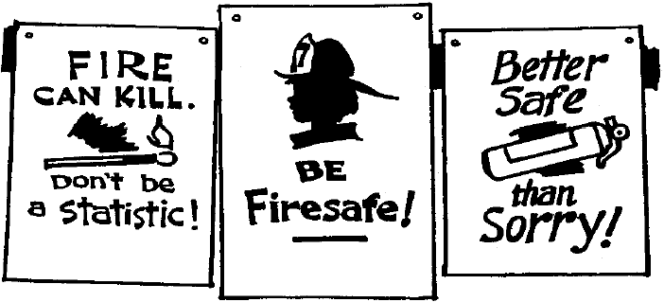

Have boys create their own slogans and designs for posters. Use Poster Board and felt tip pens, crayons, or paint. Display at Pack Meeting.

**Safety Projects for Den Meetings**

*Timucua District, North Florida Council*

* Learn how to build a fire and put it out. (Webelos outdoor activity)
* Learn how to call the fire department and how to escape from home in case of fire.
* Learn how to put out fire on a person and give him first aid; learn exits in public places boys frequent such as movies, schools and churches.
* Ask boys to tell how they held a home fire inspection.
* Make a card of emergency numbers.

**Fire- Triangle Experiment**

*Baltimore Area Council*

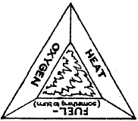

Fire requires three things: air, fuel, and heat. Take away any one and the fire goes out. Demonstrate this with a wooden match and bottle.

Have a Cub Scout (or a parent at the Den Meeting) strike a match (creating heat by friction). Let it burn a moment (using oxygen to burn the wood or fuel), and then drop it into the bottle and place his hand over the top. This cuts off the oxygen and the hatch goes out even though there is still plenty of fuel.

Have a Cub Scout strike a match and dip it into a glass of water. The water cuts off the air and cools the fuel, extinguishing the fire even quicker

Your boys may want to make a poster showing the fire triangle as illustrated.

**Instant Inventor Problems**

*Greater St. Louis Area Council*

**Goal:** To have the Dens try to invent solutions

As a pack activity, run all stations simultaneously, with dens starting at different stations and rotating. Separate stations, so a den can’t copy another den’s solutions. Allow Tigers about 15 minutes per station, Wolf and Bear Dens about 10 and Webelos dens about 8.

As a Den activity give your den one problem at a time.

**PROBLEM 1: Rescue!**Place a doll on the floor about 8 feet from a line. Behind the line, have a pile of 15-20 3-ft. garden canes or similar sticks, string and scissors. Also, have some decoy materials. Give the Denner this message: A child is in danger of drowning in this alligator infested river. Save her! Use any material you see.

**Possible solution:** Build a triangle or rectangle with the sticks and string. Maneuver it behind the child and pull her to safety.

**Scoring** 5 pts for good try, 10 pts making a rescue

**PROBLEM 2: Move the Poison!**Have an empty soda standing on the floor. Nearby are drinking straws, a length of string, and as decoys a wooden slat, a fork and a length of heavy wire. Give the Denner this message: There has been an accident in which a powerful poison has spilled out of this bottle and down its sides. The bottle must be moved to the table as soon as possible. Do not touch it or you will be burned badly. Use any materials you see here.

**2 Possible Solutions:** Use the drinking straws as shown in the “Lift the Bottlestick” game in the Den Chief Handbook or make an overhand knot in the string, slip it over the bottle, and tighten it.

**Scoring** 5 pts for good try hard, 10 for moving bottle

**PROBLEM 3: Deliver the Medicine!**Mark off a canyon on the floor. Place a coffee can inside the canyon, approximately 8 feet from the edge. In a pile along the outside edge, have 2-10 ft. lengths of molding or other light strips of wood. Have other items as decoys. Give the Denner this message: One of your den members is far down in this canyon. He has suffered a bad cut in a fall and needs first aid supplies. It would take hours to climb down to reach him where the coffee can is. Invent a way to get the first aid supplies to him quickly without throwing them over the edge of the canyon.

**Solution:** Have the den members hold the molding strips together to form a trough for the can. Roll the ball down the trough.

**Scoring** 5 pts for good try hard, 10 for getting kit safely to the victim

**Can-Do Stilts**

*Sam Houston Area Council*

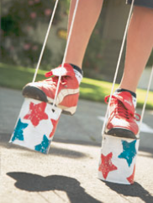

**Materials –**

* 2 clean vegetable cans (for each Scout),
* Puncture-style can opener (Church key)
* Acrylic paint in red, white, and blue,
* Paintbrush,
* Star shapes cut from sponges,
* Tape,
* 2 lengths of nylon or rope (for each Scout).

**Directions –**

1. Puncture each can on opposite spots on its side.
2. Paint both cans white.
3. When they’re dry, sponge paint red and blue stars onto them using the cut sponges.
4. Allow to dry.
5. For the handles, push one end of the rope through each hole on the can’s sides (so that both ends are inside the empty can). Measure the nylon or rope so that as the Scout holds it, it comes to his waist.
6. Knot the rope ends.

**“You Are My Hero” Buttons**

*Great Salt Lake Council*

We all have many people in our lives that we admire, dad, mom, teacher, Scout leader etc. This month would be the perfect time to let that person know how much they are appreciated and looked up to. Present them with a “You Are My Hero” button and put a smile on their face!

**What you will need:**

* Wooden badges (craft stores have all shapes and sizes)
* Acrylic paint
* Sponge and paint brushes
* Water to rinse brushes in
* Paper plates for palette
* Paper towels
* Bar pins
* Contact cement
* Stickers, if desired
* Clear varnish (Optional)

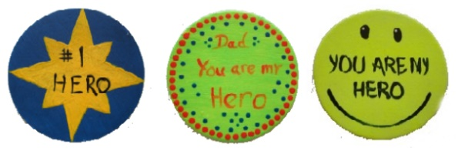

**Button Instructions:**

1. Paint button solid color using sponge brush.
2. Add small detail with small paint brush. *(To make dots, dip blunt end of paint brush in paint. Wipe off end of brush each time you dip to get more even dots.)*
3. Let dry thoroughly.
4. For a shiny finish, use a sponge brush to apply clear varnish. *Be careful, if you use some types of pens the varnish will cause them to bleed!*
5. Apply thin coat of contact cement to the back of the button where the bar pin will be placed.
6. Apply thin coat of contact cement to the bar pin.
7. Allow contact cement to dry and is touchable.  
   *(Follow directions on label)*
8. Press bar pin to button.

**Flag Mobile**

*Sam Houston Area Council*

**Materials –**

* Colored poster board,
* String,
* Hole punch,
* Coat hanger

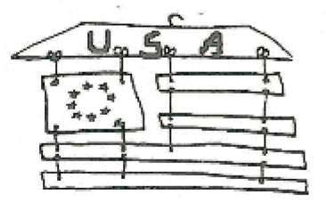

**Directions –**using pictures of historical flags as models, cut pieces from colored poster board. Draw or otherwise decorate pieces as needed. Punch appropriate holes. Start from the top and tie the first row onto the coat hanger. Assemble the flag by continuing downward, tying on the remaining flag pieces.

**First Aid Kit**

*Great Salt Lake Council*

**Materials Needed:**

* Altoids mint container,
* Bandages,
* First aid tape,
* Safety pin,
* List of emergency numbers,
* Paint or permanent markers.

**Directions:**

* Make sure the container is clean and dry.
* Cover the container with paint (may take 2 coats) or markers. *If using markers make sure they will stick to the container.*
* Putting a red cross on the top would be a good idea.
* Once the outside is finished fill the inside with first aid supplies.

**Kids Can Be Heroes Too!**

*Alice, Golden Empire Council*

If you want proof, go to: [www.chinastrategies.com/lithero.htm](http://www.chinastrategies.com/lithero.htm) for true life stories about children who have been heroes!

**Firefighter Costume**

*Greater St. Louis Area Council*

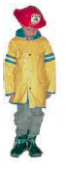**Materials:**

* Firefighter (plastic hat okay)
* Solid color raincoat (stripes are okay)
* Galoshes

**Directions:**

* 1. You can put any color shirt on because it will not show if you button the coat.
  2. Put on the galoshes, raincoat, and firefighter hat and you're all set!!

**Tips:**

* You can find inexpensive fighter hats at party supply stores, but the more durable ones are found at toy stores.
* Cut off the end of garden hose for him to carry around

**Bean Bags**

*Great Salt Lake Council*

**Materials Needed:**

* Tightly woven fabric,
* Glue or needle and thread,
* Dried beans,
* Sand or small craft bb’s.

**Directions:**

* Cut out a rectangle or other fun shape out of fabric.
* Glue or stitch together 3 sides leaving an opening to put in the filling.
* Use dried beans or other filling. Do not use rice or bird seed because it may attract bugs.
* Stuff fully.
* Glue or stitch closed the last side.

**Recipe Holder**

*Great Salt Lake Council*

**Materials Needed:**

* Small precut wood shape,
* Mini clothespin,
* 2 wood pieces (1 for the base and 1 for the riser),
* Glue,
* Finish nails and
* Hammer.

**Directions:**

* Sand all the pieces of wood to smooth the edges.
* For the riser use a medium sized dowel or a piece of wood approx. 1” x 3/8” x 2”.
* Glue the riser to the base (approx. 2” x 3 ½” x ¾”).
* Hammer 1 or 2 nails from the bottom side of the base into the riser.
* Glue the mini clothespin to the back of the riser.
* Glue the precut shape to the front of the riser.

**Letters to the Troops**

*Alice, Golden Empire Council*

[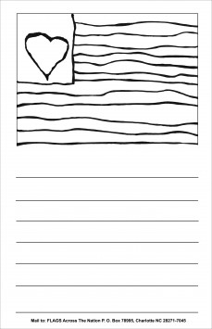](http://www.flagsacrossthenation.org/wp-content/uploads/2009/03/flag_template2009_2up.pdf)

Write letters to our Troops – you can either use the template on <http://www.flagsacrossthenation.org/our-projects/letters-to-the-troops/> , or you can make up your own – scouts or siblings can then color in the flag, write a letter below to the troops, put your name and age on the back, and then mail to Flags Across the Nation, 9426 Duckhorn Dr., Charlotte, N.C. 28277.

For younger siblings, or those who don’t feel comfortable writing a letter, click on projects at the website – they have downloadable coloring pages that can be done and also are sent to troops! ***This is a great project to share with other groups as well!***

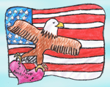

**2010 Freedom Art Contest –** Challenge the scouts to enter a piece of patriotic art in support of Letters to our Troops. Every child who enters will receive an acknowledgement gift. For details go to: [www.flagsacrossthenation.org/about-flags](http://www.flagsacrossthenation.org/about-flags)

**Eco Hero Bookmarks**

*Alice, Golden Empire Council*

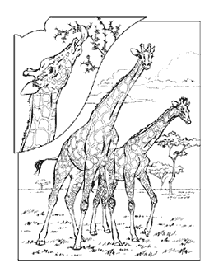

Use the black and white images at [www.nationalgeographic.com/coloringbook/archive](http://www.nationalgeographic.com/coloringbook/archive) to make bookmarks. Cut 5x7 inch index cards into strips to use as the base for bookmarks. Choose an image from the site, then decrease the size to fit, and print off the images. Scouts could color in the images, paste them to the top part of the index card and laminate. Boys could color in the images before lamination, or even add an “eco” message of their own.

**Fire Safety Coloring Book -**

*Alice, Golden Empire Council*

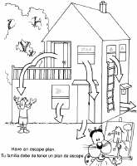

This is a sample page from a Fire Safety Coloring Book at [www.southbayfire.com/Coloring.aspx](http://www.southbayfire.com/Coloring.aspx) There are several options and all can be downloaded for free – this one also includes a list of fire safety rules – point out to the boys and their siblings that they will be a “hero” for sharing what they learn with their family and friends.

You can download pictures or symbols for almost any “hero” organization – this one is for the Coast Guard, with other projects about water safety, marine mammals – and some are available in Spanish – Check it out at [www.uscg.mil/TOP/downloads/coloring.asp](http://www.uscg.mil/TOP/downloads/coloring.asp)

**Litter Basket Slide**

*Great Salt Lake Council*

**Materials Needed:**

* Jet Dry basket (from dishwasher),
* Black plastic bag,
* Pipe cleaner,
* Paper and glue.

**Instructions:**

* Thread the pipe cleaner through the basket and form a ring for the neckerchief.
* Glue the black plastic in the basket to form a trash bag.
* Make a little sign with paper that says “Litter” and
* glue the sign to front of basket.
* Fill basket with wadded paper scraps and glue in place.

**Write a Hometown Hero Tall Story**

*Santa Clara County Council*

It’s highly unlikely that the boys want to sit down with pen and paper in hand and write up their own stories—too much like being in school! So, instead, have them work together with the leaders to create a tall story of their modern-day hometown hero.

Start with a whiteboard or sheets of newsprint hung on the walls. You will need to coach/coax them in coming up with a “hero,” but if you start with a “main event” that the hero accomplished, things should flow fairly well from there.

For example, if you give them some ideas for the main event, like “forming the Susquehanna River,” or “raising the Blue Mountain,” then they can come up with the hero and how the event was accomplished.

Gather as many ideas as you can from them and then help them put together a chronology or timeline.

Finally, piece together an outline for the few paragraphs the story should be and help them draft it.

When it’s done, make sure it gets in the Pack Newsletter.

**Craft Stick American Flag**

*Alice, Golden Empire Council*

[](http://www.enchantedlearning.com/crafts/july4/)

This is a project from [www.enchantedlearning.com](http://www.enchantedlearning.com) – they have some other great, simple patriotic craft ideas.

**Flag Slide**

*Santa Clara County Council*

**Materials:**

* United States Flag (approximately 2x3)
* Heavy plastic, cut the same size as your flag
* ¾ inch PVC slide ring

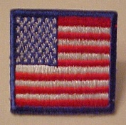

**Directions:**

* Glue the flag to the piece of heavy plastic
* Mount the slide ring to the back of the heavy plastic.

**Uncle Sam Slide**

*Santa Clara County Council*

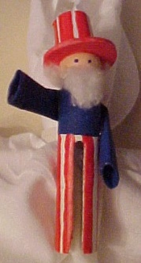

**Materials:**

* Round head wooden clothespin
* Paints, red white and blue
* White ‘wonderfoam’ or posterboard
* White paper
* Cotton ball
* ¾-inch PVC slide ring

**Equipment:**

* Hot glue
* Paintbrushes
* Small craft saw
* paperclip

**Directions:**

1. Cut the points off the clothespin.
2. Paint the lower half of legs white, allow to dry.
3. Paint the upper half, up to neck a dark blue.
4. Make a small roll of paper, glue into shape and paint same color blue as upper half.
5. Glue arms onto upper part of the clothespin.
6. Cut out a hat brim to fit the head of the clothespin,
7. Paint white paper with red stripes, or use a permanent marker to do such
8. Paint red stripes on the white pants.
9. Paint the head of the clothespin; make a flesh color paint by adding a small amount of red to white paint.
10. Roll the striped paper to fit inside the hat brim and glue in place
11. Glue hat to head of the clothespin, adjusting angle to fit,
12. Straighten out paperclip; dip one end into blue paint and dot eyes onto face.
13. Using a pinch of cotton ball, form a beard and glue onto lower face.
14. Roll another piece of cotton, glue hair around head under the hat.
15. Mount the slide ring to back of your finished Uncle Sam using hot glue.

**Strategic Air Command Patch**

*Alice, Golden Empire Council*

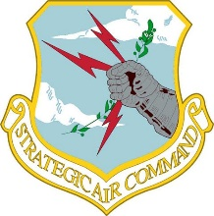

The Strategic Air Command Patch uses sky and clouds to represent the area where they perform; the arm and armor represent strength, power and loyalty (many see the lightning bolts as the ability to deliver a powerful blow), the olive branch is symbolic of protecting the peace. Color in this shield as a reminder of how the SAC team provides protection to your community every day.

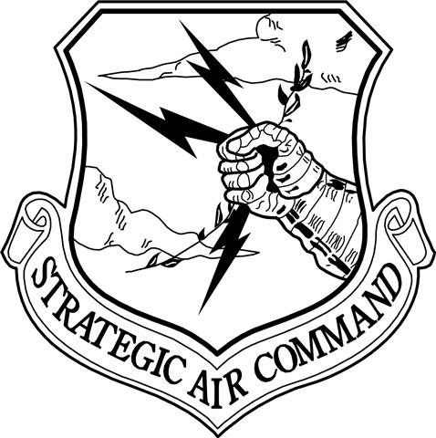

***We used this as part of a booklet about different “hero” services for the Eternal Flame Flag Retirement – but you can use it as a coloring page as well.***

**Stars & Stripes Spinner**

*Santa Clara County Council*

**Materials:**

* Glue
* 12 Crepe Paper Streamers - 18" Long
* 3' String
* Scissors
* Hole Punch

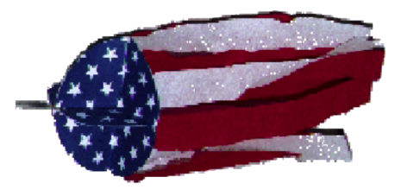

**Directions:**

1. Enlarge to 8 1/4" and make 5 copies of star pattern circle. Each circle is divided into quarters by 3 dotted lines and one solid line. On four of the circles, cut on the solid line to the center of the circle.
2. Crease on the dotted lines, folding printed pattern to the inside. First one way, then the other way.
3. Form a pocket to catch the wind by folding as shown, overlapping one quarter of the circle onto the next quarter.

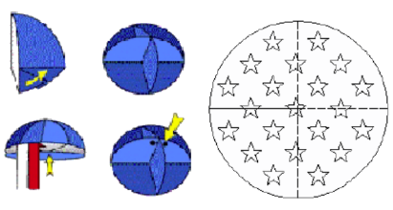

1. Glue overlap into place.
2. Repeat for the three other slit circles.
3. Glue the four pockets together to create a half ball.
4. Cut streamers to 18".
5. Glue ends around perimeter of the bottom. Glue the 5th circle to the bottom over the streamer ends.
6. Use punch to make 2 holes in the top of the ball about 1/2" from the edge.
7. Feed string through. Tie ends.
8. Hang from tree and watch it spin.

