TABLE OF CONTENTS
TABLE OF CONTENTS 1
PHILMONT CUB SCOUT RT SUPPLEMENT 1
CUB SCOUT ROUNDTABLE PLANNING GUIDE 1
ON-LINE SUPPORT 2
BSA ROUNDTABLE COMMISSIONERS FACEBOOK PAGE 2
COMMISSIONER SERVICE (BOY SCOUTS OF AMERICA) FACEBOOK PAGE 3
RT SUPPORT PAGE 3
TRAINING HELPS 3
Cub Scout Heroes 3
PACK ADMIN HELPS 5
Blue & Gold Banquet - Vegas Style 5
BE UP TO DATE 10
ROUNDTABLE HINTS 11
ROUNDTABLE RELATIONSHIPS 11
RANK ADVANCEMENT CHARTS 12
LIONS 13
WHAT’S NEW FOR LIONS FOR 2017-2018 13
LION HUB 14
CUB SCOUT LEARNING LIBRARY 17
The NEW https://cubscouts.org/ !!! 17
ADVENTURE PLAN TRACKERS 21
TRACKING BOYS’ PROGRESS 21
CUB SCOUT LEADER TRAINING 22

PHILMONT CUB SCOUT RT SUPPLEMENT
The January2018 issue is posted!!
Emily is a little ahead of me!!
Hyperlink on picture. If using paper copy – go to BSA Roundtable Commissioners on Facebook. (See On-Line Support below)

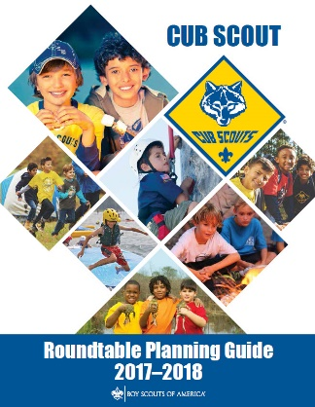
CUB SCOUT ROUNDTABLE PLANNING GUIDE
The CS RT PG is issued
The 2017-2018 CS RT PG may be found at - http://www.scouting.org/filestore/cubscouts/pdf/510-714(17)_CS.pdf
On page 37 0f the 2017-2018 CS RT PG it states:
Introduction to the New Cub Scout Interest Topic Format for 2017–2018
Based on survey input, the National Cub Scouting Committee has modified the presentation style for the Cub Scout (CS) interest topics for this year. To improve communications throughout the pack leadership, it is recommended that all CS leaders attend the interest topic discussion together as a single group. This will provide everyone with the same information and will facilitate important discussion about these topics between all CS leaders. As always, the CS Roundtable Planning Guide provides suggested options for each council or district. The use of any specific topic is flexible based on the needs of the council or district. Each council or district may also select other topics that would be beneficial to the needs of the CS leaders in their respective council or district. Additional resource materials from the BSA can be used if the district chooses to do individual leader breakout sessions. The Philmont CS Roundtable Supplements are a great resource to consider for the breakout session model.
Scott McKenzie, the Roundtable lead on the National Commissioner Service Team, posted the following on the Commissioner Service (Boy Scouts of America) Facebook page:
The 2017-2018 Cub Scout Roundtable Planning Guide has finally been completed and posted to the BSA Commissioner Roundtable Support webpage.
“You will notice that the material in the CS RT Planning Guide is significantly different this year. Based on survey input, the National Cub Scouting Committee has modified the presentation style for the Cub Scout interest topics for this year. In order to improve communications throughout the pack leadership, it is recommended that all Cub Scout leaders attend the interest topic discussion together as a single group. This new method will provide everyone with the same information and will facilitate important discussion about these topics between all Cub Scout leaders. We recommend everyone try the new method to see how it works in your district. This will further validate any input you may have for future changes.
As always, the Cub Scout Roundtable Planning Guide provides suggested options for each council or district. The use of any specific topic is flexible based on the needs of the council or district. Each council or district may also select other topics that would be beneficial to the needs of the Cub Scout leaders in their respective council or district.
Additional resource materials from the BSA can be used if the district chooses to utilize individual leader breakout sessions. The Philmont Cub Scout Roundtable Supplements are a great resource to consider for the breakout session model. These optional support materials will continue to be available on the Roundtable Commissioner Facebook Page and can be emailed to individuals upon request.
We understand that there will be a lot of opinions on this new format and the National Commissioner Service Team would like to collect your feedback to provide to the National Cub Scout Committee, who develops the program content for the CS RT Planning Guide. Please provide constructive comments only. If you like the new format, please say so and if there are additional things you would like to see in the program content please provide a description in your comments. We will also be conducting various surveys over the next several months to collect your input for future program content. Eemails can be sent to BSARoundtableChair@gmail.com
Scott McKenzie

ON-LINE SUPPORT

BSA ROUNDTABLE COMMISSIONERS FACEBOOK PAGE
The Philmont CS Roundtable Supplements referenced in the CS RT PG are available here!!
Join the over 3000 members of the “BSA Roundtable Commissioners” Open Group on Facebook.
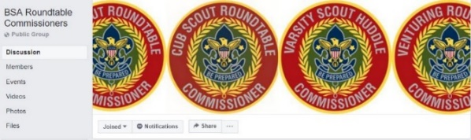
The site admins are my good friends from Philmont, Emily and George. And they do a terrific job.
Please do not add anyone but yourself to the group. Tell other Roundtable Commissioners and Assistant Roundtable Commissioners about the group and have them add themselves. The Admins frequently get 50 requests to join in the admin inbox and the majority of them have not answered the questions. If they don't answer the questions in 2 days, they are not approved and they have to repeat the process. I (CD) know the Admins and they are very thorough. They vet every person that wants to join the BSA RT Commissioners group to make sure that this continues to be a Roundtable focused group. Please help them by spreading the word with your voice...not by your clicks. And they do thank you for all that you do!

COMMISSIONER SERVICE
(BOY SCOUTS OF AMERICA)
FACEBOOK PAGE
The Commissioner Service (Boy Scouts Of America) Facebook Page provides a forum for all commissioners to ask questions and see answers. It is an Open Group, but please consider joining.
The link is - https://www.facebook.com/groups/bsa.commissioners/
Join the almost 3000 members of the “Commissioner Service (Boy Scouts of America) Facebook Group.

RT SUPPORT PAGE
Check out the RT Support page on National’s site - http://www.scouting.org/scoutsource/Commissioners/roundtable.aspx
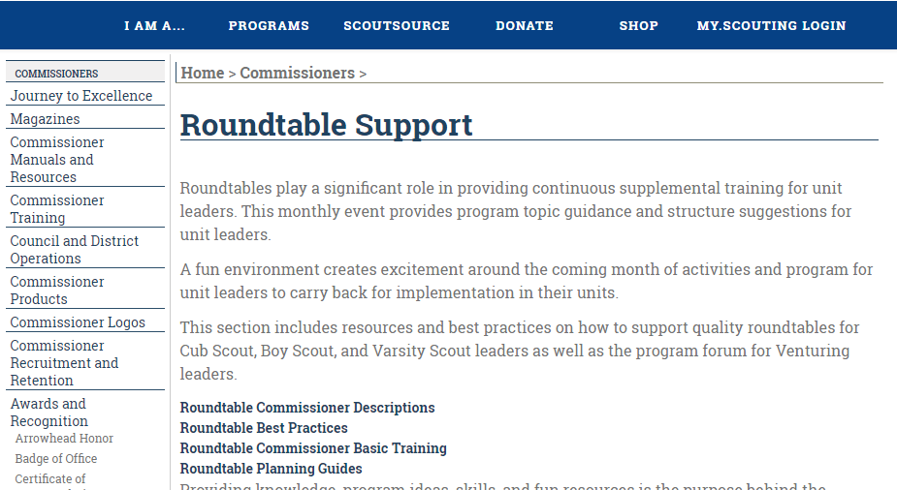
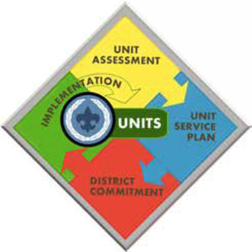

TRAINING HELPS
There are CS Adventures about Heroes
and Themes about them, too.
Here is a true story about a CS Hero! CD

Cub Scout Heroes
Kevin’s Dad
Bill Smith, the Roundtable Guy
Get to Know Your Cub's Parents -
and have them help you! Bill Smith,
Kevin was in the first group of boys to join our Cub Pack in October 1963 when three neighbors and I started it in our back yard. My wife, Shirley, had told me that I could be Cubmaster as long as she didn’t have to do anything. When Kevin’s den mother up and quit, Shirley took over den 6 and inherited Kevin along with the others.
Some of the first things I noticed about Kevin were that he loved Cub Scouting and that his mother was always around to help with the den or with our monthly outdoors activities. His dad was noticeably absent - I recalled something on the application form about him working on a ship. It wasn’t a big deal; as long as we had one parent contributing, that was a huge plus.
A couple months later, I finally got to meet Kevin’s dad. We talked for a few minutes at the end of a Pack Meeting. He told me that he was appreciative of how much Kevin was getting out of Cub Scouts and he felt guilty that his job prevented him from being a part of the program. He described his job as the navigation officer on board an oceanographic research ship.
At that time, Oceanography was one of those new, esoteric sciences that was mostly a mystery to the general public. Sort of like what many of us are presently unaware of what goes on at the CERN Laboratory in Switzerland. I nodded my head in dumb agreement with little real understanding as he described the project. His duties, as he described it, were to plot a course along a “survey line” and then plot another parallel course a few miles away. “A very boring job going back and forth across the ocean.”

The NOAA (National Oceanic and Atmospheric Administration) website describes Oceanography at this period of time. 1963 - The first operational multi-beam sounding system was installed on the USNS Compass Island. This system, and other multi-beam sounding systems that have evolved since, observe a number of soundings to the left and right of a ship's head as well as vertically allowing the development of a relatively accurate map of the seafloor as the ship proceeds on a survey line.
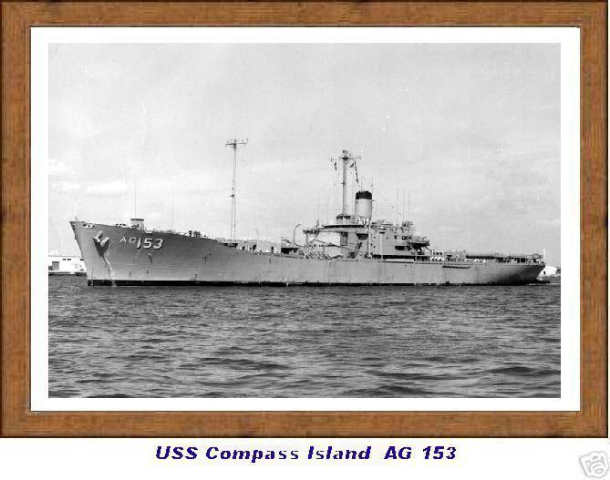
The next time that his ship was back in port at pack meeting time, he dropped a real bomb shell on us. He asked if any kids might be interested in a tour of the ship. He said that Kevin and siblings had been there several times and had pretty much lost interest in it.
Well, I knew that very few members of our pack had ever been aboard a real ocean-going ship so the pack committee and I jumped on this invitation. We used Kevin’s mom as our contact point, arranged a date for the tour, chartered a bus and were on the dock when the Navigation Officer came down the gangway to welcome us.
It was a great tour! We went from the engine room to the bridge, with all sorts of stops along the way. The crew was magnificent, describing the equipment, answering all the questions that kids have and then inviting us down to the galley for some ice cream. We had briefed the boys on proper etiquette aboard a ship and what to expect there and their conduct exceeded our expectations. The boys had great time, gave good will, and we were proud of them.
This visit was so successful and popular that it became an annual event. Lots of word-of-mouth went on in school and that helped recruiting. We heard that the ship's captain liked our visits because our pack was one of the few groups that didn’t try to steal anything not nailed down.
On our third visit, the crew had a special surprise for us. On their last trip, they had mapped the Mid-Atlantic Ridge. When we got to the sonar room, they brought out the echo maps they had made showing the two parallel mountain ranges in the ocean floor and the deep valley between where, the sonar operators explained, were under-water volcanoes. The boys were able to trace with their fingers along the ridges and gaps; they ate it all up. Some of the adults who were up on science were in awe and even those who weren’t so knowledgeable recognized that what we were seeing was important.
What we saw was, of course, the early discoveries that led to the theories of plate tectonics and seafloor spreading. This experience helped the Cub Scouts and older siblings who came along with their science education. Several years later one of our den leaders commented, “That was sort of like Galileo inviting our den over to his back yard to view the moons of Jupiter through his telescope.” When a former Cub Scout’s high school science class covered tectonic plates, he remembered: Yeah, we were there when they discovered that.
What was, perhaps, more important, is what we learned about getting parents involved. Here was a father who mistakenly thought that he had little to contribute to his son’s Scouting. His boring job kept him away from home for long periods of time. He had almost no time to work with his son on his achievements or electives and could not be a leader or contribute to the weekly pack program. What really happened was that he gave Kevin’s pack one of its most valuable and exciting episodes. He was a hero; everyone knew who Kevin’s dad was.
We were lucky to find him and work with him. Without those couple of casual conversations it may never have happened. I would guess that we miss a lot of valuable talent and human resources when parents don’t see a clear path into helping make our packs go. It often takes a lot of communication, imagination and exploration on the part of both the leaders and the parents to discover just the best ways for a parent to contribute.
We too often just write off some parents as not worth the effort. And in that way we rob the son of seeing his parents as heroes. Kevin was, I’m sure, proud of his dad.
What are YOU going to do now?
The best gift for a Cub Scout.......
......get his parents involved!
The greatest gift you can give your child
..... good self respect!

PACK ADMIN HELPS
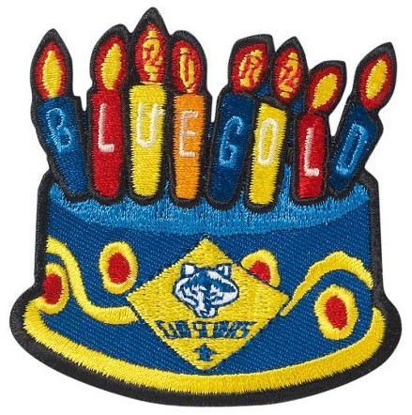

Blue & Gold Banquet - Vegas Style
Las Vegas Area Council
What is a Blue and Gold Banquet??
The Blue & Gold Banquet is a birthday dinner for celebrating the Cub Scout program. In 1933 the “Cub Leaders Round Table” suggested parent/cub dinners. Soon after a Cub Scout Family Dinner became a common occurrence.
It was in 1943 that the name “Blue & Gold Banquet” first appeared in the BSA literature. The dinner is held in February to celebrate the birthday of the Boy Scouts of America.
For many packs, their Blue & Gold banquet is one of the highlights of the program year. This is a family affair that brings the entire family together in a way that no regular pack meeting can. Therefore, this event involves more planning then the regular pack meeting.
Plan the event!!
Organize a banquet committee.
- Select a theme and discuss table decorations.
- Determine a menu and a serving style
- Consider cost.
Form subcommittees
- Facilities Committee
Determine date of event.
Pick a location -
  - The attendance at a banquet will be greater than your usual meetings so you may need to relocate to a different place to hold your banquet. Facilities committee will look into locations and rental fees. Check seating capacity and number of tables available. Check on parking and restrooms. Inquire on kitchen facilities if these are needed to prepare or serve food. Secure permission to use the public address system and access to the microphones and speakers.
- Food Committee
Develop a meal-serving plan.
  - Some packs have a pot luck with each family bringing food, Some have the pack buy the food, with the committee preparing it, and
  - Some have it catered or eat out at a restaurant's private dining room.
Plan a menu -
  - The meal is special and should coordinate with your theme, but the fun of your cubs and their families have is the most important factor.
  - If for economic reasons your pack wants to simplify, just hold a birthday party for Cub Scouts! (This year’s theme!) Run it like a children's birthday party, with balloons and games and refreshments. Birthday cake and build your own ice cream sundaes would fit the bill!
- Decorations Committee
Here is where we include the boys.
Invitations, placemats, napkin holders, centerpieces, place cards, nut cups, and favors
  - These should all be designed and made by the boys. These do not have to be professional and the parents will appreciate it more when the boy does it, the boy will be pleased with the parent’s good comments. Remember to keep all designs with the theme.
Room decorations should be the committee's responsibility.
  - Wall decorations
  - Costumes
  - Balloons for the tables
  - Display tables
Coordinate the paper goods, coordinating with the finance committee. Remember - Keep it simple, Make it fun!
- Publicity committee
Special Invitations
  - Have the boys make extra invitations, after they have taken theirs home to their parents, to invite the “special” people to the banquet. The publicity committee will send these out.
  - Special Invitation could include
    - Chartered Organization Representative,
    - School principal,
    - Religious Leaders,
    - A special person who helped you with a project or activity or badge work,
    - Special teachers.
    - Be sure to invite the Den Chiefs, and
    - People at the council that helped you - Unit Commissioner, Roundtable Commissioner (I put that one on the list. I love B&G's. CD) District Comm member,
    - Past Pack Leaders,
    - You may want to invite a City Councilman, Mayor or school board member, PTO president.
  - Track RSVP’s, to assure accurate seating and enough food. They may also put notices in school and church bulletins - make up posters to remind parents and kids of the event.
- Finance Committee
Cost –
  - Always a determining factor as to the type of banquet you can have.
Remember to think “outside the box”.
Don’t be stuck in a dinner rut!! Have a -
  - Blue & Gold Breakfast - blue pancakes and gold orange juice!
  - A cowboy picnic at the local park (depending on the weather)
  - Have lunch instead of dinner.
  - A Back to the 50’s hot dogs and milk shakes.
Parent Son Cake Bake
  - The banquet is a good time to have a Parent Son cake bake - auction off the cakes and use the money to offset the banquet cost.
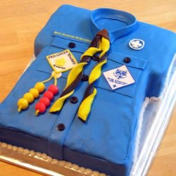
Sharing the Cost
  - If having it catered or at a restaurant, decide in advance if the pack will cover the whole cost or only half with the parents help. This may determine how many parents can attend.
  - This would be a good time to secure donations from local vendors. See if you can get paper goods donated, beverages or even a cake. Most of these places require a formal letter of request, which the committee can prepare.
Recognitions
  - Recognition for leaders and special helpers needs to be taken into consideration also. Is there someone who needs a very special gift? Can all the gifts be purchased at the scout store? Do we keep the gifts to the theme as well? This will help to determine costs.
  - Work with the Recognition Committee
- Recognition Committee
The B&G Banquet is the only time the Pack Committee Chair steps up to the front of the room to lead the meeting.
While the Cubmaster runs the pack meetings during the year, the Committee Chair should
co-hoss the banquet.
  - Remember to thank everyone! Parents, Leaders, past and present, special guests.
  - Boy recognition is the most important and the CM handles that. But on this night the Committee Chair must be sure to provide lots of recognition for the adults.
  - Work with the finance committee on the type and costs of awards to be presented. Handmade and funny recognition are always good sport.
  - Someone needs to remember to get a gift for the Pack Committee Chair!
- Program Committee
Program is still to be prepared by the Cubmaster and Pack Leaders, with some assistance.
  - There should be skits and songs, with maybe some imported fun!
    - A clown at the birthday party
    - A trick roper at the cowboy lunch .
    - K-9 dogs if you go with a police theme
Programs and song sheets –
  - Prepare whatever is needed for information are the responsibility.

SAMPLE PROGRAM
Displays / Gathering
Opening Ceremony with Pledge
Invocation (Prayer – not Grace)
Welcome, introduction of special guests, Announcements
Greetings from Institutional Head
Friends of Scouting Presentation
Awards and Recognitions for Cub and Webelos Scouts
Recognition of parents and leaders
Explanation of dinner serving process
Grace
Dinner
Entertainment - skits - songs - special fun
(Maybe a slide show of the pack year)
Closing Announcements and thanks
Closing ceremony
Dessert
TIPS!! TIPS!! TIPS!!
- Make sure the food is served HOT!
- Get an older youth group from your facility to assist - Boy Scout or Girl Scout troop, youth ministry or teen association, with serving and clean up.
- Plan early!
- Remember if you fail to plan, you plan to fail.
- Make reservations well in advance ask for RSVP’s so you can plan seating and food accordingly
- Use all resources available to you
- Involve THE BOYS - this day is important to them!
- Keep songs and skits short and simple
- Keep a sample of your decorations, invitations and a report of your committees for the next committee to reference.
- Don’t get trapped into thinking you MUST do this in February. If space and calendar do not coordinate - use the end of January or the beginning of March.
Something I learned at a Pack by me -
A few years ago I visited a pack who was having their B&G on a Saturday afternoon. I was there for an FOS presentation. They did the recognitions before dinner. They started the program early enough that no one was starving and needing to eat (as happens with weekday evening B&G's) and did the ceremonies while the serving line was being set up. This had a wonderful effect on the boys - they knew the quieter they were, the sooner they got to eat! Also, they had not already been sitting for an hour and were not getting to the severe antsy stage yet!! We tried it the next year at my pack, and it worked, too!! So think about it, try changing your paradigm (I remember when that term was new and not a cliché) and see what happens!! CD
Some Possible Themes
for Future Years (If we still theme the B&G)
Blue & Gold Gone to the Dogs!!!
Decorate with all dog decorations use Snoopy, Dalmatians, dog houses, people dog biscuits, dog food bowls for ice cream!
Let’s go to the Circus!
balloons, cotton candy, peanuts, three rings (for awards), leaders as clowns, juggling
Sports!!!
Use baseball bats, bases (for awards) scoreboard, pennants, football helmets, hockey sticks, soccer shirts, goal posts. pom poms
Olympics
medals, trophies, 5 ring flags, theme music, torch, food from foreign countries, country flags (let each den be a different country)
Indian Lore
Teepees, bow/arrows, dream catchers, animal hides, drums, totem poles, horses, peace pipes, campfires, tomahawks
World of Transportation
decorate with cars, trucks, trains, busses, boats, planes, luggage, tickets, passports, conductor, road maps, road signs, billboards, gas stations, dress Cubmaster as cruise ship captain
Patriotic/Presidents
flags, eagles, bunting, town crier, 1776 scroll, buttons, slogans, donkeys, elephants, constitution, quill pens, president pix, White House
Southwest
pueblos, cactus, rocks, sunsets, pottery, rugs, music,
Western
cattle, brands, campfires, chuck wagons, fences, hay bales, wagon wheels, bandanas
Luau
palm trees, mats, mu mu’s, leis, music, pineapples, coconuts, volcanoes, tiki’s, hula skirts, surfboards
Seaworthy/Pirates
lighthouses, waves, fish, beach, shells, boats, fish nets, coral, ships, treasure chests, Jolly Roger, eye patch, gold doubloons, maps, parrot, cannons
Holidays
use the standards - Christmas, Valentines, and Thanksgiving
School/Library
books, stands, cart, card catalogue, Dewey Decimals, chalkboards, report card, apples, rulers, dunce cap, letter charts, globes, bell
Knights
banners, armor, knights, castles, jousting, dragons, swords, shields
Jungle
animals, trees, vines, bushes, Tarzan
Noah’s Ark
ark, animals, rainbow, dove, olive tree
Garden
tools, wheelbarrow, plants, flowers, gloves, birds, branches, nest, birdseed, birdbath, bird feeders, bees, hives, honey, clover, honeycomb, clouds, trees, baskets
Outer Space
Rockets, stars, aliens, planets, space suits, moon rocks, mission control panel
Round the world
Have each den be a different country (check the ones who have scouting and see how their program operates) do food, flag, oath and law in that language, costumes, scout uniforms, artifacts, customs
Asian
Chopsticks, origami, silk, kimonos, hats, dishes, lanterns, tea sets
Also, check the Blue & Gold section
in the How To Book, page 6-3

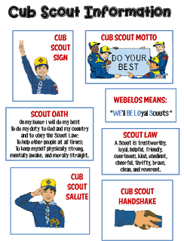
Go to http://strongarmor.blogspot.com/2015/06/cub-scouts-scout-oath-and-law-helps-and.html to get full size, full color (or black and white) printable versions

BE UP TO DATE
www.scouting.org/programupdates
The Program Updates page has been regrouped. Since the CS Adventure is in full swing, the emphasis on getting ready for it has been reduced. The downloads are still all there.
Philmont Training Center
Get great information about the Cub Scout Courses available at Philmont Training Center during the summer of 2018. Lots of FUN CS things are planned for this summer. So go and have FUN.
Check it all out – stay current!!

Same is true for Boy Scout Leaders!!

ROUNDTABLE HINTS

ROUNDTABLE RELATIONSHIPS
Baloo with help from the Philmont Training Center
"Effective Roundtables" Syllabus
ROUNDTABLE TEAM’S RESPONSIBILITIES TO UNIT LEADERS:
1. Demonstrate and discuss program ideas found Den Leader Guides, CS Leader Book, and other literature in support of pack programs.
2. Promote the monthly highlighted point of the Scout Law (core value) by presenting ideas suitable to fit the needs and abilities of Cub Scout-age boys.
3. Provide continuing training in Scout leader skills, unit administration, and leadership.
4. Give specific help to each leader.
5. Demonstrate, explain, and discuss with leaders the national and local council program of emphasis.
6. Extend the service of the council and local Scout distributors to unit leaders in the district.
7. Create enthusiasm, increase knowledge, develop skills, and improve attitudes.
UNIT LEADERS' RESPONSIBILITIES TO ROUNDTABLE TEAM:
1. Attend roundtables.
2. Promote roundtable attendance within the unit.
3. Become involved and assist at roundtable when called upon to help.
RT COMMISSIONER’S RESPONSIBILITIES TO THE DC, ADC-RTs, and STAFF:
1. The roundtable commissioner should attend the monthly commissioner’s meeting and report on the status of roundtable.
2. Unit commissioners should be alerted to any units that are not attending.
3. Provide a quality roundtable that will help strengthen units thereby making unit service more effective.
COMMISSIONER STAFF’S RESPONSIBILITIES TO ROUNDTABLE LEADERS:
1. District commissioner is responsible for recruiting, appointing, training, supervising, and motivating an effective Roundtable Commissioner.
2. Unit Commissioners should actively promote roundtable attendance and feel responsible for the participation of the people from their assigned units.
3. Unit Commissioners should attend roundtables and assist whenever possible. Roundtable helps to keep units strong and healthy.
ROUNDTABLE STAFF'S RESPONSIBILITIES TO THE DISTRICT EXECUTIVE:
1. Keep the district executive informed of unit attendance at roundtable and alert him or her to any unit problems that arise at roundtable.
2. Invite the district executive to take part in annual and monthly roundtable planning meetings.
DISTRICT EXECUTIVE’S RESPONSIBILITIES TO THE ROUNDTABLE STAFF:
1. Work as a team with the roundtable commissioner to make the roundtable successful.
2. Meet with the roundtable commissioner and staff regularly and assist in planning the roundtable program.
3. Help secure equipment and materials not readily available to the roundtable staff.
4. Attend every roundtable and help promote attendance.
5. Make district announcements at roundtable.
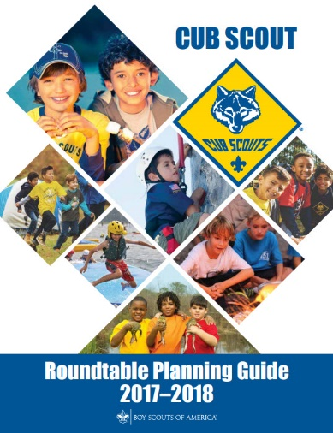
Remember -
EPIC ROUNDTABLES -
E - Exceptional & Experiential
Strive to present an exceptional and experience based program
P - Personally & Program Relevant
Make the presentation personally and program level relevant to the Leaders who attend.
I - Instructional & Inspiring
Structure your program so that it is an instructional experience, providing examples of the method of delivery, that motivates and inspires Leaders
C - Concrete
Bring all of these components together at one place at one time, to deliver a concrete experience that provides Cub Scout Leaders with what they need to deliver a successful program at the Den and Pack level.

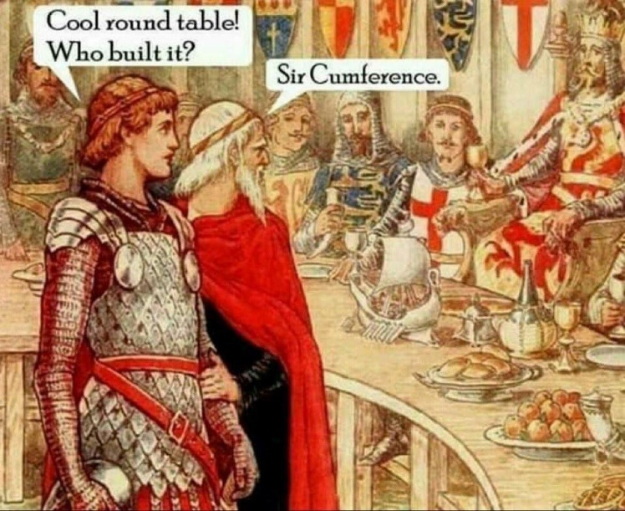
If you don’t get it -
Show it at your Roundtable,
someone will be able to explain it

RANK ADVANCEMENT CHARTS
Track your Den's completed Adventures and progress to earning their next rank on a wall chart. This worked wonders for us when our son was a Cub Scout. Everyone wanted to have the most completions. And they could see where the goal was.
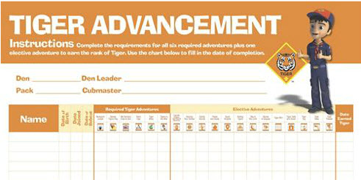
Tiger Advancement Chart, Item: 620578
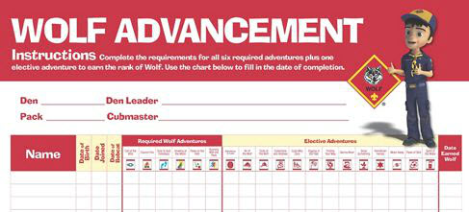
Den Advancement Chart, Item: 620579
(Scoutstuff.org listing says Den Advancement Chart not Wolf)
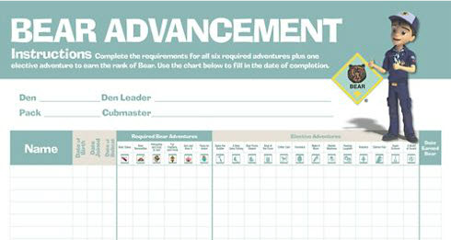
Cub Scout Bear Advancement Chart, Item: 621006
(Not sure why this one says Cub Scout. None of the others do)
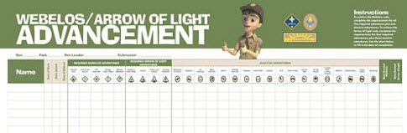
Webelos® Advancement Chart, Item: 620577

LIONS

WHAT’S NEW FOR LIONS FOR 2017-2018
There is a new PowerPoint available at http://scoutingwire.org/lion/ with everything you need to know about changes to the still a Pilot Lion Program.
Highlights include:
- Lots of new recruitment help, for example:
A new PDF brochure PDF is on-line.
A Recruiter patch is available!
And other recruitments hints and materials.
- A Lion may wear either the Lion Cap and Tee shirt (Currently, $3 discount if you buy hat and Tee together!!) or, if he and his parents desire, the Blue Cub Scout Field Uniform.
- Attendance at Pack Meetings is acceptable. Packs should find ways to actively involve the Lions in PM program, activities, skits, etc
- Pinewood Derby is a Pack decision – Lions may participate in Pinewood Derby (Use of wedge car is mentioned to minimize cutting) or hold a “Veggie Derby.”
Pre-Cut Pinewood Derby Wedge Kit, SKU# 614417
The same top quality pine blocks that are used in the Official Pinewood Derby® Kit pre-shaped into a wedge with pre-cut axle grooves. Eliminates the need for woodworking tools or skills. All you need to do is add wheels, weights, sand and decorate for a car that is ready to race!
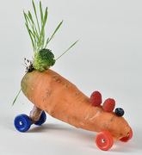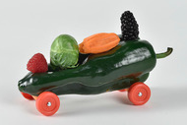
Veggie Derby Cars
- Fundraising participation is the family’s decision. Fundraising and mandatory levels are not required. Some parents do want to have the individual option to fundraise. If popcorn is sold by Lions then Show and Sell with older boys and parents would be the preference, door to door selling needs the parents at the Lions’ side.
BRYAN’S BLOG ON 2017-2018 LION PROGRAM
Lion pilot program for kindergarteners off to a roaring start, with exciting changes coming for 2017-2018
August 14, 2017
Based on feedback from parents, as well as surveys and focus groups, the BSA has some changes to announce to the Lion pilot program for this fall. The link is: https://blog.scoutingmagazine.org/ Then search for LION (singular not plural)
Later in this item you will find links to all Bryan’s Blog entries (that I know) on the Lion Program.
WHY SHARED LEADERSHIP?
- Engages the families and helps create ownership of program by families.
- Creates a stronger loyalty and connection to the den, families, and Scouting.
- Provides an opportunity to watch potential leaders in action—as a unit or pack considers future leaders.
- Millennial parents want to try things out before committing. They prefer to commit to small roles first.
- The boys love watching their “parents be the leader!” (Ask them for their meeting in front of their son. Watch how he encourages them to do it! (Please, Please Mommy! (Daddy!) You can do it!) be sure to tell them, all you need to know is in the “Parent and Leader Guide.”
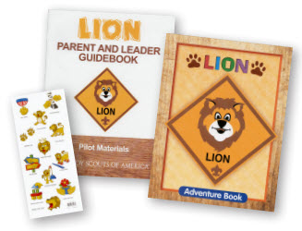
LION ORIENTATION VIDEO
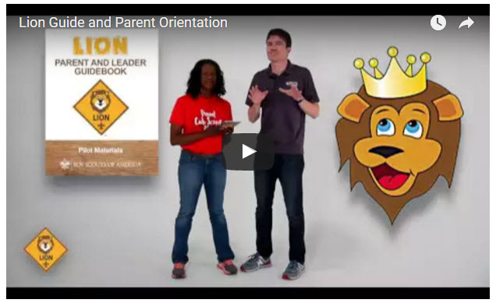
Video URL - https://youtu.be/YaIBTUO70JA
ORGANIZING FOR LIONS
From – New Birth of Freedom Council
For those packs that are thinking ahead about participating in the Lion Scouts program, having the right volunteers involved in delivering the Lion Scouts program will be important. Research shows that the most important person for a successful Scouting experience is a good leader. There are two new adult leader positions within the pack that are directly engaged in the delivery of the Lion Scouts program – a Lion Coordinator and a Lion Guide. Where do these positions fit into the current pack structure? What is the Lion Coordinator’s job description?
- Is an experienced and successful den leader
- Understands den and pack operations within the overall structure of Cub Scouting
- Demonstrates excellent communication and organization skills (and will remain in at least monthly contact with the Lion dens)
- Participates as needed in the unit’s School Night with all new Lions and their parents
- Assists the Lion guide in hosting the first orientation meeting for all the individual Lion dens in their pack
- Serves as a coach and mentor for Lion Guide
HIGHLIGHTS
- 61% of Lion parents indicate they have no other child in Scouting. We are reaching Families new to Scouting as well as siblings of Scout familie.
- 91% of parents say their Lion will be moving to Tigers and 82% of Lion Guides say most will stay.
- Satisfaction is very high 90%. For the T-shirt, shared leadership, age appropriate activities, youth Adventure book, immediate recognition stickers, meeting duration, frequency and content. The Leader Guidebook is not intimidating and is simple and easy for new parents to follow for effective meetings. Adventures are engaging for the boys.

LION HUB
Big Smiles - Build Bigger Futures
BSA has launched a new Lion Hub at:
http://scoutingwire.org/lion/
Available Lion Resources include:
LION VEGGIE CAR DERBY FLYER
PARTICIPATING COUNCILS
PROGRAM OVERVIEW
FAQS
The FAQ PDF is 13 pages long!! Lots of information!!
LION GUIDE AND PARENT ORIENTATION VIDEO
LION GUIDE AND PARENT ORIENTATION POWERPOINT
LION PRODUCTS NOW AVAILABLE!
NEW LION PROGRAM MATERIALS
LION RECRUITMENT BROCHURE
LION RECRUITMENT BROCHURE, PRINT-READY WITH CROP MARKS
CONTACT US
For Councils
COUNCIL OVERVIEW POWERPOINT
LION PROMOTIONAL MATERIALS (HELP SPREAD THE WORD!)
LION PROMOTIONAL VIDEO
LION RECRUITMENT BROCHURE
LION RECRUITMENT BROCHURE, PRINT-READY WITH CROP MARKS
REGISTRATION PROCESSING
Lion Parents say developing character is the #1 reason to join Scouting.
THE CHIEF SCOUT EXECUTIVE ON LIONS
What We Know According to a 2014 U.S. Census Bureau report, 57 percent of kids ages 6–17 participate in at least one after-school extracurricular activity. This means that by the time they are eligible for Tigers, more than half of them already are engaged in some type of athletic, artistic or other program.
Often, children become attached to lifelong activities at an early age — that is certainly a goal we would have, as we know the long-term benefits of Scouting involvement include strong asset development in the areas of character and leadership. However, we also know that when youth participate in numerous activities at an early age, and miss joining Scouting, they are unlikely to do so at adolescence.
What will be important to learn in the next few years, if the initial entry point works at the kindergarten-age level, is will this cause losses at a different age, or will the program keep the same retention all the way through to Boy Scouting?
What we learn from the pilot Lion format could also help us assess and create a smoother transition from Webelos into Boy Scouting. Too many parents now see a barrier or obstacle, rather than a smoother transition. You will often hear parents say, “We did Cub Scouting, now we’re not sure if we are going to do Boy Scouts.” We do not have a seamless transition into Boy Scouts for a number of reasons. This pilot test will help us think through some of these issues.
We want to be sure that our Lion program delivers the right mix of character and leadership values and that we set the bar high. The program must be sustainable, we must have the right infrastructure to support it, and it needs to meaningfully address the needs of parents who want their kids to join Scouting at an earlier age.
You can rest assured that we will carefully evaluate our progress and keep you apprised of the results. Stay tuned
Reprinted from "The Chief's Corner" on Scoutingwire.org
MORE LION INFORMATION
Bryan's Blog has written about Lions –
Go to http://blog.scoutingmagazine.org and you can look them up. Here are a few -
August 14, 2017
Lion pilot program for kindergarteners off to a roaring start, with exciting changes coming for 2017-2018 Based on feedback from parents, as well as surveys and focus groups, the BSA has some changes to announce to the Lion pilot program for this fall.
September 27, 2016
Lion pilot program brings Scouting to kindergartners in nearly 200 councils Answering the call of families who want a Scouting program for kindergarten-age boys, the BSA has expanded its Lion pilot program to nearly 200 councils.
April 28, 2016
In full gear: Here’s your first look at Lion Scouts T-shirts and hats This week we get our first look at new T-shirts and caps to be worn by Lions — members of the pilot program for kindergarten boys set to roll out this fall.
April 15, 2016
Will Lions be part of the pack? (And answers to your other Lion questions) Will Lions be part of the Cub Scout pack? By adding another year to the program, is the BSA concerned about "burnout"? And why was the Lions name chosen?
March 10, 2016
New details released about Lions, the pilot program for kindergarten boys In Lions, the new pilot program for kindergartners, boys wear T-shirts instead of uniforms and earn adventure stickers instead of adventure loops.
There are slideshows on the web put up
by local councils. Some examples are:
Be sure to vet these against the 2017-2018 changes!!
WD Boyce Council has "Lion Cub Pilot Program" at: http://www.wdboyce.org/document/lion-cub-pilot-program/161325
Northern Star Council has a training slide show for District Coordinators and others at: https://www.signup4.net/UPLOAD/NORT26A/LION12E/District%20Lion%20Cub%20Coordinator%20Training.pdf
Councils have put up webpages about what their packs need to know to begin a Lions Program. Examples are:
WD Boyce:http://www.wdboyce.org/cub-scouts/lion-cub-pilot-program/63360
Garden State (My Council): http://www.gardenstatescouting.org/lion-program-0
Garden State, also, has an FAQ PDF - http://www.gardenstatescouting.org/sites/default/files/Lion%20Program%20FAQ.pdf
And we have created a Facebook page for our units with Lions - https://www.facebook.com/GSCLion/
Selected FAQ's
National has posted a PDF file of FAQs about the LION program at http://www.scouting.org/filestore/pdf/Lion_FAQs.pdf
Cub Hub Blog Lion Posts
The items listed below are from the Cub Scout Learning Library . Check it out frequently for new lion and other new Cub Scout items. You can go to www.cubscouts.org and click on the Cub Hub Blog.
New Post -
Why Cub Scouting’s Program for Kindergarten-age Boys is Right for Your Family: About the Lion Pilot Program The Boy Scouts of America’s program for 5 and 6-year-olds has families around the country thrilled to…

A Look at the Lion Uniform and Gear Lion uniform, shirts and hats! In case you’ve missed the Lion uniform images floating around the Digital Pack…
Will Lions Join Tigers and Bears? Oh My! — A Lions FAQ Lions: Answers to your top questions. We have seen a lot of great feedback, comments and questions from…
5 Questions (and Answers) for the New Lion ProgramMore Information on the New Lion Program As we mentioned earlier on the Cub Hub, Select councils will…
Lion Program will bring Scouting to Kindergarten BoysSomething Roaring in the Jungle There is an exciting new Scouting program called “Lion” for Kindergarten-aged boys…
CUB SCOUT LEARNING LIBRARY

The NEW https://cubscouts.org/ !!!
Per my contacts at National Council (some of which have since moved back to Council assignments or other departments), further development of the Cub Scout Learning Library (aka https://cubscouts.org ) is currently on hold as BSA assesses its digital strategy.
BUT, obviously,
the Cub Scout Blog is still active!!
Once that assessment is done and plan for moving forward is developed, additional on-line support for CS leaders will be available, either at cubscouts.org or a new site depending on the results.
The November 30, 2016, Adventure Plan changes will not be on this site until the assessment is done.
This is the Cub Scout Learning Library –
Everything you could want to know for Cub Scouts is or will be here. And all within a click or 3 of the home page. National heard the message that although things were at www.scouting.org they were often buried too deep to be found.
This site has admin stuff and practical stuff. The new Den Leader Resource Books are here. You can download some of the pages for FREE
This website is a great resource. There are still parts under construction but what is there is
GREAT!!
Yes,
https://cubscouts.org
runs on a phone, too!!!

There are 3 tabs on top of the home page –
- Learning Library
- Cub Hub Blog
- Join Scouting
Plus – a magnifying Glass to start a search and Icons for various Social Media –
- Learning Library takes you where you can learn about your position and pick up hints. Besides specifics for dens of each rank, other clickable links include – KEY:
- All or most of material was placed on site this past month
- All or most of material was in place and listed as such in last month's Baloo's Bugle.
- Site / pages under construction
Den Leader
- Den Meeting Basics
- Your First Den Meeting
- Planning Den Outings
- The Parts of a Den Meeting
- Getting Started
Three Core Adventures for the selected rank are listed here. You see & can download the Leader's Guide info for these 3 Adventures.
- Additional Required Adventures
The remaining Core Adventures for the selected rank are listed here. When you click them you get an intro to the Adventure but do not get the Meeting Plans and Resources. You see this note:
To get you started in delivering fun and engaging meetings, complete Den Meeting Plans are available here on the Learning Library for the Backyard Jungle and Games Tigers Play adventures. To obtain Den Meeting Plans for all other adventures, Den Leader Guides are available at your local Scout Shop, online at scoutstuff.org, or as an eBook through Amazon.
- Elective Adventures
All the Elective Adventures for the selected rank are listed here. When you click them you get an intro to the Adventure but do not get the Meeting Plans and Resources. You see the same note (above).
- Building Strong Dens
The Basics of Cub Scouts
- Advancement
- BSA Mission and Vision Statements
- Cub Scout Ages and Ranks
- Cub Scout Uniforming
- Den Flags
- Den Yells
- Leader Survival Kit
- Methods of Cub Scouting
- Purpose of Cub Scouting
- Roles and Responsibilities
- Scout Oath and Law
- What Is Cub Scouting?
- Training
- The Role of Training
- Youth Protection
- Den Planning And Administration
- Advancement Basics
- Advancement Requirements
- Annual Planning For Your Den
- Coordinating Your Den Plan with Pack
- Tracking and Recognizing Advancement
- Youth Protection Training
- Positive Youth Development and Working with Boys
- Developmental Differences Boys 7-11
- Behavior and Discipline
- Positive Youth Development
- Working With Special Needs Cub Scouts (Advice is specific to each Special Need. Lots of research was done to prep these pages.)
- Parents’ Prejoining Conference
- Leadership Techniques
- Working With Specific Disabilities and Needs
- The other positions are still under development:
- Cubmaster
- Committee Chair/Member
- Chartered Org Rep
- Parent / Adult Partner
- Cub Hub Blog takes you to a Cub Scout specific Blog similar to Bryan's Blog. The most recent topics discussed are listed here. There are more at www.cubscouts.org:
Here are the posts from September and October (In reverse chronological order).

November 15, 2017
Start a New Tradition This Thanksgiving by Hosting a “Campsgiving” What’s Campsgiving? It’s a chance to go outdoors with your loved ones and celebrate the day with…
November 10, 2017
A Very Dutch Oven Campsgiving
dutch-oven If you’re looking for a way to change up the ol’ kitchen mess this year for Thanksgiving…
October 24, 2017
How to Use Every Part of Your Carved Pumpkin If you’re like us, it pains you to toss aside the insides and seeds from your carved…
October 17, 2017
Best Halloween Candy According to Boys’ Life Online Readers If you’re stocking up on candy to hand out on Halloween, we have sweet answers to the…
October 11, 2017
Cub Scouts Welcomes Girls to Expanded Programs Cub Scouts is thrilled to bring the benefits of Scouting to more kids than ever! Beginning in…
October 5, 2017
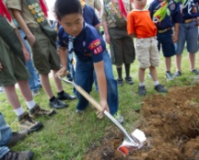6 Activities You’ll Remember if You Grew Up in Scouting From outdoor fun to Scout style, if you grew up in Scouting, your mind probably brims with…
September 29, 2017
Cook an Egg with No Cookware: Fry an Egg in a Potato Over Your Campfire Did you know you can cook an egg in a potato? Try this resourceful and unique recipe…
September 29, 2017
Cub Scouts Race Pinewood Derby Cars in SunTrust Park and Get a Visit From Their MLB Heroes Nothing tops the feeling of sending your Pinewood Derby car flying down a track … unless, you’re…
September 26, 2017
#ShareScouting to Win a $100 Gift Card for the Scout Shop! Is your camera roll packed with photos of the pack? Do you love sharing updates about your…
September 22, 2017
5 More Camping Recipes to Cook in Oranges When we shared our recipe for how to make a brownie in an orange, you responded with…
September 20, 2017
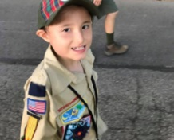Her Son is on the Autism Spectrum so She Signed Him Up for This Activity…If your son has a unique way of learning or different abilities than his peers, you may…
September 12, 2017
3 Research-Backed Benefits of Being a Cub Scout The benefits of being a Cub Scout make a big difference in the course of a Scout’s…
September 8, 2017
The Campfire Recipe Your Kids Will Love: Brownie in an Orange If you’ve never tasted the citrusy, sweet concoction that is a brownie in an orange, here’s how…
September 7, 2017
Why Cub Scouting’s Program for Kindergarten-age Boys is Right for Your Family: About the Lion Pilot Program The Boy Scouts of America’s program for 5 and 6-year-olds has families around the country thrilled to…
September 1, 2017
5 Cool Things You Can Do if You’re a Cub Scout Being a kid can be a lot of fun. But if you’re a Cub Scout, those years…
- Join Scouting takes you to
www.beascout.org
This picture on https://beascout.scouting.org/ home page. Check it out!!

Also, on the home page –
Click for a YouTube Video on Cub Scouting.
https://www.youtube.com/watch?feature=player_embedded&v=dqKFgk8SJlE
And 6 picture links -
These Six Links take you to:
www.scoutstuff.org –The Supply Division site where you can locate your nearest National Scout Shop or other local seller of Scout Stuff or buy your Scouting supplies on-line.
http://scoutingwire.org/ - Where you can get the latest Scouting News from around the country. You can sign up to get notifications when things are posted here...
https://cubscouts.org/pinewood-derby-2016-photo-contest Apparently they are not going to run this event for 2017 as you get taken to a page that says promotion has ended. Pictures of entries that were received have been removed.
https://www.scoutbook.com/Where you can get the Scoutbook APP to track your son's Scouting Experience from Tiger to Eagle Scout.
www.boyslife.org– Go directly to the on-line edition of Boys 'Life
http://scoutingwire.org/marketing-membership/ Get resources and materials to strengthen your unit at BSA's marketing and membership site. Learn the best practices and tips employed by the most successful units.

ADVENTURE PLAN TRACKERS
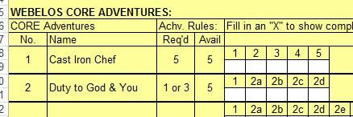
- Tracking Spreadsheets are posted on the USScouts Advancement webpage (http://usscouts.org/advance/cubscout/intro.asp). The spreadsheets were tested by a software developer who said they are so good he sees no reason to develop his own!!
- Utah National Parks Council, also, has Excel spreadsheets posted for all the new Adventure Plan requirements on their Akela's Council BlogSpot.
http://akelascouncil.blogspot.com/search/label/Tracking%20Sheet (The page starts with Arrow of Light scroll down for other ranks)
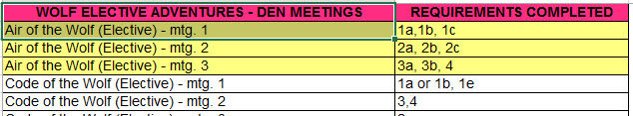
- A spreadsheet that correlates Meetings to Adventure requirements is available on the Utah National Parks' Akela's Council Blogspot at https://www.dropbox.com/s/yb8fweg7etnhqrt/WOLF%20BEAR%20WEBELOS%20REQUIREMENTS%20-%20MTGS.xlsx?dl=0 . It has all the Wolf, Bear, Webelos and AOL Adventure requirements.
These Advancement Spreadsheet workbooks are FREE for Scouters. But be COURTEOUS and observe the following -
PLEASE do not download the files from either site to email or send them digitally to others.
They are for your personal / pack use only. If you would like to share these files with others, please copy / send the link to them and send them to the site so they can print off their own. They would love everyone that wants a copy to get their own copy absolutely free. Both USScouts and Utah National Parks receive Ad money based on the number of people visiting the site. That ad money helps keep their websites open. Please help them (us) by encouraging others to visit to obtain files.

TRACKING BOYS’ PROGRESS
IN THE MODIFIED CUB SCOUT ADVENTURE PLAN
Judy and I have found several places on the web where there are aids to use to track boys’ progress in the modified Adventure Plan. Judy is placing a more detail in Baloo’s Bugle, Part IV – Den Meeting Helps.
- The Bobwhite Bather blog site (https://bobwhiteblather.com/mid-year-cub-scout-program-updates/ ) has a discussion of changes.
- Cubmaster Tom, responded providing links to documents he formatted to paste into the boys’ books for each modified Adventure. See example below:
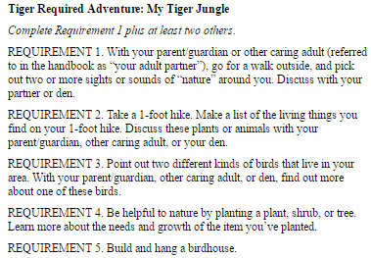
The complete Tiger document is at: https://docs.google.com/document/d/1ka_AkwxDkKgNjLrAOUHzbQQqCkruDCC8RyxtMFvrFO8/edit?usp=sharing. The links for the other ranks are in the comment on Bobwhite Blather.
- Bert Bender, Atlanta Area Council, replied,
Having finished several deep dives through the requirements changes, I’ve updated the page at http://www.southfultonscouting.com/node/3557 to not only show exactly what got changed and what didn’t change, but now also add comments intended to be a practical guide to whether you need to look at the new 11/30/16 language, and whether when those might be a useful alternative.
Comments after some Adventures encourage (sometimes plead) that dens avoid the “easy button” approach. Doing the June 1, 2015 handbook elements will often result in better outcomes and experience in Cub Scouting.
- Utah National Parks Council’s Akelas Council Blogspot has revised paper tracking sheets (http://akelascouncil.blogspot.com/) Thanks to Celeste Hunt for creating these.
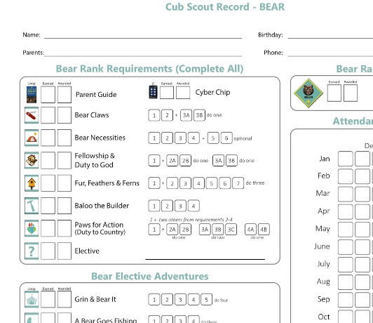
Celeste says, “Tracking, planning, and recognition are so important in Cub Scouts. This new tracking sheet helps you to be able to keep track of where each boy is at towards the Bear, Adventures, and Cyber Chip requirements. I print 2 copies of the tracker on cardstock for each boy. One for his book and one for my leader binder. I place it next to the trackers for the religious and other awards we are doing. I have tab for every boy with all his trackers. Complete information on each boy in one place. Not every boy is there every week. By doing this, I always know what each boy has done. If the parents ever have questions, I have a place to check, and I can always copy each tracking sheet to show them where their boy is.

CUB SCOUT
LEADER TRAINING
IN-PERSON TRAINING
Position-Specific In-Person Training Guides Available Now! The training guides for
- Den Leader (http://www.scouting.org/filestore/training/pdf/515-215.pdf ),
- Cubmaster/Assistant Cubmaster (http://www.scouting.org/filestore/training/pdf/511-503_WB.pdf ), and
- Pack Committee (http://www.scouting.org/filestore/training/pdf/511-504_WB.pdf )

Are available on Scouting University. You can access them at http://www.scouting.org/training/adult.aspx .
ON-LINE TRAINING
On-Line Training for all Cub Scout positions has been available since October 25, 2015
The online training for Den Leaders, Cubmasters, Committee Chairs and members, and Chartered Organization Representatives is totally updated with help from volunteers from around the country. The new training is divided into shorter, more targeted modules so leaders can get the training they need, in the order they want, any time they need it. It is organized around the learning needed prior to the first meeting, in the first 30 days, and to be position-specific trained. This training was developed to be implemented in conjunction with the BSA’s new learning management system. Keep an eye on
my. Scouting Tools (log in at https://My.Scouting.org) for more information.
Go to the BSA Volunteer Training Team Facebook page (Link above) and.
Then you automatically receive the latest news!!
If you are having difficulties with
the training or system call
BSA Member Care at 972-580-2489
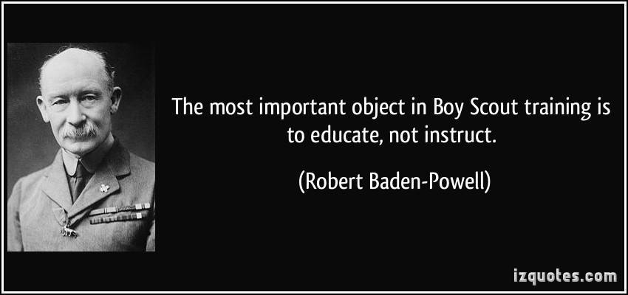
A Typical Learning Plan has several parts –
There is no need to complete more than one section at a time. Do what you have time to do.
Here you can see the three parts of the CM Course -
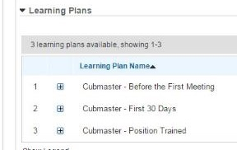

Each of these three parts is broken down into "bite sized" chunks:
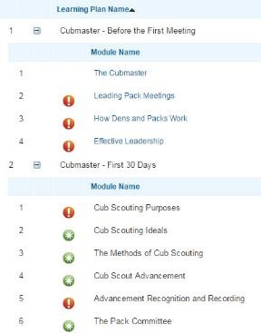
Go check it out and get your
people trained!!!

