TABLE OF CONTENTS
TABLE OF CONTENTS 1
PHILMONT CUB SCOUT RT SUPPLEMENT 1
CUB SCOUT ROUNDTABLE PLANNING GUIDE 1
ON-LINE SUPPORT 2
TRAINING HELPS – 3
Training Continuum 3
PACK ADMIN HELPS 5
UNIT LEADERSHIP ENHANCEMENTS 5
BE UP TO DATE 8
ROUNDTABLE HINTS 8
ROUNDTABLE PIZZAZZ 8
Positive Values Emphasis 11
CUBMASTER THOUGHTS 12
The Uniform 12
BSA Official Uniform Policy 13
RANK ADVANCEMENT CHARTS 15
LIONS 16
WHAT’S NEW FOR LIONS FOR 2017-2018 16
LION HUB 17
MORE LION INFORMATION 18
CUB SCOUT LEARNING LIBRARY 20
The NEW https://cubscouts.org/ !!! 20
ADVENTURE PLAN TRACKERS 23
TRACKING BOYS’ PROGRESS 24
CUB SCOUT LEADER TRAINING 25
IN-PERSON TRAINING 25
ON-LINE TRAINING 25

PHILMONT CUB SCOUT RT SUPPLEMENT
The November issue is posted!!
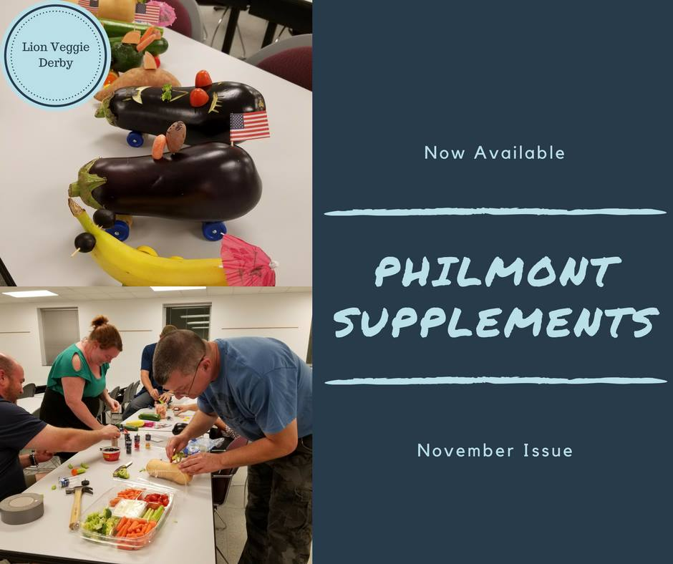
Hyperlink on picture. If using paper copy – go to BSA Roundtable Commissioners on Facebook. (See On-Line Support below)

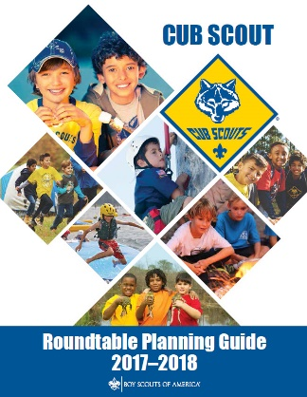
CUB SCOUT ROUNDTABLE PLANNING GUIDE
The CS RT PG is issued
The 2017-2018 CS RT PG may be found at - http://www.scouting.org/filestore/cubscouts/pdf/510-714(17)_CS.pdf
On page 37 0f the 2017-2018 CS RT PG it states:
Introduction to the New Cub Scout Interest Topic Format for 2017–2018
Based on survey input, the National Cub Scouting Committee has modified the presentation style for the Cub Scout (CS) interest topics for this year. To improve communications throughout the pack leadership, it is recommended that all CS leaders attend the interest topic discussion together as a single group. This will provide everyone with the same information and will facilitate important discussion about these topics between all CS leaders. As always, the CS Roundtable Planning Guide provides suggested options for each council or district. The use of any specific topic is flexible based on the needs of the council or district. Each council or district may also select other topics that would be beneficial to the needs of the CS leaders in their respective council or district. Additional resource materials from the BSA can be used if the district chooses to do individual leader breakout sessions. The Philmont CS Roundtable Supplements are a great resource to consider for the breakout session model.
Scott McKenzie, the Roundtable lead on the National Commissioner Service Team, posted the following on the Commissioner Service (Boy Scouts of America) Facebook page:
The 2017-2018 Cub Scout Roundtable Planning Guide has finally been completed and posted to the BSA Commissioner Roundtable Support webpage.
“You will notice that the material in the CS RT Planning Guide is significantly different this year. Based on survey input, the National Cub Scouting Committee has modified the presentation style for the Cub Scout interest topics for this year. In order to improve communications throughout the pack leadership, it is recommended that all Cub Scout leaders attend the interest topic discussion together as a single group. This new method will provide everyone with the same information and will facilitate important discussion about these topics between all Cub Scout leaders. We recommend everyone try the new method to see how it works in your district. This will further validate any input you may have for future changes.
As always, the Cub Scout Roundtable Planning Guide provides suggested options for each council or district. The use of any specific topic is flexible based on the needs of the council or district. Each council or district may also select other topics that would be beneficial to the needs of the Cub Scout leaders in their respective council or district.
Additional resource materials from the BSA can be used if the district chooses to utilize individual leader breakout sessions. The Philmont Cub Scout Roundtable Supplements are a great resource to consider for the breakout session model. These optional support materials will continue to be available on the Roundtable Commissioner Facebook Page and can be emailed to individuals upon request.
We understand that there will be a lot of opinions on this new format and the National Commissioner Service Team would like to collect your feedback to provide to the National Cub Scout Committee, who develops the program content for the CS RT Planning Guide. Please provide constructive comments only. If you like the new format, please say so and if there are additional things you would like to see in the program content please provide a description in your comments. We will also be conducting various surveys over the next several months to collect your input for future program content. Private emails can also be sent to BSARoundtableChair@gmail.com
Scott McKenzie

ON-LINE SUPPORT
BSA ROUNDTABLE COMMISSIONERS FACEBOOK PAGE
The Philmont CS Roundtable Supplements referenced in the CS RT PG are available here!!
Join the over 3000 members of the “BSA Roundtable Commissioners” Open Group on Facebook.
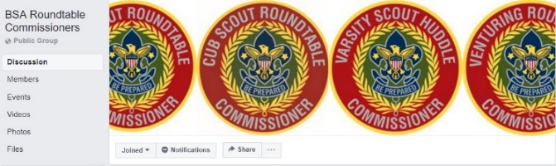
The site admins are my good friends from Philmont, Emily and George. And they do a terrific job.
Please do not add anyone but yourself to the group. Tell other Roundtable Commissioners and Assistant Roundtable Commissioners about the group and have them add themselves. The Admins frequently get 50 requests to join in the admin inbox and the majority of them have not answered the questions. If they don't answer the questions in 2 days, they are not approved and they have to repeat the process. I (CD) know the Admins and they are very thorough. They vet every person that wants to join the BSA RT Commissioners group to make sure that this continues to be a Roundtable focused group. Please help them by spreading the word with your voice...not by your clicks. And they do thank you for all that you do!
COMMISSIONER SERVICE
(BOY SCOUTS OF AMERICA)
FACEBOOK PAGE
The Commissioner Service (Boy Scouts Of America) Facebook Page provides a forum for all commissioners to ask questions and see answers. It is an Open Group, but please consider joining.
The link is - https://www.facebook.com/groups/bsa.commissioners/
Join the almost 3000 members of the “Commissioner Service (Boy Scouts of America) Facebook Group.
RT SUPPORT PAGE
Check out the RT Support page on National’s site - http://www.scouting.org/scoutsource/Commissioners/roundtable.aspx
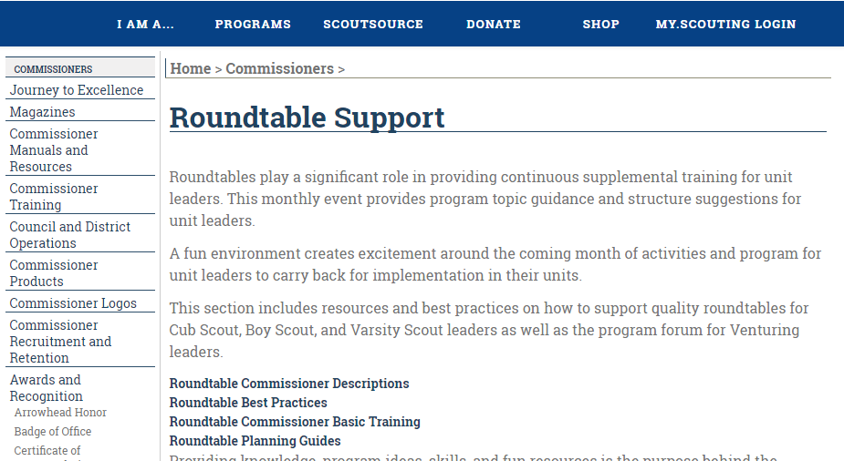

TRAINING HELPS

Training Continuum
Jay Reeves, Gamehaven Council, MN
Updated by Commissioner Dave
So, at Cub Scout Roundtable, I'm known as the "Can Man." When someone asks me, "What can I do with my boys?" I say, "It's in the can!” As we know all too well, parents today are being pulled in all sorts of different directions. Scouting can be seen as just another place to drive your kids. So, it's not surprising that it can be hard to find and retain Den and Pack leadership.
The retort I hear most often when a parent is asked to take a more active role in Cub Scouts is, "I have no idea what to do." This is where the "can" comes into the discussion. The Boy Scouts of America has gone to great lengths to provide parents the tools they need to become effective Scout leaders. This begins with training programs to introduce them to their roles and continues with supplemental training that will enrich their experience (and their Scouts).
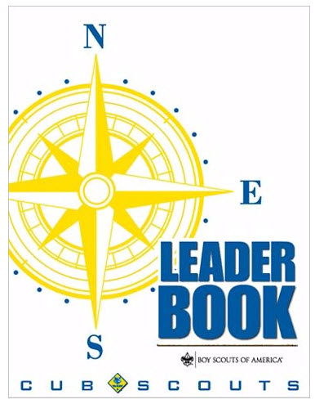
The Cub Scout Leader Book (620569 - 2015 Printing) has a complete outline of the BSA's Training Continuum for Cub Scout Leaders. And the CS Leader Book is, also, a great tool for bringing a group of parents together to learn and to create an effective leadership team. It lays out in excellent detail the basics of the Cub Scout program and how it all fits together into a meaningful program for both our Scouts and their families.
CUB SCOUT LEADER TRAINING
Every Cub Scout deserves trained leaders because trained leaders are best able to provide a quality Scouting experience.
Every leader deserves to be trained because training makes a leader's role easier and more enjoyable. Scouting offers a full range of training opportunities. Some cover a wealth of topics, others are very specialized. Some apply to all leaders, others target a single role. Training is offered in a variety of settings to meet the needs of leader. Pack trainers or district training teams offer most basic courses, while courses that require more resources are held at the council or national level. www.My.Scouting.org offers e-learning that conveniently fits the leader' schedule. Some courses are self-study.
Your pack trainer, unit commissioner, or local council staff can provide information on district training opportunities and put you in touch with the district training team
The Training Continuum
The BSA's training plan not only provides training for new leaders to help them get started in the right direction, but also provides continuing education for all leaders. In this way, leader continue to learn through experiences and from additional training opportunities. Leaders stay up to date on Cub Scouting and acquire new skills that help them succeed with the boys.
Basic Training
To be considered "trained" for their position, Cub Scout leaders need to at least take Youth Protection Training and Position Specific training for their registered position.
Youth Protection Training - Every leader in Cub Scouting shall complete Youth Protection Training prior to turning in their Application to Join the BSA and conducting their first meeting with Cub Scouts. Youth Protection training may be taken via e-learning at www.My.Scouting.org
Alternatively, your district or council may provide a facilitated, live training session. BSA policy requires volunteers to renew their Youth Protection certification every two years; however, some states require the course be taken annually or be taken in person. Check with your council for your state's policy.
Position-Specific Training - Separate position-specific training offers basic knowledge and explains the fundamental skills needed for each volunteer position. There are courses for:
- Den Leaders and Assistants (all ranks)
- Cubmaster and Assistants
- Pack Committee Member (all positions)
- Pack Trainer
Position-specific training at my.Scouting.org is designed to offer new leaders the content they need, when they need it. As such it is divided into three- to eight-minute training module or topics. The training begins with what a leader needs to know before the first meeting in his or her assigned role. Leaders in direct contact with Cub Scouts will especially want this training before their first den or pack meeting.
Because we are always learning, and no one is ever "fully trained," these Basic Courses and the Additional Training Opportunities make up the BSA training continuum.
Additional Training Opportunities
This Is Scouting. This Is Scouting highlights the values, aims, history, funding, and methods of the Scouting program.
Roundtable. Cub Scout leader roundtables are usually held monthly on the district level. Den and pack leaders join for fun and fellowship while learning about theme, activities, and alternates to bring to life next month's den and pack meetings. Roundtables also provide opportunities for sharing ideas and activities with leaders from other packs.
Cubcast. Cubcast is a podcast on a topic of interest to Cub Scout leaders. Leaders can listen online or download the podcast for sharing or future Listening. Cubcast, and archives of past Cubcast and Scoutcast podcasts, are found at www.scouting.org/scoutcast.
Pow Wow/University of Scouting. A pow wow (or university) is an annual district or council training conference that takes place in a festive atmosphere. There are typically classes on games, crafts, skits and puppets, ceremonies, administration, and the Webelos den. It's a time for parents and leaders of all experience levels to share ideas and see what other packs are doing. The local council may combine the fun and excitement of pow wow with a variety of other training activities for leaders in Boy Scouting and Venturing.
Outdoor Leader Skills for Webelos Leaders. Designed specifically for Webelos den leaders and their assistants, this course teaches outdoor-related skills through demonstration and hand -on practice. Webelo den leaders should attend this training before conducting Webelos overnight camping with the boys and parents of the den.
Basic Adult Leader Outdoor Orientation (BALOO). Basic Adult Leader Outdoor Orientation is a short training event that introduce parents and leader to the skills needed to plan and conduct pack outdoor activities, particularly pack family camping. BALOO includes information on preparation, site selection, parent involvement, health and safety, equipment, food, and outdoor skills. This training is required for any adult who is in charge of planning a pack campout.
Fundamentals of Training. This is the first part of the three-part train-the-trainer continuum (T3, or T-Cubed) in the BSA. The course introduces teaching techniques and skills to new Scout trainers but is also designed to help all Scouters, regardless of their experience, present effective training.
National Cub Scouting Conferences. Cub Scout leader training conferences are held at Philmont Training Center near Cimarron, New Mexico; at the Florida National High Adventure Sea Base in the Florida Keys, and at the Summit Bechtel Family National Scout Reserve in West Virginia. At Philmont, the leader takes part in training sessions while family members enjoy a special program of activities.
The weeklong Philmont conferences combine a family adventure with the opportunity to participate in a quality training experience and association with Scouters from aero s the country. Sea Base conferences are held in the winter and include a program for spouse
2018 Philmont Training Course info at www.philmonttrainingcenter.org
Wood Badge. Wood Badge is advanced training in leadership skill for adults and older youth in all phases of the BSA program. In addition to Cub Scouters, leaders in Boy Scouting, Varsity Scouting, Venturing, and commissioner service may participate in Wood Badge.
Unit Leadership Enhancements - This is a collection of 15 topics that each can be presented in about 10-15 minutes during a Pack parent's or Pack Committee meeting. The "Unit Leadership Enhancements" appendix starts on page 155 of the CS Leader Book. . The topics range from Advancement to Youth Protection.
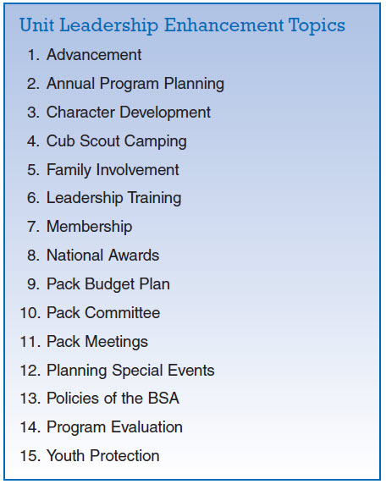
These mini training sessions can be invaluable in settling discussions about BSA policies or answering, "What is the correct thing to do?" They can provide great info to a questioning parent who wants to know.

PACK ADMIN HELPS

UNIT LEADERSHIP ENHANCEMENTS
Jay Reeves, Gamehaven Council, MN
Updated by Commissioner Dave
Now that you know about the continuum, how can you get it rolling amongst your Pack Leaders and Parents??
Conduct a Unit Leadership Enhancement either (or both) at a Pack Leadership (Committee) Meeting and/or at a Pack Parents’ Gathering. They only take 10 minutes and everyone (including the instructor) will learn a lot!!
And/Or – when someone asks you a good question – pull out the Unit Leadership Enhancement that contains his answer and sit down with it to show him.
Background
Unit Leadership Enhancements are listed as Part 4 of every Monthly Pack Leaders ' Planning Meeting (See pages 80 & 81 of the CS Leader Book).
The Pack trainer’s position description lists conducting Unit Leadership Enhancements as one of the responsibilities. But they could be lead by any committee member.
How to use Unit Leadership Enhancements:
Conduct a short discussion and exercise during each pack leaders' meeting as a regular business item. These discussions should be based on the Cub Scout Leader Book (620569 - 2015 Printing). Each leader should own his/her own copy. Each month, the Pack Trainer or other designated leader conducts one of the Unit Leadership Enhancement outlines with the other unit leaders from discussion, to exercise, to action plan. The other leaders follow along in their copies of the Cub Scout Leader Book.
After the discussion, the associated exercise is conducted. Then the group follows through by developing an Action Plan for the unit. The exercises and action plans are intended to immediately improve pack program in the chosen area.
Close by choosing the topic and leader for the Unit Leadership Enhancement at next month's pack leaders' meeting. All leaders should have input on the choice, and all should read the preparation assignment before the next pack leaders' meeting.
Pack leader can choose from the 15 topics presented here. Some topics are more appropriate at certain times of year and should be scheduled then for the most benefit to the Pack.
Unit Leadership Enhancement Descriptions
In the back of the Cub Scout Leader Book (620569 - 2015 Printing) on page 155 is the Appendix containing the Unit Leadership Enhancements. Let’s look at what they are –
- Advancement - This discussion will help leader understand the purpose of the advancement program and their responsibilities in carrying it out. A properly planned advancement program builds character in boys and help achieve the purposes of Cub Scouting.
- Annual Program Planning - This discussion will give leader additional tool to u e when planning their pack program. It will help them make the program is fun and exciting and ensure that each den ha a coordinated contribution to make. Note: Cover this topic in May or June.
- Character Development - This discussion will help leaders understand how Cub Scouting is designed to help boys develop good character trait and learn positive core values.
- Cub Scout Family Camping - This discussion will help pack leader be aware of camping opportunities approved for Cub Scout Family Camping and the health and safety guidelines related to Cub Scout Family Camping.
- Family Involvement - This discussion will help leader find ways to strengthen parents' involvement in den and pack activities. Communication among family members will be improved.
- Leadership Training - This discussion will make leaders more aware of district, council, and national leadership training requirements and programs, as well as the benefit to leader and the pack from their full participation.
- Membership - This discussion will help the pack grow in an organized and thoughtful way. Pack leaders will be able to plan for leadership needs and be prepared for shifts in your neighborhoods. Note: This topic should be discussed before any seasonal district membership drive.
- National Awards - This discussion will help the pack implement fun, year-round program for its dens. As a result, the dens will be stronger.
- Pack Budget Plan - This discussion will help pack leader gain control over pack finance and provide for required expenses; it will also allow for planning and carrying out a pack program that achieves the purposes of Cub Scouting. Note: This topic should be covered during the month after the annual pack planning conference has occurred.
- Pack Committee - This discussion will make leaders aware of the various responsibilities that a fully functioning pack committee should carry out. It should be easy to highlight functions that are not currently being handled. Develop an action plan to secure the necessary leadership to bring the committee to full strength. This might be a great one with which to start to get everyone on the same page!!
- Pack Meetings - This discussion will help leaders find ways to make monthly pack meetings more fun and interesting. As a result, parents will be more interested and involved, and Cub Scouts will look forward to each pack meeting.
- Planning Special Events - This discussion will make pack leaders aware of several special events that can enhance the pack program. Special planning steps will be discussed.
- Policies of the BSA - This discussion will help alert leaders to “Guide to Safe Scouting,” and the significant policies that guide action and activities for ail leader and members of the Boy Scout of America.
- Program Evaluation - This discussion will help pack leaders evaluate the pack program objectively so that the pack can build on its strength and strengthen its weaknesses.
- Youth Protection - This discussion will help pack leaders become more aware of their responsibilities as leaders and help them provide a sense of safety and security for the boys in the pack.
A Look at One of the Topics,
"Pack Budget Plan"
In this discussion your group will go over financial control of your Pack and conclude having the framework for a plan to present the Pack's finances to your families. The Committee Chair or designated presenter will review the Leader Book chapter, "Financing the Pack" in advance. At an appropriate meeting, discussion will include a review of the Purposes of Cub Scouting, Pack budget planning, collecting dues and donation opportunities (such as Friends of Scouting).
Preparation
- All members read the Financing the Pack chapter of the CS Leader Book.
Discussion
- Have all leader read aloud the purposes of Cub Scouting found in the What Is Cub Scouting? chapter.
- Take tum reading aloud from the Financing the Pack chapter.
- Discus the first two paragraph of "The Pack Budget Plan." Pay attention to the second one, and discuss the real purpose of the budget plan- to teach boy to handle money and accept financial responsibility.
- Review "Suggested Budget Items."
- Discuss the information under "Collecting Den Dues."
- Review the point covered in "Pack Money-Earning Projects." Review a Money-Earning Application (See www.scouting.org/cubscouts).
- Discuss the donation opportunities under "World Friendship Fund" and "Friends of Scouting."
Exercise
- Take a few minutes to run through some estirmates of a budget, using the budget worksheet found in the Pack Record Book.
- Assign one member of the committee to work with the pack treasurer to begin gathering information to use with a final budget work sheet.
- If a weekly den due collection is not already in place, agree to start one with the adoption of the new budget.
- Present the budget to pack parents and the chartered organization.
- Follow the budget to offer a quality program for boys and to have the necessary funds on-hand for expected expenses.
- Decide on next month's Unit Leadership Enhancement topic and choose the discussion leader. Encourage everyone to read the preparation assignment.
Now, a 15-minute discussion of Pack finances won't be the end of the work, it is the beginning! But from here, at least you'll have a road map to make the process easier. Remember that a budget is item number 10 on your Pack's "Journey to Excellence". So, this could be a great way to begin or continue your unit's journey!
So, the next time you're wondering what you can talk about at your next parents’ or Committee meeting, do a Unit Leadership Enhancement!
The Unit Leadership Enhancement outlines
are in the CS Leader Book!!

What are YOU going to do now?
The best gift for a Cub Scout.......
......get his parents involved!
The greatest gift you can give your child
..... good self respect!

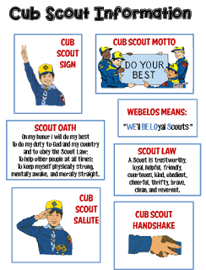
Go to http://strongarmor.blogspot.com/2015/06/cub-scouts-scout-oath-and-law-helps-and.html to get full size, full color (or black and white) printable versions

BE UP TO DATE
www.scouting.org/programupdates
The Program Updates page has been regrouped. Since the CS Adventure is in full swing, the emphasis on getting ready for it has been reduced. The downloads are still all there.
Philmont Training Center
Get great information about the Cub Scout Courses available at Philmont Training Center during the summer of 2018. Lots of FUN CS things are planned for this summer. So go and have FUN.
Check it all out – stay current!!

Same is true for Boy Scout Leaders!!

ROUNDTABLE HINTS
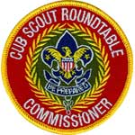

ROUNDTABLE PIZZAZZ
GAMES, SKITS, SONGS,
CHEERS, and STUNTS
Let's see what some recent Cub Scout Roundtable Planning Guides (CS RT PG) say about Games, Skits, Songs, and Cheers (Highlights are mine):
In the 2016-2017 CS RT PG –
Opening for Cub Scout Interest Topic—
Ceremony/Skit/Song/Game
Use a simple opening ceremony/skit/song/game that leaders will be able to duplicate in their units. You may wish to delegate this opportunity to a particular pack or group, or use participants if appropriate. Flag ceremonies, and reciting the Scout Oath and Law, are some of the appropriate types of opening ceremonies.
Skits, songs, or games can be tied into the monthly interest topic and are a great way to involve everyone at the meeting. Remember to provide any information needed such as song lyrics, etc., so that everyone will participate. Involve all participants in a memorable activity that they can take home and plan for their Cub Scouts. It is important to encourage everyone to participate. These activities may come from the Cub Scout Leader How-To Book, Group Meeting Sparklers, and the Cub Scout Songbook.
In the 2015-2016 CS RT PG –
Sample Ceremony
A sample ceremony is presented in this section to show leaders how Cub Scouting’s purposes and ideals can be symbolized in ceremonies. If some of your packs are known for excellent ceremonies, you might ask their leaders to perform a ceremony. Always involve as many participants as possible.
A ceremony related to the month’s point of the Scout Law or supplemental theme makes it more relevant for the unit’s monthly use and will enhance it as a take-home idea.
Skits, Songs, Cheers, and Games
Here is where the “Fun with a capital F” comes in. Involve all participants in a memorable activity they will take home and do with their Cub Scouts. It is important to encourage everyone to participate. These activities may come from the Cub Scout Leader How-To Book, Group Meeting Sparklers, the Cub Scout Songbook, and the monthly program resource provided in this guide. They should relate to a coming month’s theme.
Per the CS RT PGs - Why are doing these activities at Roundtable?
- To involve participants – After all day at work most participants do not want to just sit around and listen to someone talking, they want to participate. And for most people if they participate in a meaningful way, they will return to help again. Two plusses here – people are active and they want to return.
- For Leaders to use in their Units – Roundtable is where Leaders come to get ideas. Give them a "snazzy" (yes, I am old - CD) game, skit, song, cheer or stunt and they will take it back to their unit and use it. And if you presented it well, they will do it with confidence and their Scouts will have a great time playing, acting, singing, cheering, yelling, or "whatever-ing." One of the greatest compliments RT Commissioner or Asst RTC can receive is, "I used a ceremony (song, skit, cheer) you demonstrated last time and the boys loved it. Thanks for your help. Your demonstration gave me the confidence to do it back in the unit." Pizzazz does help retention of Leaders and Youth.
- To have FUN – Games, skits, songs, cheers and stunts are FUN to do at Roundtables and to use in Pack and Den Meetings. (I use capitals on all letters not just the "F" )
HINT - Make sure you have a copy of everything you demonstrate (game, skit, song, cheer, stunt) for participants to bring home or they will forget it and never use it. Something one of my RT mentors said became the credo for my RTs:
You will receive a copy of everything demonstrated here at RT to take home.
Otherwise it was just entertainment and there are better shows on TV and you have better things to do than watch us.
Let's look at another reason:
One of my favorite promo RT sayings is:
ROUNDTABLE – Where you get:
The WILL to do and
The SKILL to do
We demonstrate games, skits, songs, cheers and stunts at RTs to show the Leaders how easy it is to do. Getting in front of a group to lead a song or cheer is not easy for many people. They need encouragement. They need to be shown that it is all right for an adult to "act like a 9 year old." So, RTCs and Assistant RTCs demonstrate these things to give confidence to the leaders.
Although, based on a survey of leaders, the emphasis on them has been reduced in the 2016-2017 CS RT PG, the Guide still calls for skits, songs, cheers and stunts to be demonstrated to show the leaders how to do it. Because of the quality of the Pack Meeting plans (Prepped by a Task Force lead by my friend Kim) and the Den Meeting plans, it was felt that additional theme related skits, songs, cheers and stunts were not needed at RT. So, they provided items for the Interest Topics.
However, on page 5 of the CS RT PG, it states: "You may continue to emphasize the pack meeting plans during your Roundtable as a helpful resource." Your team (The ADC-RTs, you, the CS RTC, and your Assistant RTCs) are the only ones who know what plays best at your District's Roundtable.
It is important that we keep demonstrating these things or soon everyone (All generalizations are false, including this one) will be having blasé Pack Meetings. Leaders will forget or never learn what pizzazz does for a Pack or Den Meeting.
Now let's look a little at some of these –
Songs, Stunts, Cheers –
Songs and sparklers should be included as part of every roundtable and every Pack Meeting.
Knowing how to lead a song is an important skill for CS Leaders to have.
Morale features (songs, jokes, cheers, stunts) should be interjected anytime the audience becomes restless, bored, or shows other signs that a change of pace is necessary.
All songs and sparklers must follow the "Positive Values" guidelines and should not include put-downs or negativity.
Use and teach the song-leading tips in the Cub Scout Songbook (explain, provide copies).
How to Lead a Song
From CS Songbook
Choose It. As the leader you must choose the song that the group will sing. You want to be certain that all songs chosen support the values and ideals of Cub Scouting. You will also want to choose a song that fits the program. Fast action songs get the program off to a brisk start. Patriotic songs add a note of dignity to the program. At the end of the program, slower closing songs can leave every one calm and thoughtful.
Know It. The song leader should know the song—both words and tune—before leading it. Learn the song, then practice before the meeting by teaching the song to your family or to the pack committee members at the monthly pack planning meeting.
Teach It. Start by telling your audience the name of the song. Unless you are certain that everyone in the group knows the song, you need to teach both the words and the tune. You may wish to provide copies of the words. Use songbooks, reproduced song sheets, or words on a large sheet of paper or overhead projector.
Sing It. Sing the song through once, either alone or with a small group who already know it. Let the singers try a verse at a time, slowly at first. When they master it, pick up speed.
Pitch It. Set the pitch by singing the first word of the song loudly so that everyone starts out on the same key. Musical accompaniment helps—a keyboard, piano, accordion, guitar, or harmonica are all good because they can play harmony not just single melody notes.
Lead It. Be active in your song leading. Use simple arm motions to lead the song so that everyone is singing together.
- Start the singing with a slight upward motion and then a decisive downward motion (a downbeat). Begin singing yourself on the downbeat. Don’t worry if some don’t start with the first note—they’ll join in quickly.
- Beat time with a simple up-and-down motion of the arm, but make it definite and brisk. You’re in command.
- Control volume by raising your hands for loudness and lowering them for softness.
- Move around a little. Inject a little pep and personality. Keep smiling.
- Smile at your group. Relax. Radiate confidence and enthusiasm, even if you don’t feel particularly confident or enthusiastic. Morale catches.
Stop It. When the group has sung it a time or two, stop—don’t make it a music lesson. If the song isn’t going well, or it was pitched wrong at the beginning, stop the song and start over.
Ceremonies –
The ceremony at the start of the CS Leader Breakout follows the Opening Ceremony done for the combined group. The Opening Ceremony for the combined group should have included a flag ceremony and the Scout Oath and/or Law. It would be redundant to repeat that for the breakout. Use a CS Ceremony – maybe one where you take a word like CUBS or BUGS and have different people say what the letters mean. Check out the B-U-G-S Ceremony in this issue of Baloo's Bugle.
Ceremonies and Skits, too, must follow the "Positive Values" Guidelines
To add pizzazz, leaders could wear appropriate costumes for various ceremonies. If "Cubs of the Roundtable" is the theme, wear something that a knight might have worn.
There are lots of types of ceremonies used in Cub Scouting:
Advancement Flag Graduation
Recognition (Youth and Leader awards)
Use and teach the information on building good ceremonies in the Cub Scout Ceremonies for Dens and Packs. Remember don't hesitate to modify ceremonies to reflect different program level needs. Show the participants how easy it is!!
The Cub Scout Leader How-To Book has a great section on skits. Caution leaders on using skits from unofficial sources (including Baloo's Bugle) as the "Positive Values" Guidelines have changed over the years and different people may interpret them differently.
Games
The purpose of game demonstrations at roundtables is not just to learn how to play the game, but to teach the roundtable participants how to lead the boys.
Lead and Teach the games in accordance with "Suggestions for Leading Games" in the Cub Scout Leader How-To Book.
Types of games for roundtable include:
- Pre-opening games
- Team Building Games and Relays
- Core value related games
- Active and Quiet games
- Scouting Skill Games (e.g. knots, 1st Aid)
Things to consider when choosing a game
- Size of group
- Indoors or outdoors
- Space available
- Equipment needs
- Do-able by adults (For RT demos)
One last thought - Props and Costumes
Props and Costumes are another way to interject "fun" into the roundtable. An event promoted by someone in costume will have an additional value to the presentation. Costumes should be simple ideas that can be easily duplicated by leaders or boys. The Cub Scout Leader How-To Book has examples and patterns.

Positive Values Emphasis
Every Scouting activity should be a positive experience in which youth and leaders feel emotionally secure and find support from their peers and leaders. Everything we do with our Scouts - including songs, skits, and ceremonies - should be positive, meaningful, and should not contradict the philosophy expressed in the Scout Oath and Law.
Guidelines to Determine Appropriate Scouting Activities
- Cheers, songs, skits, stories, games and ceremonies should build self-esteem and be age-appropriate.
- Name-calling, put-downs, or hazing are not appropriate.
- References to undergarments, nudity, or bodily functions are not acceptable.
- Cross-gender impersonations are not appropriate.
- Derogatory references to ethnic or cultural backgrounds, economic situations, and disabilities are not acceptable.
- Alcohol, drugs, gangs, guns, suicide, and other sensitive social issues are not appropriate subjects. Refrain from “inside jokes” which are exclusionary to the audience.
- Wasteful, ill-mannered, or improper use of food or water should not be used.
- The lyrics to the following patriotic songs should not be changed: “America”, “America the Beautiful”, God Bless America”, and “The Star-Spangled Banner.”
- Similar respect should be shown for hymns and other spiritual songs.
- Avoid scary stories and bad language.
- Model the values of BSA and set a high standard for appropriateness in ALL Scouting activities.
IF IN DOUBT, TAKE IT OUT
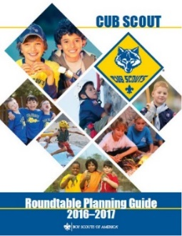

Remember -

EPIC ROUNDTABLES -
E - Exceptional & Experiential
Strive to present an exceptional and experience based program
P - Personally & Program Relevant
Make the presentation personally and program level relevant to the Leaders who attend.
I - Instructional & Inspiring
Structure your program so that it is an instructional experience, providing examples of the method of delivery, that motivates and inspires Leaders
C - Concrete
Bring all of these components together at one place at one time, to deliver a concrete experience that provides Cub Scout Leaders with what they need to deliver a successful program at the Den and Pack level.

CUBMASTER THOUGHTS
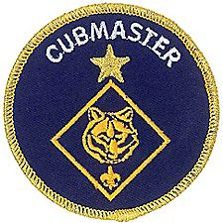

The Uniform
Mark Diienno, Cubmaster Emeritus
Why is it that in almost all BSA literature and programs, leaders, especially Cub Leaders, are pictured wearing jeans while wearing the uniform shirt?
What is it that stops volunteers from committing fully and wearing the proper uniform?
I am not embarrassed about wearing the full uniform.
Shirt, pants, belt, and socks.
If your son was on a sports team, would he pick and choose what parts of the uniform he would wear while participating in this said sport?
Of course not.
We should have the same approach.
The Uniform is the equalizer, bringing together boys and leaders from different faiths, ethnic backgrounds, and Social status.
It helps defines us as an organization.
National should set the tone with all it does and follow its own policies and program.
As Cubmaster, I know that I set the tone for my unit.
I wear the uniform properly, and help encourage others to completely commit to this important method of scouting.
We also "recycle" our uniforms by passing down uniforms as the boys continue in their scout journey.
This will help those who may have an issue with the cost of purchasing a new uniform.
A unit could also set aside a fundraiser to help defray the cost, for those in the unit who may require financial assistance.
Do not underestimate the importance of wearing the uniform properly.
It is as equally important as any other method in scouting.
Check out uniforms at BSA's Uniform site
http://bsauniforms.org/
The have a page for each Cub uniform –
- Tiger
- Wolf,
- Bear,
- Webelos, Blue and Khaki
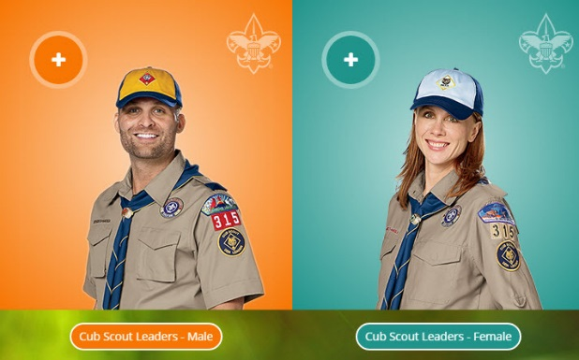
And pages for Male and Female Leaders!!
And they are all in complete uniform –
no mention of leaving parts out!!

BSA Official Uniform Policy
http://www.scouting.org/filestore/pdf/33066(15)_Web-2.pdf
The Boy Scouts of America has always been a uniformed body. Its uniforms help to create a sense of belonging. They symbolize character development, citizenship training, and personal fitness. Wearing a uniform gives youth and adult members a sense of identification and commitment.
Personal equality. The uniform represents a democratic idea of equality, bringing people of different racial, economic, religious, national, ethnic, political, and geographic backgrounds together in the Scouting tradition.
Identification. The uniform identifies youth and adult members of the Boy Scouts of America, visible as a force for good in the community. When properly and smartly worn, the uniform can build good unit spirit. When worn on the correct occasions, it can attract new members.
Achievement. The uniform shows the wearer’s activity, responsibility, and achievement. What each youth or adult member has accomplished with program opportunities can be recognized by the insignia worn on the uniform.
Personal Commitment. The uniform is a constant reminder to all Cub Scouts, Boy Scouts, Varsity Scouts, Venturers, Sea Scouts, and adults of their commitment to the ideals and purpose of the Boy Scouts of America. The uniform is a way of making visible members’ commitment to a belief in God, loyalty to country, and helping others at all times. While wearing the uniform is not mandatory, it is highly encouraged. The leaders of Scouting— both volunteer and professional—promote the wearing of the correct complete uniform on all suitable occasions.
The Rules and Regulations and Policy. The following pages contain our uniform policy as taken from the Rules and Regulations of the Boy Scouts of America. The chapters contain applications of the regulations to each program area. Neither the Rules and Regulations of the Boy Scouts of America, the policy, nor the program applications may be added to or changed in any way unless approved by the National Executive Board of the Boy Scouts of America through its Program Impact Department.
Effective Oct. 1, 2013, the official stance on the Boy Scouts of America’s uniform policy is that shirts and blouses are to be worn tucked in, regardless of whether the wearer is a Cub Scout, Boy Scout, Varsity Scout, Venturer, or adult Scouter. All Sea Scout uniforms are designed to be tucked in except youth dress whites and youth dress blues. In the past, guidelines have simply stated the uniform wearer should be neat in appearance. Neatness includes tucking in the shirt or blouse. This update will appear in related resources, such as the uniform inspection sheets, as they are revised and printed.
Cub Scout Uniforms -
According to BSA, the Cub Scout and Webelos Scout uniforms has six required parts: See: http://www.scouting.org/scoutsource/CubScouts/Uniform/Parents.aspx
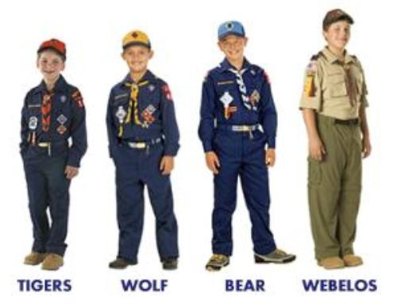

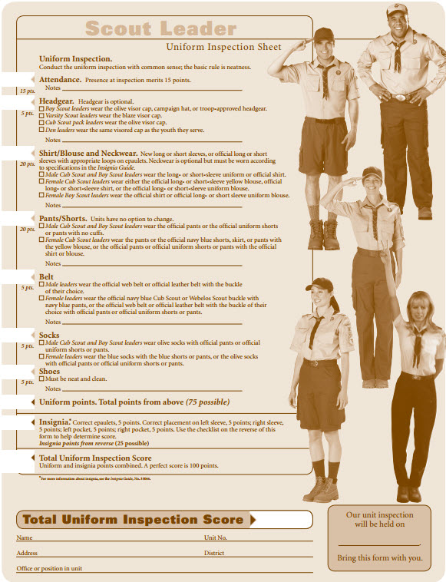

The six parts of a Cub Scout uniform are:
- Cap. Tiger cap, Cub Scout Wolf cap, Cub Scout Bear cap, or Webelos cap
- Neckerchief and Slide. Triangular shape, appropriate color for the rank level
- Shirt. Official long- or short-sleeve, blue for Tiger Cubs, Wolf Cubs, and Bear Cubs. Either blue or tan (optional) for Webelos Scouts.
- Belt. Official blue web belt. Webelos Scouts wearing optional tan uniform may wear either the blue belt (preferred) and Webelos buckle or olive belt and Webelos buckle. Cub Scout belt loops are worn only on the blue belt.
- Pants/Shorts. Official, pressed; no cuffs. Blue for Tiger, wolf, and Bear Cub Scouts. Either blue (with blue shirt) or olive (with tan shirt) for Webelos Scouts.
- Socks. Dark blue official socks with orange tops for Tiger Cubs and gold tops for Cub Scouts. Webelos Scouts wearing optional olive/tan uniform wear official Boy Scout olive socks.
Adult Leader Uniforms
The adult leader uniform parts are best shown on the Uniform Inspection Sheet (BSA # 34048) See previous page.

RANK ADVANCEMENT CHARTS
Track your Den's completed Adventures and progress to earning their next rank on a wall chart. This worked wonders for us when our son was a Cub Scout. Everyone wanted to have the most completions. And they could see where the goal was.
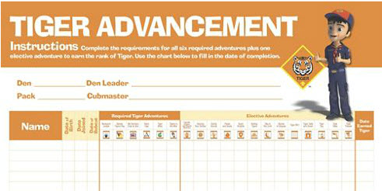
Tiger Advancement Chart, Item: 620578
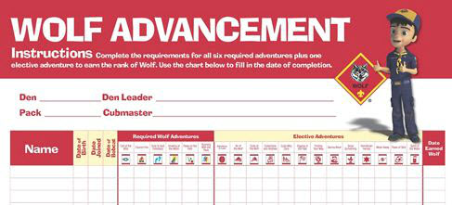
Den Advancement Chart, Item: 620579
(Scoutstuff.org listing says Den Advancement Chart not Wolf)
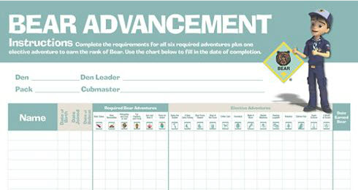
Cub Scout Bear Advancement Chart, Item: 621006
(Not sure why this one says Cub Scout. None of the others do)
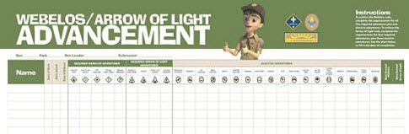
Webelos® Advancement Chart, Item: 620577

LIONS

WHAT’S NEW FOR LIONS FOR 2017-2018
There is a new PowerPoint available at http://scoutingwire.org/lion/ with everything you need to know about changes to the still a Pilot Lion Program.
Highlights include:
- Lots of new recruitment help, for example:
A new PDF brochure PDF is on-line.
A Recruiter patch is available!
And other recruitments hints and materials.
- A Lion may wear either the Lion Cap and Tee shirt (Currently, $3 discount if you buy hat and Tee together!!) or, if he and his parents desire, the Blue Cub Scout Field Uniform.
- Attendance at Pack Meetings is acceptable. Packs should find ways to actively involve the Lions in PM program, activities, skits, etc
- Pinewood Derby is a Pack decision – Lions may participate in Pinewood Derby (Use of wedge car is mentioned to minimize cutting) or hold a “Veggie Derby.”
Pre-Cut Pinewood Derby Wedge Kit, SKU# 614417
The same top quality pine blocks that are used in the Official Pinewood Derby® Kit pre-shaped into a wedge with pre-cut axle grooves. Eliminates the need for woodworking tools or skills. All you need to do is add wheels, weights, sand and decorate for a car that is ready to race!
Veggie Derby Cars
- Fundraising participation is the family’s decision. Fundraising and mandatory levels are not required. Some parents do want to have the individual option to fundraise. If popcorn is sold by Lions then Show and Sell with older boys and parents would be the preference, door to door selling needs the parents at the Lions’ side.
BRYAN’S BLOG ON 2017-2018 LION PROGRAM
Lion pilot program for kindergarteners off to a roaring start, with exciting changes coming for 2017-2018
August 14, 2017
Based on feedback from parents, as well as surveys and focus groups, the BSA has some changes to announce to the Lion pilot program for this fall. The link is: https://blog.scoutingmagazine.org/ Then search for LION (singular not plural)
Later in this item you will find links to all Bryan’s Blog entries (that I know) on the Lion Program.
WHY SHARED LEADERSHIP?
- Engages the families and helps create ownership of program by families.
- Creates a stronger loyalty and connection to the den, families, and Scouting.
- Provides an opportunity to watch potential leaders in action—as a unit or pack considers future leaders.
- Millennial parents want to try things out before committing. They prefer to commit to small roles first.
- The boys love watching their “parents be the leader!” (Ask them for their meeting in front of their son. Watch how he encourages them to do it! (Please, Please Mommy! (Daddy!) You can do it!) be sure to tell them, all you need to know is in the “Parent and Leader Guide.”
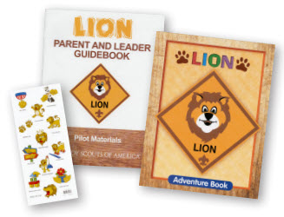
LION ORIENTATION VIDEO
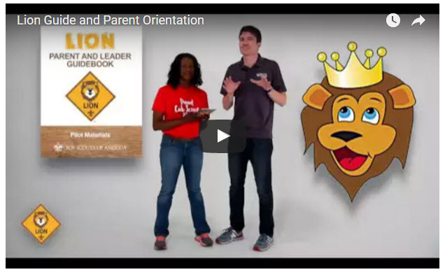
Video URL - https://youtu.be/YaIBTUO70JA
ORGANIZING FOR LIONS
From – New Birth of Freedom Council
For those packs that are thinking ahead about participating in the Lion Scouts program, having the right volunteers involved in delivering the Lion Scouts program will be important. Research shows that the most important person for a successful Scouting experience is a good leader. There are two new adult leader positions within the pack that are directly engaged in the delivery of the Lion Scouts program – a Lion Coordinator and a Lion Guide. Where do these positions fit into the current pack structure? What is the Lion Coordinator’s job description?
- Is an experienced and successful den leader
- Understands den and pack operations within the overall structure of Cub Scouting
- Demonstrates excellent communication and organization skills (and will remain in at least monthly contact with the Lion dens)
- Participates as needed in the unit’s School Night with all new Lions and their parents
- Assists the Lion guide in hosting the first orientation meeting for all the individual Lion dens in their pack
- Serves as a coach and mentor for Lion Guide
HIGHLIGHTS
- 61% of Lion parents indicate they have no other child in Scouting. We are reaching Families new to Scouting as well as siblings of Scout familie.
- 91% of parents say their Lion will be moving to Tigers and 82% of Lion Guides say most will stay.
- Satisfaction is very high 90%. For the T-shirt, shared leadership, age appropriate activities, youth Adventure book, immediate recognition stickers, meeting duration, frequency and content. The Leader Guidebook is not intimidating and is simple and easy for new parents to follow for effective meetings. Adventures are engaging for the boys.

LION HUB
Big Smiles - Build Bigger Futures
BSA has launched a new Lion Hub at:
http://scoutingwire.org/lion/
Available Lion Resources include:
LION VEGGIE CAR DERBY FLYER
PARTICIPATING COUNCILS
PROGRAM OVERVIEW
FAQS
The FAQ PDF is 13 pages long!! Lots of information!!
LION GUIDE AND PARENT ORIENTATION VIDEO
LION GUIDE AND PARENT ORIENTATION POWERPOINT
LION PRODUCTS NOW AVAILABLE!
NEW LION PROGRAM MATERIALS
LION RECRUITMENT BROCHURE
LION RECRUITMENT BROCHURE, PRINT-READY WITH CROP MARKS
CONTACT US
For Councils
COUNCIL OVERVIEW POWERPOINT
LION PROMOTIONAL MATERIALS (HELP SPREAD THE WORD!)
LION PROMOTIONAL VIDEO
LION RECRUITMENT BROCHURE
LION RECRUITMENT BROCHURE, PRINT-READY WITH CROP MARKS
REGISTRATION PROCESSING
Lion Parents say developing character is the #1 reason to join Scouting.
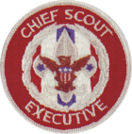
THE CHIEF SCOUT EXECUTIVE ON LIONS
What We Know According to a 2014 U.S. Census Bureau report, 57 percent of kids ages 6–17 participate in at least one after-school extracurricular activity. This means that by the time they are eligible for Tigers, more than half of them already are engaged in some type of athletic, artistic or other program.
Often, children become attached to lifelong activities at an early age — that is certainly a goal we would have, as we know the long-term benefits of Scouting involvement include strong asset development in the areas of character and leadership. However, we also know that when youth participate in numerous activities at an early age, and miss joining Scouting, they are unlikely to do so at adolescence.
What will be important to learn in the next few years, if the initial entry point works at the kindergarten-age level, is will this cause losses at a different age, or will the program keep the same retention all the way through to Boy Scouting?
What we learn from the pilot Lion format could also help us assess and create a smoother transition from Webelos into Boy Scouting. Too many parents now see a barrier or obstacle, rather than a smoother transition. You will often hear parents say, “We did Cub Scouting, now we’re not sure if we are going to do Boy Scouts.” We do not have a seamless transition into Boy Scouts for a number of reasons. This pilot test will help us think through some of these issues.
We want to be sure that our Lion program delivers the right mix of character and leadership values and that we set the bar high. The program must be sustainable, we must have the right infrastructure to support it, and it needs to meaningfully address the needs of parents who want their kids to join Scouting at an earlier age.
You can rest assured that we will carefully evaluate our progress and keep you apprised of the results. Stay tuned
Reprinted from "The Chief's Corner" on Scoutingwire.org

MORE LION INFORMATION
Bryan's Blog has written about Lions –
Go to http://blog.scoutingmagazine.org and you can look them up. Here are a few -
August 14, 2017
Lion pilot program for kindergarteners off to a roaring start, with exciting changes coming for 2017-2018 Based on feedback from parents, as well as surveys and focus groups, the BSA has some changes to announce to the Lion pilot program for this fall.
September 27, 2016
Lion pilot program brings Scouting to kindergartners in nearly 200 councils Answering the call of families who want a Scouting program for kindergarten-age boys, the BSA has expanded its Lion pilot program to nearly 200 councils.
April 28, 2016
In full gear: Here’s your first look at Lion Scouts T-shirts and hats This week we get our first look at new T-shirts and caps to be worn by Lions — members of the pilot program for kindergarten boys set to roll out this fall.
April 15, 2016
Will Lions be part of the pack? (And answers to your other Lion questions) Will Lions be part of the Cub Scout pack? By adding another year to the program, is the BSA concerned about "burnout"? And why was the Lions name chosen?
March 10, 2016
New details released about Lions, the pilot program for kindergarten boys In Lions, the new pilot program for kindergartners, boys wear T-shirts instead of uniforms and earn adventure stickers instead of adventure loops.
There are slideshows on the web put up
by local councils. Some examples are:
Be sure to vet these against the 2017-2018 changes!!
WD Boyce Council has "Lion Cub Pilot Program" at: http://www.wdboyce.org/document/lion-cub-pilot-program/161325
Northern Star Council has a training slide show for District Coordinators and others at: https://www.signup4.net/UPLOAD/NORT26A/LION12E/District%20Lion%20Cub%20Coordinator%20Training.pdf
Councils have put up webpages about what their packs need to know to begin a Lions Program. Examples are:
WD Boyce:http://www.wdboyce.org/cub-scouts/lion-cub-pilot-program/63360
Garden State (My Council): http://www.gardenstatescouting.org/lion-program-0
Garden State, also, has an FAQ PDF - http://www.gardenstatescouting.org/sites/default/files/Lion%20Program%20FAQ.pdf
And we have created a Facebook page for our units with Lions - https://www.facebook.com/GSCLion/
Selected FAQ's
National has posted a PDF file of FAQs about the LION program at http://www.scouting.org/filestore/pdf/Lion_FAQs.pdf
Cub Hub Blog Lion Posts
The items listed below are from the Cub Scout Learning Library . Check it out frequently for new lion and other new Cub Scout items. You can go to www.cubscouts.org and click on the Cub Hub Blog.

A Look at the Lion Uniform and Gear Lion uniform, shirts and hats! In case you’ve missed the Lion uniform images floating around the Digital Pack…
Will Lions Join Tigers and Bears? Oh My! — A Lions FAQ Lions: Answers to your top questions. We have seen a lot of great feedback, comments and questions from…
5 Questions (and Answers) for the New Lion ProgramMore Information on the New Lion Program As we mentioned earlier on the Cub Hub, Select councils will…
Lion Program will bring Scouting to Kindergarten BoysSomething Roaring in the Jungle There is an exciting new Scouting program called “Lion” for Kindergarten-aged boys…
CUB SCOUT LEARNING LIBRARY

The NEW https://cubscouts.org/ !!!
Per my contacts at National Council (some of which have since moved back to Council assignments or other departments), further development of the Cub Scout Learning Library (aka https://cubscouts.org ) is currently on hold as BSA assesses its digital strategy.
BUT, obviously,
the Cub Scout Blog is still active!!
Once that assessment is done and plan for moving forward is developed, additional on-line support for CS leaders will be available, either at cubscouts.org or a new site depending on the results.
The November 30, 2016, Adventure Plan changes will not be on this site until the assessment is done.
This is the Cub Scout Learning Library –
Everything you could want to know for Cub Scouts is or will be here. And all within a click or 3 of the home page. National heard the message that although things were at www.scouting.org they were often buried too deep to be found.
This site has admin stuff and practical stuff. The new Den Leader Resource Books are here. You can download some of the pages for FREE
This website is a great resource. There are still parts under construction but what is there is
GREAT!!
Yes,
https://cubscouts.org
runs on a phone, too!!!

There are 3 tabs on top of the home page –
- Learning Library
- Cub Hub Blog
- Join Scouting
Plus – a magnifying Glass to start a search and Icons for various Social Media –
- Learning Library takes you where you can learn about your position and pick up hints. Besides specifics for dens of each rank, other clickable links include – KEY:
- All or most of material was placed on site this past month
- All or most of material was in place and listed as such in last month's Baloo's Bugle.
- Site / pages under construction
Den Leader
- Den Meeting Basics
- Your First Den Meeting
- Planning Den Outings
- The Parts of a Den Meeting
- Getting Started
Three Core Adventures for the selected rank are listed here. You see & can download the Leader's Guide info for these 3 Adventures.
- Additional Required Adventures
The remaining Core Adventures for the selected rank are listed here. When you click them you get an intro to the Adventure but do not get the Meeting Plans and Resources. You see this note:
To get you started in delivering fun and engaging meetings, complete Den Meeting Plans are available here on the Learning Library for the Backyard Jungle and Games Tigers Play adventures. To obtain Den Meeting Plans for all other adventures, Den Leader Guides are available at your local Scout Shop, online at scoutstuff.org, or as an eBook through Amazon.
- Elective Adventures
All the Elective Adventures for the selected rank are listed here. When you click them you get an intro to the Adventure but do not get the Meeting Plans and Resources. You see the same note (above).
- Building Strong Dens
The Basics of Cub Scouts
- Advancement
- BSA Mission and Vision Statements
- Cub Scout Ages and Ranks
- Cub Scout Uniforming
- Den Flags
- Den Yells
- Leader Survival Kit
- Methods of Cub Scouting
- Purpose of Cub Scouting
- Roles and Responsibilities
- Scout Oath and Law
- What Is Cub Scouting?
- Training
- The Role of Training
- Youth Protection
- Den Planning And Administration
- Advancement Basics
- Advancement Requirements
- Annual Planning For Your Den
- Coordinating Your Den Plan with Pack
- Tracking and Recognizing Advancement
- Youth Protection Training
- Positive Youth Development and Working with Boys
- Developmental Differences Boys 7-11
- Behavior and Discipline
- Positive Youth Development
- Working With Special Needs Cub Scouts (Advice is specific to each Special Need. Lots of research was done to prep these pages.)
- Parents’ Prejoining Conference
- Leadership Techniques
- Working With Specific Disabilities and Needs
- The other positions are still under development:
- Cubmaster
- Committee Chair/Member
- Chartered Org Rep
- Parent / Adult Partner
- Cub Hub Blog takes you to a Cub Scout specific Blog similar to Bryan's Blog. The most recent topics discussed are listed here. There are more at www.cubscouts.org:
Here are the posts from September and October (In reverse chronological order).
October 24, 2017
How to Use Every Part of Your Carved Pumpkin If you’re like us, it pains you to toss aside the insides and seeds from your carved…
October 17, 2017
Best Halloween Candy According to Boys’ Life Online Readers If you’re stocking up on candy to hand out on Halloween, we have sweet answers to the…
October 11, 2017
Cub Scouts Welcomes Girls to Expanded Programs Cub Scouts is thrilled to bring the benefits of Scouting to more kids than ever! Beginning in…
October 5, 2017
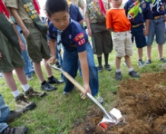6 Activities You’ll Remember if You Grew Up in Scouting From outdoor fun to Scout style, if you grew up in Scouting, your mind probably brims with…
September 29, 2017
Cook an Egg with No Cookware: Fry an Egg in a Potato Over Your Campfire Did you know you can cook an egg in a potato? Try this resourceful and unique recipe…
September 29, 2017
Cub Scouts Race Pinewood Derby Cars in SunTrust Park and Get a Visit From Their MLB Heroes Nothing tops the feeling of sending your Pinewood Derby car flying down a track … unless, you’re…
September 26, 2017
#ShareScouting to Win a $100 Gift Card for the Scout Shop! Is your camera roll packed with photos of the pack? Do you love sharing updates about your…
September 22, 2017
5 More Camping Recipes to Cook in Oranges When we shared our recipe for how to make a brownie in an orange, you responded with…
September 20, 2017
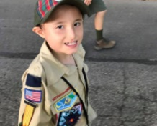Her Son is on the Autism Spectrum so She Signed Him Up for This Activity…If your son has a unique way of learning or different abilities than his peers, you may…
September 12, 2017
3 Research-Backed Benefits of Being a Cub Scout The benefits of being a Cub Scout make a big difference in the course of a Scout’s…
September 8, 2017
The Campfire Recipe Your Kids Will Love: Brownie in an Orange If you’ve never tasted the citrusy, sweet concoction that is a brownie in an orange, here’s how…
September 7, 2017
Why Cub Scouting’s Program for Kindergarten-age Boys is Right for Your Family: About the Lion Pilot Program The Boy Scouts of America’s program for 5 and 6-year-olds has families around the country thrilled to…
September 1, 2017
5 Cool Things You Can Do if You’re a Cub Scout Being a kid can be a lot of fun. But if you’re a Cub Scout, those years…
- Join Scouting takes you to
www.beascout.org
This picture on https://beascout.scouting.org/ home page. Check it out!!
Also, on the home page –
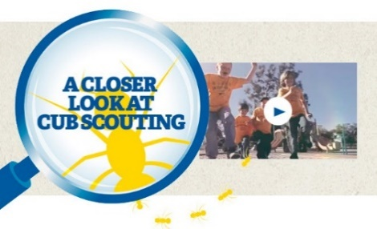
Click for a YouTube Video on Cub Scouting.
https://www.youtube.com/watch?feature=player_embedded&v=dqKFgk8SJlE
And 6 picture links -
These Six Links take you to:
www.scoutstuff.org –The Supply Division site where you can locate your nearest National Scout Shop or other local seller of Scout Stuff or buy your Scouting supplies on-line.
http://scoutingwire.org/ - Where you can get the latest Scouting News from around the country. You can sign up to get notifications when things are posted here...
https://cubscouts.org/pinewood-derby-2016-photo-contest Apparently they are not going to run this event for 2017 as you get taken to a page that says promotion has ended. Pictures of entries that were received have been removed.
https://www.scoutbook.com/Where you can get the Scoutbook APP to track your son's Scouting Experience from Tiger to Eagle Scout.
www.boyslife.org– Go directly to the on-line edition of Boys 'Life
http://scoutingwire.org/marketing-membership/ Get resources and materials to strengthen your unit at BSA's marketing and membership site. Learn the best practices and tips employed by the most successful units.

ADVENTURE PLAN TRACKERS
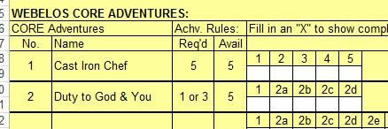
- Tracking Spreadsheets are posted on the USScouts Advancement webpage (http://usscouts.org/advance/cubscout/intro.asp). The spreadsheets were tested by a software developer who said they are so good he sees no reason to develop his own!!
- Utah National Parks Council, also, has Excel spreadsheets posted for all the new Adventure Plan requirements on their Akela's Council BlogSpot.
http://akelascouncil.blogspot.com/search/label/Tracking%20Sheet (The page starts with Arrow of Light scroll down for other ranks)
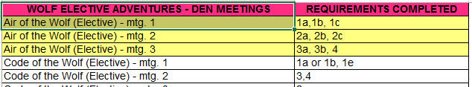
- A spreadsheet that correlates Meetings to Adventure requirements is available on the Utah National Parks' Akela's Council Blogspot at https://www.dropbox.com/s/yb8fweg7etnhqrt/WOLF%20BEAR%20WEBELOS%20REQUIREMENTS%20-%20MTGS.xlsx?dl=0 . It has all the Wolf, Bear, Webelos and AOL Adventure requirements.
These Advancement Spreadsheet workbooks are FREE for Scouters. But be COURTEOUS and observe the following -
PLEASE do not download the files from either site to email or send them digitally to others.
They are for your personal / pack use only. If you would like to share these files with others, please copy / send the link to them and send them to the site so they can print off their own. They would love everyone that wants a copy to get their own copy absolutely free. Both USScouts and Utah National Parks receive Ad money based on the number of people visiting the site. That ad money helps keep their websites open. Please help them (us) by encouraging others to visit to obtain files.

TRACKING BOYS’ PROGRESS
IN THE MODIFIED CUB SCOUT ADVENTURE PLAN
Judy and I have found several places on the web where there are aids to use to track boys’ progress in the modified Adventure Plan. Judy is placing a more detail in Baloo’s Bugle, Part IV – Den Meeting Helps.
- The Bobwhite Bather blog site (https://bobwhiteblather.com/mid-year-cub-scout-program-updates/ ) has a discussion of changes.
- Cubmaster Tom, responded providing links to documents he formatted to paste into the boys’ books for each modified Adventure. See example below:
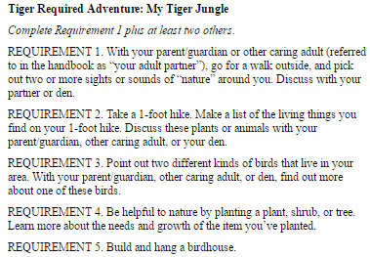
The complete Tiger document is at: https://docs.google.com/document/d/1ka_AkwxDkKgNjLrAOUHzbQQqCkruDCC8RyxtMFvrFO8/edit?usp=sharing. The links for the other ranks are in the comment on Bobwhite Blather.
- Bert Bender, Atlanta Area Council, replied,
Having finished several deep dives through the requirements changes, I’ve updated the page at http://www.southfultonscouting.com/node/3557 to not only show exactly what got changed and what didn’t change, but now also add comments intended to be a practical guide to whether you need to look at the new 11/30/16 language, and whether when those might be a useful alternative.
Comments after some Adventures encourage (sometimes plead) that dens avoid the “easy button” approach. Doing the June 1, 2015 handbook elements will often result in better outcomes and experience in Cub Scouting.
- Utah National Parks Council’s Akelas Council Blogspot has revised paper tracking sheets (http://akelascouncil.blogspot.com/) Thanks to Celeste Hunt for creating these.
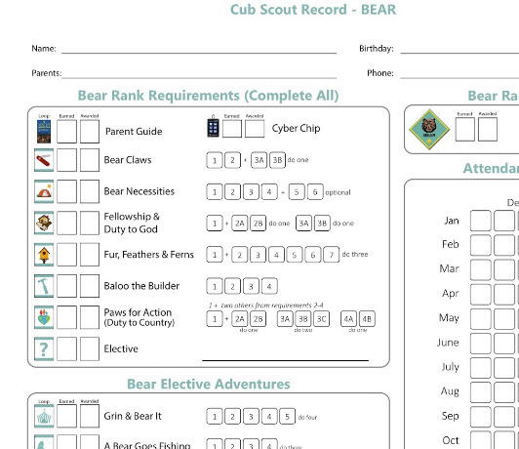
Celeste says, “Tracking, planning, and recognition are so important in Cub Scouts. This new tracking sheet helps you to be able to keep track of where each boy is at towards the Bear, Adventures, and Cyber Chip requirements. I print 2 copies of the tracker on cardstock for each boy. One for his book and one for my leader binder. I place it next to the trackers for the religious and other awards we are doing. I have tab for every boy with all his trackers. Complete information on each boy in one place. Not every boy is there every week. By doing this, I always know what each boy has done. If the parents ever have questions, I have a place to check, and I can always copy each tracking sheet to show them where their boy is.
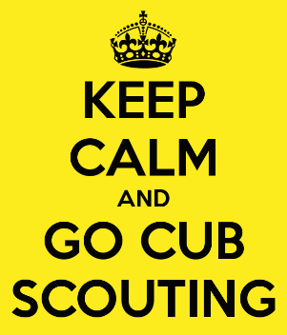

CUB SCOUT
LEADER TRAINING

IN-PERSON TRAINING
Position-Specific In-Person Training Guides Available Now! The training guides for
- Den Leader (http://www.scouting.org/filestore/training/pdf/515-215.pdf ),
- Cubmaster/Assistant Cubmaster (http://www.scouting.org/filestore/training/pdf/511-503_WB.pdf ), and
- Pack Committee (http://www.scouting.org/filestore/training/pdf/511-504_WB.pdf )

Are available on Scouting University. You can access them at http://www.scouting.org/training/adult.aspx .
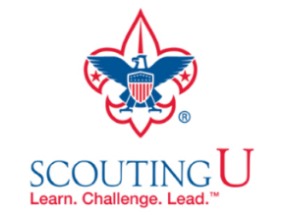

ON-LINE TRAINING
On-Line Training for all Cub Scout positions has been available since October 25, 2015
The online training for Den Leaders, Cubmasters, Committee Chairs and members, and Chartered Organization Representatives is totally updated with help from volunteers from around the country. The new training is divided into shorter, more targeted modules so leaders can get the training they need, in the order they want, any time they need it. It is organized around the learning needed prior to the first meeting, in the first 30 days, and to be position-specific trained. This training was developed to be implemented in conjunction with the BSA’s new learning management system. Keep an eye on
my. Scouting Tools (log in at https://My.Scouting.org) for more information.
Go to the BSA Volunteer Training Team Facebook page (Link above) and.
Then you automatically receive the latest news!!
If you are having difficulties with
the training or system call
BSA Member Care at 972-580-2489
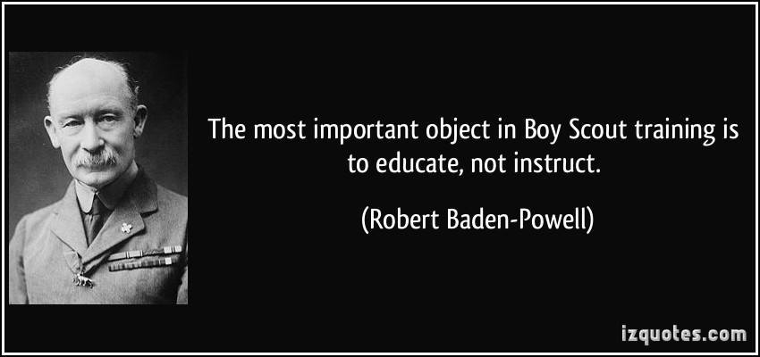
A Typical Learning Plan has several parts –
There is no need to complete more than one section at a time. Do what you have time to do.
Here you can see the three parts of the CM Course -
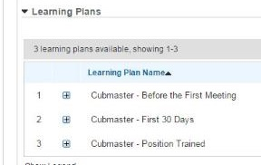

Each of these three parts is broken down into "bite sized" chunks:
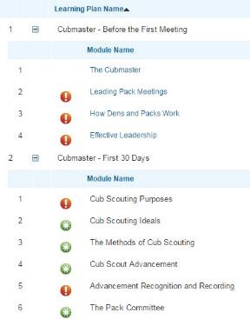
Go check it out and get your
people trained!!!

