# CUB SCOUT ROUNDTABLE PLANNING GUIDE

**The CS RT PG is issued**

The 2017-2018 CS RT PG may be found at - <http://www.scouting.org/filestore/cubscouts/pdf/510-714(17)_CS.pdf>

On page 37 0f the 2017-2018 CS RT PG it states:

**Introduction to the New Cub Scout Interest Topic Format for 2017–2018**

Based on survey input, the National Cub Scouting Committee has modified the presentation style for the Cub Scout (CS) interest topics for this year. To improve communications throughout the pack leadership, it is recommended that all CS leaders attend the interest topic discussion together as a single group. This will provide everyone with the same information and will facilitate important discussion about these topics between all CS leaders. As always, the CS Roundtable Planning Guide provides suggested options for each council or district. The use of any specific topic is flexible based on the needs of the council or district. Each council or district may also select other topics that would be beneficial to the needs of the CS leaders in their respective council or district. **… The Philmont CS Roundtable Supplements are a great resource to consider for the breakout session model.**

**See Baloo’s Bugle, Part II this month for more details on the CS Roundtable Planning Guide.**

## PHILMONT CUB SCOUT RT SUPPLEMENT

**The November issue is posted!!**

[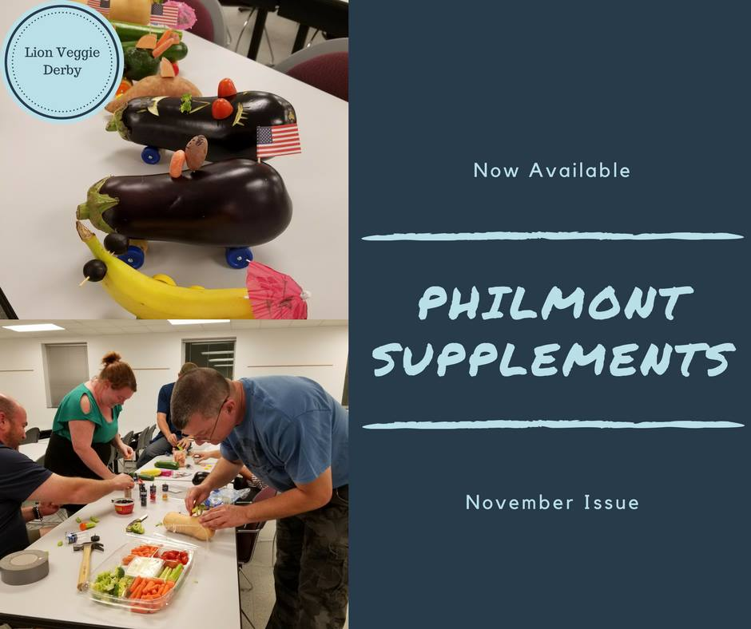](https://lookaside.fbsbx.com/file/The%20Philmont%20Cub%20Scout%20Roundtable%20Supplements%20November%202017%20Kind-%20Paying%20it%20Forward.pdf?token=AWyeZMwaPG2g7Yw3onQHN7CllYk4heHCJx6YOAZhKOf6xvKtxFKOa32YsH_e9tPenWl3c_DHj904O9nDvvvShX9WVnWl8kD7OkMrsKwfWC-GbBvJa62CQRqYnLe_qVxwz5jr-R5Mmc4nuCtuQENLubFY)

Hyperlink on picture. If using paper copy – go to BSA Roundtable Commissioners on Facebook. (See On-Line Support below)

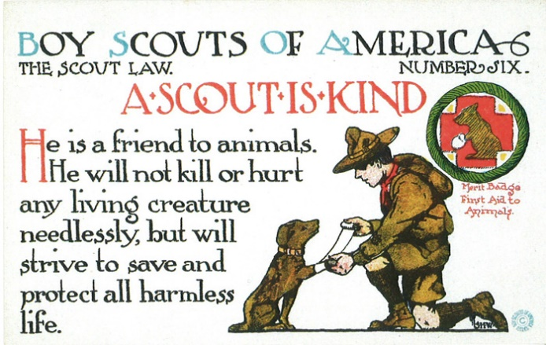

# TABLE OF CONTENTS

CUB SCOUT ROUNDTABLE PLANNING GUIDE 1

PHILMONT CUB SCOUT RT SUPPLEMENT 1

TABLE OF CONTENTS 2

CORE VALUES 2

Roundtable Prayer Ideas 3

KIND(NESS) QUOTES 3

BIOGRAPHY 6

“Be Kind to Animals Week®” 6

THOUGHTFUL ITEMS 9

Roundtable Prayers 9

Sowing Seeds of Kindness 9

Charity Begins At Home 9

CUB SCOUT TIPS 12

SIGNS OF SCOUTING 12

DEN MEETING TOPICS 14

CHARACTER COMPASS 14

THEME RELATED STUFF 15

THEME RELATED ADVENTURES 15

PACK MEETING THEMES AND PLANS 15

PACK MEETING THEMES 16

Paying it Forward Diagram 16

UPCOMING MONTHS 17

CUBMASTER THOUGHTS 18

Lions (The Beginning) 18

WEBELOS 20

December Crazy Holidays 22

December – A Month for Kindness 24

THE BILL OF RIGHTS 26

Fun Facts About Ties 27

SPECIAL OPPORTUNITIES 28

WORLD CREST 28

BSA WORLD CREST RINGS 29

THE MESSENGERS OF PEACE RING 29

INTERNATIONAL SPIRIT AWARD 30

CUB GRUB 31

FORWARD RECIPES 31

HOLIDAY IDEAS 33

LAST THINGS 36

THE CHRISTMAS SCOUT 36

CHRISTMAS SPIRIT AND THE GIMME PIG 37

**The Christmas Scout was certainly "Paying It Forward." Check it out!**

# CORE VALUES

**The Core Value for this month, December, is the 6TH point of the Scout Law - KIND**

A Scout is **KIND.**  The theme **PAYING IT FORWARD** is used to help Cubs understand being **KIND.**

**A SCOUT IS KIND**A Scout knows there is strength in being gentle. He treats others as he wants to be treated. Without good reason, he does not harm or kill any living thing.

**HOW DOES “PAYING IT FORWARD” RELATE TO THIS SCOUT LAW POINT?**

At this pack meeting, Cub Scouts will learn the importance of treating others as they want to be treated. Although it is nice when someone does something kind for you, it is even more rewarding to do something kind for someone else—without expecting anything in return.

**Per our Founder, Lord Baden-Powell**

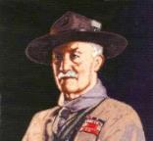

**A SCOUT IS KIND***Baden Powell said -* **A SCOUT IS A FRIEND TO ANIMALS.** He should save them as far as possible from pain, and should not kill any animal unnecessarily, even if it is only a fly---for it is one of God's creatures.  
*(Scouting For Boys, 1908)*

**The Spirit of Love is after all,   
the Spirit of God working within you.**

*Lord Robert Stephenson Smyth Baden-Powell*

***Commissioner Dave Rule of Thumb -****Although not 100%, I use this Rule of Thumb when discussing* ***Courteous*** *and* ***Kind*** *with Scouts – One is* ***Courteous*** *to people, and* ***Kind*** *to animals. "Be Kind to Animals Week" still exists!!*

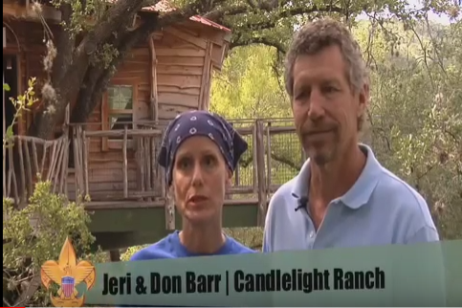**** In this video, the "Believe It Live It" team profiles Jeri and Don Barr and explains how their Candlelight Ranch demonstrates kindness to kids with sickness or disabilities. Go to URL: <https://www.youtube.com/watch?v=nCuf5GJDEcc>

**Roundtable Prayer Ideas**

*From old CS Roundtable Planning Guides*

Let us take a moment to reflect on all life, knowing that a Cub Scouts, we will do our best to take care of all of earth’s great resources. Amen

Chief Seattle said, “What is man without the beasts? If all the beasts are gone, man would die from great loneliness of spirit. For whatever happens to the beasts soon happens to man. All things are connected. AMEN

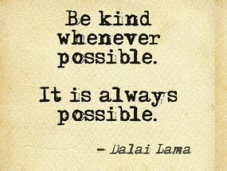

# ~~http://www.scouting.org/scoutsource/Media/Relationships/ScoutSabbathServices/~/media/Images/relationships/15-208/bp.gif.ashx?w=184&h=225&as=1~~KIND(NESS) QUOTES

*Quotations contain the wisdom of the ages, and are a great source of inspiration for Cubmaster’s minutes, material for an advancement ceremony or an insightful addition to a Pack Meeting program cover.*

An animal has been made by God, just as you have been. He is therefore a fellow-creature.   
Sir Robert Baden-Powel

“No act of kindness,   
no matter how small, is ever wasted."  
**Aesop,   
Greek Slave and Fable Author (620BC–560 BC).**

Never be so busy as not to think of others.   
– Mother Teresa

Human kindness has never weakened the stamina or softened the fiber of a free people. A nation does not have to be cruel to be tough. -Franklin D. Roosevelt

Kindness is the language which the deaf can hear and the blind can see. -Mark Twain

You cannot do a kindness too soon, for you never know how soon it will be too late.   
-Ralph Waldo Emerson

Guard well within yourself that treasure, kindness. Know how to give without hesitation, how to lose without regret, how to acquire without meanness.   
-George Sand

A warm smile is the universal language of kindness.   
-William Arthur Ward

Constant kindness can accomplish much. As the sun makes ice melt, kindness causes misunderstanding, mistrust, and hostility to evaporate. -Albert Schweitzer

Carry out a random act of kindness, with no expectation of reward, safe in the knowledge that one day someone might do the same for you.   
-Princess Diana

Love and kindness are never wasted. They always make a difference. They bless the one who receives them, and they bless you, the giver.   
-Barbara de Angelis

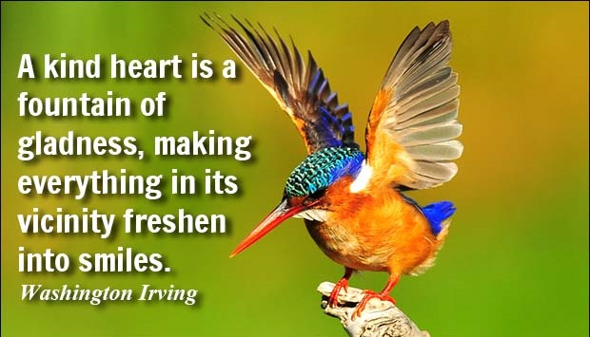

Remember there's no such thing as a small act of kindness. Every act creates a ripple with no logical end. -Scott Adams

One who is kind is sympathetic and gentle with others. He is considerate of others' feelings and courteous in his behavior. He has a helpful nature. Kindness pardons others' weaknesses and faults. Kindness is extended to all -- to the aged and the young, to animals, to those low of station as well as the high.   
-Ezra Taft Benson

There is overwhelming evidence that the higher the level of self-esteem, the more likely one will be to treat others with respect, kindness, and generosity.   
-Nathaniel Branden

Wherever there is a human being, there is an opportunity for a kindness. -Lucius Annaeus Seneca

Because that's what kindness is. It's not doing something for someone else because they can't, but because you can. -Andrew Iskander

You can accomplish by kindness what you cannot by force. -Publilius Syrus

Always be a little kinder than necessary.   
-James M. Barrie

Transparency, honesty, kindness, good stewardship, even humor, work in businesses at all times.   
-John Gerzema

Kind people are the best kind of people. -Anonymous

Kindness is more important than wisdom, and the recognition of this is the beginning of wisdom.   
-Theodore Isaac Rubin

Three things in human life are important. The first is to be kind. The second is to be kind. And the third is to be kind. -Henry James

A single act of kindness throws out roots in all directions, and the roots spring up and make new trees.   
-Amelia Earhart

How beautiful a day can be when kindness touches it!   
-George Elliston

One who knows how to show and to accept kindness will be a friend better than any possession. -Sophocles

He that has done you a kindness will be more ready to do you another, than he whom you yourself have obliged. -Benjamin Franklin

Never believe that a few caring people can’t change the world. For, indeed, that’s all who ever have.  
 – Margaret Mead

The simple act of caring is heroic. – Edward Albert

When I was young, I admired clever people. Now that I am old, I admire kind people.   
– Abraham Joshua Heschel

Do your little bit of good where you are; it’s those little bits of good put together that overwhelm the world. – Desmond Tutu

When you are kind to others, it not only changes you, it changes the world. – Harold Kushner

I feel the capacity to care is the thing which gives life its deepest significance. – Pablo Casals

Be kind, for everyone you meet is fighting a harder battle. – Plato

You cannot do a kindness too soon, for you never know how soon it will be too late. – Ralph Waldo Emerson

If you want to lift yourself up, lift someone else up.  
 – Booker T. Washington

Unless someone like you cares a whole awful lot, nothing is going to get better. It’s not. – Dr. Seuss

Always stop to think whether your fun may be the cause of another’s unhappiness. – Aesop

To belittle, you have to be little. – Kahlil Gibran

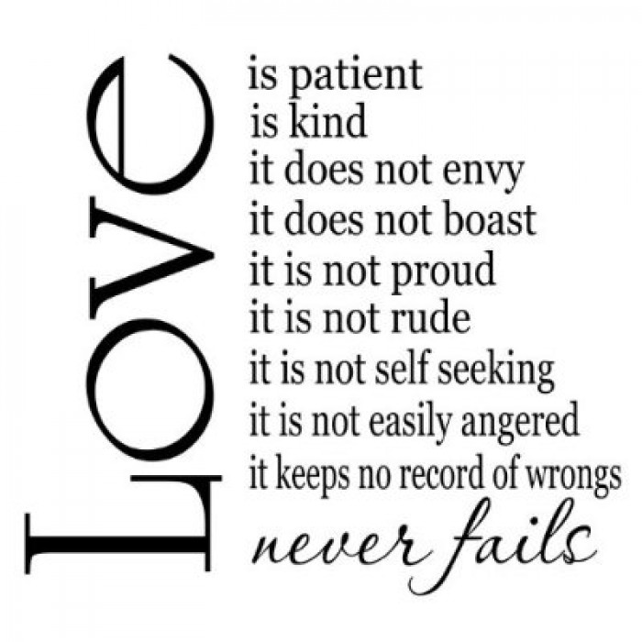

**I Corinthians 14: 4-8**

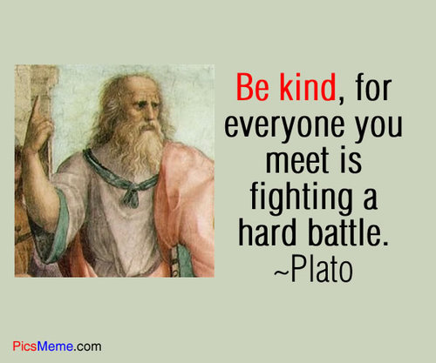

Of all virtues and dignities of the mind, goodness is the greatest. – Francis Bacon

Goodness is the only investment that never fails.  
 – Henry David Thoreau

There is no exercise better for the heart than reaching down and lifting people up. – John Holmes

Life is mostly froth and bubble. Two things stand like stone. Kindness in another’s trouble, Courage in your own. – Adam Lindsay Gordon

Too often we underestimate the power of a touch, a smile, a kind word, a listening ear, an honest compliment, or the smallest act of caring, all of which have the potential to turn a life around.  
 – Leo Buscaglia

That best portion of a man’s life, his little, nameless, unremembered acts of kindness and love.  
 – William Wordsworth

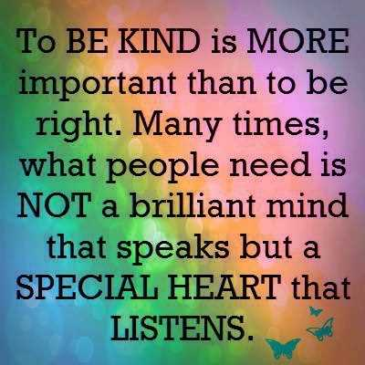

**Quotes About Compassion**

*Alice Retzinger, Golden Empire Council*

If you want others to be happy, practice compassion. If you want to be happy, practice compassion. Dali Lama

Compassion will cure more sins than condemnation.   
Harriett Ward Beecher

It is lack of love for ourselves that inhibits our compassion toward others. If we make friends with ourselves, then there is no obstacle to opening our hearts and minds to others. Anonymous

Compassion is not religious business, it is human business … it is essential for human survival.   
Dali Lama

Compassion is based on a keen awareness of the interdependence of all living beings, we are all part of one another, and all involved in one another.   
Thomas Merten

Compassion is the basis of all morality.   
Arthur Schopenhauer

Make no judgements where you have no compassion.   
Anonymous

Compassion is the antitoxin of the soul: where there is compassion even the most poisonous impulses remain relatively harmless. Eric Hoffer

Compassion is not weakness, and concern for the unfortunate is not socialism. Hubert Humphrey

It is much easier to show compassion to animals. They are never wicked. Haile Selassie

By compassion we make others' misery our own, and so, by relieving them, we relieve ourselves also.   
Thomas Browne Sr.

 No man is a true believer unless he desireth for his brother that which he desireth for himself. Muhammad

Man may dismiss compassion from his heart, but God never will William Cowper

Compassion, in which all ethics must take root, can only attain its full breadth and depth if it embraces all living creatures… Albert Einstein

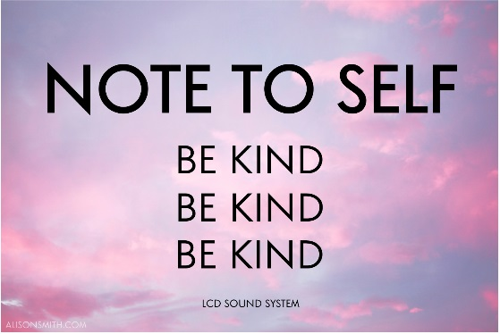

# BIOGRAPHY

## “Be Kind to Animals Week®”

**Reminding us to be kind   
and pay it forward with animals since 1915!**

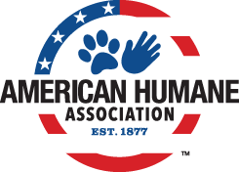

**Be Kind to Animals Week** is the oldest commemorative week in U.S. history – one that taught generations of Americans the value of treating our animal friends with kindness and compassion, turned **102** this past May and is still looking to change the world for millions of animals still in need.

**“Be Kind to Animals Week®”** (May 1-7) is the longest-running, most successful humane education campaign in America, and has been supported by U.S. Presidents, movie stars from Shirley Temple to John Wayne, Eleanor Roosevelt to Betty White, and even Dennis the Menace and Porky Pig.  Look [here](http://kindness100.org/pdfs/Kindness100-Timeline.pdf) (<http://kindness100.org/pdfs/Kindness100-Timeline.pdf> ) for stunning facts, amazing photos, and an unparalleled list of VIP supporters who have been part of this iconic and historic part of our national culture and efforts to build a more humane world during the last century.

On the first week of May every year, millions of Americans come together to voice their concern for and improve the wellness, welfare, and well-being of the nation’s animals by celebrating American Humane Association’s “Be Kind to Animals Week®,” the oldest commemorative week in American history.

Generations of schoolchildren have learned the value of treating all creatures of the earth with care, making it the most popular and successful humane education effort ever. Founded in 1877, American Humane Association is the country’s first national humane organization and the only one dedicated to protecting both children and animals.

The outbreak of World War I in July 1914 set the stage for a global conflagration that would eventually lead to the deaths of some 10 million horses used in fighting across Europe. The need for a strong national voice on the importance of treating animals with kindness, compassion, and humanity was never greater.

On October 5-8 of that year American Humane Association held its 38th annual meeting in Atlantic City, New Jersey. Its leaders recognized that then, more than ever, they needed to step up and champion the issue of humane education and animal welfare.

During those four days in Atlantic City, American Humane Association leaders adopted a resolution that local humane societies and individuals across the country would observe a “Humane Sunday which shall be devoted to the consideration of humanity to all living creatures” and “that this Sunday be followed by a week to be devoted to a special plan for kindness to animals, and to be known as ‘Be Kind to Animals’ week.”

Several churches across the country had held annual “Mercy Sunday” events, where members of the clergy delivered sermons on the importance of the humane treatment of animals. Mercy Sunday was the forerunner to “Be Kind to Animals Week,” but the idea did not yet have the backing of a national leader in the humane movement.

Clergy of all denominations were provided sample sermons to use for Humane Sunday, teaching their parishioners the importance of being humane to all creatures great and small. Local humane groups and schools were likewise given toolkits to help them celebrate “Be Kind to Animals Week” in their own communities. This tradition of providing toolkits and campaign materials has continued to this day.

In the century since, associating the first full week of May starting on a Sunday with kindness and compassion for animals has been an indelible rite of passage for many children in America. An annual poster contest has allowed children to imagine creative ways we all can be kind to our furry, feathered, and finned friends.

***Highlights of First 100 Years –***For a beautiful booklet, download the Adobe.pdf at -<http://kindness100.org/pdfs/Kindness100-Timeline.pdf>

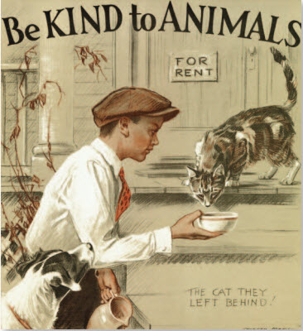

**1927:** Popular poet Edgar Guest pens a poem entitled “On Kindness to Animals,” which contains the verse:

They cannot ask for kindness   
Nor for our mercy plead,   
Yet cruel is our blindness   
Which does not see their need

**1932:** Morgan Dennis, the artist most famously tied to “Be Kind to Animals Week,” unveils the first of many posters for the week. Each year, his poster is a powerful visual representation of a person – usually a child – displaying an act of kindness toward an animal in need. His period specific details – from the fashions worn to even the model years of the cars – create a timeless snapshot of each particular year.

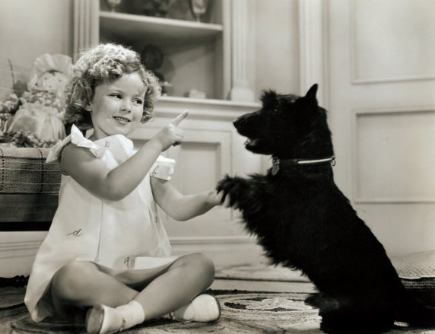

**1936:** Shirley Temple, the biggest child star of her era, serves as junior chair for “Be Kind to Animals Week.” Though she herself is too young to drive, she urges motorists to be vigilant to avoid animals crossing the roadway. Temple appears twice on the cover of National Humane Review, American Humane Association’s monthly publication, in June 1935 and January 1936, and her participation prompts national coverage.

**1950:** Porky Pig learns an important lesson of compassion on a special “Be Kind to Animals Week”-themed “Looney Tunes” short entitled “Dog Collared,” where he eventually befriends and adopts a dog who follows him everywhere.

**1959:** On Sunday May 3, the nationally syndicated comic strip “Dennis the Menace” features a “Be Kind to Animals Week” theme, reaching out to children and adults alike with the importance of treating all animals with compassion.

 

**1960:** Following the lead of his comic strip character, child actor Jay North, the star of the sitcom “Dennis the Menace,” serves as spokesperson for the year’s celebration; he is joined by fellow CBS child star Jerry Mathers, better known as Beaver Cleaver on “Leave it to Beaver.”

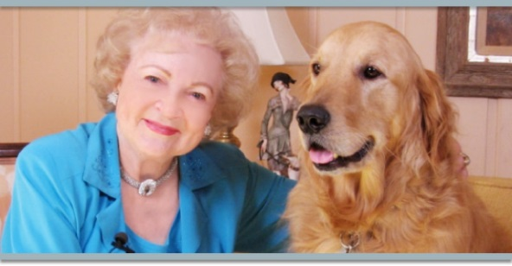

**1971:** Betty White is appointed “National Kindness Chairman,” beginning her decades-long legacy of working with American Humane Association, which endures to this day

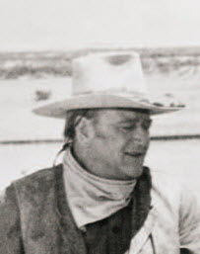 

**1973:** Iconic movie cowboy **John Wayne** lends his voice as chair of the year’s celebration. Popular television show **“Romper Room”** promotes “Be Kind to Animals Week” to its millions of tiny viewers.

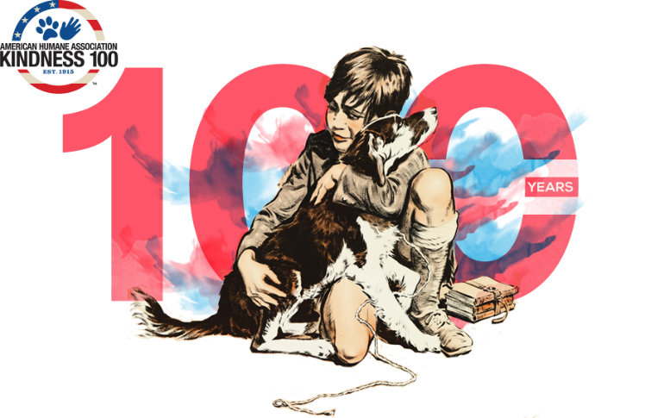

***A New Campaign to Recruit All Americans to the Cause of Animals.*** Unlike most 100-year-olds, this historic, 100-year-old campaign shows no sign of slowing down. In fact, for the Centennial, the American Humane Association is ramping up efforts, launching an ambitious campaign called “**Kindness 100”** to recruit all Americans to become animal advocates and help solve the remaining challenges still facing millions of animals in need. The campaign, which kicked off the with the 100th Anniversary "Be Kind to Animals" Week, seeks to enlist a new generation to do four simple things that can make a world of difference to billions of farm animals, millions of animals abandoned to U.S. shelters each year, animals in entertainment, and disappearing and endangered species.

***Kindness100.org – Where you can find “how to be kind”*** To reach children and adults nationwide, American Humane Association is embarking on a year-long campaign starting with a national media tour, educational roadshow to schools with a traveling museum aboard its fleet of famed Red Star Rescue trucks that save animals in disasters, and a website [www.Kindness100.org](http://www.kindness100.org/) where readers can find a fascinating historical retrospective of “Be Kind to Animals Week,” a series of pre-K-5 curricula to teach children compassion in all areas of life, official downloadable proclamations for local, state and federal officials, and a **Kindness 100 Pledge** with four things people can do to improve the lives of millions – actually, billions – of animals.

***1,000,000 Challenged to Take the Kindness 100 Pledge*** American Humane Association is challenging 1 million people to take the Kindness 100 Pledge online at [www.Kindness100.org](http://www.kindness100.org/) to protect and better the lives of animals in four distinct areas, including 10 billion farm animals by seeking out humanely raised foods, the 6-8 million animals abandoned each year by adopting from a shelter, the more than 100,000 animal actors who entertain, educate and charm us in film and television each year by looking for the “No Animals Were Harmed®” end-credit, and the many endangered and disappearing species of the world by cultivating caring and understanding of magnificent creatures by taking their children to accredited zoos, aquariums, and conservation centers. This year, in honor of the centennial every person who takes the pledge will join the illustrious figures of the past 100 years as an Honorary Chair of Be Kind to Animals Week.

“The need has never been greater and the time has never been better to start a new Compassion Movement,” said Dr. Robin Ganzert, president and CEO of American Humane Association. “To help all of the creatures of the world, big and small, we encourage every American to celebrate ‘Be Kind to Animals Week’ – not only for a week, but all year round. By teaching our children the value of kindness and doing a few simple things that require little or no cost, we may together build a better world for our animals….and ourselves.”

Created against the backdrop of World War I when millions of horses were perishing on the blood-soaked battlefields of Europe, Be Kind to Animals Week has touched hundreds of millions of people, and over the years has featured many iconic spokespeople and advocates including President Warren Harding, Shirley Temple, Eleanor Roosevelt, Milton Berle, Doris Day, Porky Pig, Dennis the Menace, John Wayne, Lorne Greene, Carol Burnett, Clint Eastwood, Betty White and many others.

To join the movement and celebrate the centennial of “Be Kind to Animals Week®,” please visit [www.Kindness100.org](http://www.kindness100.org/). To learn more about how you can support American Humane Association’s Kindness 100 campaign, and to help support America’s first national humane organization and the only one working for the protection of both the nation’s children and animals, please call 1-800-227-4645 or email Anastasia Staten, Vice President, Philanthropic Services at[anastasias@americanhumane.org](mailto:anastasias@americanhumane.org).

**About American Humane Association**American Humane Association is the country’s first national humane organization and the only one dedicated to protecting both children and animals. Since 1877, American Humane Association has been at the forefront of virtually every major advance in protecting our most vulnerable from cruelty, abuse and neglect. Today we’re also leading the way in understanding the human-animal bond and its role in therapy, medicine and society. American Humane Association reaches millions of people every day through groundbreaking research, education, training and services that span a wide network of organizations, agencies and businesses. You can help make a difference, too. Visit American Humane Association at [www.americanhumane.org](http://www.americanhumane.org/) today.

To learn how the American Humane Association became involved with children, too, go to their history pages and click on articles about Mary Ellen at <http://www.americanhumane.org/about-us/who-we-are/history>



When I was looking for info for this item, I found other similar organizations – the American Society for the Prevent Cruelty to Animals (<https://www.aspca.org/> ) and The Humane Society of the United States (<http://www.humanesociety.org/> ). And I became confused. I my aim was to write about **"Be Kind to Animals Week"** and the American Humane Association owns the copyright to that title, so I chose to write about them and their work and history. No evaluation of other organizations was made.

# THOUGHTFUL ITEMS

## Roundtable Prayers

*2008-2009 CS Roundtable Planning Guide*

"We come together in the spirit of brothers and sisters, each charged with taking care of one another. God, give us what we need to serve each other to the best of our ability.  
**AMEN**

Thank you, Lord, for all you have given us. Help us notice people who need our help. Help us do our best in helping children who are alone, and our parents and teachers when they need a hand. **AMEN**

## Sowing Seeds of Kindness

*Scouter Jim, Bountiful UT*

Paul, the Apostle, gave the following quote and attributed it to Jesus Christ.: “It is more blessed to give than to receive.” *Holy Bible, Acts 20:35 Currently I have been going through a health crisis in my life. I can assure you that it is easier to give than to receive. I have friends all around the world praying for my health.* November is a great time to teach the joys of service. We can remind our Cub Scouts of the help the Native Americans gave the Pilgrim that first year and beyond. There are many ideas for giving service. It may be harder to find someone to give service to, than to find service to give. I have had many people ask me what they can do, and I am at a loss. It is not that I do not care about these wonderful friends, I have just been a Scout for so long, it is hard for me to take service, even when I am in real need. Try to think outside the box, think of someone completely different to give service to. You might find someone in real need of service that you would not expect. I would much rather give service, it is easier. However, I realize that sometimes each of us must receive the harvest of kindness sown by others with dignity and gratitude.

## Charity Begins At Home

Scouter Jim, Bountiful Utah

**This item is a reprint from December 2005. I have not updated the events, but I am sure you can use current events and the story will be the same! CD**

One of my favorite quotes is, “*When all is said and done, more is said than done.”* This past year has been a historic year. We have seen devastating events all around the world. We have seen a massive tsunami hit Southeast Asia. Hurricanes and the resulting floods of mud have covered portions of Central America. A killer earthquake flattened whole villages in Pakistan leaving thousands dead. Closer to home, a series of Hurricanes has left many parts the Gulf Coast of the United States in ruin. With each disaster the call for aid has gone out and the American people have responded by opening their hearts and wallets. All this is wonderful, but we need to remember Charity begins at home. Where I live the local food pantry shelves are almost bare. Many of my neighbors are going hungry because much of the food and money that is normally donated to the Food Bank has gone elsewhere.

This summer a bus pulled up in front of a home in my community. It was the ABC Television Network’s, Extreme Makeover, Home Edition crew. They built the Gordon Harrison Family a new home. Gordon has for years been a volunteer Scout Leader. He has pancreatic cancer, which very well might take his life. This episode has already aired, so many may have seen that while he was sick in the hospital, his thoughts turned to neighbors and friends in need. He found a way to give a neighbor a Kitchen Makeover. Why, when his life was fading away, did his thoughts turn to others? “*Do it now. There may be no tomorrow,”* is his answer. He chooses to live out the life he has left giving back to others.

Each of us can look around and see others in need. Even if we can’t do something as dramatic as Gordon Harrison, we can give generously of our time and money to those in need. Drop some extra money in the Salvation Army Kettle, buy a sack of groceries for your local food pantry, or even just visit an elderly neighbor, begging for someone to talk to.

*When all is said and done, lets all make sure more is done than said.*

**Scout Beatitudes**

*2005-2006 Cub Scout Roundtable Planning Guide*

Blessed are the Scouts who are taught to see beauty in all things around them, for their world will be a place of grace and wonder.

Blessed are the Scouts who are led with patience understanding, for they will learn the strength of endurance and the gift of tolerance.

Blessed are the Scouts who are provided a home where family members dwell in harmony and close communication, for they shall became the peacemakers of the world.

Blessed are the Scouts who are taught the value and power of truth, for they search for knowledge and use it with wisdom and discernment.

Blessed are the Scouts who are loved and know that they are loved, for they shall sow seeds of love in the world and reap joy for themselves and others.

## Fun Facts About Kindness:

*Alice, Golden Empire Council*

* Giving a smile is easier than giving a frown –   
  it takes fewer muscles!
* In 2007, 163,000 volunteers at the National Park Service donated 5.4 million hours of time worth $101 million or the equivalent of 2,596 full time employees!
* 80% of the people in this county give to nonprofits.
* Only 10-12% of financial giving is provided by foundations and 5-6% comes from corporations.
* Most of the money given by individuals is from middle and low income people, not the super wealthy!
* Eleven percent of households contributed to religious causes only.
* Twenty-one percent of households contributed to only secular causes.
* Thirty-four percent contributed to both religious and secular causes.
* Only 28.8% of the people in this country do the actual volunteer work for the many service organizations and projects in this country – so your time does matter!
* Recognition in front of their peers is the most valued form of “payback” for volunteers – so remember to recognize parents, leaders and others who help your scout program!
* The median amount of time that people volunteer is 52 hours a year, ranging from 21% who spend from one to fourteen hours up to the 28% who donate between one hundred and four hundred hours a year.
* Doing a good deed actually changes the body physically – endorphins create a feeling of well-being when a good deed is done.

**Some personal rules for satisfying giving:**

*Alice, Golden Empire Council*

**Give anonymously –** not knowing who the benefactor is leaves the receiver feeling loved by and grateful to all!

**Keep your eyes and ears open – when you see or hear of a need, fill it!**

**Be creative –** and let children offer their creative ideas as well.

**Share the bounty – if you have season tickets to a sports event, concerts, theatre and can’t use them, share them.**

**And of course, you can literally share the bounty –** flowers or produce from your garden, or even the seeds from a successful growing season!

**Let everyone participate –** even the youngest children can make play doh (recipe in Cub Grub) or pick out pictures to use to make a picture dictionary for another child.

**Make an inventory of the talents and supplies available to you –** you might be surprised at how much you have to offer!

**Keep a “Giving” Diary –** it could be personal, family or a scrapbook for a den or pack project. Include pictures of preparations, and ask everyone how doing the service project made them feel**.**

**Think about personal passions –** if you are especially interested in the environment, help clean up a local creek or “adopt” a local bus stop or neighborhood playground.Make a commitment to go by on a regular basis and pick up trash. Another environmental way to share seeds of kindness is by giving a gift of trees ($60) or a share of seedlings ($10), both thru Heifer International. (See websites)

**Contact local volunteer bureaus for some ideas for a project you can do.** If you don’t know where they are, check with a local librarian – she will have a listing of local possibilities.

**Recognize other people and what they contribute.** Every week choose people who quietly perform service – the church organist, the neighbor who takes in your garbage can – send them a thank you note or put a container of cookies or some flowers on their doorstep by way of saying “thanks for what you do.” Boys could also give service to a Cubmaster, grandparent, pack chair, or someone else who helps make the scout program go.

**Hope Quotations**

*Santa Clara Council Pow Wow Book*

“A. C. Benson used to say “There are four Christian values, not three: they are Faith, Hope, Charity – and humor” - Lord Robert Baden-Powell

“Press forward with Hope; mix it with optimism and temper it with the sense of humor which enables you to face difficulties with a sense of proportions.” - Lord Robert Baden-Powell

“I’ve always maintained that if the right spirit is there, it can knock the “im” out of impossible.” - Lord Robert Baden-Powell

“Hope sees the invisible, feels the intangible and achieves the impossible.” - Anonymous

“Hope is the feeling you have that the feeling you have isn't permanent.” - Jean Kerr

“All human wisdom is summed up in two words - wait and hope.” - Alexander Dumas

“Expect to have hope rekindled. Expect your prayers to be answered in wondrous ways. The dry seasons in life do not last. The spring rains will come again.” - Sarah Ban

“ Listen now to the gentle whispers of hope.” - Charles D. Brodhead

“While there's life, there's hope!” - Ancient Roman Saying

“Hope has been and always will be safe. It's inside every one of us.” - Xenia

“Hope is the thing with feathers that perches in the soul and sings the tune without the words And never stops at all.” - Emily Dickinson

“Hope for the best but prepare for the worst.” - English Proverb

“Never deprive someone of hope -- it may be all they have.” - Unknown

“Hope is a waking dream.” - Aristotle (384-322 B.C.)

“In all pleasure hope is a considerable part.” - Samuel Johnson

“Hope is necessary in every condition. The miseries of poverty, sickness and captivity would, without this comfort, be insupportable.” - Samuel Johnson

“Hope begins in the dark, the stubborn hope that if you just show up and try to do the right thing, the dawn will come. You wait and watch and work: you don't give up.”

“We must accept finite disappointment, but we must never lose infinite hope.” - Dr. Martin Luther King Jr.

“Learn from yesterday, live for today, hope for tomorrow. The important thing is to not stop questioning.” - Albert Einstein

“Everything that is done in the world is done by hope.” - Dr. Martin Luther King Jr.

“Hope is not the conviction that something will turn out well, but the certainty that something makes sense regardless of how it turns out.” - Vaclav Havel

“Your hopes, dreams and aspirations are legitimate. They are trying to take you airborne, above the clouds, above the storms, if you only let them.” - William James

“We should not let our fears hold us back from pursuing our hopes.” - John Fitzgerald Kennedy

“Every area of trouble gives out a ray of hope; and the one unchangeable certainty is that nothing is certain or unchangeable.” - John Fitzgerald Kennedy

“There is no hope of joy except in human relations.” - Antoine de Saint-Exupery

“If you haven't any charity in your heart, you have the worst kind of heart trouble.” - Bob Hope

“Nine requisites for contented living: Health enough to make work a pleasure. Wealth enough to support your needs. Strength to battle with difficulties and overcome them. Grace enough to confess your sins and forsake them. Patience enough to toil until some good is accomplished. Charity enough to see some good in your neighbor. Love enough to move you to be useful and helpful to others. Faith enough to make real the things of God. Hope enough to remove all anxious fears concerning the future.” - Johann Wolfgang von Goethe

“A little more patience, a little more charity for all, a little more devotion, a little more love; with less bowing down to the past, and a silent ignoring of pretended authority; brave looking forward to the future with more faith in our fellows, and the race will be ripe for a great burst of light and life.” - Elbert Hubbard

“The intuitive mind is a sacred gift and the rational mind is a faithful servant. We have created a society that honors the servant and has forgotten the gift.” - Albert Einstein

“Enthusiasm is nothing more or less than faith in action.” - Henry Chester

“Optimism is the faith that leads to achievement. Nothing can be done without hope or confidence.” - Helen Keller

“Never talk defeat. Use words like hope, belief, faith, victory.” - Norman Vincent Peale

“Faith and love are apt to be spasmodic in the best minds. Men live the brink of mysteries and harmonies into which they never enter, and with their hands on the door-latch they die outside.” - Ralph Waldo Emerson

**“He who loses money, loses much; He who loses a friend, loses much more, He who loses faith, loses all.” -** Eleanor Roosevelt

“The leader seeks to communicate his vision to his followers. He captures their attention with his optimistic intuition of possible solutions to their needs. He influences them by the dynamism of his faith. He demonstrates confidence that the challenge can be met, the need resolved, the crisis overcome.” - John Haggai

“Faith is the strength by which a shattered world shall emerge into the light.” - Helen Keller

“Nine requisites for contented living: **Health** enough to make work a pleasure. **Wealth** enough to support your needs. **Strength** to battle with difficulties and overcome them. **Grace** enough to confess your sins and forsake them. **Patience** enough to toil until some good is accomplished. **Charity** enough to see some good in your neighbor. **Love** enough to move you to be useful and helpful to others. **Faith** enough to make real the things of God. **Hope** enough to remove all anxious fears concerning the future.” - Johann Wolfgang von Goethe (1749-1832)

“Take the first step in faith. You don't have to see the whole staircase, just take the first step.” - Dr. Martin Luther King Jr. Minister, Civil Rights Leader

“I do not pray for success. I ask for faithfulness.” - Mother Teresa

“Faith is an oasis in the heart which will never be reached by the caravan of thinking.” - Kahlil Gibran

“A little faith will bring your soul to heaven; A great faith will bring heaven to your soul.” - Charles Spurgeon

“The only limit to our realization of tomorrow will be our doubts of today; Let us move forward with strong and active faith.” - Franklin D. Roosevelt

“Without faith, nothing is possible. With it, nothing is impossible.” - Mary McLeod Bethune (1875 - 1955) Educator

“To one who has faith, no explanation is necessary. To one without faith, no explanation is possible.” St. Thomas Aquinas (1225-1274)

# CUB SCOUT TIPS

## SIGNS OF SCOUTING

*Baloo’s Archives*

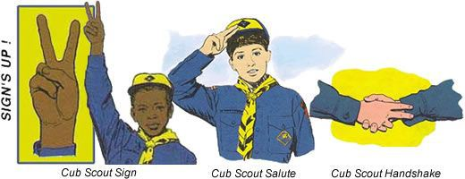

***Although none of the signs changed, some of   
the meanings changed because of moving to   
the Scout Oath and Scout Law.***

**The Cub Scout Sign**

The Cub Scout sign is made with the right arm held high and straight up above the shoulder, with the index and middle fingers forming a V. The other fingers are held down by the thumb. It’s the sign of Cub Scouts in many countries around the world.

***The two extended fingers stand for the Scout Oath and Scout Law.*** They also represent the ears of an alert wolf ready to listen to Akela! They remind boys to be attentive.

**Cub Scout Leaders and Cub Scouts should make the Cub Scout sign when repeating the Scout Oath and Scout Law.** The sign is also used in the Living Circle and other ceremonies.

Leaders can use the sign to get the boys’ attention or to remind them to be quiet in meetings. When a leader raises the sign, the boys should become quiet and make the sign themselves—and activities cease until each boy has responded appropriately. Reinforce this use of the sign by complimenting the first Cub Scout who reacts. Avoid saying “signs up” to get their attention; let the sign do the work. ***See additional discussion in "Den Discipline" item on this use of the Cub Scout Sign.***



**The Boy Scout Sign**

The Boy Scout sign is made with the right arm held straight out from the shoulder in a horizontal position, the elbow bent 90 degrees, with the hand in an upraised vertical position, the three middle fingers relatively straight (not spread wide apart), with the thumb holding down the pinky.

In 1907 in Scouting for Boys, Robert Baden-Powell chose the three-finger salute for Scouts to represent the three aspects of the Scout Oath or Promise:

* Honor God and Country
* Help Others
* Obey the Scout Law

BSA has expanded this a little. In the BSA, the three parts of the Scout Oath are:

**Duty to God and Country -** The core of your being is your relationship with God. Your duty to your country is being a good citizen, obeying the laws, working to make it a stronger nation, and defending it and its principals.

**Duty to Other People -** Doing your Good Turn each day, looking for people that could use a hand, and providing aid for community services are all ways to help others. We are obligated to help those that cannot help themselves and helping with a **CHEERFUL** spirit builds our own character.

**Duty to Self -** Caring for yourself physically, mentally, and morally will result in a more rewarding life. ***This includes Obeying the Scout Law as well as the ending of the Scout Oath.***

The thumb and little finger together represents the bond (brotherhood) between all Scouts

The Boy Scout sign has the same uses as the Cub Scout sign (above) when saying the Scout Oath and Scout Law, in ceremonies, and for quiet.

**The Cub Scout Salute**

The Cub Scout salute is made by joining the index and middle fingers of the right hand while holding the other fingers with the thumb and touching them to the cap visor or forehead above the right eyebrow. The hand is held the same as for the Cub Scout sign, except the index and middle fingers are together. ***(The meaning (reason) for the two fingers used is the same as for the Cub Scout sign.)***

The salute is used to salute the flag when in uniform—otherwise hold your right hand over your heart—and to show respect to Cub Scout leaders. It may also be used when greeting other Scouts.

 

**The Cub Scout Handshake**

The Cub Scout handshake is made by putting the index and middle fingers of the right hand against the other person’s wrist when shaking hands. It signifies that you will help each to remember and obey the Scout Oath and Scout Law.

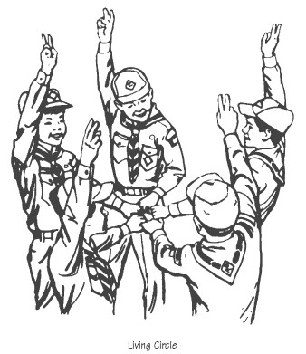

**The Living Circle**

***Note from Commissioner Dave – I remember learning this ceremony at my first Den Meeting at Mrs. Kneale’s in September 1957. We still teach it to dens today.***

The Living Circle is a ceremony that may be used as an opening or closing at a Cub Scout meeting. It reminds boys of the friendships they are making that link them together with other Cub Scouts.

To form a Living Circle, Cub Scouts and leaders stand in a close circle, facing inward and slightly to the right. With their right hands, they make the Cub Scout sign.

With their left hands, they reach into the center of the circle. Each thumb is pointed to the right, and each person grasps the thumb of the person on his left, making a complete Living Circle handclasp. The Scout Oath, Scout Law, Cub Scout motto, or other Scouting related phrase can then be repeated.

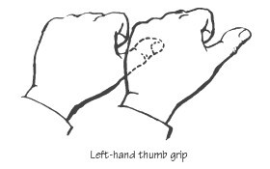

The Living Circle can also be used by moving all the left hands up and down in a pumping motion while the members say, “A-ke-la! We-e-e-ll do-o-o ou-r-r best,” snapping into a circle of individual salutes (with right hands) at the word “best.” ***(I like having my Webelos Den yell the meaning of Webelos (We'll Be Loyal Scouts) in a chant as a team does before a game or after a time out. CD)***

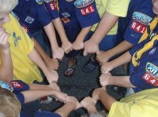

# DEN MEETING TOPICS

Remember – Boys want to be active!!   
See, too, that they earn their awards   
***(Never say GET. You get sick, you do not get awards – You earn awards. A little CD Philosophy)***.

**Big Rock Ideas** – suggestions for Big Rocks that fit Interest Topics or seasonal activity. The years next to an item (e.g. 13-14) is the Roundtable Planning Guide where the suggested Big Rock is published. All Big Rocks are on-line at <http://www.scouting.org/scoutsource/Commissioners/roundtable.aspx>



# CHARACTER COMPASS

**DECEMBER -**ADVENTURES with a **CHARACTER COMPASS** pointing to **KIND:**

**TIGER –**

* Tiger Jungle (Core)
* Tiger-iffic(Elec)

**WOLF –**

* Duty to God – Footsteps (Core)
* Cubs Who Care (Elec)

**BEAR –**

* Fur, Feathers, and Ferns (Core)
* Critter Care (Elec)

**WEBELOS CORE –**

* Webelos Walkabout (Core)

**ARROW OF LIGHT CORE –**

* Duty to God In Action(Core)

**WEBELOS & AOL ELECTIVES –**

* Into the Wild (Elec)



**JANUARY -**ADVENTURES with a **CHARACTER COMPASS** pointing to **HELPFUL:**

**TIGER –**

* Tiger Bites (Core)
* Curiosity, Intrigue, and Magical Mysteries (Elec)

**WOLF –**

* Howling at the Moon (Core)
* Paws of Skill (Elec)

**BEAR –**

* Fellowship & Duty to God (Core)

**WEBELOS CORE –**

* (None)

**ARROW OF LIGHT CORE –**

* Camper (Core)

**WEBELOS & AOL ELECTIVES –**

* Fix It (Elec)

# http://www.orgsites.com/in/pack3092/tsalute.jpgTHEME RELATED STUFF

## THEME RELATED ADVENTURES

All Adventures are fun. –

**GOOD ADVENTURES FOR “PAYING IT FORWARD” and KIND**

**TIGER –**

* Tiger Jungle (#3 Helping plants and animals, #4, hang a birdhouse) Core
* Earning Your Stripes (#3 – One new task to help, #6 – Service project) Elec
* Family Stories (#4 – interview Grandparent) Elec
* Good Knights (#1b – Make a Den Code of Conduct – could have item to be Kind to others) Elec

**WOLF –**

* Cubs Who care (Most requirements pertain to being Kind to others) Elec

**BEAR –**

* Grin and Bear It (#3 – Help younger Cub Scouts …) Elec
* Critter Care (Adventure is about being kind to your pets) Elec

**WEBELOS CORE –**

* None

**ARROW of LIGHT CORE –**

* Building a Better World (#8 – Being Kind to the earth – recycling) Core
* Duty to God in Action (#2e – Service Project for another) Core

**WEBELOS ELECTIVES –**

* Aware & Care (Badge is about learning to be Kind to those with disabilities) Elec
* Fix It (#4 – projects on the list could be done as an act of kindness for someone else) Elec





# PACK MEETING THEMES AND PLANS

[*www.scouting.org*](http://www.scouting.org)

**From National's Website for the new plans using the Core Values based on the Scout Law:**

Here are a few thoughts to consider around these new pack meeting plans. First, there is a plan for each month that corresponds with a point of the Scout Law. In addition, each plan has a theme to help make the pack meeting even more fun! The plans do not have to be used in a specific order.

**Tips for Utilizing the Plans**

* Pack meeting plans do not have to be done in any special order, but it is recommended that you include all of the points of the Scout Law each year. The pack planning meeting would be a good time to determine the order.
* There are pack meeting plans for multiple years posted on the website. It is your pack's choice of which one to select from each point of the Scout Law for each year.
* Pack meetings should not last longer than an hour. Adjust the plan to make it fit within the time. Research and experience tells us that Cub Scouts have a hard time sitting still for that long. Keep the meetings fun, active, and engaging.
* If you are comfortable with a costume to fit the theme of the meeting, go for it!
* Importantly, keep it simple and make it fun.



* The following required adventures have a requirement that suggests or requires completion at a pack meeting. Please plan accordingly as part of your annual program planning process. Work with your den leaders to plan when these activities will take place.

**Tiger**

* **Tigers in the Wild,** requirement 5. Participate in an outdoor pack meeting or pack campout campfire. Sing a song and act out a skit with your Tiger den as part of the program.
* **Games Tigers Play,** requirement 3. Make up a new game, and play it with your family or members of your den or pack.

**Wolf**

* **Council Fire,** requirement 6c. Create a den project from recyclables for a pack meeting.

**Bear**

* **Grin and Bear It**, requirement 2. Working with the members of your den, organize a Cub Scout carnival and lead it at a special event.
* **Grin and Bear It**, requirement 3. Help younger Cub Scouts take part in one of the events at the Cub Scout carnival.

**Webelos**

* **Stronger, Faster, Higher**, requirement 5. With adult guidance, lead younger Scouts in a fitness game or games as a gathering activity for a pack or den meeting.

**Arrow of Light**

* **Building a Better World (if chosen**), requirement 10b. Set up an exhibit at a pack meeting to share information about the World Friendship Fund.

Check them out at:   
<http://www.scouting.org/Home/CubScouts/Leaders/CubmasterResources/PackMeetingPlans.aspx>





## PACK MEETING THEMES

Kim, the chair of the task force, says **"I do want to stress that the focus is still the Core Value and the theme is just there as an enhancement. Pack meeting theme plans are specifically crafted to bring out the important points of the Core Value in a fun way."**

|  |  |  |
| --- | --- | --- |
| **2017–2018 Pack Meeting Plans** | | |
| Nov | Reverent | [Cubs Give Thanks](http://www.scouting.org/filestore/cubscouts/pdf/2017/310-842(17)_November_Reverent.pdf) |
| Dec | Kind | [Paying It Forward](http://www.scouting.org/filestore/cubscouts/pdf/2017/310-842(17)_December_Kind.pdf) |
| Jan | Helpful | [Jobs, Jobs, Jobs](http://www.scouting.org/filestore/cubscouts/pdf/2017/310-842(17)_January_Helpful.pdf) |
| Feb | Cheerful | [Abracadabra!](http://www.scouting.org/filestore/cubscouts/pdf/2017/310-842(17)_February_Cheerful.pdf) |
| Mar | Trustworthy | [Cub Scout Investigators](http://www.scouting.org/filestore/cubscouts/pdf/2017/310-842(17)_March_Trustworthy.pdf) |
| Apr | Loyal | [Cubs in the Future](http://www.scouting.org/filestore/cubscouts/pdf/2017/310-842(17)_April_Loyal.pdf) |
| May | Friendly | [Treasure Hunters](http://www.scouting.org/filestore/cubscouts/pdf/2017/310-842(17)_May_Friendly.pdf) |
| Jun | Obedient | [Wheel Into Summer](http://www.scouting.org/filestore/cubscouts/pdf/2017/310-842(17)_June_Obedient.pdf) |
| Jul | Brave | [Home of the Brave](http://www.scouting.org/filestore/cubscouts/pdf/2017/310-842(17)_July_Brave.pdf) |
| Aug | Clean | [Destination Parks](http://www.scouting.org/filestore/cubscouts/pdf/2017/310-842(17)_August_Clean.pdf) |

**If you are using a paper copy the link to all the   
Pack Meeting Plans is:**

<http://www.scouting.org/Home/CubScouts/Leaders/CubmasterResources/PackMeetingPlans.aspx>

## Paying it Forward Diagram

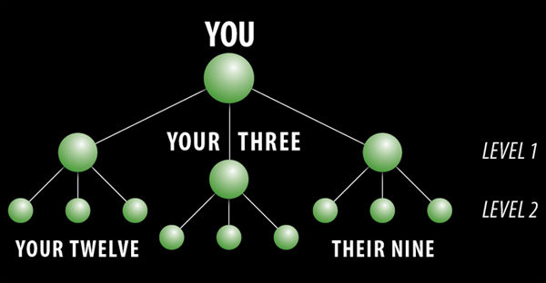

**You help 3 people and they each help 3**

**You therefore helped 12 people!!**

program updates banner

## **UPCOMING MONTHS**

**For December,** the suggested Pack Meeting theme, **Paying It Forward**, emphasizes the Scout Law point, **KIND.**



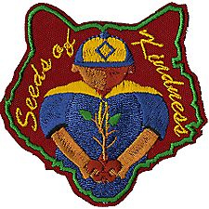

**For January,** the suggested Pack Meeting theme, **Jobs, Jobs, Jobs**, emphasizes the Scout Law point, **HELPFUL.**

A Scout is **HELPFUL.**  The theme **JOBS, JOBS, JOBS** is used to help Cubs understand being **HELPFUL.**

**A SCOUT IS HELPFUL**

* A Scout is helpful. A Scout cares about other people. He willingly volunteers to help others without expecting payment or reward.

**HOW DOES "JOBS, JOBS, JOBS" RELATE TO THIS SCOUT LAW POINT?**

* A There are many ways that people can be helpful. One way is by volunteering time to help others. Cub Scouts, Scout leaders, and coaches are examples of volunteers. Another way people help is by doing jobs that provide a service. This month we celebrate those who help out in their homes, schools, and communities.

|  |  |  |
| --- | --- | --- |
| **Month** | **Year** | **Theme** |
| **HELPFUL Months** in Adventure Program | | |
| November | 2015 | Cubs In Action |
| September | 2016 | To The Rescue |
| **Potential HELPFUL Months** | | |
| October | 1941 | Live and Help Live |
| December | 1945 | Follows - Helps - Gives |
| December | 1947 | Helps and Gives |
| December | 1950 | Helps |
| December | 1951 | F-H-G |
| December | 1961 | Follows, Helps, and Gives |
| December | 1972 | Follows, Helps, Gives |
| December | 1984 | Do a Good Turn |
| December | 1985 | Follows, Helps, Gives |
| December | 1991 | Follows, Helps, Gives |
| December | 1992 | To Help Other People |
| December | 1995 | Do a Good Turn |
| December | 1996 | Helping Others |
| December | 1997 | The Golden Rule |
| November | 2008 | Spreading Seeds Of Kindness |
| **Jobs, Jobs, Jobs  Providing Service** | | |
| September | 1951 | Barn Raisin' |
| September | 1965 | Barn Raising |
| December | 1969 | The Cub Scout Gives Good Will |
| December | 1971 | Cub Scout Gives Good Will |
| December | 1975 | Cub Scout Gives Good Will |
| April | 1999 | Pollution Solution |
| April | 2001 | Save It For Us |
| February | 2003 | Uncle Sam Depends on You |
| December | 2003 | A Cub Scout Gives Good Will |
| October | 2005 | To The Rescue |
| December | 2005 | Faith, Hope & Charity |
| April | 2010 | Spring into Action |
| November | 2010 | Citizenship |
| November | 2011 | Citizenship |
| March | 2013 | Planting Seeds of Kindness |
| April | 2013 | Cub Scouts Give Thanks |
| August | 2013 | Kids Against Crime |
| November | 2014 | Give Goodwill |
| March | 2015 | Aware and Care |
| September | 2015 | Cubservation |

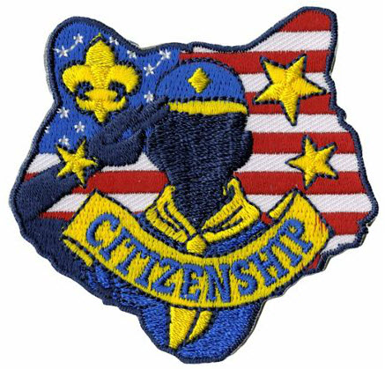

CUBMASTER THOUGHTS

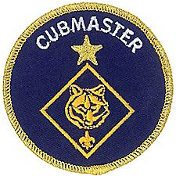

**Lions (The Beginning)**

*Mark Diienno, Cubmaster,   
Garden State Council*

*When the Lion Pilot started, Mark added Lion Coordinator and Lion Guide to his position as Cubmaster. He has a strong belief that the youngest Scouts and parents need have a great start and learn about Scouting the right way. He has now lead several Lion Dens.*  ***100% of his first one are still active!!***



The Lion program is a new level in Cub Scouting. It is not “pretend” Cubs. It is a vibrant, relevant program geared towards boys in kindergarten to begin their journey in The Scouting Program.

They have their own identity, unique program, and Adventures.



The Stakes are very high in offering this program, for you have only one shot to win these boys and their families over to the marvelous world of Scouting.

It is extremely important to start out slowly so as to gain the confidence of the Lion and his parents.

The delicate situation your unit is undertaking becomes obvious at the first gathering, when upon meeting The Lion, you find yourself talking through the legs of one of the parents, as the Lion ducks for cover. It is crucial that in this situation, and every activity moving forward, that the Lion Leader maintain a positive, upbeat, energetic tone. Notice the word “Gathering” is used to describe the first meeting. It is more important to start to form the unity of The Den, than it is to plunge into the program headfirst.

It is also important to realize that just asking a 5 yr boy to enter a strange house, or meeting place, could be a deal breaker right off the bat. Consider having your first meeting outside, or at least the first part of the meeting outside. Begin with simple games. Bean bag tosses, kicking balls for distance, running around cones, or just letting the Lions play catch with their parents is a great way to begin the team building process.

It is amazing that after only 10-15 minutes of game playing how much easier it is to lead the Lions and have them follow direction.

***Keep It Simple, Make It Fun,***

As a Leader, it is our job to put our Scouts in a position to succeed, so try not to have competitions, for the heart of a 5 yr old is very fragile. Describe it as a display of skill.

As with the Tiger program, The Lion program relies on the scout and the parent to work together in all activities so, directing the parents as to what the goal is will help greatly in obtaining that goal.

The Lion Program is very easy to follow and execute.

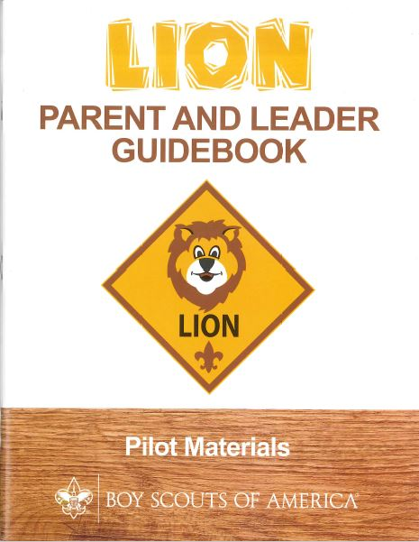

Everything in the Parent/Leader manual is there to aid in delivering the program with little effort, time, resources, and most importantly stress.

Because of the high stakes, it is strongly recommended that the Lion Pride be “Mentored” by a seasoned leader, who can help not only in delivering the program to the Lions , but also begin to groom the parents to become the new crop of leaders in the pack. ***An experienced Cubmaster would be ideal for this role.***

Singing songs, clapping hands, and having fun are the Cubmaster's greatest talents, and these talents are tailor made for the Lion Pride.

The Cub Master’s Leadership experience will also influence these potential new leaders to properly follow the program, seek training, and contribute to the unit for years to come.

Having The Cubmaster involved in the den will also have a very strong calming effect on the Lions when they attend their first pack meeting and see the familiar face of the Cubmaster running the show.

The Lion Program is the most important thing to hit Scouting since the Blue uniform.

***We are in a competition. -   
A competition for a family’s time.***

There are many activities that begin at this young age and vie for a family's attention.

The Lion Program is Scouting’s answer to help capture our place in this market.

Next month we will look deeper into this amazing program. And yes, The Scout Law and Oath are relevant even at this young age.

Stay tuned…

For more help, be sure to check out –

[](http://www.cubmaster.org)

# WEBELOS

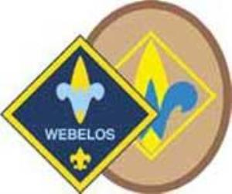



**Always an S -** Webelos always ends with an S whether talking about one Webelos Scout or a den of Webelos. It is an acronym – **WE**’ll **BE** **LO**yal **S**couts. As the CS RT Commissioner who mentored me says – "If you don’t have an S at the end – then there is nothing to which to be loyal." **(She was the N5-690-17 Wood Badge Scoutmaster!!)**

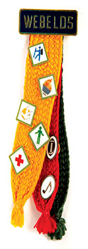

**The Two Dens –** The correct names for the two years of the Webelos Program are the **Webelos Den** and the **Arrow of Light Den**. In the National Scout Shop where I work part-time, at Roundtables, and almost everywhere I go, I hear people refer to Webelos I and Webelos II. Webelos I and II are a little like Class A and Class B Uniforms. They are terms many Scouts and Scouters use but are not found in any material printed by the BSA. I am looking for why the BSA did not choose Webelos I and II and will let you know when I know. But please use the correct terms so all will understand. Thank you. CD





***Commissioner Dave*** *with help from -* [*http://usscouts.org/advance/cubscout/aol-core-2015.asp*](http://usscouts.org/advance/cubscout/aol-core-2015.asp)

**I love this Adventure!! -**This Adventure takes all the Boy Scout related requirements that were just a long list of extra things to do in the previous advancement program and combines them into an Adventure. This keeps them from getting overlooked and earns the Scout an award for all his hard work. I know many Webelos Leaders who assumed the Activity Awards were it and there was not much else to do who were very surprised at the extent of Boy Scout related requirements. NOW they are all together and the Webelos Scout earns another Adventure Pin!!

**Let's look at the requirements -** *(*[*http://usscouts.org/advance/cubscout/aol-core-2015.asp*](http://usscouts.org/advance/cubscout/aol-core-2015.asp) *)*

Do all of these:

1. Prepare yourself to become a Boy Scout by completing **at least a, b, & c** of the items below:
   1. **Repeat from memory** the Scout Oath, Scout Law, Scout motto, and Scout slogan. In your own words, explain their meanings to your den leader, parent, or guardian.

***NOTE – It says "repeat from memory" not "With help as needed" like the Bobcat Award.)***

* 1. **Explain what Scout Spirit is**. Describe for your den leader, parent, or guardian some ways you have shown Scout Spirit by practicing the Scout Oath, Scout Law, Scout motto, and Scout slogan.
  2. **Give the Boy Scout sign, salute, and handshake.** Explain when they should be used.



* 1. **Describe the First Class Scout badge,** and tell what each part stands for. Explain the significance of the First Class Scout badge.

***The Webelos Den Leader Guide has a puzzle you can reproduce for this requirement. I have a wooden replica built on thin plywood that the Scouts take apart and reassemble. Hands On versus simply memorizing is the key!***

* 1. **Repeat from memory** the Pledge of Allegiance. In your own words, explain its meaning.

1. Visit a Boy Scout troop with your parent or guardian and, if possible, with your den members and leaders. After the meeting, do the following:
   1. Describe how the Scouts in the troop provide its leadership.
   2. Describe the four steps of Boy Scout advancement.
   3. Describe ranks in Boy Scouting and how they are earned.
   4. Describe what merit badges are and how they are earned.
2. Practice the patrol method in your den for one month by doing the following:
   1. Explain the patrol method. Describe the types of patrols that might be part of a Boy Scout troop.
   2. **Hold an election to choose the patrol leader.**
   3. **Develop a patrol name and emblem** (if your den does not already have one), as well as a patrol flag and yell. Explain how a patrol name, emblem, flag, and yell create patrol spirit.

***Not too early to begin using these Boy Scout methods. Choosing a name often immediately boosts morale and spirit. Guide them here though – make sure the name has a positive meaning and the Patrol Leader will be an asset. The Webelos Leader Book has guidance on PL elections.***

***Need ideas for patrol names & patches? Here are some samples and places to go look.–***

***From BSA's*** [***www.scoutstuff.org***](http://www.scoutstuff.org) ***-   
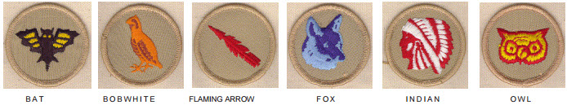***

***From*** ***www.classb.com*** ***–   
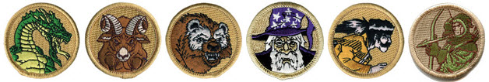***

***Just Google for "Boy Scout Patrol Patches" and you will find many more!!!***

* 1. As a patrol, make plans with a troop to participate in a Boy Scout troop's campout or other outdoor activity.

1. With your Webelos den leader, parent, or guardian, participate in a Boy Scout troop's campout or other outdoor activity. **Use the patrol method while on the outing.**

* ***Again not too early – get them started on the correct foot. The Webelos Leader Book has a Duty Roster & other stuff needed for this activity.***
* ***The Scouts will plan their meals for the campout.***
* ***If attending a troop campout at the end of this adventure, make sure the parents/guardians are aware that they are required to have an adult attend the campout with their son.***
* ***Determine a cost per boy and his parent/guardian to cover the purchase of food and any other materials for the campout. Let the boys and their parent/guardian know the***
* ***total cost of the campout in your take-home flier***

1. Do the following:
   1. **Show how to tie a square knot, two half hitches, and a taut-line hitch**. Explain how each knot is used.
   2. **Show the proper care of a rope** by learning how to whip and fuse the ends of different kinds of rope.
2. Demonstrate your knowledge of the pocketknife safety rules and the pocketknife pledge. If you have not already done so, earn your [Whittling Chip](http://usscouts.org/advance/cubscout/whittlingchip.asp)card.

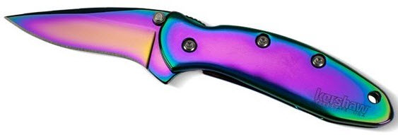

**To summarize:**This great Adventure provides an excellent intro to the Webelos Scouts to Boy Scouting. It wraps up a lot of requirements that previously were just a list into a neat package. The Webelos Den Leader guide for this Adventure has excellent information and resources.

Comments welcome. Let me know your opinion -   
[Davethecommish@gmail.com](mailto:Davethecommish@gmail.com)

# December Crazy Holidays

*Dr. Darby, Garden State Council, Adapted from* <http://holidayinsights.com/moreholidays/index.htm>  
[http://www.brownielocks.com/month2.html](http://www.brownielocks.com/month2.html%20)

**December is:**

* [AIDS Awareness Month](https://en.wikipedia.org/wiki/World_AIDS_Day#AIDS_Awareness_Month)
* [Bingo (the game) Birthday Month](http://www.zanyholidays.com/2008/12/bingos-birthday-month.html)

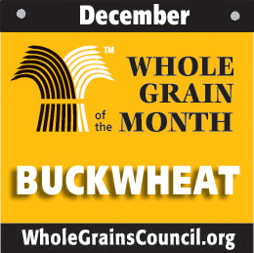

* [Buckwheat Month](http://wholegrainscouncil.org/whole-grains-101/buckwheat-december-grain-of-the-month)
* [National Impaired Driving Prevention Month](https://youth.gov/feature-article/december-national-impaired-driving-prevention-month)

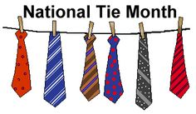

* [National Tie Month](https://www.nonstopcelebrations.com/months/december/celebrate-national-tie-month-every-december/)

*I had to learn to tie a tie (and my shoes) in   
order to earn my Wolf Badge in 1957.* **CD**

* National Write a Business Plan Month



* [Operation Santa Paws (1-19)](http://www.pinterest.com/prevuehendryx/operation-santa-paws-december/)
* [Quince and Watermelon Month](http://kisbyto.blogspot.com/2011/12/watermelon-and-quince.html)
* Safe Toys and Gifts Month
* Spiritual Literacy Month
* [Take a New Year's Resolution to Stop Smoking (TANYRSS)](http://whyquit.com/NewYears2005.html) (12/17 - 2/5)
* [Universal Human Rights Month](https://dignityandrespect.org/universal-human-rights-month/)
* Worldwide Food Service Safety Month
* [Write a Friend Month](http://www.euclidlibrary.org/kids/tickle-your-brain/write-a-friend-month)
* [Youngsters on the Air Month (YOTA)](https://events.ham-yota.com/) Similar to the BSA's JOTA, Jamboree on the Air.

**December Weekly Celebrations:**

* Tolerance Week: 1-7

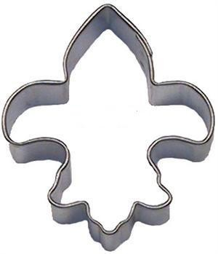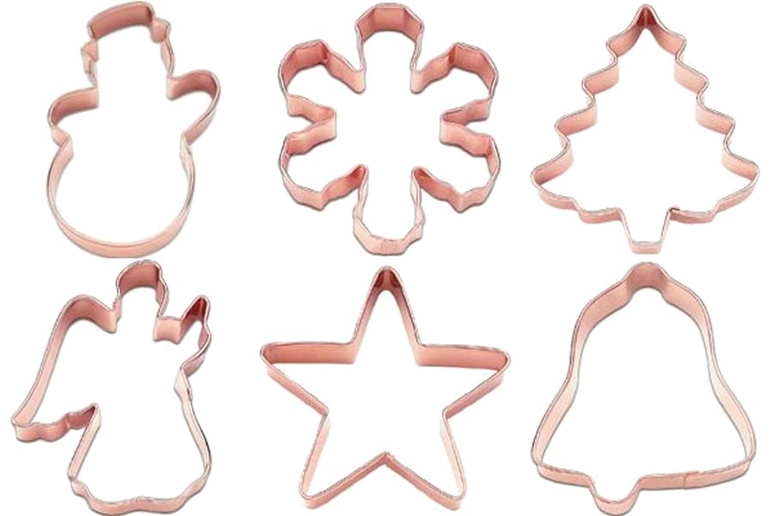

* [Cookie Cutter Week:](http://www.frankencutters.com/cccc/) 1-7
* [Clerc-Gallaudet Week](https://storytimestuff.wordpress.com/2013/12/02/celebrate-deaf-history-with-clerc-gallaudet-week-december-3-9/): 3-9 (Deaf Awareness)

[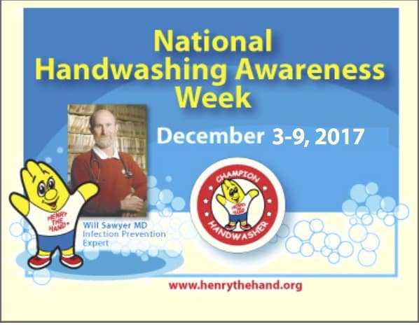](http://www.henrythehand.com/news-events/national-handwashing-awareness-week/)

* [National Handwashing Awareness Week](http://www.henrythehand.com/news-events/national-handwashing-awareness-week/): 3-9 For more info and posters, go to Henry the Hand's site, <https://www.henrythehand.com/>.
* Recipe Greetings For The Holidays Week: 3-10



* [Computer Science Week](https://csedweek.org/) 3-9
* [Older Driver Safety Awareness Week](http://www.aota.org/Conference-Events/Older-Driver-Safety-Awareness-Week.aspx): 4-8
* International Coelenterate Biology Week: 7-11



* [Hanukkah **12-20**](http://www.chabad.org/holidays/chanukah/default_cdo/jewish/Hanukkah.htm)
* [Gluten-free Baking Week](https://gepl.org/2016/12/national-gluten-free-baking-week-december-17-23/): 17-23 (Week Before Christmas)
* Halcyon Days: 14-28 (Always 7 days before and 7 days after the Winter Solstice)

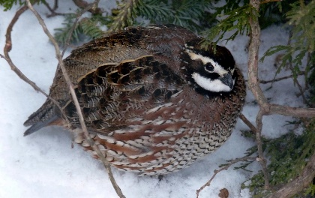

* [Christmas Bird Count Week](http://birds.audubon.org/christmas-bird-count): 12/14-1/5
* [Posadas:](http://www.haciendatresrios.com/special-occasions/posada-christmas-in-mexico-traditions/) 16-24
* [Saturnalia:](https://en.wikipedia.org/wiki/Saturnalia) 17-23
* It's About Time Week: 25-31
* Kwanzaa: 26-1/1

**December Daily Holidays, Special   
and Wacky Days:**

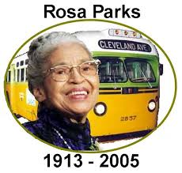

* **1** [Rosa Parks Day](http://memory.loc.gov/ammem/today/dec01.html)
* 1 [Eat a Red Apple Day](http://www.holidayinsights.com/moreholidays/December/eataredappleday.htm)
* 1 [World Aids Awareness Day](http://www.holidayinsights.com/moreholidays/December/aidsawarenessday.htm)
* 2 [National Fritters Day](http://www.holidayinsights.com/moreholidays/December/frittersday.htm)



* 3 [Advent](http://www.holidayinsights.com/christian/advent.htm)  begins
* 3 [National Roof over Your Head Day](http://www.holidayinsights.com/moreholidays/December/rooofoveryourhead.htm)
* 4 [Santa’s List Day](http://www.holidayinsights.com/moreholidays/December/santaslistday.htm) -   
  we hope you are on the "Nice" list
* 4 [Wear Brown Shoes Day](http://www.holidayinsights.com/moreholidays/December/brownshoesday.htm)
* 5 [Bathtub Party Day](http://www.holidayinsights.com/moreholidays/December/bathtubpartyday.htm)
* 5 [Repeal Day](http://www.holidayinsights.com/moreholidays/December/repealday.htm) - The 21st Amendment ends Prohibition
* 6 [St. Nicholas Day](http://www.holidayinsights.com/moreholidays/December/stnicholasday.htm)
* 6 [Mitten Tree Day](http://www.holidayinsights.com/moreholidays/December/mittentreeday.htm)
* 6 [Put on your own Shoes Day](http://www.holidayinsights.com/moreholidays/December/yourshoesday.htm)
* 7 [International Civil Aviation Day](http://www.holidayinsights.com/moreholidays/December/civilaviationday.htm)
* 7 [Letter Writing Day](http://www.holidayinsights.com/moreholidays/December/letterwritingday.htm)
* 7 [National Cotton Candy Day](http://www.holidayinsights.com/moreholidays/December/cottoncandyday.htm) -   
  Would you like some fairy floss?

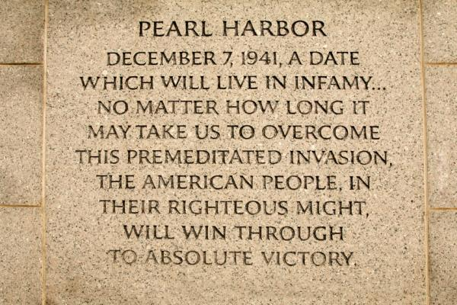

* **7** [**Pearl Harbor Day**](http://www.holidayinsights.com/other/pearlharbor.htm)



* 8 [Pretend To Be A Time Traveler Day](https://www.daysoftheyear.com/days/pretend-to-be-a-time-traveler-day/)
* 8 [National Brownie Day](http://www.holidayinsights.com/moreholidays/December/brownieday.htm)
* 8 [Take it in the Ear Day](http://www.holidayinsights.com/other/earday.htm)
* 9 [International Children's Day](http://www.holidayinsights.com/other/children.htm)
* 9 [Christmas Card Day](http://www.holidayinsights.com/moreholidays/December/christmascardday.htm)
* 9 [National Pastry Day](http://www.holidayinsights.com/other/pastryday.htm)
* 10 [Human Rights Day](http://www.holidayinsights.com/moreholidays/December/humanrightsday.htm)

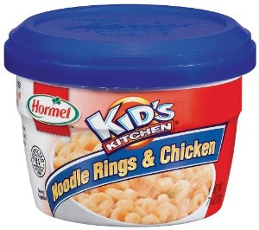

* 11 [National Noodle Ring Day](http://www.holidayinsights.com/moreholidays/December/noodleringday.htm)
* 12 [National Ding-a-Ling Day](http://www.holidayinsights.com/moreholidays/December/dingalingday.htm)
* 12 [Poinsettia Day](http://www.holidayinsights.com/other/poinsettia.htm)
* 13 [Ice Cream Day](http://www.holidayinsights.com/other/icecreamday.htm)
* 13 [Violin Day](http://www.holidayinsights.com/moreholidays/December/violinday.htm)
* 14 [Roast Chestnuts Day](http://holidayinsights.com/moreholidays/December/roast-chestnuts-day.htm)
* 14 [International Monkey Day](http://holidayinsights.com/moreholidays/December/international-monkey-day.htm)
* 14 [National Bouillabaisse Day](http://www.holidayinsights.com/moreholidays/December/bouillabaisseday.htm)

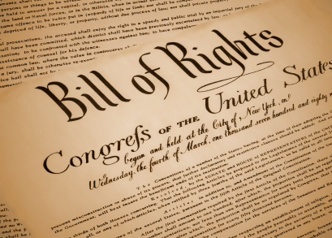

* 15 [Bill of Rights Day](http://www.holidayinsights.com/moreholidays/December/billofrightsday.htm)
* 15 [National Lemon Cupcake Day](http://www.holidayinsights.com/moreholidays/December/lemoncupcakeday.htm)
* 16 [National Chocolate Covered Anything Day](http://www.holidayinsights.com/moreholidays/December/chocolatecovered.htm)
* 17 [National Maple Syrup Day](http://www.holidayinsights.com/moreholidays/December/maplesyrupday.htm)
* 18 [Bake Cookies Day](http://www.holidayinsights.com/other/bakecookiesday.htm)
* 18 [National Roast Suckling Pig Day](http://www.holidayinsights.com/moreholidays/December/sucklingpigday.htm)
* 19 [Look for an Evergreen Day](http://www.holidayinsights.com/moreholidays/December/evergreenday.htm)
* 19 [Oatmeal Muffin Day](http://www.holidayinsights.com/moreholidays/December/oatmealmuffinday.htm)
* 20 [Go Caroling Day](http://www.holidayinsights.com/moreholidays/December/gocarolingday.htm)



* 21 [Crossword Puzzle Day](http://holidayinsights.com/moreholidays/December/crossword-puzzle-day.htm)
* 21 [Forefather's Day](http://www.holidayinsights.com/moreholidays/December/forefathersday.htm)
* 21 [Humbug Day](http://www.holidayinsights.com/moreholidays/December/humbugday.htm)
* 21 [National Flashlight Day](http://www.holidayinsights.com/moreholidays/December/flashlightday.htm)
* 21 [Look on the Bright Side Day](http://www.holidayinsights.com/moreholidays/December/brightsideday.htm)

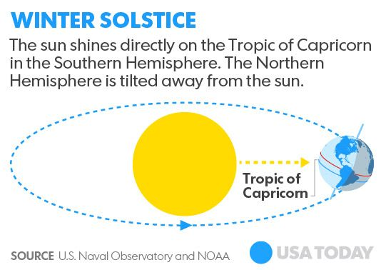

* 21 [Winter Solstice](http://www.holidayinsights.com/other/winter.htm) - shortest day of the year
* 22 [National Date Nut Bread Day](http://www.holidayinsights.com/moreholidays/December/datenutbreadday.htm)
* 23 [Festivus](http://www.holidayinsights.com/moreholidays/December/festivus.htm)- for the rest of us
* 23 [Roots Day](http://www.holidayinsights.com/moreholidays/December/rootsday.htm)
* 24 [National Chocolate Day](http://www.holidayinsights.com/moreholidays/December/chocolateday.htm)
* 24 [National Egg Nog Day](http://www.holidayinsights.com/moreholidays/December/eggnogday.htm)



* 25 [Christmas Day](http://www.holidayinsights.com/xmas/index.htm)

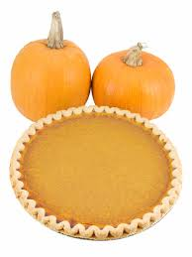

* 25 [National Pumpkin Pie Day](http://www.holidayinsights.com/moreholidays/December/pumpkinpieday.htm) for recipes see [Pumpkin Nook 's Cookbook](http://pumpkinnook.com/cookbook.htm)
* 26 [Boxing Day](http://www.holidayinsights.com/other/boxing.htm)
* 27 [Make Cut Out Snowflakes Day](http://www.holidayinsights.com/moreholidays/December/snowflakeday.htm)
* 27 [National Fruitcake Day](http://www.holidayinsights.com/other/fruitcakeday.htm)
* 28 [Card Playing Day](http://www.holidayinsights.com/moreholidays/December/cardplayingday.htm)
* 29 [Pepper Pot Day](http://www.holidayinsights.com/moreholidays/December/pepperpotday.htm)
* 30 [National Bicarbonate of Soda Day](http://www.holidayinsights.com/moreholidays/December/bicarbonateofsodaday.htm)
* 31 [Make Up Your Mind Day](http://www.holidayinsights.com/moreholidays/December/makeupyourmindday.htm)
* 31 [New Year's Eve](http://www.holidayinsights.com/other/newyears.htm)
* 31 [Unlucky Day](http://www.holidayinsights.com/moreholidays/December/unluckyday.htm)

**December – A Month for Kindness**

*Alice, Golden Empire Council*

**December 1 – Rosa Parks Day**

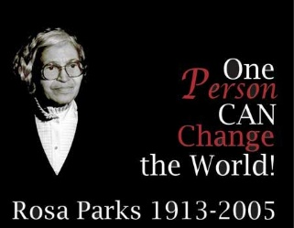

On this day in 1955, Rosa Parks, an African American tailor’s assistant at a department store in Montgomery, Alabama refused to give up her seat on the bus to a white man. She was arrested and fined. That simple action of demanding personal respect led to a boycott of the bus system by other African Americans. Her action was a major one in the fight for civil rights, including a Supreme Court ruling against segregation.

Martin Luther King, Jr. helped organize the bus boycott – and many people walked miles every day to get to and from work, rather than take the buses that only allowed them to sit in the back or stand, leaving the whole front of the bus available only to white people. Car pools were also organized, but many black families depended on the bus – some white people took a great personal risk to pick up black workers and drive them to work. The boycott lasted for 381 days!

On November 13, 1956, with future Supreme Court Justice Thurgood Marshall representing the boycotters, the US Supreme Court ruled that segregation on city buses is unconstitutional. On December 20, 1956, the bus system was finally desegregated.

In 1957, after numerous death threats, Mrs. Parks and her husband moved to Detroit and founded the Rosa & Raymond Parks Institute for Self-Development, which helps young African-Americans develop leadership skills. Her autobiography, “Quiet Strength,” was published in 1994, and she received the Congressional Gold Medal in 1999.

After her death, on October 24, 2005, Mrs. Rosa Parks lay in state in the US Capitol Rotunda in Washington, D.C., to honor her pivotal role in US history. She was the first woman and the second African-American to be given that honor.

**December 4 – National Cookie Day**

Make some cookies – you can make some to share with family and friends, too! If there are some special family cookie recipes from a relative, this could also be a way to show your respect for family. Several Adventures have requirements to make and bring a snack. This could be it!



**December 5 – Walt Disney’s Birthday**

Walt Disney not only created Mickey Mouse, Disneyland and Disney World – in every project he showed respect. He insisted on the very best quality even in his cartoons. In Disneyland, he insisted that animals and even the plantings be as true to life as possible – even when creating a miniature world, or when a character was behind and only partially viewed. He also expected his employees to be treated with respect and to treat those who came to the park with respect. He insisted on very high standards of cleanliness, dress, language and authenticity for his employees.

**December 12 – Hanukkah Begins**

Hanukkah is the Jewish Festival of Lights, an eight day holiday that commemorates rededication of the Temple, after the Macabees discovered that almost all the ritual olive oil had been polluted. They found only enough to light the menorah (a special candle holder) for a single day – but it burned for eight days, till new oil could be pressed and ready. It is considered a miracle, and is celebrated by Jews around the world. Special foods are also eaten and a special game with a dreidel, or spinner, is played. ***Check out WEB SITES to find more information and directions for making your own dreidel game.***

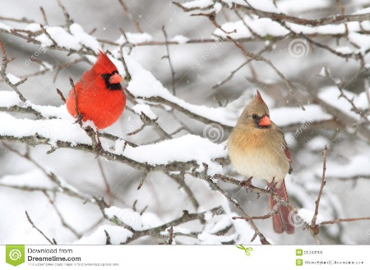

**December 14 – Winter Bird Count**

On a single day during the 16-day Christmas Count, small groups all over North, South and Central America identify and count as many birds as they can within a certain area.

**December 15 – Native American Winter Count -**

Some Plains Indian Tribes showed their respect for their own personal and tribal history by keeping an ongoing record on a buffalo skin, in the form of pictures that represented the most important events of each year

**December 23 – Roots Day –**

Early in the month, challenge the boys to work with family members to gather enough information to make a chart showing family roots. Some people have a special interest in learning about their family history, culture and genealogy

**December 24  
Artist Joseph Cornell born 1903 in New York City**

Yes, I KNOW it’s Christmas Eve – so do this a little earlier - Cornell used all kinds of everyday “found items” from nature or purchased at thrift shops, then transformed them into works of art by mounting them in a box. He gave them a place of honor so they could be enjoyed for their shape, form or importance. He added glass to protect the items while they could still be seen – but just arranging items in a box gives them importance. So celebrate and show respect for the every day items in our lives by making an art construction***. Directions in Den & Pack Activities.***

**December 26 – Kwanzaa Begins**

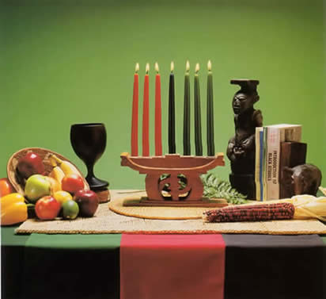

Kwanzaa is a weeklong celebration held in the [United States](http://en.wikipedia.org/wiki/United_States) to honor [African-American heritage](http://en.wikipedia.org/wiki/African-Americans) and culture, and values that are cherished in the family. It starts on December 26 and goes to January 1 each year. There are special activities each night, including lighting a candleholder with seven candles. A special feast and gift giving are held on the last night. The holiday was created by [Maulana Karenga](http://en.wikipedia.org/wiki/Maulana_Karenga) and was first celebrated in 1966–1967.

**December 29 – Look to the Future Day -**

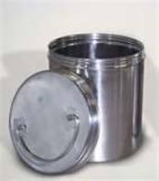

Make and bury a “Time Capsule” – Could be for yourself, the den and/or pack, or for the family. Your time capsule could be a metal container, or as simple as a 2 liter bottle cut in half, then pushed together and sealed with duct tape. Include items that represent the time period, then bury your capsule and mark a calendar for when you will dig it up – for a den, it could be at the end of the Cub years, just before the boys become Webelos or earn their Arrow of Light. A family might wait 5 years – and make sure that every family member is included!

## THE BILL OF RIGHTS

**OF THE UNITED STATES OF AMERICA Adopted 1791**

<https://www.billofrightsinstitute.org>

The first 10 amendments to the Constitution make up the Bill of Rights. Written by James Madison in response to calls from several states for greater constitutional protection for individual liberties, the Bill of Rights lists specific prohibitions on governmental power. The Virginia Declaration of Rights, written by George Mason, strongly influenced Madison.

One of the many points of contention between Federalists and Anti-Federalists was the Constitution’s lack of a bill of rights that would place specific limits on government power. Federalists argued that the Constitution did not need a bill of rights, because the people and the states kept any powers not given to the federal government. Anti-Federalists held that a bill of rights was necessary to safeguard individual liberty.

Madison, then a member of the U.S. House of Representatives, went through the Constitution itself, making changes where he thought most appropriate. But several Representatives, led by Roger Sherman, objected that Congress had no authority to change the wording of the Constitution itself. Therefore, Madison’s changes were presented as a list of amendments that would follow Article VII.

The House approved 17 amendments. Of these 17, the Senate approved 12. Those 12 were sent to the states for approval in August of 1789. Of those 12, 10 were quickly approved (or, ratified). Virginia’s legislature became the last to ratify the amendments on December 15, 1791.

The Bill of Rights is a list of limits on government power. For example, what the Founders saw as the natural right of individuals to speak and worship freely was protected by the First Amendment’s prohibitions on Congress from making laws establishing a religion or abridging freedom of speech. For another example, the natural right to be free from unreasonable government intrusion in one’s home was safeguarded by the Fourth Amendment’s warrant requirements.

Other precursors to the Bill of Rights include English documents such as the Magna Carta, the Petition of Right, the English Bill of Rights, and the Massachusetts Body of Liberties.

**THE BILL OF RIGHTS**

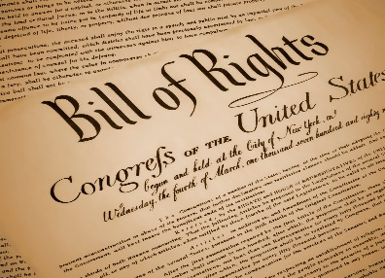

**Amendment I**Congress shall make no law respecting an establishment of religion, or prohibiting the free exercise thereof; or abridging the freedom of speech, or of the press; or the right of the people peaceably to assemble, and to petition the government for a redress of grievances.

**Amendment II**A well-regulated militia, being necessary to the security of a free state, the right of the people to keep and bear arms, shall not be infringed.

**Amendment III**No soldier shall, in time of peace be quartered in any house, without the consent of the owner, nor in time of war, but in a manner to be prescribed by law.

**Amendment IV**The right of the people to be secure in their persons, houses, papers, and effects, against unreasonable searches and seizures, shall not be violated, and no warrants shall issue, but upon probable cause, supported by oath or affirmation, and particularly describing the place to be searched, and the persons or things to be seized.

**Amendment V**No person shall be held to answer for a capital, or otherwise infamous crime, unless on a presentment or indictment of a grand jury, except in cases arising in the land or naval forces, or in the militia, when in actual service in time of war or public danger; nor shall any person be subject for the same offense to be twice put in jeopardy of life or limb; nor shall be compelled in any criminal case to be a witness against himself, nor be deprived of life, liberty, or property, without due process of law; nor shall private property be taken for public use, without just compensation.

**Amendment VI**In all criminal prosecutions, the accused shall enjoy the right to a speedy and public trial, by an impartial jury of the state and district wherein the crime shall have been committed, which district shall have been previously ascertained by law, and to be informed of the nature and cause of the accusation; to be confronted with the witnesses against him; to have compulsory process for obtaining witnesses in his favor, and to have the assistance of counsel for his defense.

**Amendment VII**In suits at common law, where the value in controversy shall exceed twenty dollars, the right of trial by jury shall be preserved, and no fact tried by a jury, shall be otherwise reexamined in any court of the United States, than according to the rules of the common law.

**Amendment VIII**Excessive bail shall not be required, nor excessive fines imposed, nor cruel and unusual punishments inflicted.

**Amendment IX**The enumeration in the Constitution, of certain rights, shall not be construed to deny or disparage others retained by the people.

**Amendment X**The powers not delegated to the United States by the Constitution, nor prohibited by it to the states, are reserved to the states respectively, or to the people.



## Fun Facts About Ties

*Baloo*

* Neck ties existed at least by 221 BC. Proof exists in the tomb of China’s first emperor, Shih Huang Ti.
* From the mid-1600s to 1840, most people called their neckwear “cravats.” These were not the ties we consider standard today.
* Over time neckwear evolved, as fashion tends to do. Men wore ascots, bowties, long ties, and more. Today these are all simply different kinds of ties.
* And, of course, even the long tie has gone through evolutions. Every few years a different width becomes popular. From super skinny to crazy wide (5 inches during the 1950s!), men seem to have tried them all.
* Arizona has an official state tie: the bolo tie. Now, you might argue the bolo isn’t a real tie. And you might be right. Or not. … But at least you don’t have to tie yourself in knots trying to learn how to tie one!
* The necktie originated from a silk scarf worn by Croatian soldiers - it became known as the cravate.
* Marv Beloff invented the wooden bow tie in 1993. He sells nine basic homemade styles and insists that the only things you have to worry about when you wear them are "termites and fires."
* 300 years ago, the English developed neckwear so thick that they could stop a sword thrust. We do not recommend trying that with today's ties...
* The stripes on British ties usually run from top left to bottom right while the stripes on American ties run from top right to bottom left.
* At one point in history, merely touching a man's tie knot was cause for a duel.
* At the height of its popularity, Americans spent more than $1 billion each year to buy a staggering 100 million ties.
* A good quality silk tie will require approximately 110 silkworm cocoons.
* The city of Shengzhou in China is one of the world's biggest tie producers, with 200 million ties made there each year.
* It is possible to buy a bulletproof tie that will stop a 9mm bullet. Could be useful?
* A person who collects ties is called a Grabatologist. Really.
* Al Pacino won the Tony Award for best Supporting Actor in the Play "Does a tiger wear a necktie?". Yes, that is a bit of a tenuous link...
* In 2002 the tie industry in America saw sales slump by 10% due to the popularity of "dress down days".
* Iran banned the sale of ties after the 1979 Islamic revolution, deeming it a symbol of western decadence. Wearing them however, is not banned.
* The most expensive tie ever made cost a mere $220,000. Designed by Satya Paul Design Studio, it contained 271 diamonds and 150 grams of gold.

**What Cubs Are Made Of**

*Baltimore Area Council*

Cub Scouts are made of all of these,

Scarves of gold, patches on sleeves,

Trousers of blue and well-worn knees,

That’s what Cub Scouts are made of.

They’re partly Indians, of fringe and feather,

And beads and buttons and bits of leather,

With war-paint and freckles mixed together,

That’s what Cub Scouts are made of.

They’re made of a promise, a pledge, and a prayer

Of hands that are willing, of hearts that play fair,

With something inside them that God put there,

And that’s what Cub Scouts are made of.

# SPECIAL OPPORTUNITIES

***All Special Opps discussed this month are for Scouts and Scouters. No Knot of the Month in this issue.***

## WORLD CREST



An emblem of the World Organization of the Scout Movement, WOSM, ([www.scout.org](http://WWW.SCOUT.ORG)). The World Crest may be worn by all registered youth members and adult leaders as a symbol of their membership in a worldwide Scouting brotherhood. A small amount from the sale of each emblem is sent to the World Scout Foundation to help extend Scouting in developing nations throughout the world. This adds an opportunity for each Scout to personally share indirectly in the activities of brother Scouts in other lands.

Over the years, member national Scout organizations have made use of the badge in different ways. In 1988 the World Organization of the Scout Movement asked that every national Scout association authorize this emblem to be worn by all members to signify membership in a worldwide movement.



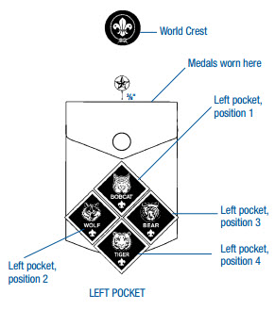

Sew the World Crest halfway between top of left pocket and left shoulder seam

The emblem is worn as a permanent patch centered horizontally over the left pocket and centered vertically between the left shoulder seam and the top of the pocket.

**FAQ -** If the World Crest may be worn by all youth and adults in the BSA, why isn’t the World Crest pre-sewn on BSA uniforms? In summary, Bryan's Blog's (<http://blog.scoutingmagazine.org/>) answer to the question said: The fee paid by the BSA to WOSM for use of the emblem is based on the cost of the item sold. By selling the patches separately, the fee is a based on the cost of the patch. If it were pre sewn on a shirt, the fee would be a percentage of the cost of the shirt. Doing that would essentially double the cost of the patch to Scouts and Scouters.

Find the World Crests on these Scouts from other countries -

 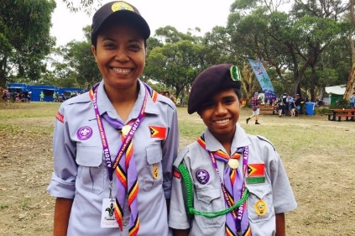  
From United Kkingdom From East Timor

 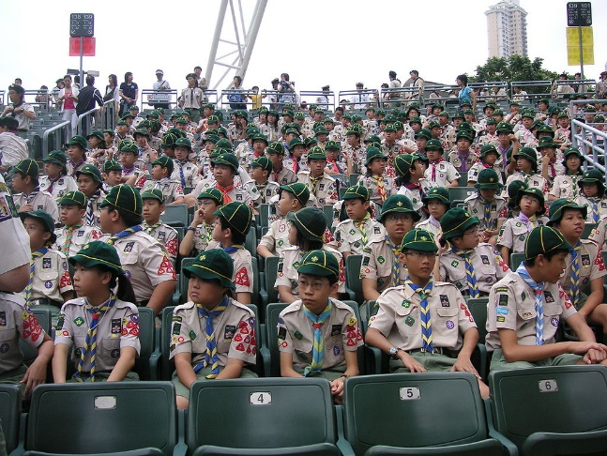

From Papua New Guinea From Hong Kong

**SCOUT NERD FACT**

The BSA receives all its World Crest patches from the World Organization of the Scouting Movement (WOSM [www.scout.org](http://www.scout.org)). WOSM sells these patches to all National Scouting organizations that are members. You can tell this because there are no BSA logos on the back of the World Crest.

Typical BSA patch with BSA logos on back 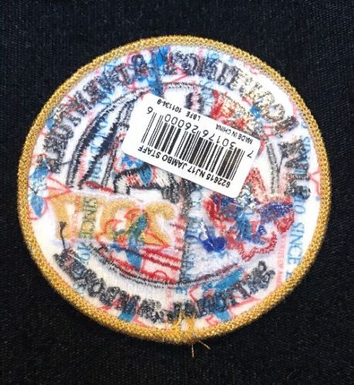

World Crest back with no BSA logo

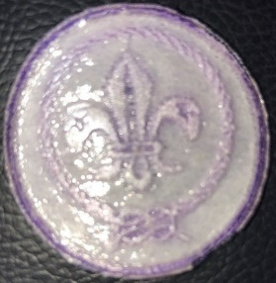

**BSA WORLD CREST RINGS**

The BSA has authorized rings that may be worn around the World Crest emblem. **Only one ring may be worn at a time.**

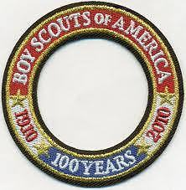 

*BSA 100th Anniversary ring Current BSA World Crest ring*

In 2010 the BSA issued a 100th Anniversary (on the left) ring that all Scouts and Scouters could wear around the World Crest ring. This ring is no longer being sold by BSA.

After the 100th Anniversary celebration was over, BSA replaced the original ring with the 1910 ring on the right. This ring, just like the 100th Anniversary ring was, may be placed around the World Crest emblem by any Scout or Scouter. There are no requirements to wear either ring.

**THE MESSENGERS OF PEACE RING**



This ring is earned by participating in a Messengers of Peace (MOP) Service Project.

**FAQ's**

**What is Messengers of Peace? -** Messengers of Peace is a World Scout Committee initiative designed to promote and recognize service projects that contribute to world peace. Launched in September 2011, Messengers of Peace is a global initiative designed to inspire millions of young men and women in more than 220 countries and territories to work toward peace. Using state-of-the-art social media, the initiative lets Scouts from around the world share what they’ve done and inspire fellow Scouts to undertake similar efforts in their own communities. The initiative is inspired by the World Scout Committee, administered by the World Scout Bureau, and driven by youth volunteers worldwide. For more information –

* BSA Website - <http://www.scouting.org/Home/International/messengersofpeace.aspx>. There is a lot more information here and many more FAQs.
* World Organization of the Scout Movement (WOSM) Website - <https://www.scout.org/messengersofpeace>

**How do I submit a project?**  MOP service projects should be reported by the individual in each unit designated to report Journey to Excellence service projects. To designate a Messengers of Peace project, simply select Messengers of Peace as the partner organization when entering a service project through the Journey to Excellence website ([www.scouting.org/Awards/JourneyToExcellence](http://www.scouting.org/Awards/JourneyToExcellence) ).

**What recognition items are available?** A participating unit (pack, troop, …) will receive a unit certificate. Each Scout or Scouter who participates in a qualifying project is eligible to wear a Messengers of Peace ring patch around the World Crest on his or her uniform. A unit representative can purchase these ring patches at a local Scout shop, council service center, or Scoutstuff.org

**INTERNATIONAL SPIRIT AWARD**



[www.usscouts.org/awards/](http://www.usscouts.org/awards.asp)

For youth and adult leaders, the International Spirit Award emblem is worn as a temporary patch centered on the right uniform pocket. The award seeks to broaden knowledge of international Scouting and increase appreciation and awareness of different cultures and countries.

This award replaced the former International Activity Award and the International Youth Exchange Award, which are no longer available.

The Award application may be obtained at <http://www.scouting.org/filestore/international/pdf/130-044_WB.pdf>

**Requirements**

**Cub Scout**

1. Earn the Cub Scout World Conservation Award.
2. Learn 10 words that are in a different language than your own.
3. Play two games that originated in another country or culture.
4. Participate in Jamboree-on-the-Air or Jamboree-on-the-Internet.
5. Organize a World Friendship Fund collection at a unit meeting or district roundtable.
6. Complete two of the 10 Experience Requirements.

**Boy Scout/Varsity/Venturer**

1. Earn the Boy Scout or Venturing World Conservation Award.
2. Earn the Citizenship in the World Merit Badge. (Alternative for Venturers: Complete the “Understanding Other Cultures” requirement of the TRUST Award.)
3. Participate in Jamboree-on-the-Air or Jamboree-on-the-Internet.
4. Organize a World Friendship Fund collection at a unit meeting or district roundtable.
5. Complete three of the 10 Experience Requirements.

**Scouter (Adult)**

1. Learn about the World Organization of the Scout Movement (www.scout.org). Explain to your unit or at a district roundtable what this organization is and at least three ways that the WOSM website can be used to promote participation in international Scouting.
2. Read the most current International Department newsletter ([www.scouting.org/international/newsletter](http://www.scouting.org/international/newsletter)) and promote at least two items from the newsletter within your unit or at a district roundtable.
3. Help organize or participate in two Jamboree-on-the-Air or Jamboree-on-the-Internet events.
4. Organize a World Friendship Fund collection at a unit meeting or district roundtable.
5. Complete four of the 10 Experience Requirements.

**Experience Requirements**

1. Host an international Scout or unit and plan activities to help you learn about Scouting in their country.
2. Learn about another country and prepare a dinner traditionally served there. Explain what you learned to friends or family over the meal.
3. Participate in a World Scout Jamboree, international camporee, or another international Scouting event. Share the experience with your unit or at a district roundtable.
4. Take a trip to another country as an individual or with your family or Scouting unit. Make sure to visit a Scouting event or unit in that country. When you return home,share your experience with another unit.
5. Organize and participate in a Messengers of Peace project. Share the experience with your unit or at a district roundtable, making sure to explain which dimensions of the program your project promoted.
6. Earn the interpreter strip.
7. Research Scouting in another country. Make a presentation at a unit meeting or district roundtable.
8. Contact your local council’s international representative and assist them with at least two items they need help with promoting.
9. Research the process of obtaining a U.S. passport. Create a fact sheet for your unit or district to assist them with requirements for traveling internationally.
10. Research a region of the World Organization of the Scout Movement. Make a presentation at a unit meeting or district roundtable.

# CUB GRUB

**Cub Grub Cookbook**

This is a really great cookbook for Cubs -

<http://balboaoaks.bsa-la.org/download/blog/Cub%20Grub%20Cookbook.pdf>

You can save a copy on your PC by selecting   
**File, Save As...** in your web browser's menu bar.

## FORWARD RECIPES

**Recipe for a Happy Day**

*Baltimore Area Council*

**Ingredients**

1 cup of friendly words

1 cup of courteous manners

1 headful of understanding

4 heaping teaspoons of kindness

Dash of laughter

**Directions**

* Mix well.
* Cook but keep temperature low, do not boil.
* Serve everyone you meet.

**Johnny Appleseed Smiles**

*Alice, Golden Empire Council*

***Use these to celebrate Smile Day, too. And they go great with the Girl Scout Brownie Smile! Alice.***

**Ingredients**

Red medium apple, cored & sliced

Peanut butter or cream cheese

Tiny marshmallows

**Directions**

* Spread one side of each apple slice with peanut butter.
* Place 3 or 4 tiny marshmallows on top of the peanut butter on one apple slice.
* Top with another apple slice, peanut butter side down.
* Squeeze gently. Eat right away.

**Leprechaun Pudding**

*Alice, Golden Empire Council*

***A fun, green recipe for Saint Patrick's Day.***

**Total Time:** 20 minutes

**Ingredients: (Per boy)**

1 Tbsp Instant Pistachio Pudding;

1/2 Cup Milk;

Ziploc Baggie

**Preparation:**

* Put the tablespoon of pudding mix and 1/2 cup of milk into the ziploc sandwich bag.
* Close the baggie tightly, squeeze and shake.
* Eat your pudding once it is nice and thick!
* You can refrigerate it for awhile if needed.

**Irish Freckle Bread**

*Alice, Golden Empire Council*

***Really easy, traditional bread   
(with an updated name)***

**Ingredients:**

3-3/4 cups all purpose flour;

1/4 cup brown sugar;

1 T. baking powder;

1 tsp. baking soda;

1/2 tsp. salt;

3/4 cup dried currants, raisins or dried cranberries;

2 cups buttermilk; 1 egg

**Directions:**

* Preheat the oven to 375 degrees F.
* Grease a cookie sheet or line with parchment paper.
* In a large bowl, mix together the flour, brown sugar, baking powder, baking soda, and salt.
* Add the dried currants and mix well.
* In another bowl, stir together the buttermilk and the egg.
* Pour the buttermilk mixture into the flour mixture, and stir well until everything is blended.
* The dough will be quite soft.
* Sprinkle some additional flour onto the counter or table and turn the dough out onto this floured surface.
* Knead the dough about 10 times - just to make it reasonably smooth and pliable.
* Gently form it into one large, round loaf and place it onto the prepared baking sheet.
* With a very sharp knife, cut a shallow X into the top of the loaf. (This allows the bread to expand in the oven rather than crack and split.)
* Bake for 50 to 55 minutes, or until the loaf is nicely browned, and a toothpick poked into the middle of it comes out clean.

**Irish Scones**

*Alice, Golden Empire Council*

***This takes only about 35-45 minutes, so if you have the ingredients ready and make up your batter at the beginning of the meeting, you can do this in a den meeting – or make them to share with everyone at the Pack Meeting - just make a larger batch and cut the scones into half size when done - Alice.***

**Ingredients:**

1/2 stick butter

2 cups flour

1 tsp baking powder

2T sugar (optional)

1/2 tsp salt

1/4 pint milk

1 egg beaten with a little milk

**Directions:**

* Heat the oven to 400F
* Grease and flour a baking sheet.
* Sieve the flour into a bowl and add the butter, baking powder and salt.
* Quickly rub the butter into the flour until the mixture resembles fine breadcrumbs. Add the sugar if desired and stir.
* Make a well in the center of the dry mix and using a dinner knife, stir in enough milk to make a soft, pliable dough.
* Turn the mixture on to a floured board and knead very lightly until just smooth then lightly roll out to 3/4" thick.
* Cut 6 - 8 rounds (or as many as your dough will make) with a 3" cutter or cut into triangles with a sharp knife.
* Place on the baking tray and brush with the beaten egg and milk mixture.
* Bake near the top of oven for 15 minutes or until golden brown and well risen.
* Cool on a wire rack before eating.
* Serve with butter, jam or clotted cream.
* Makes 12 scones

**Fruit Scones**

* Add 1/4 cup currants or sultanas or chopped dates to the dry ingredients in the basic recipes.

**Cheese Scones**

* Add 1/2 cup grated cheese and 1/2 tsp dry mustard powder to the mixture after rubbing in the fat and flour and continue with the basic recipe.
* Sprinkle the scones with 1/2 cup more grated cheese before baking the scones in the oven.

**Ice Cream Cone Cornucopias**

*Baltimore Area Council*

**Materials:**

Ice Cream Cones with Pointed ends

Runts Candies, Candy Corn, Nuts

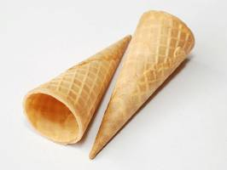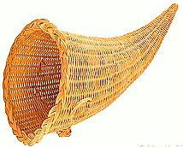

**Directions**

* Mix well.
* Roll a small piece of foil into a ball and place it in the opening of the cone.
* Place a small square piece of foil in a steamer basket and place the steamer basket in a pan of boiling water above the water line.
* Lay a cone on the square of foil in the basket and cover.
* Steam the cone for a few minutes.
* When the cone is pliable, but not soaked, remove it (it will be hot!) and shape the end into the curled up end of a cornucopia.
* Flatten the bottom slightly.
* When cool, remove the foil ball and fill the cone with the candies and nuts.

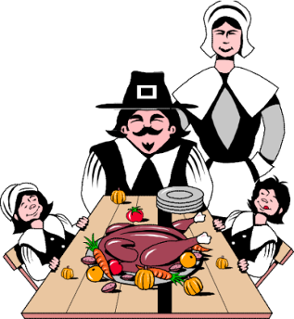

**Roasted Pumpkin Seeds**

*Baltimore Area Council*

**Ingredients:**

2 cups raw pumpkin seeds  
1 cup sesame seeds  
2 Tablespoons grated parmesan or Romano cheese  
1 Tablespoon butter or margarine, melted  
1 Tablespoon Worcestershire sauce  
Salt

**Directions**

* Combine all of the ingredients.
* Season to taste with salt and spread out the mixture on a baking sheet.
* Bake, stirring frequently, until lightly toasted.
* Let cool.

**George Washington’s Trifle**

*Alice, Golden Empire Council*

Trifle was a favorite dessert of George Washington, and he also loved cherries – (although that cherry tree story is just fiction)

This is really simple to do:

**Ingredients:**

Can of cherry pie filling

One recipe of vanilla pudding

Whipped Cream



**Instructions:**

* Use a clear plastic cup; Start with a spoonful of cherry pie filling, then layer some vanilla pudding.
* Keep alternating to the top of the cup.
* Then add a dollop of whipped cream and a cherry.

## HOLIDAY IDEAS

**Snowy Trail Mix**

*Sam Houston Area Council*

**Ingredients –**

3 cups pretzel sticks

1 ½ cup corn cereal

¾ cup pecan halves

½ cup cashews

½ cup dried cranberries

12 oz white chocolate



**Directions –**

1. In large bowl, mix together the pretzel sticks, corn cereal, pecans, cashews, and dried cranberries.
2. Melt the white chocolate according to the package directions and slowly pour it over the mix, stirring gently.
3. Scoop the mix onto waxed paper to cool, about 20 minutes,
4. Then break it in to bite sized pieces.
5. Makes about 10 cups.

**Edible Treats for Birds  
(NOT for people)**

*Capital Area Council*

Use your old Christmas tree or your backyard shrubs as a bird feeder. Decorate them by making Orange Slice Ornaments and Cookie Cutter Bird treats. This not only makes a festive feeder, but also provides shelter for small birds like sparrows and juncos.

This activity can be a 1 week or 2 week Den Meeting. This would depend on the size of the den.

**Orange Slice Ornaments**

**Materials:** Oranges, paring knife, cutting boards, yarn, raffia or ribbon, and pencils.

Give each Cub Scout his own orange and experiment slicing his orange, along with knife safety instructions. When it’s time to deck the tree or shrub, tie each slice to a branch.

**Cookie Cutter Bird Treats**

**Materials:** Mixing bowls, measuring cups, measuring spoons, mixers-electric or manual, rolling pin, drinking straws, and ribbon.

**Ingredients**1 Cup unsalted butter, softened   
3 eggs, beaten,   
3 l/2 cups all-purpose flour, sifted   
1 teaspoon baking soda,   
1 1/2 teaspoons cream of tartar   
1/2 teaspoon salt, mixed birdseed

**Directions:**

* Cream the butter, then beat in the eggs.
* Sift together the flour, baking soda, cream of tartar, and salt.
* Gradually add the dry ingredients to the butter and egg mixture.
* When well mixed, cover and chill.
* Flour surface of cabinet top and roll out the dough to about a 1/4 in thickness.
* Cut out shapes with the cookie cutters;
* At the top of each cookie, make a hole with a drinking straw.
* Press in a coating of the birdseed.
* Preheat oven to 350 and bake for about 12 minutes.
* When cookies are cool, insert a length of ribbon through each and tie.

***Since the cookie dough will need to chill, make dough first and chill. Then try the Orange Slice Ornaments while waiting for the dough.***

**Apple – Raspberry Spiced Cider**

*Alice, Golden Empire Council*

A sweet nonalcoholic alternative, this splendid spiced cider blends refreshing raspberry and apple in a pretty punch that's sure to bring some holiday cheer to your Christmas party. Serve with additional cinnamon sticks for stirring, if desired.

**Ingredients:**

2 quarts apple cider

1 can (12 oz) thawed raspberry cocktail concentrate

1-2 whole cinnamon sticks, broken in half

2 cups frozen raspberries

**Instructions:**

* In a saucepan, stir together apple cider, raspberry cocktail concentrate and cinnamon sticks.
* Bring to a boil over medium heat,   
  Then lower the heat to low and let simmer for about 10 minutes.
* Stir in raspberries and
* Serve directly from the saucepan or transfer to a Crock-Pot to keep warm.
* Servings: 8 to 10

**African Groundnut Stew**

*Alice, Golden Empire Council*

Peanuts, called groundnuts in Africa, are used in a lot of African cooking ***But be careful of allergies!***   
Lots of ingredients, but a simple vegetarian dish!

**Ingredients:**

1 Tbsp. olive oil

1 Large onion, chopped

2 cloves garlic, minced

1-2 fresh hot chilies, chopped

1 Tbsp. grated fresh ginger root

1 Tbsp. light brown sugar

1 tsp. Cumin

1-1/2 lbs. (750 g) butternut or other winter squash,

1-1/4 cups (300 mL) hot water

1 tsp. (5 mL) salt

1/4 tsp. (1 mL) black pepper

1/4 cup (50 mL) peanut butter

1 can (19 oz./540 mL) chickpeas, drained and rinsed

1/2 cup (125 mL) chopped roasted peanuts

1/4 cup (50 mL) chopped fresh parsley or cilantro

**Instructions:**

* Peel and seed the squash. Then cut it into 1-inch (2-cm) chunks. (You will have about 4 cups)
* In a large saucepan or Dutch oven, heat oil over medium heat.
* Add onion. Cook, stirring, until soft, about 5 min.
* Add the garlic, chilies, ginger, brown sugar and cumin and stir to mix.
* Cook for a minute or two, then add the squash and toss to coat everything evenly.
* Add 1 cup (250 mL) of the hot water, the salt and pepper and bring the mixture to a boil.
* Meanwhile, stir the remaining 1/4 cup (50 mL) of hot water into the peanut butter,
* Then add to the squash mixture in the pot.
* Mix well, cover and lower the heat to low.
* Let cook for 15 to 20 minutes or until the squash is nearly tender.
* Add chickpeas and roasted peanuts to the stew and continue cooking for another 10 minutes.
* Stir parsley or cilantro in just before taking it off the heat. Serve immediately.

**Brownies in a Jar – Great Christmas Gift!**

*Alice, Golden Empire Council*

These Christmas brownies make a gift that tastes and looks great. You can add a nice touch by printing the recipe and including it with the brownies so that the recipient can craft their own batch.

**Ingredients:**

1 quart canning jar and lid

Measuring cups and spoons

Printer to print a card and recipe

Measuring spoons

1/3 cup cocoa powder

2/3 cup sugar

1/2 cup chocolate chips

1/2 cup anilla chips

2/3 cup brown sugar, packed

1 cup all-purpose flour

2 tablespoons all-purpose flour

3/4 teaspoon salt

1/2 cup chopped pecans

**Instructions:**

* Layer ingredients in order given in a quart glass jar.
* Place lid and ring on securely.
* You can add a circle of holiday fabric underneath the ring to add some color to the jar.
* Try experimenting with multiple ingredient layers to get a different look.
* You can replace both the chocolate and vanilla chips with one cup of M&M baking chips

**Easy Mexican Bunuelos**

*Alice, Golden Empire Council*

There must be hundreds of recipes for bunuelos – but these are easy ones the boys can make during a den meeting for their snack.

1. Use canned biscuits, cut them in half, then drop into hot oil and cook till both sides are golden.
2. You can also cut small flour tortillas into quarters, drop them into hot oil and cook till slightly golden.
3. Now toss your bunuelos in a paper bag or plastic sealable bag filled part way with cinnamon sugar. Another option is to just drizzle them with maple syrup or honey.
4. Eat and enjoy!

**Yule Log Cake**

*Alice, Golden Empire Council*

The traditional Buche de Noel or Yule Log cake, is made by baking a cake in a jelly roll pan, frosting it, then carefully rolling it up into a “log.” Usually, a wedge is cut from one end and used to make a “knot” on one side, and the whole thing is frosted. Sometimes, meringue mushrooms are added. You can find recipes for this cake everywhere – but here are two easier versions the boys could help make.

**Version #1 -**

1. Make a regular cake mix, but bake in a loaf pan.
2. Remove from pan, let cool thoroughly,
3. Then use a knife to round the top edges so you have a log shape.
4. Cut one end at an angle to create a wedge shape – this can be added to one side to make the “knot” where a “branch” would have been.
5. Now frost your cake and decorate with small plastic animals, such as squirrels, or add artificial leaves or berries along the bottom.

**Version #2 -**

The second version is made like a cheese log –

1. Purchase a log or trim cheese to a log shape
2. Then “frost” with cream cheese and add decorations.
3. Serve with crackers for a great snack.

You can’t find an easier snack to fit the Value of Faith! Share pretzels in the traditional shape – after you tell the boys the story of how a village priest used the pretzel shape to remind the children to pray! Check it out under AUDIENCE PARTICIPATIONS & STORIES.

***If you want a bigger challenge, pretzels are very easy to make – the trick is doing the twist to make them look like folded arms ready for prayer!***

**DOUGHNUT SNOWMEN**

*Trapper Trails*

**Ingredients:**

Powdered doughnuts

mini doughnuts

doughnut holes

Haviland thin mints

miniature Reese’s cups

pretzel sticks

black and orange gel frosting

Fruit Rollups

**Directions**

* Stack doughnuts large to small to make snowman.
* You can use pretzel sticks to hold them together.
* Use gel frosting to make face and buttons.
* The mint with Reese’s cup placed upside down on top makes the hat and
* Cut Fruit Rollups to make a scarf around snowman’s neck.

**Cub Cakes**

*Alice, CS RT Commissioner*

*Pioneer District, Golden Empire Council*

**Cupcake Caterpillar:** Or use green frosting, line up a wavy row of cupcakes. Finish off with M&M or Skittles, coconut, licorice or other candies to make a fuzzy beastie.

**Moth or Butterfly:** To make a butterfly, pour the cake mix in a cupcake liner inside the cupcake pan – now take 2 little balls of tin foil and put it between the paper liner and the cupcake pan at the top and bottom of the cupcake – it will keep the cupcake from baking in a round shape – instead you will have a moth or butterfly shape. Once baked and cooled, decorate with frosting, licorice antennae, and other candies or sprinkles for a unique butterfly!

**Lady Bug Cupcakes:** Use red frosting and chocolate chips turned upside down and pushed part way into the frosting to decorate your lady bug. Add black licorice antennae.

**Buggy Bake Off:** Each boy makes his own cupcake “bug” – and brings it to the pack meeting to be judged – Everyone gets a prize made by attaching plastic bugs available at dollar and party stores to a cardboard or scrap wood base with appropriate titles - things like “Most Colorful Bug” or “Best Use of Sprinkles” or “Scariest Bug.”

# LAST THINGS

**THE CHRISTMAS SCOUT**

*Various Sources  
This story appears in many Scouting related and non-scouting websites. It has, also, appeared previously in Baloo's Bugle One newspaper's title is "The true Story of the Christmas Scout," and credits a Scoutmaster for the story. One version says the author first heard it from a boy who received one of the gifts. Enjoy!*

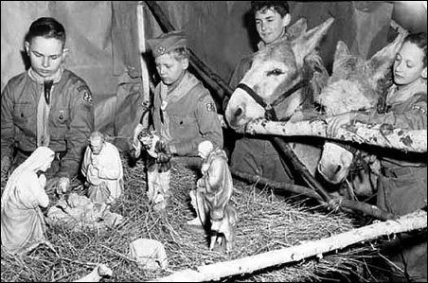

***If there are poor among you, in one of the towns of the land the Lord your God is giving you, do not be selfish or greedy toward them. But give freely to them, and freely lend them whatever they need.  
 Deut. 15:7-8***

This is the legend of the Christmas Scout. It was told to me first by a small boy, whose faith in the story was absolute. He showed me a toy airplane and said emphatically that it came from the Christmas Scout.

Despite the fun and laughter, 13-year-old Frank Wilson was not happy.

It was true that he had received all the presents he wanted. And he enjoyed these traditional Christmas Eve reunions of relatives—this year at Aunt Susan’s—for the purpose of exchanging gifts and good wishes.

But Frank was not happy because this was his first Christmas without his brother, Steve, who, during the year, had been killed by a reckless driver. Frank missed his brother and the close companionship they had together.

Frank said good-bye to his relatives and explained to his parents that he was leaving a little early to see a friend: from there he could walk home. Since it was cold outside, Frank put on his new plaid jacket. It was his favorite gift. The other presents he placed on his new sled.

Then Frank headed out, hoping to find the patrol leader of his Boy Scout troop. Frank always felt understood by him. Though rich in wisdom, he lived in the Flats, the section of town where most of the poor lived, and his patrol leader did odd jobs to help support his family. To Frank’s disappointment, his friend was not at home.

As Frank hiked down the street toward home, he caught glimpses of trees and decorations in many of the small houses. Then, through one front window, he glimpsed a shabby room with the limp stockings hanging over an empty fireplace. A woman was seated near them weeping.

The stockings reminded him of the way he and his brother had always hung theirs side by side. The next morning, they would be bursting with presents. A sudden thought struck Frank—he had not done his “good turn” for the day.

Before the impulse passed, he knocked on the door.

“Yes?” the sad voice of the woman inquired.

“May I come in?”

“You are very welcome,” she said, seeing his sled full of gifts, and assuming he was making a collection, “but I have no food or gifts for you. I have nothing for my own children.”

“That’s not why I am here,” Frank replied. “Please choose whatever presents you’d like for your children from this sled.”

“Why, God bless you!” the amazed woman answered gratefully.

She selected some candies, a game, the toy airplane and a puzzle. When she took the new Scout flashlight, Frank almost cried out. Finally, the stockings were full.

“Won’t you tell me your name?” she asked, as Frank was leaving.

“Just call me the Christmas Scout,” he replied.

The visit left the boy touched, and with an unexpected flicker of joy in his heart. He understood that his sorrow was not the only sorrow in the world. Before he left the Flats, he

The visit left the boy touched, and with an unexpected flicker of joy in his heart. He understood that his sorrow was not the only sorrow in the world. Before he left the Flats, he had given away the remainder of his gifts. The plaid jacket had gone to a shivering boy.

But he trudged homeward, cold and uneasy. Having given his presents away, Frank now could think of no reasonable explanation to offer his parents. He wondered how he could make them understand.

“Where are your presents, son?” asked his father as he entered the house.

“I gave them away.”

“The airplane from Aunt Susan? Your coat from Grandma? Your flashlight? We thought you were happy with your gifts.”

“I was—very happy,” the boy answered lamely.

“But, Frank, how could you be so impulsive?” his mother asked. “How will we explain to the relatives who spent so much time and gave so much love shopping for you?”

His father was firm. “You made your choice, Frank. We cannot afford any more presents.”

His brother gone, his family disappointed in him, Frank suddenly felt dreadfully alone. He had not expected a reward for his generosity. For he knew that a good deed always should be its own reward. It would be tarnished otherwise. So, he did not want his gifts back, however, he wondered if he would ever again truly recapture joy in his life. He thought he had this evening, but it had been fleeting. Frank thought of his brother and sobbed himself to sleep.

The next morning, he came downstairs to find his parents listening to Christmas music on the radio. Then the announcer spoke: “Merry Christmas, everybody! The nicest Christmas story we have this morning comes from the Flats. A crippled boy down there has a new sled this morning, another youngster has a fine plaid jacket, and several families report that their children were made happy last night by gifts from a teenage boy who simply referred to himself as the Christmas Scout. No one could identify him, but the children of the Flats claim that the Christmas Scout was a personal representative of old Santa Claus himself.”

Frank felt his father’s arms go around his shoulders, and he saw his mother smiling through her tears. “Why didn’t you tell us? We didn’t understand. We are so proud of you, son.”

The carols came over the air again filling the room with music.

*“Praises sing to God the King,   
and peace to men on Earth.”*

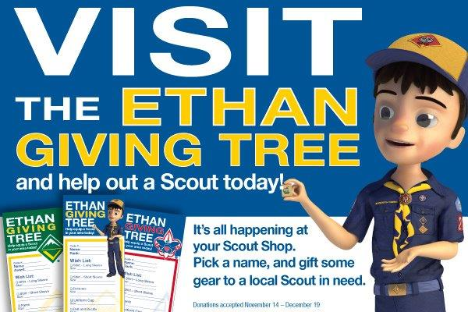

## CHRISTMAS SPIRIT AND THE GIMME PIG

*I first heard this from my Scoutmaster, Mr. Jack Bullis of Troop 227, Township of Washington, North Bergen County Council (#350), BSA. He may have gotten it from Ideas and Stories for the Scoutmaster’s Minute, BSA, 1956 And it is now my annual Christmas present for Baloo's Bugle Readers and any Scouts and Scouters to whom I relate the story.* ***CD***

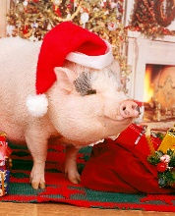

There's a strange animal to be found in especially large numbers at this time of the year. It's called a "gimme pig." You can recognize it very easily. It will be saying something like this, "Gimme a bicycle-gimme an electric train-gimme a record player-gimme a motor scooter-gimme a pony." (Note – you may want to update the toys for current year)

Do you think you have ever seen any of these strange animals?

Surely you haven't seen one in this room!

No Scout could possibly be a gimme pig.

A Scout is pledged to help other people at all times.

He wants to give - that's what he's thinking about.

A real Scout never thinks "gimme."

He thinks about the good he can do, the happiness he can bring to somebody else. Because, as you know, he puts other people ahead of himself.

He is thinking about other people especially at this time of the year.

What will you give this Christmas?

How much service to other people?

How much happiness to your family?

What will you give?

