TABLE OF CONTENTS
TABLE OF CONTENTS 1
CUB SCOUT ROUNDTABLE PLANNING GUIDE 1
ON-LINE SUPPORT 2
ADMIN HELPS 3
Youth Protection Training 3
PACK ADMIN HELPS – 4
BE UP TO DATE 6
ROUNDTABLE HINTS 7
Attendance Incentives 7
LIONS 8
WHAT’S NEW FOR LIONS FOR 2017-2018 8
BRYAN’S BLOG ON 2017-2018 LION PROGRAM 8
WHY SHARED LEADERSHIP? 8
LION ORIENTATION VIDEO 9
ORGANIZING FOR LIONS 9
HIGHLIGHTS 9
LION HUB 9
THE CHIEF SCOUT EXECUTIVE ON LIONS 10
MORE LION INFORMATION 10
CUB SCOUT LEARNING LIBRARY 12
The NEW https://cubscouts.org/ !!! 12
ADVENTURE PLAN TRACKERS 15
TRACKING BOYS’ PROGRESS 16
CUB SCOUT LEADER TRAINING 17
IN-PERSON TRAINING 17
ON-LINE TRAINING 17

CUB SCOUT ROUNDTABLE PLANNING GUIDE
The CS RT PG is issued
The 2017-2018 CS RT PG may be found at - http://www.scouting.org/filestore/cubscouts/pdf/510-714(17)_CS.pdf
On page 37 0f the 2017-2018 CS RT PG it states:
Introduction to the New Cub Scout Interest Topic Format for 2017–2018
Based on survey input, the National Cub Scouting Committee has modified the presentation style for the Cub Scout (CS) interest topics for this year. To improve communications throughout the pack leadership, it is recommended that all CS leaders attend the interest topic discussion together as a single group. This new method will provide everyone with the same information and will facilitate important discussion about these topics between all CS leaders. As always, the CS Roundtable Planning Guide provides suggested options for each council or district. The use of any specific topic is flexible based on the needs of the council or district. Each council or district may also select other topics that would be beneficial to the needs of the CS leaders in their respective council or district. Additional resource materials from the BSA can be used if the district chooses to do individual leader breakout sessions. The Philmont CS Roundtable Supplements are a great resource to consider for the breakout session model.
Scott McKenzie, the Roundtable lead on the National Commissioner Service Team, posted the following on the Commissioner Service (Boy Scouts of America) Facebook page:
The 2017-2018 Cub Scout Roundtable Planning Guide has finally been completed and posted to the BSA Commissioner Roundtable Support webpage.
“You will notice that the material in the CS RT Planning Guide is significantly different this year. Based on survey input, the National Cub Scouting Committee has modified the presentation style for the Cub Scout interest topics for this year. In order to improve communications throughout the pack leadership, it is recommended that all Cub Scout leaders attend the interest topic discussion together as a single group. This new method will provide everyone with the same information and will facilitate important discussion about these topics between all Cub Scout leaders. We recommend everyone try the new method to see how it works in your district. This will further validate any input you may have for future changes.
As always, the Cub Scout Roundtable Planning Guide provides suggested options for each council or district. The use of any specific topic is flexible based on the needs of the council or district. Each council or district may also select other topics that would be beneficial to the needs of the Cub Scout leaders in their respective council or district.
Additional resource materials from the BSA can be used if the district chooses to utilize individual leader breakout sessions. The Philmont Cub Scout Roundtable Supplements are a great resource to consider for the breakout session model. These optional support materials will continue to be available on the Roundtable Commissioner Facebook Page and can be emailed to individuals upon request.
We understand that there will be a lot of opinions on this new format and the National Commissioner Service Team would like to collect your feedback to provide to the National Cub Scout Committee, who develops the program content for the CS RT Planning Guide. Please provide constructive comments only. If you like the new format, please say so and if there are additional things you would like to see in the program content please provide a description in your comments. We will also be conducting various surveys over the next several months to collect your input for future program content. Private emails can also be sent to BSARoundtableChair@gmail.com
Scott McKenzie

ON-LINE SUPPORT
BSA ROUNDTABLE COMMISSIONERS FACEBOOK PAGE
The Philmont CS Roundtable Supplements referenced in the CS RT PG are available here!!
Join the over 3000 members of the “BSA Roundtable Commissioners” Open Group on Facebook.
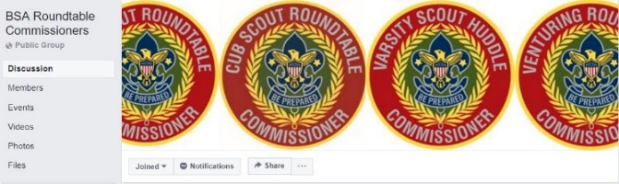
The site admins are my good friends from Philmont, Emily and George. And they do a terrific job.
Two things I found on the page while prepping Baloo’s Bugle –
Emily is leading a Team prepping “Philmont CS Roundtable Supplements.” A September Supplement has been posted. The link is on Facebook – not here. Go check the page out!!
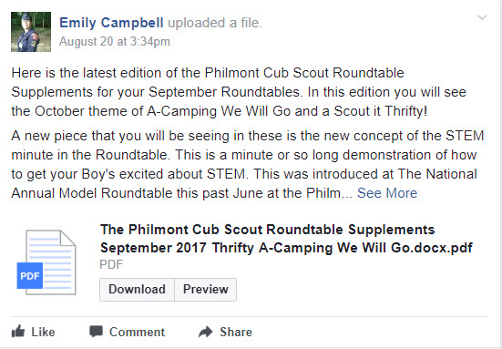
Please do not add anyone but yourself to the group. Tell other Roundtable Commissioners and Assistant Roundtable Commissioners about the group and have them add themselves. The Admins frequently get 50 requests to join in the admin inbox and the majority of them have not answered the questions. If they don't answer the questions in 2 days, they are not approved and they have to repeat the process. I (CD) know the Admins and they are very thorough. They vet every person that wants to join the BSA RT Commissioners group to make sure that this continues to be a Roundtable focused group. Please help them by spreading the word with your voice...not by your clicks. And they do thank you for all that you do!
COMMISSIONER SERVICE
(BOY SCOUTS OF AMERICA)
FACEBOOK PAGE
The Commissioner Service (Boy Scouts Of America) Facebook Page provides a forum for all commissioners to ask questions and see answers. It is an Open Group, but please consider joining.
The link is - https://www.facebook.com/groups/bsa.commissioners/
Join the almost 3000 members of the “Commissioner Service (Boy Scouts of America) Facebook Group.

RT SUPPORT PAGE
Check out the RT Support page on National’s site - http://www.scouting.org/scoutsource/Commissioners/roundtable.aspx
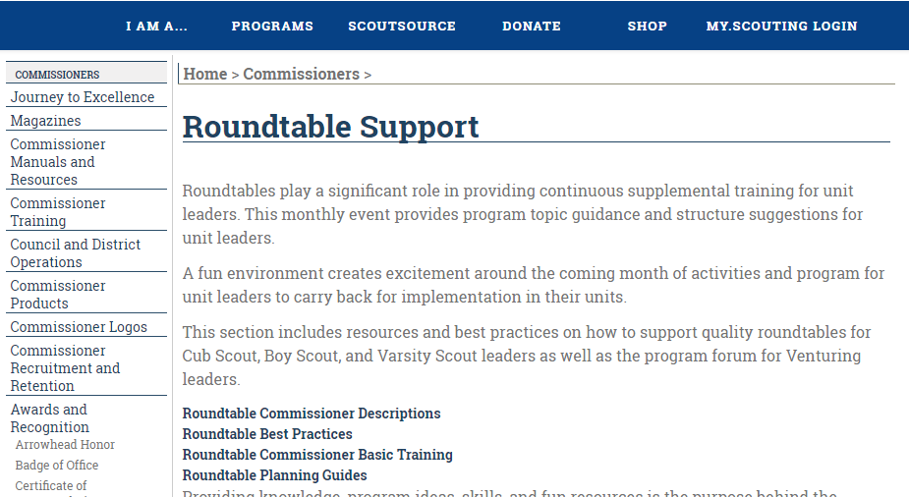

ADMIN HELPS

Youth Protection Training
There is no badge or patch for your uniform to signify that you have completed Youth Protection Training (YPT), yet this training is required before you can even register to be a leader in the Boy Scouts of America. Since BSA now requires completion certs for YPT to be included with an Adult Application, this is a good time to emphasize the importance of this training. This training is not only for new leaders, but it is required to be renewed every two years. If your Youth Protection Training is not current at the time of your Unit Recharter, you will not be reregistered.

I heard a great idea at a Council Commissioners Meeting focusing on Youth Protection Training. Just like the firefighters promote changing your smoke detector batteries when you change your clock to and from Daylight Saving Time, you should get in the habit of taking the on-line Youth protection training every year in April. Smoke detector batteries last longer than the few months between time changes, but we change them anyway, just to be safe. In the same manner, taking Youth Protection Training every year ensures that you are always current. – Pat
from Scouting.org
Youth Protection
The following is a small excerpt from the Youth Protection page at the scouting.org web site. The full page, which contains many useful facts and links, may be accessed at: http://www.scouting.org/Training/YouthProtection.aspx.
The Boy Scouts of America places the greatest importance on creating the most secure environment possible for our youth members. To maintain such an environment, the BSA developed numerous procedural and leadership selection policies and provides parents and leaders with resources for the Cub Scout, Boy Scout, and Venturing programs.
Leadership Selection
The Boy Scouts of America takes great pride in the quality of our adult leadership. Being a leader in the BSA is a privilege, not a right. The quality of the program and the safety of our youth members call for high-quality adult leaders. We work closely with our chartered organizations to help recruit the best possible leaders for their units.
The adult application requests background information that should be checked by the unit committee or the chartered organization before accepting an applicant for unit leadership. While no current screening techniques exist that can identify every potential child molester, we can reduce the risk of accepting a child molester by learning all we can about an applicant for a leadership position—his or her experience with children, why he or she wants to be a Scout leader, and what discipline techniques he or she would use.
Mandatory Training
- Youth Protection training is mandatory for all BSA registered volunteers.
- Youth Protection training must be taken every two years. If a volunteer’s Youth Protection training record is not current at the time of recharter, the volunteer will not be reregistered.
Youth Protection Reporting Procedures for Volunteers
There are two types of Youth Protection–related reporting procedures all volunteers must follow:
- When you witness or suspect any child has been abused or neglected—See "Mandatory Report of Child Abuse" below.
- When you witness a violation of the BSA's Youth Protection policies—See "Reporting Violations of BSA Youth Protection Policies" below.
Mandatory Report of Child Abuse
All persons involved in Scouting shall report to local authorities any good-faith suspicion or belief that any child is or has been physically or sexually abused, physically or emotionally neglected, exposed to any form of violence or threat, exposed to any form of sexual exploitation, including the possession, manufacture, or distribution of child pornography, online solicitation, enticement, or showing of obscene material. You may not abdicate this reporting responsibility to any other person.
Steps to Reporting Child Abuse
- Ensure the child is in a safe environment.
- In cases of child abuse or medical emergencies, call 911 immediately. In addition, if the suspected abuse is in the Scout's home or family, you are required to contact the local child abuse hotline.
- Notify the Scout executive or his/her designee.
Reporting Violations of BSA Youth Protection Policies
If you think any of the BSA's Youth Protection policies have been violated, including those described within Scouting's Barriers to Abuse, you must notify your local council Scout executive or his/her designee so appropriate action can be taken for the safety of our Scouts.
You do not have to be a registered member or have a member ID to take Youth Protection training.
To take Youth Protection training go to MyScouting.org and create an account.
From the MyScouting.org portal, click on E-Learning and take the Youth Protection training.
Upon completion, you may print a certificate of completion to submit with a volunteer application or submit the completion certificate to the unit leader for processing at the local council.
When your volunteer application is approved, you will receive a BSA membership card which includes your member ID number. After you receive your membership card, log back into MyScouting, click on My Profile and update the system by inputting your member ID number. This will link your Youth Protection training records, and any other training, in MyScouting to your BSA membership.

PACK ADMIN HELPS –
Judy, Pack CC and RTC Emeriti,
Western LA County Council
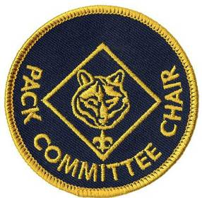
Pack Committee Planning Meeting
The Pack Committee Chair leads the monthly Pack Committee Planning Meeting. The agenda for the monthly Pack Committee Planning Meeting should include the following:
Evaluate the Previous Month
Cubmaster (CM) leads discussion on past month's activities, solicits comments and suggestions, makes notes to help planning the next month.
Finalize the Current Month
Assignments for current month are confirmed.
Special Committees make reports
Den Leaders (DL) turn in advancements to Advancement Chair (or designated committee member)
Den Leaders turn in Den Dues
Plan Ahead
Committee Chair (CC) leads discussion about upcoming month's activities, pack meetings, and den meetings
CM comments on next month's den and pack meetings and confirms assignments.
Special committees report
DL's report on their den meeting plans
Webelos leaders and/or Activity Badge coordinators report on their plans
CC reports on pack needs, problems, and progress
Committee completes plans (e.g. form new dens, pack-troop relations, financial matters, family participation)
Conduct a Leadership Enhancement
These take about ten minutes and may be found in the Cub Scout Leader Book Appendix. They make excellent reminders of duties, responsibilities, rules, and other stuff in bite size pieces.
Social Time and Fellowship
Allow time for all to enjoy a snack and talk informally. If someone has to leave, of course they may.
The Committee Chair's responsibilities during the meeting continue after the meeting and throughout the month. Here are a few hints I have learned. Judy
Item CC Responsibility
Discussion in what is coming up Lead discussion
Planning Status & Needs Make sure activities
and meetings are well planned
Calendar Verifies it is updated and distributed
Roster Verifies it is up to date and distributed
Pack Leadership Ensures all leadership needs
are being addressed
Concerns Listens to and help and solve
Tiger (and other) Recruitment:
Tiger recruitment is important and needs to be continually addressed. I am a person who uses as few words as possible. I linked up with the BSA planning guide and other resources.
Most packs are connected with a school or church where they should hold at least semi-annual recruitments.
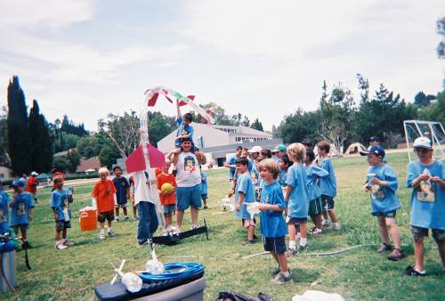
Pictures say a thousand words.
Use pictures of Tigers / Cubs doing fun stuff in your flyers. That means you need to plan fun stuff for the recruitment event.
Keep your stuff organized. Know what worked last year (or what was a dud) I have wasted more time scrambling for resources. i.e. where did I put that when I needed it the most scenarios.
District Events
Our district has struggled with annual recruiting events. We identified when our district does do a recruiting event it is usually held in some obscure location where we do not get enough visibility in the community.
This year one of our pack leaders who going thru Wood Badge has a ticket item to put on a district recruiting event. We want it to be at a place where we get a lot of exposure.
What fun activities can you do:
Our pack has done Tiger Kite events which went well. This you will find in the Tiger Resource Book.
I have put on raingutter regatta demonstrations at school PTA, open houses, etc. That's the easiest one to put on.
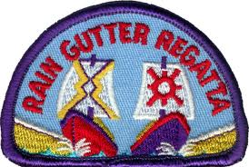
Paper rockets is another one. My husband put together the contraption that worked the best. See picture -
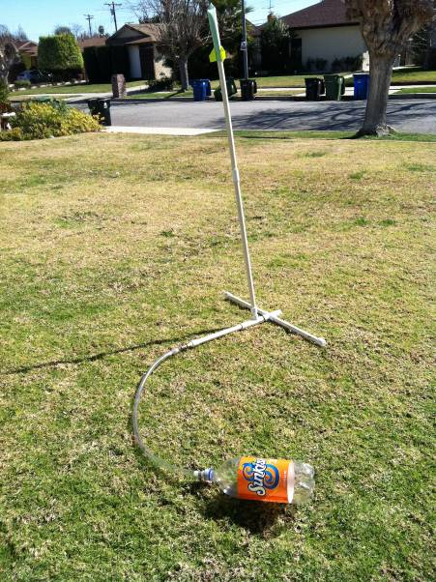
Where to find the schematics for some of these things. Write me at the E-mail address above and I can send you the files we use. If you live near me, I have always made available what we have for packs to borrow. Many Packs do not have a handyman to build stuff or they have too little time until the event to develop all the stuff needed to put on the program.
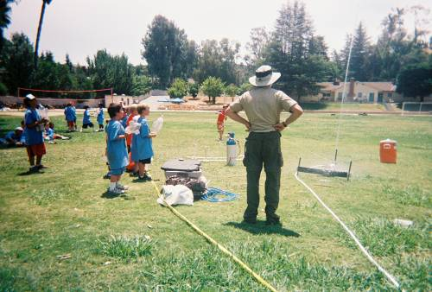

What are YOU going to do now?
The best gift for a Cub Scout.......
......get his parents involved!
The greatest gift you can give your child
..... good self respect!

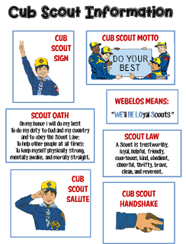
Go to http://strongarmor.blogspot.com/2015/06/cub-scouts-scout-oath-and-law-helps-and.html to get full size, full color (or black and white) printable versions

BE UP TO DATE
www.scouting.org/programupdates
The Program Updates page has been regrouped. Since the CS Adventure is in full swing, the emphasis on getting ready for it has been reduced. The downloads are still all there.
Philmont Training Center
Get great information about the Cub Scout Courses available at Philmont Training Center during the summer of 2018. Lots of FUN CS things are planned for this summer. So go and have FUN.
Check it all out – stay current!!

Same is true for Boy Scout Leaders!!

ROUNDTABLE HINTS
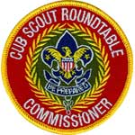

Attendance Incentives
Barbara J. Hicklin, ACC – Roundtables(Emeritus)
DelMarVa Council
From the Cub Scout Roundtable Planning Guide:
“Now that you have succeeded in getting leaders to attend a roundtable, how do you keep them coming back? A well-planned roundtable program will inspire leaders to try the program ideas they see, and they will want to come back next month for more ideas, fun, and fellowship. But with the many demands on leaders’ time, you may want to consider using other incentives to ensure continued attendance, including awards, competitions, and rewards for regular attendance. That little something extra might make the difference on an extremely busy day”
See the Guide for more information on:
Name Tags with vinyl lace to collect attendance beads • Slide of the Month • Certificates • Pins • First-nighter recognition • Cubbies or Trophies •Traveling Totem • Cub Scouting Bucks • Door Prizes or • Special Drawings.
Back in 1994, our traveling totem was a tablecloth. The Pack with the largest number of leaders in attendance was charged with adding an embellishment. At the end of the year the table cloth was given as recognition. Many years later the individual embellishments were returned to the respective Packs. Our pack had all the adults and youth members autographed a 6” x 6” square. To this day I cherish that small square of fabric and enjoy the memories of those years shared with our Pack family. What a treasured keepsake.
Promotion gets them there the first time.
Good program gets them to return.

Remember -

EPIC ROUNDTABLES -
E - Exceptional & Experiential
Strive to present an exceptional and experience based program
P - Personally & Program Relevant
Make the presentation personally and program level relevant to the Leaders who attend.
I - Instructional & Inspiring
Structure your program so that it is an instructional experience, providing examples of the method of delivery, that motivates and inspires Leaders
C - Concrete
Bring all of these components together at one place at one time, to deliver a concrete experience that provides Cub Scout Leaders with what they need to deliver a successful program at the Den and Pack level.

LIONS

WHAT’S NEW FOR LIONS FOR 2017-2018
There is a new PowerPoint available at http://scoutingwire.org/lion/ with everthing you need to know about changes to the still a Pilot Lion Program.
Highlights include:
- Lots of new recruitment help, for example:
A new PDF brochure PDF is on-line.
A Recruiter patch is available!
And other recruitments hints and materials.
- A Lion may wear either the Lion Cap and Tee shirt (Currently, $3 discount if you buy hat and Tee together!!) or, if he and his parents desire, the Blue Cub Scout Field Uniform.
- Attendance at Pack Meetings is acceptable. Packs should find ways to actively involve the Lions in PM program, activities, skits, etc
- Pinewood Derby is a Pack decision – Lions may participate in Pinewood Derby (Use of wedge car is mentioned to minimize cutting) or hold a “Veggie Derby.”
Pre-Cut Pinewood Derby Wedge Kit, SKU# 614417
The same top quality pine blocks that are used in the Official Pinewood Derby® Kit pre-shaped into a wedge with pre-cut axle grooves. Eliminates the need for woodworking tools or skills. All you need to do is add wheels, weights, sand and decorate for a car that is ready to race!
Veggie Derby Cars
- Fundraising participation is the family’s decision. Fundraising and mandatory levels are not required. Some parents do want to have the individual option to fundraise. If popcorn is sold by Lions then Show and Sell with older boys and parents would be the preference, door to door selling needs the parents at the Lions’ side.

BRYAN’S BLOG ON 2017-2018 LION PROGRAM
Lion pilot program for kindergarteners off to a roaring start, with exciting changes coming for 2017-2018
August 14, 2017
Based on feedback from parents, as well as surveys and focus groups, the BSA has some changes to announce to the Lion pilot program for this fall. The link is: https://blog.scoutingmagazine.org/ Then search for LION (singular not plural)
Later in this item you will find links to all Bryan’s Blog entries (that I know) on the Lion Program.

WHY SHARED LEADERSHIP?
- Engages the families and helps create ownership of program by families.
- Creates a stronger loyalty and connection to the den, families, and Scouting.
- Provides an opportunity to watch potential leaders in action—as a unit or pack considers future leaders.
- Millennial parents want to try things out before committing. They prefer to commit to small roles first.
- The boys love watching their “parents be the leader!” (Ask them for their meeting in front of their son. Watch how he encourages them to do it! (Please, Please Mommy! (Daddy!) You can do it!) be sure to tell them, all you need to know is in the “Parent and Leader Guide.”
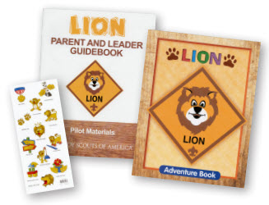

LION ORIENTATION VIDEO
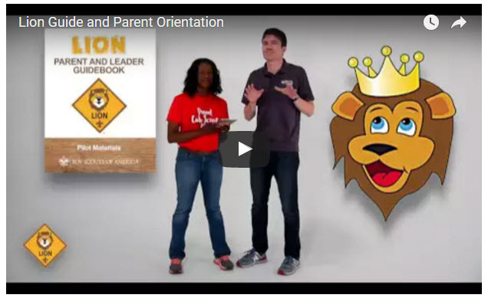
Video URL - https://youtu.be/YaIBTUO70JA

ORGANIZING FOR LIONS
From – New Birth of Freedom Council
For those packs that are thinking ahead about participating in the Lion Scouts program, having the right volunteers involved in delivering the Lion Scouts program will be important. Research shows that the most important person for a successful Scouting experience is a good leader. There are two new adult leader positions within the pack that are directly engaged in the delivery of the Lion Scouts program – a Lion Coordinator and a Lion Guide. Where do these positions fit into the current pack structure? What is the Lion Coordinator’s job description?
- Is an experienced and successful den leader
- Understands den and pack operations within the overall structure of Cub Scouting
- Demonstrates excellent communication and organization skills (and will remain in at least monthly contact with the Lion dens)
- Participates as needed in the unit’s School Night with all new Lions and their parents
- Assists the Lion guide in hosting the first orientation meeting for all the individual Lion dens in their pack
- Serves as a coach and mentor for Lion Guide

HIGHLIGHTS
- 61% of Lion parents indicate they have no other child in Scouting. We are reaching Families new to Scouting as well as siblings of Scout familie.
- 91% of parents say their Lion will be moving to Tigers and 82% of Lion Guides say most will stay.
- Satisfaction is very high 90%. For the T-shirt, shared leadership, age appropriate activities, youth Adventure book, immediate recognition stickers, meeting duration, frequency and content. The Leader Guidebook is not intimidating and is simple and easy for new parents to follow for effective meetings. Adventures are engaging for the boys.

LION HUB
Big Smiles - Build Bigger Futures
BSA has launched a new Lion Hub at:
http://scoutingwire.org/lion/
Available Lion Resources include:
LION VEGGIE CAR DERBY FLYER
PARTICIPATING COUNCILS
PROGRAM OVERVIEW
FAQS
The FAQ PDF is 13 pages long!! Lots of information!!
LION GUIDE AND PARENT ORIENTATION VIDEO
LION GUIDE AND PARENT ORIENTATION POWERPOINT
LION PRODUCTS NOW AVAILABLE!
NEW LION PROGRAM MATERIALS
LION RECRUITMENT BROCHURE
LION RECRUITMENT BROCHURE, PRINT-READY WITH CROP MARKS
CONTACT US
For Councils
COUNCIL OVERVIEW POWERPOINT
LION PROMOTIONAL MATERIALS (HELP SPREAD THE WORD!)
LION PROMOTIONAL VIDEO
LION RECRUITMENT BROCHURE
LION RECRUITMENT BROCHURE, PRINT-READY WITH CROP MARKS
REGISTRATION PROCESSING
Lion Parents say developing character is the #1 reason to join Scouting.

THE CHIEF SCOUT EXECUTIVE ON LIONS
What We Know According to a 2014 U.S. Census Bureau report, 57 percent of kids ages 6–17 participate in at least one after-school extracurricular activity. This means that by the time they are eligible for Tigers, more than half of them already are engaged in some type of athletic, artistic or other program.
Often, children become attached to lifelong activities at an early age — that is certainly a goal we would have, as we know the long-term benefits of Scouting involvement include strong asset development in the areas of character and leadership. However, we also know that when youth participate in numerous activities at an early age, and miss joining Scouting, they are unlikely to do so at adolescence.
What will be important to learn in the next few years, if the initial entry point works at the kindergarten-age level, is will this cause losses at a different age, or will the program keep the same retention all the way through to Boy Scouting?
What we learn from the pilot Lion format could also help us assess and create a smoother transition from Webelos into Boy Scouting. Too many parents now see a barrier or obstacle, rather than a smoother transition. You will often hear parents say, “We did Cub Scouting, now we’re not sure if we are going to do Boy Scouts.” We do not have a seamless transition into Boy Scouts for a number of reasons. This pilot test will help us think through some of these issues.
We want to be sure that our Lion program delivers the right mix of character and leadership values and that we set the bar high. The program must be sustainable, we must have the right infrastructure to support it, and it needs to meaningfully address the needs of parents who want their kids to join Scouting at an earlier age.
You can rest assured that we will carefully evaluate our progress and keep you apprised of the results. Stay tuned
Reprinted from "The Chief's Corner" on Scoutingwire.org

MORE LION INFORMATION
Bryan's Blog has written about Lions –
Go to http://blog.scoutingmagazine.org and you can look them up. Here are a few -
August 14, 2017
Lion pilot program for kindergarteners off to a roaring start, with exciting changes coming for 2017-2018 Based on feedback from parents, as well as surveys and focus groups, the BSA has some changes to announce to the Lion pilot program for this fall.
September 27, 2016
Lion pilot program brings Scouting to kindergartners in nearly 200 councils Answering the call of families who want a Scouting program for kindergarten-age boys, the BSA has expanded its Lion pilot program to nearly 200 councils.
April 28, 2016
In full gear: Here’s your first look at Lion Scouts T-shirts and hats This week we get our first look at new T-shirts and caps to be worn by Lions — members of the pilot program for kindergarten boys set to roll out this fall.
April 15, 2016
Will Lions be part of the pack? (And answers to your other Lion questions) Will Lions be part of the Cub Scout pack? By adding another year to the program, is the BSA concerned about "burnout"? And why was the Lions name chosen?
March 10, 2016
New details released about Lions, the pilot program for kindergarten boys In Lions, the new pilot program for kindergartners, boys wear T-shirts instead of uniforms and earn adventure stickers instead of adventure loops.
There are slideshows on the web put up
by local councils. Some examples are:
Be sure to vet these against the 2017-2018 changes!!
WD Boyce Council has "Lion Cub Pilot Program" at: http://www.wdboyce.org/document/lion-cub-pilot-program/161325
Northern Star Council has a training slide show for District Coordinators and others at: https://www.signup4.net/UPLOAD/NORT26A/LION12E/District%20Lion%20Cub%20Coordinator%20Training.pdf
Councils have put up webpages about what their packs need to know to begin a Lions Program. Examples are:
WD Boyce:http://www.wdboyce.org/cub-scouts/lion-cub-pilot-program/63360
Garden State (My Council): http://www.gardenstatescouting.org/lion-program-0
Garden State, also, has an FAQ PDF - http://www.gardenstatescouting.org/sites/default/files/Lion%20Program%20FAQ.pdf
And we have created a Facebook page for our units with Lions - https://www.facebook.com/GSCLion/
Selected FAQ's
National has posted a PDF file of FAQs about the LION program at http://www.scouting.org/filestore/pdf/Lion_FAQs.pdf
Cub Hub Blog Lion Posts
The items listed below are from the Cub Scout Learning Library . Check it out frequently for new lion and other new Cub Scout items. You can go to www.cubscouts.org and click on the Cub Hub Blog.

A Look at the Lion Uniform and Gear Lion uniform, shirts and hats! In case you’ve missed the Lion uniform images floating around the Digital Pack…
Will Lions Join Tigers and Bears? Oh My! — A Lions FAQ Lions: Answers to your top questions. We have seen a lot of great feedback, comments and questions from…
5 Questions (and Answers) for the New Lion ProgramMore Information on the New Lion Program As we mentioned earlier on the Cub Hub, Select councils will…
Lion Program will bring Scouting to Kindergarten BoysSomething Roaring in the Jungle There is an exciting new Scouting program called “Lion” for Kindergarten-aged boys…
CUB SCOUT LEARNING LIBRARY

The NEW https://cubscouts.org/ !!!
Per my contacts at National Council (some of which have since moved back to Council assignments or other departments), further development of the Cub Scout Learning Library (aka https://cubscouts.org ) is currently on hold as BSA assesses its digital strategy.
BUT, obviously,
the Cub Scout Blog is still active!!
Once that assessment is done and plan for moving forward is developed, additional on-line support for CS leaders will be available, either at cubscouts.org or a new site depending on the results.
The November 30, 2016, Adventure Plan changes will not be on this site until the assessment is done.
This is the Cub Scout Learning Library –
Everything you could want to know for Cub Scouts is or will be here. And all within a click or 3 of the home page. National heard the message that although things were at www.scouting.org they were often buried too deep to be found.
This site has admin stuff and practical stuff. The new Den Leader Resource Books are here. You can download some of the pages for FREE
This website is a great resource. There are still parts under construction but what is there is
GREAT!!
Yes,
https://cubscouts.org
runs on a phone, too!!!

There are 3 tabs on top of the home page –
- Learning Library
- Cub Hub Blog
- Join Scouting
Plus – a magnifying Glass to start a search and Icons for various Social Media –
- Learning Library takes you where you can learn about your position and pick up hints. Besides specifics for dens of each rank, other clickable links include – KEY:
- All or most of material was placed on site this past month
- All or most of material was in place and listed as such in last month's Baloo's Bugle.
- Site / pages under construction
Den Leader
- Den Meeting Basics
- Your First Den Meeting
- Planning Den Outings
- The Parts of a Den Meeting
- Getting Started
Three Core Adventures for the selected rank are listed here. You see & can download the Leader's Guide info for these 3 Adventures.
- Additional Required Adventures
The remaining Core Adventures for the selected rank are listed here. When you click them you get an intro to the Adventure but do not get the Meeting Plans and Resources. You see this note:
To get you started in delivering fun and engaging meetings, complete Den Meeting Plans are available here on the Learning Library for the Backyard Jungle and Games Tigers Play adventures. To obtain Den Meeting Plans for all other adventures, Den Leader Guides are available at your local Scout Shop, online at scoutstuff.org, or as an eBook through Amazon.
- Elective Adventures
All the Elective Adventures for the selected rank are listed here. When you click them you get an intro to the Adventure but do not get the Meeting Plans and Resources. You see the same note (above).
- Building Strong Dens
The Basics of Cub Scouts
- Advancement
- BSA Mission and Vision Statements
- Cub Scout Ages and Ranks
- Cub Scout Uniforming
- Den Flags
- Den Yells
- Leader Survival Kit
- Methods of Cub Scouting
- Purpose of Cub Scouting
- Roles and Responsibilities
- Scout Oath and Law
- What Is Cub Scouting?
- Training
- The Role of Training
- Youth Protection
- Den Planning And Administration
- Advancement Basics
- Advancement Requirements
- Annual Planning For Your Den
- Coordinating Your Den Plan with Pack
- Tracking and Recognizing Advancement
- Youth Protection Training
- Positive Youth Development and Working with Boys
- Developmental Differences Boys 7-11
- Behavior and Discipline
- Positive Youth Development
- Working With Special Needs Cub Scouts (Advice is specific to each Special Need. Lots of research was done to prep these pages.)
- Parents’ Prejoining Conference
- Leadership Techniques
- Working With Specific Disabilities and Needs
- The other positions are still under development:
- Cubmaster
- Committee Chair/Member
- Chartered Org Rep
- Parent / Adult Partner
- Cub Hub Blog takes you to a Cub Scout specific Blog similar to Bryan's Blog. The most recent topics discussed are listed here. There are more at www.cubscouts.org:
Here are the posts from August, July, and June (In reverse chronological order).
October 11, 2017
Cub Scouts Welcomes Girls to Expanded Programs Cub Scouts is thrilled to bring the benefits of Scouting to more kids than ever! Beginning in…
October 5, 2017
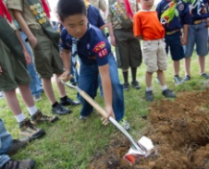6 Activities You’ll Remember if You Grew Up in Scouting From outdoor fun to Scout style, if you grew up in Scouting, your mind probably brims with…
September 29, 2017
Cook an Egg with No Cookware: Fry an Egg in a Potato Over Your Campfire Did you know you can cook an egg in a potato? Try this resourceful and unique recipe…
September 29, 2017
Cub Scouts Race Pinewood Derby Cars in SunTrust Park and Get a Visit From Their MLB Heroes Nothing tops the feeling of sending your Pinewood Derby car flying down a track … unless, you’re…
September 26, 2017
#ShareScouting to Win a $100 Gift Card for the Scout Shop! Is your camera roll packed with photos of the pack? Do you love sharing updates about your…
September 22, 2017
5 More Camping Recipes to Cook in Oranges When we shared our recipe for how to make a brownie in an orange, you responded with…
September 20, 2017
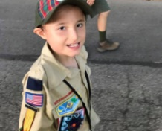Her Son is on the Autism Spectrum so She Signed Him Up for This Activity…If your son has a unique way of learning or different abilities than his peers, you may…
September 12, 2017
3 Research-Backed Benefits of Being a Cub Scout The benefits of being a Cub Scout make a big difference in the course of a Scout’s…
September 8, 2017
The Campfire Recipe Your Kids Will Love: Brownie in an Orange If you’ve never tasted the citrusy, sweet concoction that is a brownie in an orange, here’s how…
September 7, 2017
Why Cub Scouting’s Program for Kindergarten-age Boys is Right for Your Family: About the Lion Pilot Program The Boy Scouts of America’s program for 5 and 6-year-olds has families around the country thrilled to…
September 1, 2017
5 Cool Things You Can Do if You’re a Cub Scout Being a kid can be a lot of fun. But if you’re a Cub Scout, those years…
- Join Scouting takes you to
www.beascout.org
This picture on https://beascout.scouting.org/ home page. Check it out!!
Also, on the home page –
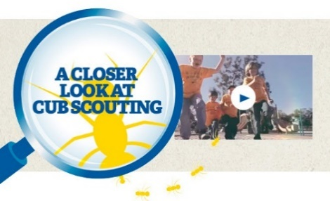
Click for a YouTube Video on Cub Scouting.
https://www.youtube.com/watch?feature=player_embedded&v=dqKFgk8SJlE
And 6 picture links -
These Six Links take you to:
www.scoutstuff.org –The Supply Division site where you can locate your nearest National Scout Shop or other local seller of Scout Stuff or buy your Scouting supplies on-line.
http://scoutingwire.org/ - Where you can get the latest Scouting News from around the country. You can sign up to get notifications when things are posted here...
https://cubscouts.org/pinewood-derby-2016-photo-contest Apparently they are not going to run this event for 2017 as you get taken to a page that says promotion has ended. Pictures of entries that were received have been removed.
https://www.scoutbook.com/Where you can get the Scoutbook APP to track your son's Scouting Experience from Tiger to Eagle Scout.
www.boyslife.org– Go directly to the on-line edition of Boys 'Life
http://scoutingwire.org/marketing-membership/ Get resources and materials to strengthen your unit at BSA's marketing and membership site. Learn the best practices and tips employed by the most successful units.

ADVENTURE PLAN TRACKERS
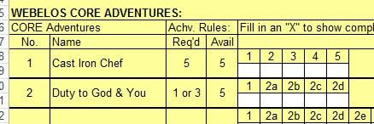
- Tracking Spreadsheets are posted on the USScouts Advancement webpage (http://usscouts.org/advance/cubscout/intro.asp). The spreadsheets were tested by a software developer who said they are so good he sees no reason to develop his own!!
- Utah National Parks Council, also, has Excel spreadsheets posted for all the new Adventure Plan requirements on their Akela's Council BlogSpot.
http://akelascouncil.blogspot.com/search/label/Tracking%20Sheet (The page starts with Arrow of Light scroll down for other ranks)
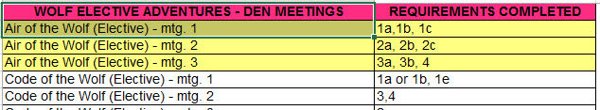
- A spreadsheet that correlates Meetings to Adventure requirements is available on the Utah National Parks' Akela's Council Blogspot at https://www.dropbox.com/s/yb8fweg7etnhqrt/WOLF%20BEAR%20WEBELOS%20REQUIREMENTS%20-%20MTGS.xlsx?dl=0 . It has all the Wolf, Bear, Webelos and AOL Adventure requirements.
These Advancement Spreadsheet workbooks are FREE for Scouters. But be COURTEOUS and observe the following -
PLEASE do not download the files from either site to email or send them digitally to others.
They are for your personal / pack use only. If you would like to share these files with others, please copy / send the link to them and send them to the site so they can print off their own. They would love everyone that wants a copy to get their own copy absolutely free. Both USScouts and Utah National Parks receive Ad money based on the number of people visiting the site. That ad money helps keep their websites open. Please help them (us) by encouraging others to visit to obtain files.

TRACKING BOYS’ PROGRESS
IN THE MODIFIED CUB SCOUT ADVENTURE PLAN
Judy and I have found several places on the web where there are aids to use to track boys’ progress in the modified Adventure Plan. Judy is placing a more detail in Baloo’s Bugle, Part IV – Den Meeting Helps.
- The Bobwhite Bather blog site (https://bobwhiteblather.com/mid-year-cub-scout-program-updates/ ) has a discussion of changes.
- Cubmaster Tom, responded providing links to documents he formatted to paste into the boys’ books for each modified Adventure. See example below:
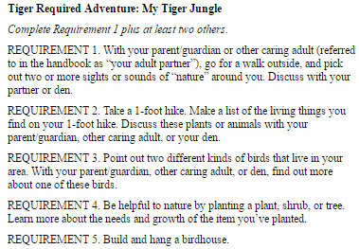
The complete Tiger document is at: https://docs.google.com/document/d/1ka_AkwxDkKgNjLrAOUHzbQQqCkruDCC8RyxtMFvrFO8/edit?usp=sharing. The links for the other ranks are in the comment on Bobwhite Blather.
- Bert Bender, Atlanta Area Council, replied,
Having finished several deep dives through the requirements changes, I’ve updated the page at http://www.southfultonscouting.com/node/3557 to not only show exactly what got changed and what didn’t change, but now also add comments intended to be a practical guide to whether you need to look at the new 11/30/16 language, and whether when those might be a useful alternative.
Comments after some Adventures encourage (sometimes plead) that dens avoid the “easy button” approach. Doing the June 1, 2015 handbook elements will often result in better outcomes and experience in Cub Scouting.
- Utah National Parks Council’s Akelas Council Blogspot has revised paper tracking sheets (http://akelascouncil.blogspot.com/) Thanks to Celeste Hunt for creating these.
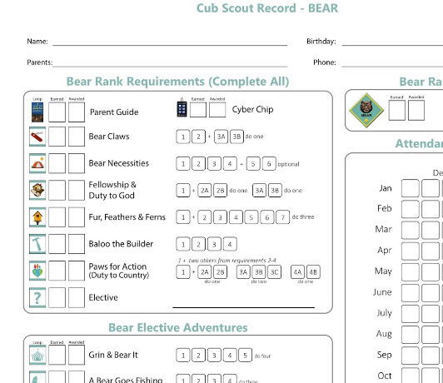
Celeste says, “Tracking, planning, and recognition are so important in Cub Scouts. This new tracking sheet helps you to be able to keep track of where each boy is at towards the Bear, Adventures, and Cyber Chip requirements. I print 2 copies of the tracker on cardstock for each boy. One for his book and one for my leader binder. I place it next to the trackers for the religious and other awards we are doing. I have tab for every boy with all his trackers. Complete information on each boy in one place. Not every boy is there every week. By doing this, I always know what each boy has done. If the parents ever have questions, I have a place to check, and I can always copy each tracking sheet to show them where their boy is.

CUB SCOUT
LEADER TRAINING

IN-PERSON TRAINING
Position-Specific In-Person Training Guides Available Now! The training guides for
- Den Leader (http://www.scouting.org/filestore/training/pdf/515-215.pdf ),
- Cubmaster/Assistant Cubmaster (http://www.scouting.org/filestore/training/pdf/511-503_WB.pdf ), and
- Pack Committee (http://www.scouting.org/filestore/training/pdf/511-504_WB.pdf )

Are available on Scouting University. You can access them at http://www.scouting.org/training/adult.aspx .
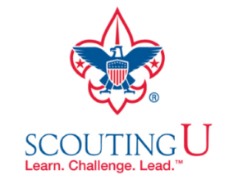

ON-LINE TRAINING
On-Line Training for all Cub Scout positions has been available since October 25, 2015
The online training for Den Leaders, Cubmasters, Committee Chairs and members, and Chartered Organization Representatives is totally updated with help from volunteers from around the country. The new training is divided into shorter, more targeted modules so leaders can get the training they need, in the order they want, any time they need it. It is organized around the learning needed prior to the first meeting, in the first 30 days, and to be position-specific trained. This training was developed to be implemented in conjunction with the BSA’s new learning management system. Keep an eye on
my. Scouting Tools (log in at https://My.Scouting.org) for more information.
Go to the BSA Volunteer Training Team Facebook page (Link above) and.
Then you automatically receive the latest news!!
If you are having difficulties with
the training or system call
BSA Member Care at 972-580-2489
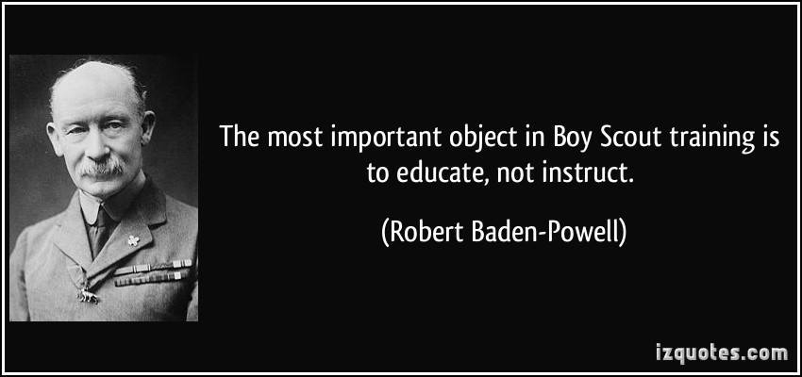
A Typical Learning Plan has several parts –
There is no need to complete more than one section at a time. Do what you have time to do.
Here you can see the three parts of the CM Course -
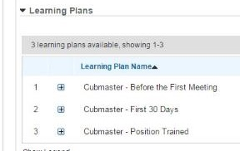

Each of these three parts is broken down into "bite sized" chunks:
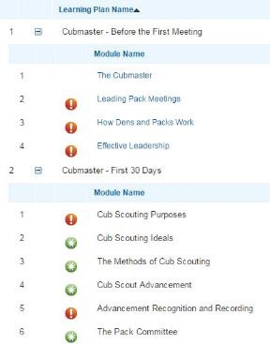
Go check it out and get your
people trained!!!

