# COMMISSIONER'S CORNER

The 2017-2018 Cub Scout Roundtable Planning Guide is not issued yet. I have seen drafts of the 12 sessions and the material has promise. The Task Force is not assigning months to the sessions, they are allowing each CS RTC to decide which session works best each month. Baloo’s Bugle will continue to use the Pack Meeting Themes and Core Values found at <http://www.scouting.org/Home/CubScouts/Leaders/CubmasterResources/PackMeetingPlans.aspx> . Judy and Dave will put out a schedule of which sessions we will support each month once the CS RT PG is issued.

Until then, The Philmont Roundtable Crew is issuing the “Philmont CS Roundtable Supplement”

The October issue for Cubs Give Thanks and a Scout is Reverent is available at two locations on Facebook.

First, on at “BSA Roundtable Commissioners” <https://www.facebook.com/groups/ScoutRTCommish/> This is an open group that discusses CS, BS and Venturing RTs

On “Commissioner Service (Boy Scouts of America)” <https://www.facebook.com/search/top/?q=commissioner%20service> This is a Public Group to discuss all facets of BSA Commissioning.

**Be a player on God's team.**

*Lord Robert Baden-Powell, Rovering to Success, 1922*

Ernest Thompson Seton, one of the BSA’ once said, **“Many years ago in Montana, I heard a missionary severely rebuke an Indian for driving his team on Sunday. The Indian looked puzzled, as he was merely minding his business and caring for his family. The missionary reiterated that this was the Lord’s Day. At last a light dawned on the Indian. He glanced up with a gleam in his eye and answered, “Oh, I see. Your God comes only one day a week; my God is with me every day and all the time.”**

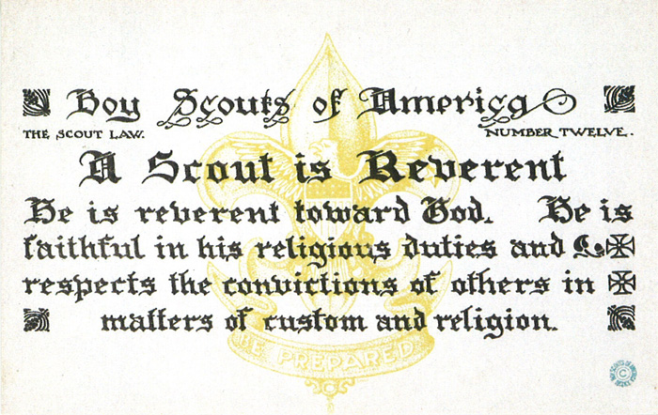

# TABLE OF CONTENTS

COMMISSIONER'S CORNER 1

TABLE OF CONTENTS 2

CORE VALUES 2

THE FOUNDER'S PRAYER 3

Duty to God Statements by Lord Baden-Powell 3

Baden-Powell Quotes on Faith 4

REVERENT QUOTES 4

Faith Quotations 4

Reverent / Reverence Quotations 5

BIOGRAPHY 5

Native American Spirituality 5

Gospel of the Redman 7

Another Man of Faith 8

THOUGHTFUL ITEMS 9

Prayers 9

Character for a Character **Error! Bookmark not defined.**

CUB SCOUT TIPS 10

SCOUTING ACRONYMS 11

CUB SCOUT GLOSSARY 12

DEN MEETING TOPICS 17

CHARACTER COMPASS 17

THEME RELATED STUFF 18

THEME RELATED ADVENTURES 18

PACK MEETING THEMES AND PLANS 18

PACK MEETING THEMES 19

UPCOMING MONTHS 20

CUBMASTER THOUGHTS 21

WEBELOS 22

Webelos Scout Uniform 23

November Crazy Holidays 24

November – A Month to Celebrate 28

VETERANS DAY 29

SPECIAL OPPORTUNITIES 31

DUTY TO GOD PUZZLE PATCH 31

RELIGIOUS EMBLEMS 32

Adult Religious Recognitions 34

Religious Emblems Coordinator 35

CUB GRUB 36

MY SCOUT SHORTS. **Error! Bookmark not defined.**

# CORE VALUES

**The Core Value for this month, November, is the 12TH point of the Scout Law - REVERENT**

A Scout is **REVERENT.**  The theme **CUBS GIVE THANKS** is used to help Cubs understand being **KIND.**

**A SCOUT IS REVERENT**A Scout knows there is strength in being gentle. He treats others as he wants to be treated. Without good reason, he does not harm or kill any living thing.

**HOW DOES “CUBS GIVE THANKS” RELATE TO THIS SCOUT LAW POINT?**

At this pack meeting, Cub Scouts will learn the importance of treating others as they want to be treated. Although it is nice when someone does something kind for you, it is even more rewarding to do something kind for someone else—without expecting anything in return..

**Per our Founder, Lord Baden-Powell**

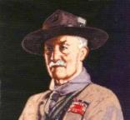

***Note –*** *Although Duty to God was part of B-P’s program, Reverent was not part of the Scout Law. The original Scout Law published in 1908 had nine points. In 1910, the BSA added Brave, Clean, and* ***Reverent****. In 1911 B-P added Clean to his list.*

**A SCOUT'S DUTY TO GOD**   
"No man is much good unless he believes in God and obeys His laws. So every Scout should have a religion....Religion seems a very simple thing: First: Love and Serve God. Second: Love and serve your neighbour." - (Scouting For Boys, 1908)

**[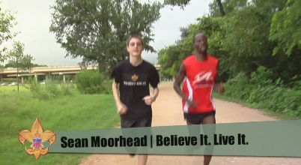](https://vimeo.com/24863948)**

 In this video, the “Believe It Live It” team interviews a Gilbert, a runner who survived a horrific attack by rebels in Burundi, Africa. This video relates his reverence to God to the Scout Law <https://vimeo.com/24863948>

## THE FOUNDER'S PRAYER

*Written by Baden-Powell for international events.*

Father of us all, we meet before Thee here today, numerous in the lands we come from and in the races we represent, but one in our Brotherhood under Thy Divine Fatherhood.

We come before Thee with hearts grateful and gladdened by the many blessings Thou hast granted us and thankful that our Movement has prospered as acceptable in Thy sight. In return we would lay on Thine Altar, as our humble thank-offering, such sacrifice as we can make of self in service to others. We ask that during our communion here together we may, under Thy Divine Inspiration, gain a widened outlook, a clearer vision of all that lies open before us and of our opportunity. Thus we may then go forth with strengthened faith to carry on our mission of heightening the ideals and powers of manhood, and of helping through closer understanding to bring about Thy happier Rule of Peace and Goodwill upon Earth.

The method of expression of reverence to God varies with every sect and denomination. What sect or denomination a boy belongs to depends, as a rule, on his parents' wishes. It is they who decide. It is our business to respect their wishes and to second their efforts to inculcate reverence, whatever form of religion the boy professes.

***From Rovering to Success, 1922, B-P***

# http://www.scouting.org/scoutsource/Media/Relationships/ScoutSabbathServices/~/media/Images/relationships/15-208/bp.gif.ashx?w=184&h=225&as=1Duty to God Statements by Lord Baden-Powell

* "The Scout, in his promise, undertakes to do his duty to his king and country only in the second place; his first duty is to God. It is with this idea before us and recognizing that God is the one Father of us all, that we Scouts count ourselves a brotherhood despite the difference among us of country, creed, or class. We realize that in addition to the interests of our particular country, there is a higher mission before us, namely the promotion of the Kingdom of God; that is, the rule of Peace and Goodwill on earth. In the Scouts each form of religion is respected and its active practice encouraged and through the spread of our brotherhood in all countries, we have the opportunity in developing the spirit of mutual good will and understanding.
* "There is no religious "side" of the movement. The whole of it is based on religion, that is, on the realization and service of God.
* "Let us, therefore, in training our Scouts, keep the higher aims in the forefront, not let ourselves get too absorbed in the steps. Don't let the technical outweigh the moral. Field efficiency, back woodsmanship, camping, hiking, Good Turns, jamboree comradeship are all means, not the end. The end is CHARACTER with a purpose.
* "The atheists .maintain that a religion that has to be learnt from books written by men cannot be a true one. But they don't seem to see that besides printed books God has given us as one step the great Book of Nature to read; and they cannot say that there is untruth there - the facts stand before them. I do not suggest Nature Study as a form of worship or as a substitute for religion, but advocate understanding of Nature as a step, in certain cases, towards gaining religion." - (Rovering To Success, 1930).
* "Our objective in the Scouting movement is to give such help as we can in bringing about God's Kingdom on earth by including among youth the spirit and the daily practice in their lives of unselfish goodwill and cooperation."

## Baden-Powell Quotes on Faith

*Alice, Golden Empire Council*

"No man can be really good, if he doesn't believe in God and he doesn't follow His laws. This is why all Scouts must have a religion". *(Scouting for Boys, 1908)*

"Scouting has been described as "a new religion". It's not, of course, a new religion: it's just the application to religious formation of the principle now accepted in non-religious formation, i.e. to point out a precise aim to the boy and give him the way to learn and practice by himself" *[Quoted in Taccuino, a collection of B-P's writings and essays published in Italy. Dated January 1912]*

***From Aids to Scoutmastership, 1919:***

"Love of God, love of your neighbour and respect of oneself as God's servant are the basis for any form of religion"

"Many difficulties may arise while defining religious formation in a Movement such as ours, where many religions coexist; so, the details of the various forms of expressing the duty to God must be left to those responsible of each single association. We insist however on observance and practice of that form of religion the boys profess"

"Nowadays the actions of a large part of youths are guided just in a small part by religious convictions. That can be attributed for the most to the fact that in the boy's religious formation the worry was on teaching instead of educating".

"If you really wish to find the way towards success, i.e. your happiness, you must give a religious base to your life. It's not simply attending church or knowing history or comprehend theology. Many men are sincerely religious almost without knowing it or having studied these things. Religion, briefly explained, means: First: know who God is; Second: use to the best the life He gave us, and do what He expects from us. This means mostly doing something for the others."

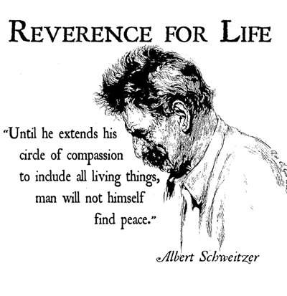

**REVERENT QUOTES**

*Quotations contain the wisdom of the ages, and are a great source of inspiration for Cubmaster’s minutes, material for an advancement ceremony or an insightful addition to a Pack Meeting program cover.*

PlatoLet parents then bequeath to their children not riches but the spirit of reverence. Plato

**Faith Quotations**

Faith is not without worry or care, but faith is fear that has said a prayer. Author Unknown

Faith is spiritualized imagination. Henry Ward Beecher

Faith is courage; it is creative while despair is always destructive. David S. Muzzey

Faith is a passionate intuition. William Wordsworth

Faith is putting all your eggs in God's basket, then counting your blessings before they hatch.   
Ramona C. Carroll

Faith is what makes life bearable, with all its tragedies and ambiguities and sudden, startling joys.   
Madeleine L'Engle

Be like the bird that, passing on her flight awhile on boughs too slight, feels them give way beneath her, and yet sings, knowing that she hath wings. Victor Hugo

Faith is raising the sail of our little boat until it is caught up in the soft winds above and picks up speed, not from anything within itself, but from the vast resources of the universe around us. W. Ralph Ward

As your faith is strengthened you will find that there is no longer the need to have a sense of control, that things will flow as they will, and that you will flow with them, to your great delight and benefit. Emmanuel

A little faith will bring your soul to heaven, but a lot of faith will bring heaven to your soul. Author Unknown

Faith is believing that the outcome will be what it should be, no matter what it is. Colette Baron-Reid

Faith can move mountains, but don't be surprised if God hands you a shovel. Author Unknown

Faith is believing in things when common sense tells you not to. George Seaton

Faith is taking the first step even when you don't see the whole staircase. Martin Luther King, Jr.

**Reverent / Reverence Quotations**

***Pursue some path, however narrow and crooked, in which you can walk with love and reverence.   
Henry David Thoreau***

Reverence is an emotion that we can nurture in our very young children, respect is an attitude that we instill in our children as they become school-agers, and responsibility is an act that we inspire in our children as they grow through the middle years and become adolescents.― Zoe Weil, Above All, Be Kind: Raising a Humane Child in Challenging Times

Authentic faith leads us to treat others with unconditional seriousness and to a loving reverence for the mystery of the human personality. Authentic Christianity should lead to maturity, personality, and reality. It should fashion whole men and women living lives of love and communion. False, manhandled religion produces the opposite effect. Whenever religion shows contempt or disregards the rights of persons, even under the noblest pretexts, it draws us away from reality and God.― Brennan Manning, The Ragamuffin Gospel: Good News for the Bedraggled, Beat-Up, and Burnt Out

Abba is not Hebrew, the language of liturgy, but Aramaic, the language of home and everyday life … We need to be wary of the suggestion … that the correct translation of Abba is ‘Daddy.’ Abba is the intimate word of a family circle where that obedient reverence was at the heart of the relationship, whereas Daddy is the familiar word of a family circle from which all thoughts of reverence and obedience have largely disappeared … The best English translation of Abba is simply ‘Dear Father.”― Thomas Allan Smail, The Forgotten Father

He’d never really given religion much thought himself. It was just there, one of the basic fundamentals of life and living; Heaven is generally good and one should aspire to end up there, and Hell is decidedly foul and one should generally direct their enemies there.  
― T.A. Miles, Raventide

The sympathy which is reverent with what it cannot understand is worth its weight in gold.   
― Oswald Chambers, Baffled to Fight Better

Bond is stronger than blood. The family grows stronger by bond.― Itohan Eghide, Master of Maxims

Carrying little Kunta in his strong arms, he walked to the edge of the village, lifted his baby up with his face to the heavens, and said softly, “Fend kiling dorong leh warrata ka iteh tee.” (Behold—the only thing greater than yourself.)” ― Alex Haley, Roots

Each of us experiences the perpetual revival of the self. We constantly recast our connate emotional index by perceiving each encounter in life as a marvel, impedance, problem, disaster, or nothing at all. Living in the moment allows us to escape the lonely landscape of self-interest and be part of a larger world filled with beauty, reverence, and adoration.   
― Kilroy J. Oldster, Dead Toad Scrolls

Faith in God, reverence of a Creator!  
― [Lailah Gifty Akita](http://www.goodreads.com/author/show/8297615.Lailah_Gifty_Akita), [Pearls of Wisdom](http://www.goodreads.com/work/quotes/45089802)

An enlightened person strives to live a meaningful life, defined by their personal humility joy, passion, and profound reverence for life.”   
― Kilroy J. Oldster, Dead Toad Scrolls

# BIOGRAPHY

## Native American Spirituality

**An integral part of their cultures -   
Living your beliefs 24 - 7**

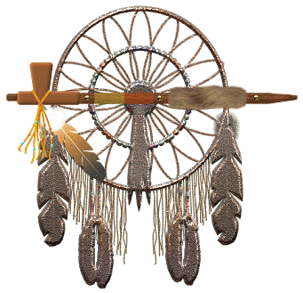

**Native Americans saw their beliefs (spirituality, religions) as an integral part of their culture.***In other words - they lived their beliefs every hours of every day. Not just a few hours a week on a perceived Sabbath Day.* Most adherents to traditional American Indian ways do not see their spiritual beliefs and practices as a "religion"; rather, they see their whole culture and social structure as infused with 'spirituality' - an integral part of their lives and culture.

Native American religion is very closely connected to the land in which Native Americans dwelt and the supernatural. Native American spirituality is often characterized by a strong emphasis on the importance of personal spirituality and its inter-connectivity with one's own daily life, and a deep connection between the natural and spiritual 'worlds'. Native Americans did not practice religion as we do today. They lived it with spirituality penetrating every aspect of their lives. Most adherents to traditional American Indian ways do not see their spiritual beliefs and practices as a "religion"; rather, they see their whole culture and social structure as infused with 'spirituality' - an integral part of their lives and culture.

Spiritual power, they believed, suffused the world, and sacred spirits could be found in all kinds of living and inanimate things-animals, plants, trees, water, and wind. Through religious ceremonies, they aimed to harness the aid of powerful supernatural forces to serve the interests of man. In some tribes, hunters performed rituals to placate the spirits of animals they had killed.



**What were their Basic Beliefs and Practices**While recognizing that there is great diversity in the religious practice of the various Native American religious traditions, we can also see that they do share worldview similarities that allow us to make a few general observations.

* **First, in every case, all of creation is seen to be interrelated.** These systems all believe that it is the responsibility of humans to oversee and protect the material world.
* **Secondly, there is a basic belief that all of life is of equal value.** They understand there to be a spark of life in all humans, animals and plants. This life force is considered to be sacred and connects all living things together. All life forms have as much right to existence as human beings, and should not be damaged or destroyed. They believe that plants and animals may be used for food, medicine and to take care of other needs, but there are limitations on that use.
* **A third common characteristic relates to a long-term concern for life.** They are willing to forego short-term expediency in order to assure the long-term viability of the natural world.
* **Finally, there is a deep gratitude to the Creator for life and for the things it makes possible.** This gratitude is expressed by both public and private worship traditions.

The basic Native American view of deity is dualistic – there is believed to be good and bad in the spiritual world. Most believe in a creator God who was responsible for creating the world. They acknowledge him in their worship practices and pray to him. They also believe that there are other spirits which are able to interact in the material world. These spirits have control over such things as the weather and other circumstances which affect humans.

**Native American Prayer**

*For that solemn moment towards the end of Den or Pack meeting, try this Native American Prayer:*

Morning Star wake us, filled with joy.  
To new days of growing to man from boy.  
Sun, with your power, give us light.  
That we can tell wrong and do what is right.  
South Wind, we ask, in your gentle way.  
Blow us the willingness of obey.  
North Wind, we ask, live up to thy name.  
Send us the strength to always be game.  
East Wind, we ask, with your breath so snappy.  
Fill us with knowledge of how to be happy.  
West Wind, we ask, blow all that is fair.  
To us, that we may always be square.  
Moon, that fills the night with red light.  
Guard us well while we sleep in the night.  
Akela, please guide us in every way.  
We'll follow your trail in work or play.

**Should not we all strive to live our Faith 24 - 7   
as did the Native Americans??**

Failure is a reality; we all fail at times, and it's painful when we do. But it's better to fail while striving for something wonderful, challenging, adventurous, and uncertain than to say, I don't want to try because I may not succeed completely*.* Sources of Strength: Meditations on Scripture for a Living Faith

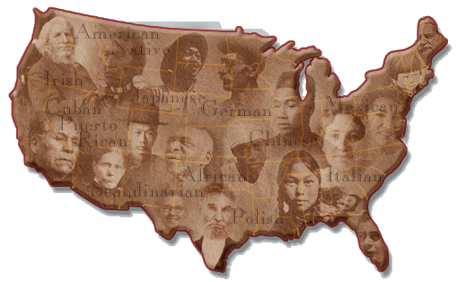

As Mankind becomes more liberal, they will be more apt to allow that all those who conduct themselves as worthy members of the community are equally entitled to the protections of civil government. I hope ever to see America among the foremost nations of justice and liberality." - George Washington

Only when the last tree has died  
and the last river has been poisoned  
and the last fish has been caught  
will we realize we cannot eat money.   
*Cree Indian Expression*



**Do you remember the crying Indian commercials??**

***(See Above)***

To see the associated PSA go to [http://www.youtube.com/watch?v=j7OHG7tHrNM](http://www.youtube.com/watch?v=j7OHG7tHrNM%20)

or for a later version - <https://www.youtube.com/watch?v=DH0U2AsyoWU>

or Google "Crying Indian Chief"

The actor is "Iron Eyes" Cody. Although he was not a Native American, he did a lot of good for the Native Americans who readily accepted him.

**For more information**

## Gospel of the Redman

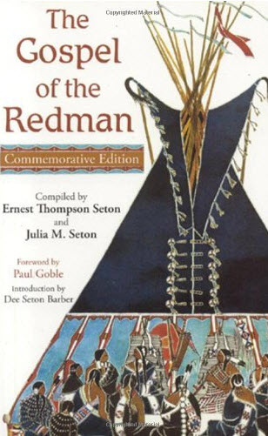

Gospel of the Redman,  
by Ernest Thompson Seton, the creator of   
“Woodcraft Indians,” a youth group he merged into the BSA, and one of the founders of the BSA

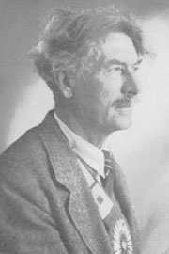***The Gospel of the Redman*** was first compiled in 1937 by E.T. Seton and his wife Julia. The current edition has an Introduction by their daughter Dee Seton Barber, a Foreword by renowned children’s book illustrator, Paul Goble as well as Ernest Thompson Seton's American Indian sketches and photographs from throughout his life.

Ernest Thompson Seton greatly respected the “Redman,” a common term which was used to refer to First Peoples. In recent years there is a tendency to think that this expression carries a racial connotation, but to Seton and his American Indian friends this word showed admiration and respect. Seton wrote this book to help the Whiteman realize the value of the doctrines by which the Redman lived in the days of his unspoiled grandeur.

"My lifelong dream and hope is that I may be the instrument of giving to the Whiteman’s world the inspiring teachings of the American Indian, in all and the full measure of their values.

“There is no Indian Bible written by an Indian, just as there was no Pentateuch written by Moses, no Tripitika by Buddha, no Dialogues by Socrates, no Gospels written by Christ. All these records were made long after by those who knew their Master in his lifetime, or at least received the traditions of his teachings from those who were privileged to hear his voice. I have never yet had an Indian tell me fully and frankly the details of his faith; but by respectfully questioning the old men, by assembling their traditions, by noting their customs, by observing their lives, by gathering the records of their prophets, by consulting living White men who knew the Indian in primitive days, and especially by conferring with Indians who were educated as Whites after spending their youth in the ancient way of their people, we have achieved something like a comprehension of the Indian’s creed, of his unwritten laws, of his sense of relationship and duty to the Great Oversoul, the Creator and Ruler, as well as to his neighbor and to himself.” E.T. Seton

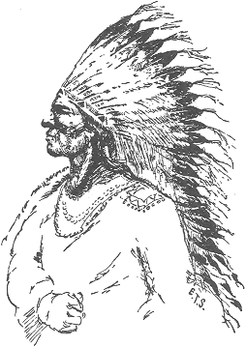

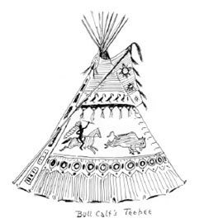

Quotes From ***“The Gospel of the Redman:”***

Be hospitable. Be kind. Always assume that your guest is tired, cold, and hungry. If even a hungry dog enters your lodge, you must feed him. Always give your guest the place of honor in the lodge, and at the feast, and serve him in reasonable ways. Never sit while your guest stands. Go hungry rather than stint your guest. If he refuses certain food, say nothing; he may be under vow. Protect your guest as one of the family; feed his horse, and beat your dogs if they harm his dog. Do not trouble your guest with many questions about himself; he will tell you what he wishes you to know.

"And still I held my vision of the perfect man, athletic, fearless, kind, picturesque, wise in the ways of the woods, and without reproach of life. And by a long, long trail, with ample knowledge of histories and of persons, I was led, as many before have been, to choose the ideal American Indian. By all the evidence at hand, his was a better system, a better thought, because it produced far nobler, better men. He, more than any type I know, is the stuff that fires our highest dreams of manhood, realized complete. Him, therefore, I proclaim as the model for an outdoor life, our travel guide on the fourfold way that leads to perfect manhood.”

“There was no stronger impulse in the Indian than the deep abiding love of his country and the soil on which he and his people had lived for generations. Their most desperate fights were those in which the bravest gladly gave their lives to hold their own country for their own people.”

“The honor of their tribe, and the welfare of their nation is the first and most predominant emotion of their hearts; and from hence proceed in a great measure all their virtues and their vices. Actuated by this, they brave every danger, endure the most exquisite torments, and expire triumphing in their fortitude, not as a personal qualification, but as a national characteristic.”

**In Summary -**Throughout, The Gospel of Redman, Ernest Thompson Seton has demonstrated his deep admiration for the “Redman,” and out of respect for them incorporated many of their traditions and beliefs into the Boy Scouts of America, including a deep respect for nature, profound respect for God, and a love of vigorous outdoor living.

**Indian Prayers from “Gospel of the Redman”**

“O Great Spirit of my fathers, this is my prayer.  
Help me to feel Thine urge and Thy message.  
Help me to be just even to those who hate me;   
and at all times help me to be kind.

If mine enemy is weak and faltering,   
help me to the good thought that I forgive him.  
If he surrender,   
move me to help him as a weak and needy brother.”

“O Great Spirit of my fathers,   
help me to wholly void my heart of fear.  
And above all things,   
O God of my people and of my soul,   
help me to be a man.”

“O God, show me the way of wisdom,   
and give me strength to follow it without fear.”

“O Great Spirit, this is my prayer!   
Grant that fear may never enter into my heart   
to be the guide of my feet.”

“Help me to win, if win I may, but—and this especially,   
O Great Spirit—if it be not ordained that I may win,   
make me at least a good loser.”

## Another Man of Faith

**William Penn Adair Roger (Will Rogers)**

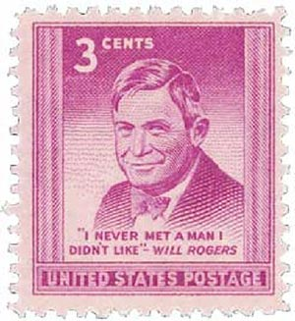

Go to [http://usscouts.org/bbugle/bb1112P.pdf](http://usscouts.org/bbugle/bb1112P.pdf%20)   
to read about Will Rogers

# THOUGHTFUL ITEMS

## Prayers

George Washington

Most Gracious Lord God, from whom proceedeth every good and perfect gift, I offer to thy divine majesty my unfeigned praise & thanksgiving for all thy mercies towards me. . . . Bless our rulers in church and state. Bless O Lord the whole race of mankind, and let the world be filled with the knowledge of Thee and thy son Jesus Christ. Pity the sick, the poor, the weak, the needy, the widows and fatherless, and all that morn or are broken in heart, and be merciful to them according to their several necessities. Bless my friends and grant me grace to forgive my enemies as heartily as I desire forgiveness of Thee my heavenly Father. I beseech thee to defend me this night from all evil, and do more for me than I can think or ask, for Jesus Christ sake, in whose most holy name & words, I continue to pray, Our Father. **Amen**

Monday Evening Prayer,   
George Washington 1752, Age 20

*From William J. Johnson,   
George Washington, The Christian   
(New York: The Abingdon Press, 1919).*

**Thanks for Everyday Heroes**

*CS Roundtable Planning Guide*

Great Spirit, we give you thanks for the everyday people who do heroic things:

* The firefighters who answer the call for help,
* The police officers who work at keeping our cities safe,
* The military personnel who keep our country safe, and
* The cub scouts who unselfishly give service to others.

May we recognize all these everyday heroes and give them our thanks. **AMEN**

## The First Salute

*Scouter Jim, Bountiful UT*

*If you can't get them to salute when   
they should salute and wear the clothes   
you tell them to wear, how are you   
going to get them to die for their country?   
General George S. Patton*

A co-worker of mine had a son graduate from a local University and its ROTC program. He had two brothers in the military. One, a commissioned officer was able to swear his brother in as a new officer. The other, a Master Sergeant was the first soldier to give the new officer a salute. It was considered a great honor that the first salute he would receive as a Commissioned Officer was from his brother. I know from the culture of the family that the young man was once a Boy Scout and an Eagle Scout. Most likely he was a Cub Scout before that.

That salute was not his first. He had given many salutes in his training no doubt. As a Boy Scout he would have given Salutes during flag ceremonies. But his first salute was no doubt as a Cub Scout. In a blue shirt with his arm proudly held up and two fingers placed to his forehead or against a Blue and Gold hat. This young officer’s first salute as an American in uniform was probably as a Cub Scout proudly wearing a blue shirt.

As leaders, it is well that we remember that our young Cub Scouts giving their first salutes in uniform as Americans with two fingers, will advance in Scouting and start giving three finger salutes as Americans. Some will go on to serve their county and start to give four finger salutes, but their first salutes in uniform will always be as Cub Scouts with two fingers against the hat. The theme this month is Giving Thanks. Saluting people is giving them Thanks and Respect. There may be no better way to teach respect for the country, the flag, and those who serve in uniform that to teach the importance of that first salute to the flag. Teach boys to wear their uniforms with pride and to be respectful of the flag and to give a crisp proper salute when they honor it.

Many have left their families to defend our freedom. We salute their bravery; we express our appreciation and support to their families. And we pray for their safe return. Bob Taft

## Trees & Faith for Scouters



***Thoughts from Alice: Planting a tree is really a testament of faith – faith in the future and in God, as this first poem demonstrates – to share with scouts, you might just read the underlined verses – although there are good thoughts in every verse.  
(OR You can use the second poem by Kilmer - CD)***

**Why Does an Old Man Plant a Tree?***by Robert H Mealey*

My friends quite often ask of me,  
Why does an old man plant a tree?  
It grows so slow it will not pay  
A profit for YOU anyway.  
Then why in storm and winter cold,  
Do you plant when you are so old?

The answer seems hard to define,  
When muscles ache and they are mine.  
But I just cannot stand to see,  
A space where there should be a tree.  
So that in part as years unfold,  
Is why I plant when I'm so old.

I know that animals, bugs and things,  
Love trees, and so do such as go on wings.  
So creatures wild that benefit,  
Is one more reason I can't quit  
From planting trees while I can hold,  
My planting hoe, though I'm so old.

They say that those retired from labor,  
Should fish and play and talk to neighbor.  
They say also that folks in leisure,  
Should do the things which give them pleasure.  
And so the thought on which I'm sold,  
I'll plant some trees though I'm so old.

As time goes on my trees will grow.  
So tall and clean and row on row.  
The furry folk will have a home,  
The birds can nest, and kids can roam.  
And all of this as I have told,  
I planted trees though I'm so old.

And then there is my family,  
Young folks who will follow me.  
I'd like to leave them with some land,  
Stocked with trees and looking grand.  
These gifts I value more than gold,  
So I plant some trees though I'm so old.

And taxes too for schools and roads,  
With jobs and lumber for abodes.  
I won't see these things, I won't be here.  
But to my mind it's very clear.  
The words of some who could be polled,  
Might thank a man who is so old.

Man should be proud of what's his own,  
And how he's managed what he's grown.  
But management must be begun,  
By planting seedlings one by one.  
And so my pride I shall uphold,  
I'll plant some trees though I'm so old.

So when my friends ask of me,  
Why does and old man plant a tree?  
Perhaps the lines above explain,  
How aching back and limbs in pain,  
May by commitment be controlled,  
To plant my trees though I'm so old.

***Here’s a second famous poem –I am a native of New Jersey, so I am very well acquainted with Kilmer. Don’t be fooled by appearances! Joyce is actually an honorable male name in Great Britain, along with Kip and Evelyn, pronounced Eve-A-Lyn) CD***

**Trees**

*By Joyce Kilmer (1886-1918)*

I think that I shall never see   
A poem lovely as a tree.

A tree whose hungry mouth is prest   
Against the earth's sweet flowing breast;

A tree that looks at God all day,   
And lifts her leafy arms to pray;

A tree that may in Summer wear   
A nest of robins in her hair;

Upon whose bosom snow has lain;   
Who intimately lives with rain.

Poems are made by fools like me,   
But only God can make a tree

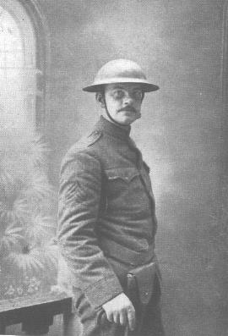Alfred Joyce Kilmer (1886-1918), the noted American poet killed in action during World War I, was born in New Brunswick, New Jersey, on 6 December 1886. Educated at Rutgers College and Columbia University. In June 1908 Kilmer married Aline; they had five children. In 1911 Kilmer's first volume of poetry, entitled *A Summer of Love*, was published to acclaim.

Kilmer's best-known poem today is *Trees*, written in 1913.  In it he demonstrated his deeply-held affinity for nature and God.

# CUB SCOUT TIPS

## SCOUTING ACRONYMS

[*www.usscouts.org*](http://WWW.USSCOUTS.ORG)

AOL - Arrow of Light (the highest rank in the Cub Scout Program)

ASM - Assistant Scoutmaster

BOR - Board of Review

BS - Boy Scout(s) (also used for the BS Div)

BSA - Boy Scouts of America

CA Assistant Cubmaster

CAC - Council Advancement Committee

CACC - Council Advancement Committee Chair

CC - Committee Chair (for packs, troops, crews, and ships)

CM Cubmaster

CS - Cub Scout(s) (also used for the CS Div)

DAC - District Advancement Committee

DACC - District Advancement Committee Chair

DC Den Chief (A Boy Scout who helps lead a CS Den)

DL - Den Leader

EBOR - Eagle Board of Review

G2SS (or GTSS) Guide to Safe Scouting

GTA - Guide to Advancement

LFL - Learning for Life, the BSA subsidiary that includes career oriented Exploring.

MB - Merit Badge

MBC - Merit Badge Counselor

OA - Order of the Arrow

RT Roundtable (Unit service offered by Commissioners to unit leaders that provides monthly continuing training)

RTC Roundtable Commissioner

SA (or ASM) Assistant Scoutmaster

SM - Scoutmaster

SPL - Senior Patrol Leader (the highest-elected youth leadership position in a Troop)

SS - Sea Scout

UC Unit Commissioner (A representative of the district responsible for helping units)

WDL - Webelos Den Leader

## CUB SCOUT GLOSSARY

*Updated from several lists I found on the Web.* ***CD***

Cub Scouting has a language all its own. If you are not familiar with it, below are definitions of many terms you will encounter as you get more and more involved in the program.

**Adventures**To earn the rank badge, Tiger, Wolf, Bear, Webelos, and Arrow of Light Cub Scouts must complete Adventures found in their specific handbooks. The Adventures involve one or more of these areas: Character Development, Participatory Citizenship, Personal Fitness, Outdoors, and Leadership. For each completed Tiger, Wolf, or Bear Adventure a belt loop is awarded. For each completed Webelos or Arrow of light Adventure a pin is awarded. One Adventure for each rank involves a Scout’s Duty to God.

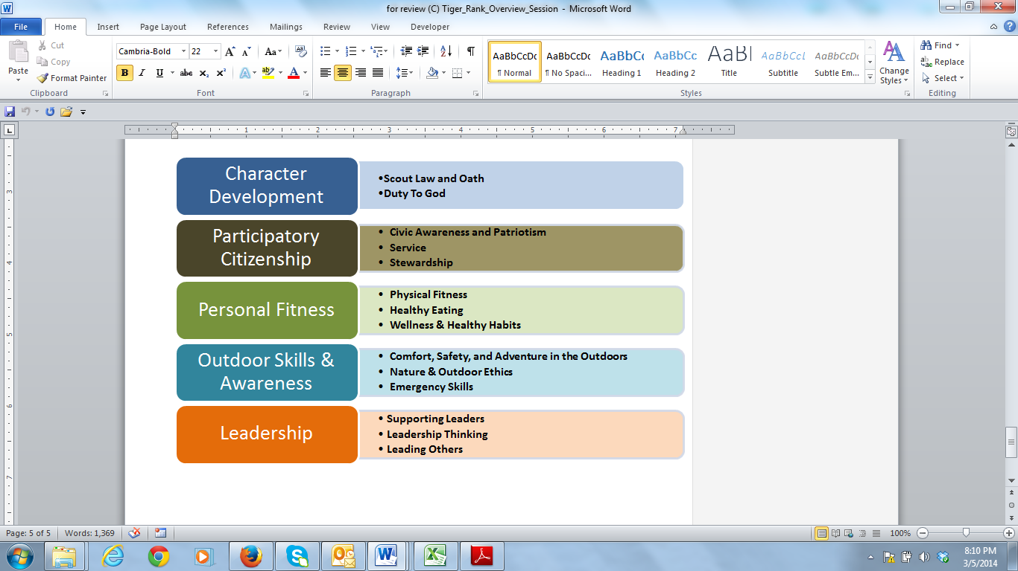

**Advancements**Advancements in rank are presented at each pack meeting and include Bobcat, Tiger, Wolf, Bear, Webelos, and Arrow of Light badges.

**Akela**Akela is the Cub Scout term for a leader - any leader - including den leaders, Cubmasters, teachers, parents, and any other adult the Cub Scout looks up to.

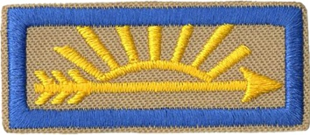

**Arrow of Light**This is the highest award a boy can earn in Cub Scouting - also the ONLY Cub Scout advancement award which can be worn on a Boy Scout Uniform.

**Arrow of Light den**An Arrow of Light den consists of 6 to 8 5th Grade Webelos Scouts working toward the Arrow of Light Badge with a Webelos DL and assistants, as well as a Webelos den chief. It meets every week at a time and place chosen by the Webelos den leader and parents.

**Assistant Cubmaster**An assistant Cubmaster is an adult (18 years or older) who assists the Cubmaster with the pack program. You may have several assistant Cubmasters. One of them might be the next Cubmaster.

Assistant Den Leader  
An assistant den leader is an adult (18 years or older) who assists the den leader with the den meetings.

Assistant Webelos leader  
An assistant Webelos leader is an adult (18 years or older) who assists the Webelos den leader with the den meetings.

**Bear Cub Scouts and Bear Den**These are generally third grade Cub Scouts, who work on Adventures. To earn the Bear Award a Bear Scout must complete the 6 Core (Required) Adventures and at least one Elective Adventure.

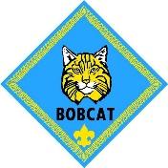

**Bobcat**Every boy who joins Cub Scouts must first earn the Bobcat badge. Doing this, he learns the basic tenets of Cub Scouting: the Scout Oath, the Scout Law, the Cub Scout sign, the Cub Scout handshake, the Cub Scout motto, and the Cub Scout salute. He, also, completes exercises in the pamphlet, “Protecting Your Children from Child Abuse,” with his parents.

**Boy Scout**A Boy Scout is between the ages of 11 and 18 and belongs to a Troop. Boy Scouting furthers the development of the boy through camping, outdoor activities, skills development, and advancement. The Boy Scout advances through these ranks: Scout, Tenderfoot, Second Class, First Class, Star, Life, then Eagle.

**Boy Scout Sign**The Boy Scout sign is used by Boy Scouts in a similar fashion to the Cub Scouign used in cub Scouting. To make the sign, raise the right hand palm forward, upper arm straight, and out to the side. The arm is bent at the elbow, forming a right angle. The three middle fingers are held erect and the thumb covers the nail of the little finger.

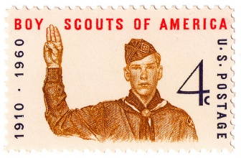

**Boy Scouts of America**The Boy Scouts of America is a nationally chartered organization that encompasses Cub Scouts, Boy Scouts, Venturing, Exploring, and Varsity Scouts.

**Boys Life**A magazine for boys. To subscribe, ask a den or pack leader for the special rate for registered scouts.

**Bridging**A ceremony where Webelos Scouts cross a ceremonial bridge to signify their transition from Cub Scouts to Boy Scouts. This is normally done at a Cub Scout Pack Meeting with Boy Scouts from the Webelos' new troop participating. This is NOT a graduation ceremony from Cub Scouts, it is rather an induction ceremony into Boy Scouts.

**Buddy System**Whenever a scout needs to go somewhere at camp, hiking, meetings, etc. it is always done in groups of at least two. A scout always takes a "buddy" scout with him.

**Bug Juice**A fun little term for a refreshment drink (Kool-Aid or lemonade).

**Chartered Organization**A chartered organization is a community group - often a religious, civic, fraternal, educational, or other organization - that sponsors a Scouting unit, such as a Cub Scout pack, Boy Scout troop, or Venturing crew. The Boy Scouts of America issues a charter to each chartered organization, allowing them to use Scouting as part of their youth program. The Chartered Organization has certain specific responsibilities to the unit that are spelled out on the Unit’s Charter.

**Charter Renewal**Charter renewal is the annual process during which the charter issued by BSA to your chartered organization is renewed. The pack committee must help by verifying the list of boys and adults registered in the pack.

**Code of Conduct**The Code of Conduct helps your meetings run smoothly without disruption by getting the Cub or Webelos Scouts' agreement on what behavior is acceptable.

**Committee**This is the group of adult volunteers who "run" the Pack. Any interested adult is welcome to attend Committee meetings.

**COR**Charter Organization Representative - A person assigned by the Charter Organization to be the liaison between the troop and the chartered organization.

**Council**The Council is an organization that oversees all Cub Scout Packs, Boy Scout Troops and other units in a designated geographical area. A council employs a Sscout Executive who is the CEO of the council, and other Professional Scouters to serve as Unit Serving Executives, Camp Rangers, Budget oversight, fund Raising, program and other positions.

**Court of Honor**A Court of Honor is a special awards ceremony conducted by Boy Scout Troops. In Cub Scouting, the awards earned each month should be presented at the next Pack meeting. There are usually many awards presented at the annual Blue & Gold Banquet.

**Cracker Barrel**A scout term for a social gathering with refreshments after a meeting or activity. Often an evening activity at camp before taps.

**Cub or Cub Scout**A Cub Scout is any member of Boy Scouts in first through fifth grade (or age 7 - 11).

**Cub Scout Leader**All the adult volunteers in your pack.

**Cub Scout sign**The Cub Scout sign is used when Cub Scouts say the Scout Oath and Law. The sign is also used to get the attention of all Cub Scouts in attendance at a meeting or event. To make the sign, hold up your right hand with the arm straight and first and middle fingers extended. The other fingers and thumb are folded over into the palm. If using the sign to get the group quiet, stand there with the sign up until all are quiet. If anyone tries to help you by saying, “Sign is Up,” tell them please don’t. The object is for the boys to exert peer pressure to get each other quiet not the leaders yelling at them to be quiet.

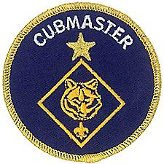

**Cubmaster**The Cubmaster is the chief adult volunteer leader and is responsible for monthly pack meetings, the overall program of the pack, and the operation of the dens. Planning of activities besides the Pack Meeting is the responsibility of the assigned Committee members.

**Den**The Den is a group of Cub Scouts who meet at regular intervals. Ideally, a den consists of 6 to 8 boys meeting weekly who are all working toward the same rank.

**Den chief**A den chief is a Boy Scout, Varsity Scout, or Venturer who serves as an activities assistant, helping the den leader with the den and providing fun and interesting things for the boys to do.

**Den chief handbook**The Den Chief Handbook contains many fun tricks and stunts and other things for the Den Chief to do to keep the meeting moving and the Cubs interested such as the Floating Ball Trick.

**Den Leader**A Cub Scout den leader is an adult volunteer who leads a Cub Scout den, with the help of assistant den leaders and parents.

**Den Meeting**Individual Den Meetings are held for each rank level of Cub Scouts. These usually occur at a regular interval, such as. Tiger, Wolf and Bear Dens work on fun projects, crafts, skits, and other activities that help them earn their Adventure Belt Loops. Webelos and Arrow of Light Dens use this time to work on the their Adventures and earn Webelos Pins to be placed on their colors.

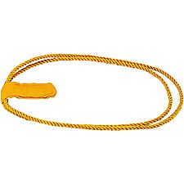

**Denner**

**The Cub Scout Denner** is a den member selected by the den for a short period, usually one or two months. His responsibilities are determined by the den leader and den chief. This might include helping to set up the den meeting place and cleanup; helping with games, ceremonies, tricks, and puzzles; leading a song; or acting as den cheerleader. He should be given meaningful responsibilities and recognition to help him learn how to be a leader, so all boys will look forward to their turn as denner. (The short term of office is to give all boys the opportunity to serve. The shoulder cord is worn on the left shoulder.)

**The Webelos Scout Denner** is a Webelos Scout who has been selected by the Webelos den for a short term of office, usually three to six months. His responsibilities are determined by the Webelos den leader and Webelos den chief, and might include such things as leading ceremonies, preparing equipment, setting up the meeting room, greeting new boys and helping them get acquainted, assisting with tricks and puzzles, or other worthwhile tasks.

**District**Each Council is divided into several Districts. Each Districts is managed by its Key Three. The Key Three are the District Chairman, a volunteer, the District Commissioner, a volunteer, and the District Executive, a professional Scouter. They oversee the activities of all Units in the District through various committees and the commissioner Staff.

**Dutch Oven**A large cast iron covered pot used to bake and cook in.

**Field Trip**Field trips are den or pack trips away from the usual meeting place. They can be as simple as a den trip to tour a local fast food restaurant or as big as a bus trip to a museum or sports event.

**Friends of Scouting**Friends of Scouting (FOS) is a fund-raiser for your local council. You may be asked to host an FOS presentation at a meeting or gathering of your Pack.

**Good Turn**"Do a Good Turn Daily" is the Boy Scout slogan. A good turn is something you do without being asked or expected to do it and for which you expect no reward.

**Handbook**Each level of Scouting has its own Handbook. The Handbook is **ESSENTIAL** for your Scout, as it spells out the requirements for advancement, as well as providing a place to record completion of the same.

**Leave No Trace (LNT)**A set of guidelines that set standards for outdoor activities that are environmentally sound and considerate to others using the same area.

**Living Circle**In a Living Circle, Cub Scouts and leaders stand in a circle, left hands extended to the center, palm down. Each person grasps the thumb of the person to their left, forming a complete circle of hands. The right hand is raised in the Cub Scout sign. Pumping the left hands up and down, everyone says "Ah-KAY-la, we'll do our best."

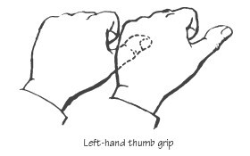 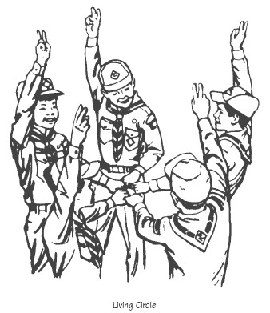

**Outdoor Activities**Outdoor activities are an important part of Cub Scouting. They can include hikes, picnics, games, and similar day events. Cub Scouts can also participate in pack camping, in which each Cub Scout has family members present. Cub Scout day camp and resident camp, as well as family camping opportunities, are also an important part of the program.

**Pack**A Pack is a group of Cub Scouts made up of one or more dens. The Pack usually meets togther once every month.

**Pack activities**Pack activities are additional activities and trips run by the pack.

**Pack committee**The pack committee is responsible for the operation of the pack, including planning, finances, records, activities, advancement, and more.

**Pack leaders' meeting**A pack leaders' meeting is held monthly to finalize details for the pack program and pack meeting for the current month, and to plan upcoming months. All Cub Scout prents are invited to the Pack Leaders’ Meeting.

**Pack meeting**The pack meeting is a monthly gathering of all the dens in the pack, along with their families (parents, siblings, and other family members), for recognition, fun, and program.

**Pack Meeting Planning Chart**The Pack Meeting Planning Chart is a guide to planning your pack meeting. It lists all the required and optional parts of the meeting. You can choose the parts you want, determine their order, and indicate who will be responsible for preparing each.

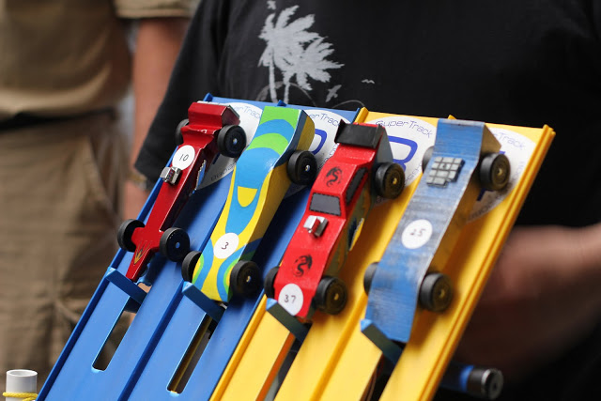

**Pinewood Derby**Pinewood derby is an activity for all Cub Scouts and Webelos Scouts. Boys are given a block of pine wood and use it to build a wooden race car with adult assistance. The cars are then raced down tracks for prizes and trophies. Other similar activities are the rain gutter regatta (boats) and space derby (spaceships).



**Popcorn Sales**Trail’s End brand popcorn is sold by Scouts to raise money for their unit activities. This is the main fundraiser for the scouting year for many packs.

**Pow Wow or University**A Pow Wow / University is an annual Cub Scout Leader learning extravaganza sponsored by the council. Check with your council for a schedule.

**Program**The annual pack program is planned to lay out the themes and activities that will be used for the upcoming year. A monthly theme is chosen, and most den and pack activities for the month relate to that theme.

**Rank Badges**The Rank Badges, in order, are: Bobcat (Must be earned first by all boys before they work on the badge for their grade / age.), Tiger, Wolf, Bear, Webelos, Arrow of Light.

**Religious Awards**Religious Awards are earned through a Scout's religious institution. Medals and knot patches are awarded. The medal may be worn on ceremonial occasions and is pinned to the seam of the top flap of the left pocket in similar fashion to an Eagle Scout medal. The knot is worn touching the seam of the top flap of the left pocket. Each religion controls its own awards.

**Roundtable**Each District holds a monthly Roundtable meeting for its Boy Scout and Cub Scout leaders. The purpose of Roundtable is to help units succeed by providing useful program ideas, information on policy, leadership training, and current information on upcoming Council events and training opportunities. Roundtables are the best way to find out what's going on!

**Service projects**Service projects are part of Cub Scouting's citizenship training. They can include service in the neighborhood, to the community, or to the chartered organization.

**Spiritual Growth**The Boy Scouts of America encourages the spiritual growth of its members but is nonsectarian and leaves decisions about religion to each Cub Scout's family.

**Theme**A monthly theme is chosen by the pack committee, and den and pack activities for the month may relate to that theme.

**Tiger**The Tiger program is for first grade boys and their adult partners. Tigers earn six Core Adventures and one Elective Adventure to earn the tiger Badge. The Tiger Cub, works with his adult partner to complete the seven Adventures.

**Tiger Handbook**Every Tiger Cub gets a copy of the Tiger Cub Handbook, containing advancement requirements and ideas used to plan the den program.

**Tiger badge**The Tiger badge is awarded to a Tiger when he earns the six Core Adventures and one Elective Adventure from the Tiger handbook.

**Tiger Partner**The adult partner of a Tiger, usually a family member, is the Tiger Partner.

**Troop**A Troop is a group of Boy Scouts made up of one or more patrols. (Cub Scouts is to boy Scouts as Pack is to Troop, and Den is to Patrol)

**Uniform**The Uniform is the prescribed clothing for any and all official Cub Scout events. The Uniform consists of a uniform shirt, (with all patches), uniform switchback (pants that zip off to shorts) pants, the rank appropriate neckerchief. Rank appropriate hats and belts are neede, too. An optional red felt vest gives the Cubs a good place to show off their patch collection. Webelos Scouts use the "colors" for their Adventure pins. For "casual" events, a Cub or Webelos Scout T-shirt and shorts is acceptable.

**Unit**Each individually chartered Pack, Troop, Post or Lodge is a Unit.

**Webelos**Webelos means **WE**'ll **BE LO**yal **S**couts. Or for you old timers, WeBeLoS stood for Wolf, Bear, Lion, Scout to indicate the progression towards being a Boy Scout.

**Webelos badge**The Webelos badge is awarded to a Webelos Scout who completes the requirements, which include Adventure pins and learning about Boy Scouting.

**Webelos den leader**A Webelos den leader is an adult volunteer who leads a Webelos Scout den, with the help of assistant Webelos den leaders and parents.

**Webelos Leader Guide**The Webelos Leader Guide provide plans for earning each Webelos, Arrow of light, and Elective Adventure pin. Plans include suggested activities for each badge.

**Webelos Den Meeting Program form**The Webelos Den Meeting Program form lists all the parts of a den meeting and is used to plan your weekly meetings. You can find a copy in your Cub Scout Leader Book.

**Webelos Scout**These are fourth and fifth grade Cub Scouts, who work on up to Webelos Adventures in the den setting. These activities are designed to prepare the boys for the merit badge methodology utilized in Boy Scouts.

**Webelos Scout den**A Webelos Scout den consists of six to eight 4th Grade Webelos Scouts working toward the Webelos Badge with a Webelos den leader and assistants, as well as a Webelos den chief. It meets every week at a time and place chosen by the Webelos den leader and parents.

**Wolf**These are generally second grade Cub Scouts, who earn six Core Adventures and one Elective Adventure to earn the Wolf Badge

**Wood Badge**Advanced Training for an adult leaders. . Any adult who has taken Basic Leader Training can attend this advanced training course to expand their knowledge of the scouting program and be of more help to the pack/troop.



**Youth Protection Training**Training courses about child abuse. Training is offered for different age groups of scouts and for adults. All registered adult volunteer Scouters must complete Youth Protection Training (YPT) before their applications will be processed. Non-registered adults (parents) should be encouraged to take YPT, also. This training is available online.

*Nothing in this glossary should be considered policy or method of operation. It is intended only as a short description of some of the more common terms used in scouting. Official BSA policy should be consulted if there are any questions.*

# DEN MEETING TOPICS

Remember – Boys want to be active!!   
See, too, that they earn their awards   
***(Never say GET. You get sick, you do not get awards – You earn awards. A little CD Philosophy)***.

**Big Rock Ideas** – suggestions for Big Rocks that fit Interest Topics or seasonal activity. The years next to an item (e.g. 13-14) is the Roundtable Planning Guide where the suggested Big Rock is published. All Big Rocks are on-line at <http://www.scouting.org/scoutsource/Commissioners/roundtable.aspx>



# CHARACTER COMPASS

**NOVEMBER -**ADVENTURES with a **CHARACTER COMPASS** pointing to **REVERENT:**

**TIGER –**

* My Family’s Duty to God (Core)
* Sky Is the Limit (Elec)

**WOLF –**

* Duty to God Footsteps (Core)

**BEAR –**

* Fellowship & Duty to God (Core)

**WEBELOS CORE –**

* Duty to God and You (Core)

**ARROW OF LIGHT CORE –**

* Duty to God in Action (Core)

**WEBELOS & AOL ELECTIVES –**

* Into the Woods (Elec)



**DECEMBER -**ADVENTURES with a **CHARACTER COMPASS** pointing to **KIND:**

**TIGER –**

* Tiger Jungle (Core)
* Tiger-iffic(Elec)

**WOLF –**

* Duty to God – Footsteps (Core)
* Cubs Who Care (Elec)

**BEAR –**

* Fur, Feathers, and Ferns (Core)
* Critter Care (Elec)

**WEBELOS CORE –**

* Webelos Walkabout (Core)

**ARROW OF LIGHT CORE –**

* Duty to God In Action(Core)

**WEBELOS & AOL ELECTIVES –**

* Into the Wild (Elec)

# http://www.orgsites.com/in/pack3092/tsalute.jpgTHEME RELATED STUFF

## THEME RELATED ADVENTURES

All Adventures are fun. –

**GOOD ADVENTURES FOR “CUBS GIVE THANKS”**

**TIGER –**

* Team Tiger (#5 Do an activity to help your community or neighborhood team) Core
* Earning Your Stripes (#3 – One new task to help, #6 – Service project) Elec
* Good Knights (#5 – Service project) Elec

**WOLF –**

* Cubs Who care (All requirements pertain to Helping others) Elec
* Hometown Heroes (All requirements pertain to thanking) Elec

**BEAR –**

* None

**WEBELOS CORE –**

* None

**ARROW of LIGHT CORE –**

* Building a Better World (#10 – Various things relating to Scouting brotherhood) Core
* Duty to God in Action (#2e – Service Project) Core

**WEBELOS ELECTIVES –**

* Aware & Care (#7 – Several ideas for helping others) Elec
* Build My Own Hero (#3 – Recognize a local hero) Elec

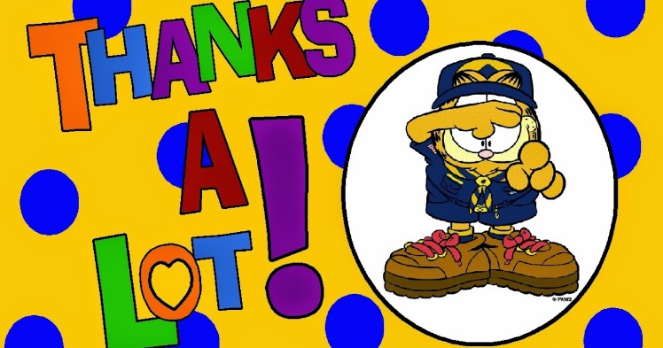



# PACK MEETING THEMES AND PLANS

[*www.scouting.org*](http://www.scouting.org)

**From National's Website for the new plans using the Core Values based on the Scout Law:**

Here are a few thoughts to consider around these new pack meeting plans. First, there is a plan for each month that corresponds with a point of the Scout Law. In addition, each plan has a theme to help make the pack meeting even more fun! The plans do not have to be used in a specific order.

**Tips for Utilizing the Plans**

* Pack meeting plans do not have to be done in any special order, but it is recommended that you include all of the points of the Scout Law each year. The pack planning meeting would be a good time to determine the order.
* There are pack meeting plans for multiple years posted on the website. It is your pack's choice of which one to select from each point of the Scout Law for each year.
* Pack meetings should not last longer than an hour. Adjust the plan to make it fit within the time. Research and experience tells us that Cub Scouts have a hard time sitting still for that long. Keep the meetings fun, active, and engaging.
* If you are comfortable with a costume to fit the theme of the meeting, go for it!
* Importantly, keep it simple and make it fun.
* The following required adventures have a requirement that suggests or requires completion at a pack meeting. Please plan accordingly as part of your annual program planning process. Work with your den leaders to plan when these activities will take place.

**Tiger**

* **Tigers in the Wild,** requirement 5. Participate in an outdoor pack meeting or pack campout campfire. Sing a song and act out a skit with your Tiger den as part of the program.
* **Games Tigers Play,** requirement 3. Make up a new game, and play it with your family or members of your den or pack.

**Wolf**

* **Council Fire,** requirement 6c. Create a den project from recyclables for a pack meeting.

**Bear**

* **Grin and Bear It**, requirement 2. Working with the members of your den, organize a Cub Scout carnival and lead it at a special event.
* **Grin and Bear It**, requirement 3. Help younger Cub Scouts take part in one of the events at the Cub Scout carnival.

**Webelos**

* **Stronger, Faster, Higher**, requirement 5. With adult guidance, lead younger Scouts in a fitness game or games as a gathering activity for a pack or den meeting.

**Arrow of Light**

* **Building a Better World (if chosen**), requirement 10b. Set up an exhibit at a pack meeting to share information about the World Friendship Fund.

Check them out at:   
<http://www.scouting.org/Home/CubScouts/Leaders/CubmasterResources/PackMeetingPlans.aspx>



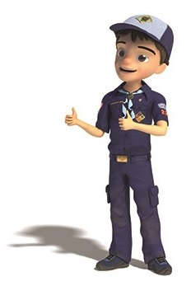

## PACK MEETING THEMES

Kim, the chair of the task force, says **"I do want to stress that the focus is still the Core Value and the theme is just there as an enhancement. Pack meeting theme plans are specifically crafted to bring out the important points of the Core Value in a fun way."**

|  |  |  |
| --- | --- | --- |
| **2017–2018 Pack Meeting Plans** | | |
| Oct | Thrifty | [A-Camping We Will Go](http://www.scouting.org/filestore/cubscouts/pdf/2017/310-842(17)_October_Thrifty.pdf) |
| Nov | Reverent | [Cubs Give Thanks](http://www.scouting.org/filestore/cubscouts/pdf/2017/310-842(17)_November_Reverent.pdf) |
| Dec | Kind | [Paying It Forward](http://www.scouting.org/filestore/cubscouts/pdf/2017/310-842(17)_December_Kind.pdf) |
| Jan | Helpful | [Jobs, Jobs, Jobs](http://www.scouting.org/filestore/cubscouts/pdf/2017/310-842(17)_January_Helpful.pdf) |
| Feb | Cheerful | [Abracadabra!](http://www.scouting.org/filestore/cubscouts/pdf/2017/310-842(17)_February_Cheerful.pdf) |
| Mar | Trustworthy | [Cub Scout Investigators](http://www.scouting.org/filestore/cubscouts/pdf/2017/310-842(17)_March_Trustworthy.pdf) |
| Apr | Loyal | [Cubs in the Future](http://www.scouting.org/filestore/cubscouts/pdf/2017/310-842(17)_April_Loyal.pdf) |
| May | Friendly | [Treasure Hunters](http://www.scouting.org/filestore/cubscouts/pdf/2017/310-842(17)_May_Friendly.pdf) |
| Jun | Obedient | [Wheel Into Summer](http://www.scouting.org/filestore/cubscouts/pdf/2017/310-842(17)_June_Obedient.pdf) |
| Jul | Brave | [Home of the Brave](http://www.scouting.org/filestore/cubscouts/pdf/2017/310-842(17)_July_Brave.pdf) |
| Aug | Clean | [Destination Parks](http://www.scouting.org/filestore/cubscouts/pdf/2017/310-842(17)_August_Clean.pdf) |

**If you are using a paper copy the link to all the   
Pack Meeting Plans is:**

<http://www.scouting.org/Home/CubScouts/Leaders/CubmasterResources/PackMeetingPlans.aspx>

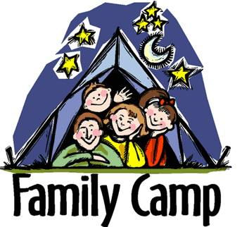

program updates banner

## **UPCOMING MONTHS**

**For November,** the suggested Pack Meeting theme, **A Cubs Give Thanks**, emphasizes the Scout Law point, **REVERENT.**

|  |  |  |
| --- | --- | --- |
| **Month** | **Year** | **Theme** |
| **REVERENT** (Themes for former CV Faith are listed here) | | |
| November | 1942 | Thanksgiving |
| November | 1952 | Faith of his Fathers |
| December | 1960 | Guiding Stars |
| November | 1974 | Pilgrims |
| December | 2005 | Faith, Hope & Charity |
| December | 2007 | Celebrations Around the World |
| April | 2011 | Faith |
| April | 2012 | Faith |
| April | 2013 | Cub Scouts Give Thanks |
| April | 2015 | Soaring the Skies |
| December | 2015 | Winter Wonderland |

|  |  |  |
| --- | --- | --- |
| **Month** | **Year** | **Theme** |
| **Cub Scouts Give Thanks** | | |
| November | 1942 | Thanksgiving |
| November | 1952 | Faith of his Fathers |
| December | 1960 | Guiding Stars |
| November | 1974 | Pilgrims |
| November | 1980 | Thanksgiving - Living and Sharing |
| November | 1984 | Turkey Day |
| November | 1992 | Turkey Day |
| December | 2000 | What do You do at Holiday Time? |
| November | 2003 | Pilgrims of Plymouth Rock |
| December | 2005 | Faith, Hope & Charity |
| April | 2013 | Cub Scouts Give Thanks |

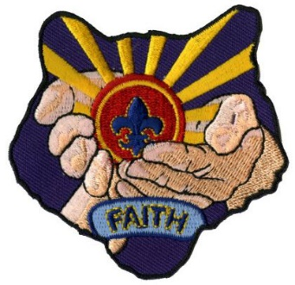

**For December,** the suggested Pack Meeting theme, **Paying It Forward**, emphasizes the Scout Law point, **KIND.**

A Scout is **KIND.**  The theme **PAYING IT FORWARD** is used to help Cubs understand being **KIND.**

**A SCOUT IS KIND**A Scout knows there is strength in being gentle. He treats others as he wants to be treated. Without good reason, he does not harm or kill any living thing.

**HOW DOES “PAYING IT FORWARD” RELATE TO THIS SCOUT LAW POINT?**

At this pack meeting, Cub Scouts will learn the importance of treating others as they want to be treated. Although it is nice when someone does something kind for you, it is even more rewarding to do something kind for someone else—without expecting anything in return..



# **CUBMASTER THOUGHTS**



**Ten Commandment Hike & Giving Thanks –**

*Pamela, North Florida Council*

This is one of my favorites! Heading our District's **"10 Commandment Hike"** enabled me to mix my 2 loves: Scouting and encouraging Scouts to learn about their faith I could not have been more delighted! The theme for our hike was: Scouting through Faith and Service. Encourage your Scouts to earn the Religious Award as well. Have your Leaders or Charter Reps or local leaders of faith set up displays and bring in some items to discuss their faith about the room. Tell them you want something that encourages Scouts to see how they can serve others. Set up displays for each of the Religious Awards and perhaps have sample booklets. Remind your leaders as well that they can earn these. Youth can earn them as a Cub Scout (Tiger Wolf, Bear), Webelos Scout (Webelos, Arrow of Light), younger Boy Scout (11-13), Older Boy Scout or Venturer (14 and older). Invite different organizations so they can tell what outreach they have. We had the Gideons set up a display at the end of the hike, Shelter Box Set up the disaster relief tent that they take to disaster areas, and different houses of faith set up displays. We also had a community can food drive and clothes drive for some of the houses of worship that participated in our **10 Commandment Hike**.

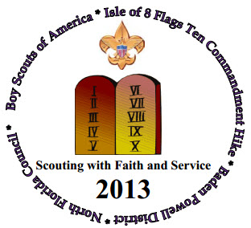

**For more info on “Ten Commandment Hikes” –**

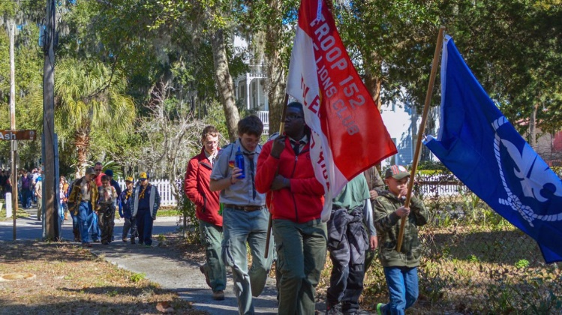Scouting Magazine’s Bryan on Scouting Blog had an issue devoted to “Ten Commandment Hikes.” See it at: <https://blog.scoutingmagazine.org/2017/01/24/ten-commandments-hikes-teach/>

Garden State Council’s Flyer for their Ten Commandment Hoke is at: <http://www.gardenstatescouting.org/sites/default/files/2017_10_commandment_hike_flyer_1.pdf>

They explained their hike this way:  
What is a Ten Commandments Hike? It’s a unique and exciting way to embrace the concept of Religious tolerance, learn local history, participate in community service, and have fun. It allows all participants to visit (hike to) different Houses of Worship, each with a representative of the Faith explaining one of the Ten Commandments. This year we will be visiting the Houses of Worship in Haddonfield, N.J. It is the perfect opportunity to complement your Pack or Troop’s commitment, “To Serve God” & “Duty to God”. Take part in a community service project by bringing canned goods to donate to the Haddonfield Food Pantry.

[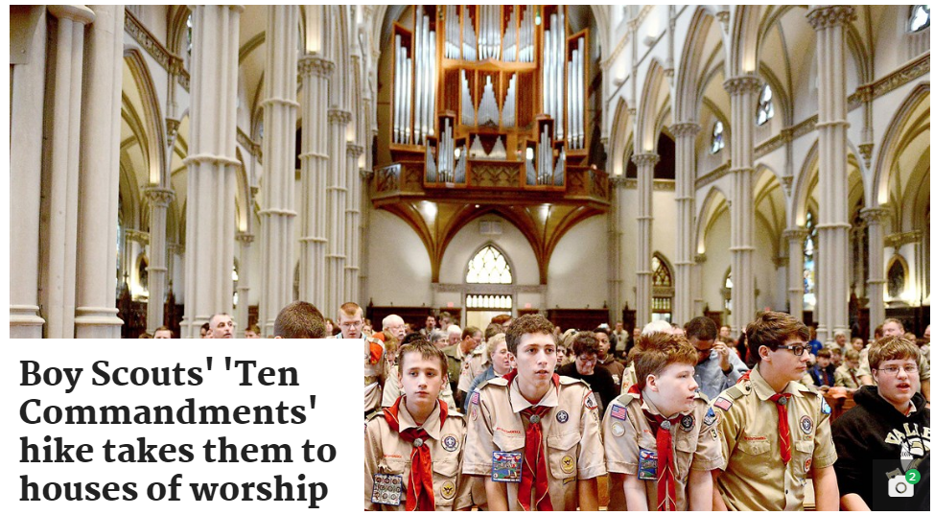](http://www.post-gazette.com/local/city/2015/11/28/Scouts-Ten-Commandment-hike-tours-multiple-worship-sites/stories/201511280043)

[On a Ten Commandment Hike in Pittsburgh, the Post-Gazette wrote](http://www.post-gazette.com/local/city/2015/11/28/Scouts-Ten-Commandment-hike-tours-multiple-worship-sites/stories/201511280043):

Ryan Infantozzi said he had at least two good reasons for taking part in the Boy Scouts’ annual “Ten Commandment Hike” on Friday. “It is cool to learn about all the different kinds of churches in Pittsburgh,” he said of the 4-mile walk to visit seven worship sites in Oakland and Shadyside. “And I like hiking.”

This year’s “Ten Commandment Hike” included a talk by Sarosh Sepai about Zoroastrianism. A faith founded in ancient Persia, Zoroastrianism is an early form of monotheism — a belief in one god.

Participants also learned about Jewish, Byzantine Catholic, Roman Catholic, Greek Orthodox, Buddhist, Hindu, Baptist and Christian Science beliefs.

This year marked the 10th anniversary for the hike. Speakers from 18 faiths, including Islam, have been represented over the years, event organizer C.W. Kreimer explained. He also is chairman of the Jewish Committee on Scouting for the Boy Scouts’ Laurel Highlands Council.

The idea behind the hike is tied directly to the 12th point in the Scout Law, which calls upon Scouts to be reverent, Mr. Kreimer said. At each stop along the way, Scouts learned what it means for people of different faiths to be reverent. He likened the event to a mini-comparative religion course.

For the complete article go to: <http://www.post-gazette.com/local/city/2015/11/28/Scouts-Ten-Commandment-hike-tours-multiple-worship-sites/stories/201511280043> .

**On Giving Thanks**   
Scouts can have a Thank You picnic. Inviting firemen, police, EMTs, Chaplains, Crossing Guards, parents, whoever they are thankful for helping others at your pack meeting.

Have your Scouts make the list of for whom they are Thankful and have your dens send the invites. So many times, the ones we know and see never are thanked. This will build a rapport between your Scouts and those that help others. Have your Scouts create your Thank You items. They can be as inexpensive as hearts cut out saying Thanks to a simple wooden plaque your Webelos can create, a pin, an apron with hand prints and their names in the middle, a button… Have a large poster the size of the wall and let all the Scouts and leaders sign it so your visitors can see it. Hand prints with their names are always nice for those who still don’t write well. However large or small you want it is up to you! Let the Scouts tell you for whom they are thankful. Give them ownership of the event. Have a vote and give an award just as they have those Volunteer of the Year Awards in most communities! The ideas are limitless.

For more help, be sure to check out –

[](http://www.cubmaster.org)

# WEBELOS

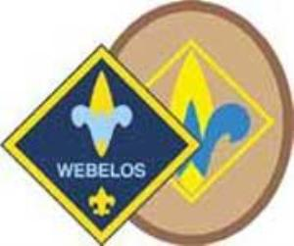

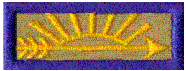

**Always an S -** Webelos always ends with an S whether talking about one Webelos Scout or a den of Webelos. It is an acronym – **WE**’ll **BE** **LO**yal **S**couts. As the CS RT Commissioner who mentored me says – "If you don’t have an S at the end – then there is nothing to which to be loyal." **(She was the N5-690-17 Wood Badge Scoutmaster!!)**

**The Two Dens –** The correct names for the two years of the Webelos Program are the **Webelos Den** and the **Arrow of Light Den**. In the National Scout Shop where I work part-time, at Roundtables, and almost everywhere I go, I hear people refer to Webelos I and Webelos II. Webelos I and II are a little like Class A and Class B Uniforms. They are terms many Scouts and Scouters use but are not found in any material printed by the BSA. I am looking for why the BSA chose the terms they use and will let you know when I know. But please use the correct terms so all will understand. Thank you. CD

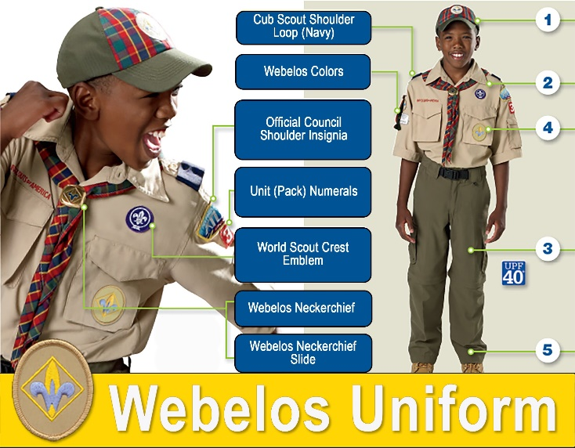

**Webelos Scout Uniform**

**From** [**www.scouting.org**](http://www.scouting.org) **-**Webelos Scouts may choose to wear either the blue Webelos uniform based on the Cub Scout uniform or the tan/olive uniform like the one Boy Scouts wear.

For the tan/olive uniform, boys wear the official Boy Scout olive trousers or shorts and official Boy Scout tan long- or short-sleeved shirt with blue shoulder loops. Official blue socks are worn with the blue uniform, and official olive socks are worn with the tan/olive uniform.

With either uniform, all Webelos Scouts should wear the Webelos neckerchief (plaid w/ Webelos emblem), Webelos neckerchief slide (handmade slides are also acceptable), Webelos cap, and Webelos belt buckle.

***Note*** *the Webelos belt buckle only fits the blue Cub Scout web belt (item number 64046-48). Adventure Belt Loops only fit Cub Scout belts not Boy Scout belts.*

**Badges and Insignia**For guidance on the proper placement of all badges and insignia, see the BSA's [*Guide to Awards and Insignia*](http://www.scouting.org/scoutsource/Media/InsigniaGuide.aspx) (No. 33066, available at your local council service center.)

BSA has two official Webelos Rank insignia – a diamond patch which matches the previous rank patches earned by the Webelos Scout. An oval patch whose shape and design match that of the Boy Scout rank patches he will soon be earning. The pack may award either.

In packs that do not do Tigers, placement of the diamond patch in the Cub Scout diamond with the Bobcat, Wolf, and Bear is simple.

In packs where many of the Scouts will already have a full Cub Scout diamond (Bobcat, Tiger, Wolf, and Bear) placement of either patch will require removal of the previous ranks, as shown in picture below.

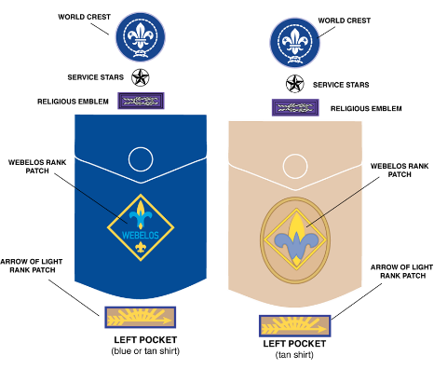

Therefore, when the Webelos Scout is awarded the Webelos badge of rank may be an appropriate time to shift to the khaki shirt.

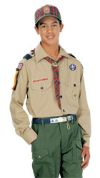http://www.scoutstuff.org/skin/frontend/enterprise/bsaretail/images/s.gifhttp://www.scoutstuff.org/skin/frontend/enterprise/bsaretail/images/s.gifhttp://www.scoutstuff.org/skin/frontend/enterprise/bsaretail/images/s.gif****

**From the Official BSA Uniform Inspection Sheet for Webelos –**

**Shirt.** Webelos Scouts have the option of wearing either the long- or short-sleeve navy blue shirt and navy blue shorts or pants OR the long- or short-sleeve tan shirt with the official convertible Boy Scout pants or official shorts or pants. If the shirt has epaulets, blue shoulder loops are worn on them.

**Pants/Shorts.** Webelos Scouts may wear either the official navy blue pants or shorts (with the navy blue shirt), or the official convertible Boy Scout pants (with the tan shirt), or the official Boy Scout pants or shorts (with the tan shirt).

**Belt.** Official navy blue web belt cut to proper length with the Webelos insignia on the buckle. Cub Scout belt loops are worn only on the navy blue belt. Webelos Scouts wearing the optional tan uniform wear the navy blue belt and Webelos buckle.

**Official Boy Scout Uniform Option**

* Webelos Scouts electing this option wear blue shoulder loops on the epaulets, Webelos neckerchief, and Webelos cap.
* The navy-blue belt is worn with and will fit only the Webelos buckle. Adventure belt loops and the old Academics and Sports belt loops will fit only on the navy-blue belt.
* Badge placement is the same as for the navy-blue uniform.

**So, when should a Webelos Scout switch to the Boy Scout uniform?**

**Short answer –   
it is up to the boy and his parents.**

Per the official literature cited in this item, the verbiage confirms that a change is not required –

* On [www.scouting.org](http://www.scouting.org) it says, "Webelos Scouts may choose to wear either …
* On the Inspection sheet it says, "Webelos Scouts have the option of wearing either …

**Things to consider –**

**Cost –** To switch shirts will, probably, involve a cost to the parents unless the unit has a great Experienced Uniform closet. Why thrust an extra cost onto your parents by telling them they must obtain a tan shirt when the Scout moves from Bear to Webelos or at any arbitrary time?

**Size –** After several years as a Cub Scout, most Scouts will be ready for a larger shirt sometime while they are a Webelos Scout. When he outgrows the blue shirt would be a great time to get him a tan shirt!! Why rush it and have to get a second Boy Scout uniform that much sooner as he grows. He might be in Boy Scouts for 7 plus years after Cub Scouts!!

**Timing –** If your unit uses the oval Webelos Badge, when a Webelos Scout is presented the oval badge might be a good time to switch shirts. The Cub Scout diamond could remain intact on his blue shirt and the shirt put away intact into a memory box. And the new oval Webelos Badge sewn on the tan shirt. The tan shirt could have been used as an incentive to encourage him to keep on going to earn the badge. This will save having to remove all the previous rank badges from the blue shirt.

**For a Lesson on Webelos Colors -**



By Mike Walton, [www.USScouts.org](http://www.USScouts.org)   
Go to the November 2015 Baloo's Bugle issue at   
<http://usscouts.org/usscouts/bbugle2015-2016.asp>

# November Crazy Holidays

*Claralyn, Golden Empire Council Adapted from* <http://holidayinsights.com/moreholidays/index.htm>  
[http://www.brownielocks.com/month2.html](http://www.brownielocks.com/month2.html%20)

**November is:**

* Aviation History Month
* Child Safety Protection Month
* International Drum Month
* National Adoption Awareness Month
* National Caregivers Appreciation Month
* National & American Diabetes Month
* National Epilepsy Month

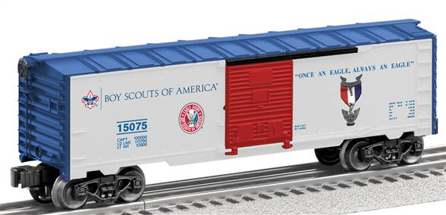

* National Model Railroad Month
* National Novel Writing Month
* [**Native American Heritage Month**](http://nativeamericanheritagemonth.gov/about/)

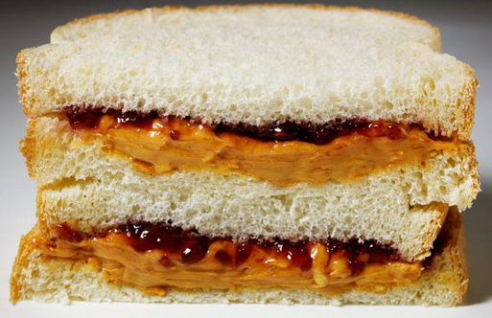

* [**Peanut Butter Lovers Month**](http://nationalpeanutboard.org/the-facts/fun-facts/) *(Beware of Food Allergies ☺ – Pat)*
* **Adopt A Senior Pet Month  
  Adopt A Boxer Rescue has sevral senior boxers available – check it out at**

[http://www.adoptaboxerrescue.com](http://www.adoptaboxerrescue.com/)  
[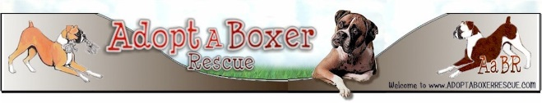](http://www.adoptaboxerrescue.com)

**Or on Facebook at –**

<https://www.facebook.com/adoptaboxerrescue?fref=ts>

[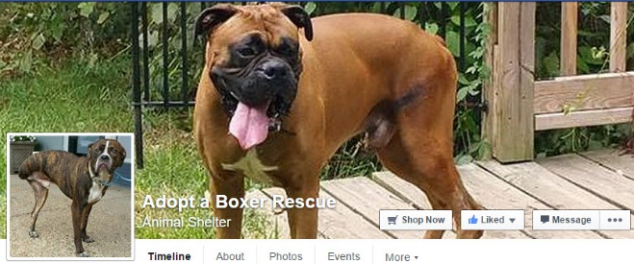](https://www.facebook.com/adoptaboxerrescue?fref=ts)

* [American Indian Heritage Month](http://www.firstnations.org/news/events/native_american_heritage_month_2015)
* Banana Pudding Lovers Month



* [Family Stories Month](http://imlostinbooks.blogspot.com/2009/11/family-stories-month.html)
* Gluten-Free Diet Awareness Month

[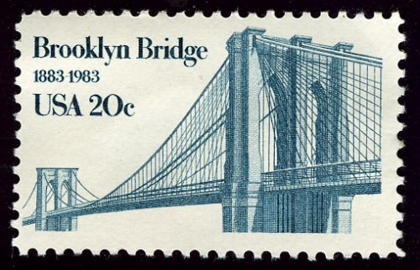](http://historicbridges.org/index.htm)

* [Historic Bridge Awareness Month](http://historicbridges.org/index.htm)

[](https://www.daysoftheyear.com/days/manatee-awareness-month/)

* [Manatee Awareness Month](https://www.daysoftheyear.com/days/manatee-awareness-month/)
* [Military Family Appreciation Month](http://www.military.com/military-family-appreciation-month)
* National Alzheimer's Disease Month
* National Family Caregivers Month
* National Georgia Pecan Month
* National Inspirational Role Models Month
* National Pomegranate Month
* [National Scholarship Month](http://www.scholarshipproviders.org/)
* [Pancreatic Cancer Awareness Month](https://www.pancan.org/wage-hope/)



* [Sweet Potato Awareness Month](http://holidaysofyear.com/sweet-potato-awareness-month/)
* [Vegan Month](https://www.facebook.com/WorldVeganMonth)

**Week Celebrations:**

* National Fig Week: 1-7
* World Communication Week: 1-7

[](http://www.scouting.org/sitecore/content/Home/HealthandSafety/SafetyThoughts/120504.aspx)

* Sherlock Holmes Weekend: 3-5
* Drowsy Driving Prevention Week 5-11



* [National Animal Shelter Appreciation Week: 5-11](http://www.humanesociety.org/news/news_briefs/2013/11/national-animal-shelter-rescue-appreciation-week-110113.html)
* National Young Reader's Week: 6-10

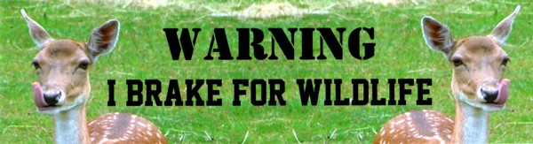

* [Give Wildlife A Brake Week: 6-10](http://www.wildlifeincrisis.com/programs/wildlife.htm) (First Week)
* National Hunger & Homeless Awareness   
  Week: 11-20

[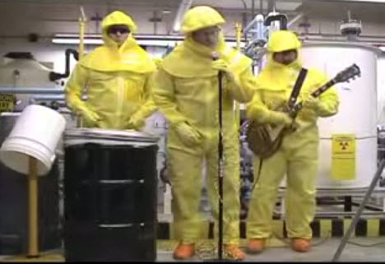](https://www.youtube.com/watch?v=mRc33sBjeSI)

"50 Ways to save a Millirem"  
Try this funny Rad Tech video at   
<https://www.youtube.com/watch?v=mRc33sBjeSI>

* [**National Rad Tech Week: 12-18**](http://www.asrt.org/events-and-conferences/national-radiologic-technology-week)
* Geography Awareness Week: 12-18
* World Kindness Week: 12-18
* American Education Week: 13-17

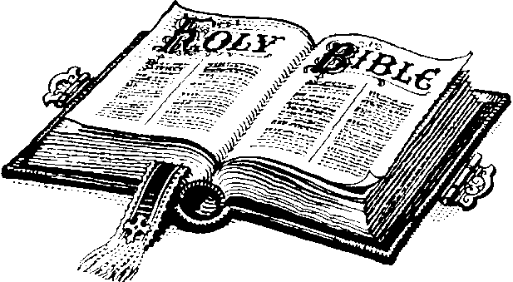

* [National Bible Week: 19-26](http://www.catholicpublishers.org/?page=NBWK2015)
* National Farm-City Week: 19-23
* National Family Week: 19-25
* **National Game & Puzzle Week: 19-25**

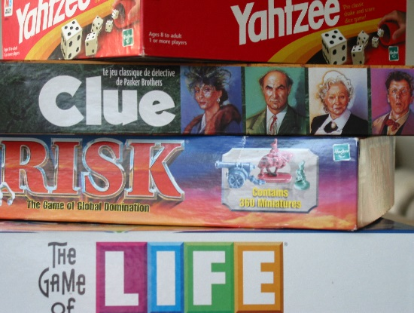

* National Global Entrepreneurship Week: 20-26

**November Daily Holidays, Special   
and Wacky Days:**

1 [All Saint's Day](http://holidayinsights.com/christian/saintsday.htm)

2 [All Soul's Day](http://holidayinsights.com/christian/soulsday.htm)

2 [Look for Circles Day](http://holidayinsights.com/moreholidays/November/lookforcirclesday.htm)

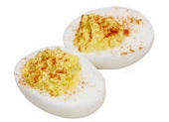

2 [Deviled Egg Day](http://holidayinsights.com/moreholidays/November/deviledeggsday.htm)

2 [Men Make Dinner Day](http://holidayinsights.com/moreholidays/November/men-make-dinner-day.htm)

2 [Plan Your Epitaph Day](http://holidayinsights.com/moreholidays/April/planyourepitaphday.htm)

3 [Housewife's Day](http://holidayinsights.com/moreholidays/November/housewifeday.htm)

3 [Sandwich Day](http://holidayinsights.com/moreholidays/November/sandwichday.htm)

4 [King Tut Day](http://holidayinsights.com/moreholidays/November/kingtutday.htm)

5 [Gunpowder Day](http://holidayinsights.com/moreholidays/November/guyfawkesday.htm)

5 [Guy Fawkes Day](http://holidayinsights.com/moreholidays/November/guyfawkesday.htm)

6 [Marooned without a Compass Day](http://holidayinsights.com/moreholidays/November/nocompassday.htm)

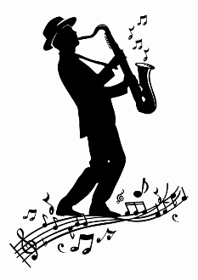

6 [Saxophone Day](http://holidayinsights.com/moreholidays/November/saxophoneday.htm)

7 [Book Lovers Day](http://holidayinsights.com/moreholidays/August/bookloversday.htm) - first Saturday of the month

7 [Bittersweet Chocolate with Almonds Day](http://holidayinsights.com/moreholidays/November/bittersweetchocolateday.htm)

7 [U.S. General Election Day](http://holidayinsights.com/moreholidays/November/election-day.htm) - first Tuesday of November after first Monday of November

8 [Cook Something Bold Day](http://holidayinsights.com/moreholidays/November/cooksomethingboldday.htm)

8 [Dunce Day](http://holidayinsights.com/moreholidays/November/dunceday.htm)

9 [Chaos Never Dies Day](http://holidayinsights.com/moreholidays/November/chaosneverdiesday.htm) - you've got that right

10 [Forget-Me-Not Day](http://holidayinsights.com/moreholidays/November/forgetmenotday.htm)

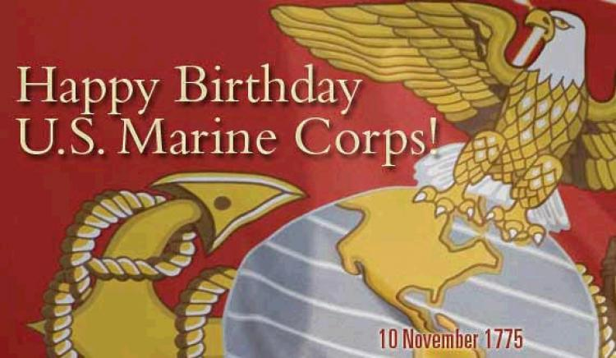

10 [USMC Day](http://holidayinsights.com/moreholidays/November/usmcday.htm)

11 [Veteran's Day](http://holidayinsights.com/other/veteran.htm)

12 [Chicken Soup for the Soul Day](http://holidayinsights.com/moreholidays/November/csftsday.htm)

13 [National Indian Pudding Day](http://holidayinsights.com/moreholidays/November/indianpuddingday.htm)

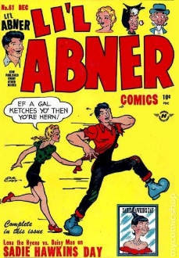

13 [Sadie Hawkins Day](http://holidayinsights.com/other/sadie.htm)

13 [World Kindness Day](http://holidayinsights.com/moreholidays/November/worldkindnessday.htm)

14 [Operating Room Nurse Day](http://holidayinsights.com/moreholidays/November/operatingroomnurse.htm)

14 [World Diabetes Day](http://holidayinsights.com/moreholidays/November/world-diabetes-day.htm)

14 [Young Readers Day](http://holidayinsights.com/moreholidays/November/youngreadersday.htm)

15 [Clean Your Refrigerator Day](http://holidayinsights.com/moreholidays/November/cleanrefrigeratorday.htm)

15 [America Recycles Day](http://holidayinsights.com/moreholidays/November/americarecyclesday.htm)

15 [National Philanthropy Day](http://holidayinsights.com/moreholidays/November/philanthropyday.htm)

16 [Button Day](http://holidayinsights.com/moreholidays/November/buttonday.htm)



16 [Have a Party with Your Bear Day](http://holidayinsights.com/moreholidays/November/partybearday.htm)

16 [International Tolerance Day](http://holidayinsights.com/moreholidays/November/international-tolerance-day.htm)

16 [National Fast Food Day](http://holidayinsights.com/moreholidays/November/national-fast-food-day.htm)

[](https://www.cancer.org/healthy/stay-away-from-tobacco/great-american-smokeout.html)

16 [Great American Smokeout](https://www.cancer.org/healthy/stay-away-from-tobacco/great-american-smokeout.html)

17 [Electronic Greeting Card Day](http://holidayinsights.com/moreholidays/November/electronicgreetingcard.htm) - now who do you think created this day!?

17 [Homemade Bread Day](http://holidayinsights.com/moreholidays/November/homemadebreadday.htm)

17 [Take A Hike Day](http://holidayinsights.com/moreholidays/November/takeahikeday.htm)

17 [World Peace Day](http://holidayinsights.com/moreholidays/November/worldpeaceday.htm)

18 [National Adoption Day](http://holidayinsights.com/moreholidays/November/adoptionday.htm) - Saturday before Thanksgiving

18 [Occult Day](http://holidayinsights.com/moreholidays/November/occultday.htm)

19 [Have a Bad Day Day](http://holidayinsights.com/moreholidays/November/haveabaddayday.htm)

20 [Absurdity Day](http://holidayinsights.com/moreholidays/November/absurdityday.htm)

20 [Beautiful Day](http://holidayinsights.com/moreholidays/November/beautifulday.htm)

20 [Universal Children's Day](http://holidayinsights.com/other/children.htm)

21 [False Confession Day](http://holidayinsights.com/moreholidays/November/falseconfessionday.htm)

21 [World Hello Day](http://holidayinsights.com/moreholidays/November/worldhelloday.htm)

22 [Go For a Ride Day](http://holidayinsights.com/moreholidays/November/goforarideday.htm)



23 [Eat a Cranberry Day](http://holidayinsights.com/moreholidays/November/eatacranberryday.htm)

23 [National Espresso Day](http://holidayinsights.com/moreholidays/November/national-espresso-day.htm)

23 [National Cashew Day](http://holidayinsights.com/moreholidays/November/cashewday.htm)

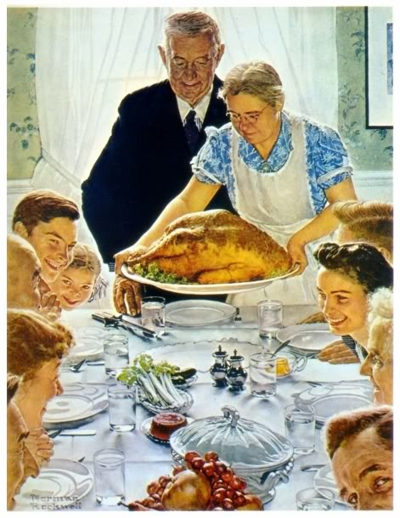

**23** [**Thanksgiving**](http://holidayinsights.com/tday/index.htm) **-   
Eat, drink, and be thankful.**

24 [Black Friday](http://holidayinsights.com/moreholidays/November/blackfriday.htm) - Friday after Thanksgiving

24 [Buy Nothing Day](http://holidayinsights.com/moreholidays/November/buynothingday.htm) - always the day after Thanksgiving...does anyone abide by it!?!

24 [You're Welcome Day](http://holidayinsights.com/moreholidays/November/yourewelcomeday.htm) - the day after Thanksgiving

24 [Evolution Day](http://holidayinsights.com/moreholidays/November/evolution-day.htm)

25 [National Parfait Day](http://holidayinsights.com/moreholidays/November/parfaitday.htm)

26 [Shopping Reminder Day](http://holidayinsights.com/moreholidays/November/shoppinreminderday.htm)

27 [Pins and Needles Day](http://holidayinsights.com/moreholidays/November/pinsandneedles.htm)

28 [Make Your Own Head Day](http://holidayinsights.com/moreholidays/November/makeyourownhead.htm)



28 [Red Planet Day](http://holidayinsights.com/other/redplanetday.htm)

29 [Square Dance Day](http://holidayinsights.com/other/squaredanceday.htm)

30 [Stay At Home Because You Are Well Day](http://holidayinsights.com/moreholidays/November/stayhomewellday.htm)

## November – A Month to Celebrate

*Alice, Golden Empire Council*

**November 1 - The United States Weather Service was established in 1870** The Smithsonian first began to organize a national weather system, but the Civil War brought that work to a half. Because weather was believed to influence disease, Army doctors kept weather diaries as early as 1814. But it wasn’t until the telegraph was invented in the 1840’s that there was any way to have a tracking system.

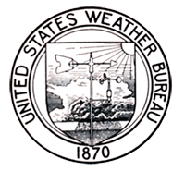

Early Weather Bureau logo.  
Courtesy of NOAA photo library

And after the Civil War, because weather and weather patterns were important to trade and commerce, President Grant authorized the military to use existing personnel to make weather observations – and the Signal Corps began operating a national weather bureau. That was good news for the Corps, because with the telegraph, signaling had lost some usefulness.

The Signal Corp began with 25 stations, located in various places, including major cities and remote sites like Pike’s Peak, Colorado. Over the next two decades, over 100 stations were opened, and the Army pioneered meteorology. They trained soldiers to take weather observations three times each day, and transmitted their reports by telegraph to Washington, DC. The Chief Signal Officer, Albert J. Myer, was known as “Old Probabilities” because of the weather predictions that appeared in the daily newspapers, based on maps and charts created from the weather data.

In 1891, the weather service was transferred to the Department of Agriculture – but today, The National Weather Service is part of NOAA, or National Oceanic and Atmospheric Administration in the Commerce Department.

Things have changed a lot since General Sherman said that the Army had no need to know what the weather would be – they would just march on. Today, we know that weather affects citizens all over the United States, and the world. We know that being able to predict and report severe weather can help prevent major damage and loss of life. We can warn people to move out of the path of hurricanes, flooding and severe weather, or protect property from damage. Monitoring, reporting, repairing, and rescuing come at a huge cost – so Weather is now a matter of Citizenship!

***For more info, go to:***

[*www.history.army.mil/banner_images/focus/weather_service.html*](http://www.history.army.mil/banner_images/focus/weather_service.html)

**November 6- John Philip Sousa’s Birthday**



Sousa was a great patriot – and he used music to stir patriotism in others! He was known as “The March King” and wrote many famous marches. Among his best known marches are "[The Washington Post](http://en.wikipedia.org/wiki/The_Washington_Post_(march))", "[Semper Fidelis](http://en.wikipedia.org/wiki/Semper_Fidelis_(march))" (Official March of the [United States Marine Corps](http://en.wikipedia.org/wiki/United_States_Marine_Corps)), and "[The Stars and Stripes Forever](http://en.wikipedia.org/wiki/The_Stars_and_Stripes_Forever)" (National March of the United States of America), and marches for several universities. When he was only 13, he became an apprentice in the United States Marine Corp band, and later became the leader of that band for several years. He also directed the Navy Band during the First World War. He donated his entire salary, less $1 a year, to the Sailors' and Marines' Relief Fund

Sousa also helped create a new instrument, called the Sousaphone – he wanted a tuba that could be usedeven while marching, and that could be heard over the band. But he had some other talents as well – he wrote three novels and his own autobiography, *Marching Along* .

But he was also an all-time great trap shooter, and he’s in the Trapshooting Hall of Fame. He even organized the first national trapshooting organization, and some call him the father of trapshooting in America. Sousa also wrote many articles about trapshooting.

***Want to listen to some of his marches? Go to:***[**www.en.wikipedia.org/wiki/John_Philip_Sousa**](http://www.en.wikipedia.org/wiki/John_Philip_Sousa)and click on the music bars

**November 8- Young Reader’s Day**

So find a book you love and read it – you could explore the story of the flag, how weather is affected by the ocean, or how candy corn is made. There’s a book on every subject!

**November 11 - Veteran’s Day**

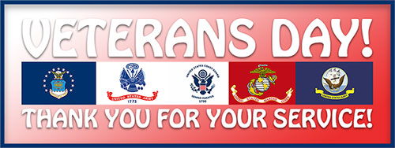

Participate in a Veterans Day Parade or other community event. Some scouts help put out flags for veterans at local cemeteries. There is also an opportunity for ongoing service at National Cemeteries.

**November 17 – Take a Hike Day**

This is the perfect time to take a hike with the den or your family – and it counts toward advancement for every level – plus it’s FUN!

**November 18 – Mickey Mouse’s Birthday, 1928**



Mickey Mouse is recognized the world over as an icon of America. He is also a symbol of the freedom of citizenship in America. Because people are free to choose their occupation and their religion and can feel secure in their homes, they have time for fun and creativity.

**November 19 – Gettysburg Address delivered 1863**

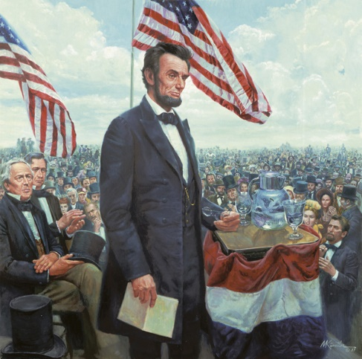

President Abraham Lincoln delivered a three-minute address during the American Civil War at the dedication of a national cemetery on the site of the Battle of Gettysburg. The Gettysburg Address is one of the most famous American speeches of all time.

**November 23 – Thanksgiving**

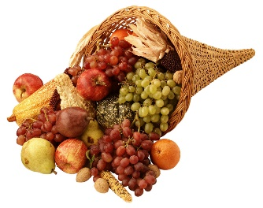

Traditionally celebrated on the fourth Thursday of November in the United States. It is usually associated with the Pilgrims and their first Thanksgiving feast in America, when they celebrated with the help of local Native Americans – but check out the amazing true story of Squanto, or Tisquantum, a Patuxet Indian who had already learned English before he met the Pilgrims. Go to:   
[**www.rootsweb.ancestry.com/~mosmd/squanto.htm**](http://www.rootsweb.ancestry.com/~mosmd/squanto.htm)

**November 27 – Bill Nye’s Birthday**



Better known as Bill Nye, the Science Guy, he has made science FUN – and since the Webelos are working on the Science Activity Pin this month, take advantage of that fun – go to his website for his take on how to do the requirements or some great ways to work on the STEM Awards or STEM related Adventures.

**For more info -** [**www.billnye.com**](http://www.billnye.com)

**VETERANS DAY**

* November 11 is Veterans Day. A veteran is a soldier who has served his/her country.
* Thirty-five countries fought in World War I. They fought for five years, from 1914 to 1918. The United States fought in the war from 1917 to 1918.
* Finally the countries stopped fighting. The leaders signed an armistice. **They signed the armistice on the eleventh hour of the eleventh day of the eleventh month.** The armistice meant that the war was over.
* Americans were very happy to hear about the armistice. No more soldiers would die in the war. The soldiers could come home.
* People went out into the streets and laughed and danced. They blew horns and whistles and rang bells. They sang songs. They thought that there would never be another war.
* President Wilson made November 11 a holiday to remember the end of the war. The holiday was called Armistice Day.
* At eleven o'clock in the morning, everyone stopped doing whatever they were doing. People were completely silent for one minute. This minute was to remember all the soldiers who have died in wars.
* The body of an unknown soldier was brought to America from the cemetery in France. His body was buried in a tomb at Arlington National Cemetery. It is called the Tomb of the Unknown Soldier.
* The US was in three more wars: World War II, the Korean War, and the Vietnam War.
* In 1954, President Eisenhower changed the name of the holiday to Veterans Day to honor all military veterans.
* The bodies of three more unknown soldiers were brought to the cemetery. On Veterans Day, there are special services at the Tomb of the Unknowns. *Recently, the Viet Nam veteran was identified and his remains removed.*
* Americans remember and honor all the veterans on Veterans Day. Veterans Day is for the living and the dead. Memorial Day in May is for those that have died in battle.

**VETERANS TODAY**

The military men and women who serve and protect the U.S. come from all walks of life; they are parents, children, grandparents, friends, neighbors and coworkers, and are an important part of their communities. Here are some facts about the veteran population of the United States.

**There are:**

* 16.1 million living Veterans who served during at least one war.
* 5.2 million Veterans served in peacetime.
* 2 million Veterans are women.
* 7 million Veterans served during the Vietnam War.
* 5.5 million Veterans served during the Persian Gulf War.
* Of the 16 million Americans who served during World War II, about 558,000 are still alive.
* 2 million Veterans served during the Korean War.
* 6 million Veterans served in peacetime.
* As of 2014, 2.9 million Veterans received compensation for service-connected disabilities.
* The VA health care system had 54 hospitals in 1930, since then it has expanded to include 171 medical centers; more than 350 clinics; 126 nursing home care units; and 35 live-in care facilities for injured or disabled vets.

**Fun Facts About the Flag**

*Alice, Golden Empire Council*

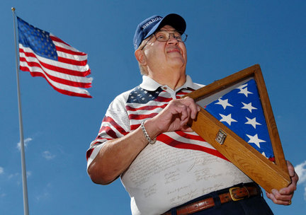

To the original members of the Continental Congress, the colors on the Great Seal had meaning: red stood for hardiness and courage, white for purity and innocence, and blue for vigilance and justice –but those meanings were not connected to the colors of the flag till much later.

The gold fringe on some flags is considered only “an honorable enhancement” and is not to be used on outdoor flags because it would deteriorate in the weather. The use of gold fringe is optional.

When folded properly, the US flag is shaped like a triangle with only the stars showing. If you have exacting standards, it usually takes 13 folds: the same number of original colonies.

The US flag must not be used on any item designed to be disposable. Unfortunately, this rule is often broken, on paper cups, etc.

Old Glory actually refers to a specific flag owned by Captain William Driver, with 24 stars and 13 stripes. Old Glory traveled on his ship and circled the globe twice before Driver retired to Nashville. He hid the flag inside his bedspread when Tennessee seceded from the Union. When the war was over, Driver joyously ripped open his bedding to an astonished group of patriots! Old Glory now lives in the Smithsonian.

If you look at a United States military uniform, you may think the flag is backwards on the right shoulder sleeve – here’s the explanation: According to regulations, the “flag patch is to be worn, right or left shoulder, so that “the star field faces forward, or to the flag’s own right. When worn in this manner, the flag is facing to the observer’s right, and gives the effect of the flag flying in the breeze as the wearer moves forward. The appropriate replica for the right shoulder sleeve is identified as the ‘reverse side flag’.”

Only State Governors and the President of the US can order flags to be set at half-staff.

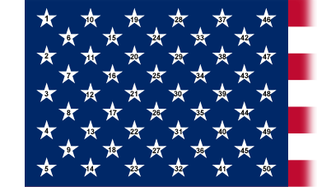

**The Real Story of the 50 Star Flag**

*Alice, Golden Empire Council*

The current version of the US flag was designed by 17year old Robert G. Heft, who only received a “B-” for his efforts. He challenged his teacher that he should receive an “A” if his design was accepted by Congress.

Heft was one of thousands to submit a flag design with alternating rows of five and six stars. But apparently he was the only person who actually stitched together a flag and shipped it to D.C. – he took his family 48-star flag, and replaced the original blue section. He used $2.87 worth of blue cloth and cut 100 stars out of white iron-on material (He put 50 stars on each side of the flag).

Heft was 17 in 1958 when he received an unusual phone call - When the caller asked for Robert G. Heft, the teenager said, “Yes, but you can call me Bob.” He didn't realize he was speaking with President Dwight D. Eisenhower. Heft's high school project had been selected by the president to represent the United States of America and the 50-star U.S. flag was born.

It has flown over every state capitol building and over 88 U.S. embassies. An uneven patch at a lower corner is evidence of an attack on the embassy in Saigon in 1967. It's the only flag in America's history to have flown over the White House under five administrations.

Heft visited the White House 14 times under nine presidents and toured with Bob Hope. He loved to visit with veterans, children and scouts, and made his last appearance just a week before his death in December, 2009.

He taught children to follow their dreams. “…Make every minute count in school and in life. You just never know how life will turn out. If you believe in what you are doing (and it's proper), never let anybody discourage you. Follow your dreams.

Heft was once asked why he decided to make a flag for his school project. His answer –

**“I selected the flag project because I was fascinated by the use of flags while in Boy Scouts** and also by the Betsy Ross story. Remember, then we didn't have the internet, Clifford the Big Red Dog, Pokemon Trading cards etc.”

***Want to know more of the story? Go to:***[www.montney.com/flag/designer.htm](http://www.montney.com/flag/designer.htm)

# SPECIAL OPPORTUNITIES

## DUTY TO GOD PUZZLE PATCH

*P.R.A.Y. at* [www.praypub.org](http://www.praypub.org)

***Consider making a Duty to God promotion at your RT (or Pack Meeting) and having patches available to all who commit to promote or earn a Duty to God award. CD***

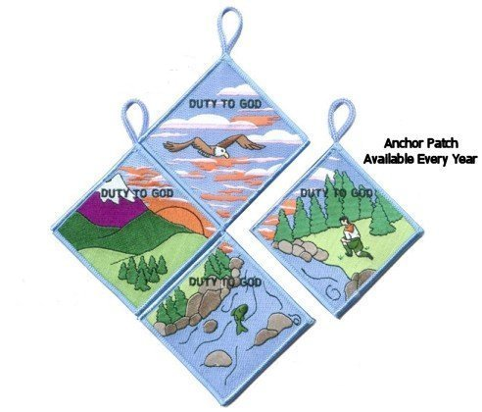

To order patches - <https://store.praypub.org/puzzle-patches>

“Duty to God” is at the heart of the Scouting movement. Religious emblems reinforce this spiritual component and promote many of the values found in the Scouting program. The purpose of this “Duty to God Promotion Patch” is to encourage youth and adults to learn about and promote the religious emblems programs.

**Requirements** –

Youth and adults must:

1. Attend or coordinate a presentation or information seminar on religious emblems (Resources and suggestions are available at [www.praypub.org](http://www.praypub.org)).
2. Make a commitment to fulfill their “Duty to God.”

*Here are some examples:*

* Adults can commit to leading a religious emblems program at their unit, nominating a worthy adult to be recognized with an adult religious award, or serving as counselor for the awards, etc.
* Youth can commit to earning the religious emblem of their faith, making a presentation on religious emblems to another unit, or helping younger Scouts earn their religious emblem, etc.

**The Patch**

* The Duty to God Puzzle Patch has four segments.
* Only one segment is presented at a time (a year).
* Participants are encouraged to earn all four segments over a four-year span.
* Visit [www.praypub.org](http://www.praypub.org) to see and order patches.
* Patches may be pre-ordered for distribution at the presentation/ information seminar.

**The DVD**The Duty to God Promotion DVD contains the resources to make a presentation on the religious emblems programs. These resources include the video “Promoting Duty to God (Religious Emblems),” Duty to God brochure/chart listing all religious emblems (No. 05-879), scripts (for presentations to Cub Scouts, Boy Scouts, and Venturers), and Parent Handout.

**Making a Presentation**

* Find scripts, videos, handouts, and other resources at [www.praypub.org](http://www.praypub.org)
* Invite parents
* Provide information on emblems of ALL faiths
* Encourage Scouts to make a commitment to earn their religious emblem
* Present the Duty to God Promotion Patch to participants

**Call and talk to the "Religious Emblems People" today! 1-800-933-7729 or visit** [**www.praypub.org**](http://www.praypub.org)

## RELIGIOUS EMBLEMS

[www.USScouts.org](http://www.USScouts.org)

 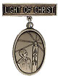 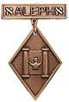

**"A Scout is Reverent."** All Scouts show this by being faithful in their duty to God. Some go further and give special service. This can qualify them for a religious emblem. Such an emblem is not a Scouting award. It is conferred on a Scout by his religious leader. Each faith has its own requirements for earning the emblem for members of its Faith. Listed <http://usscouts.org/advance/cubscout/religious.asp#Chart> on the [www.USScouts.org](http://www.USScouts.org) website are the TIGER CUB, CUB SCOUT, AND WEBELOS SCOUT emblems and where to find out about them. Before writing or visiting your local council service center, check with your religious leader. (Unless indicated otherwise below, awards listed may be earned by Cub Scouts and Webelos Scouts)

These groups (and others) also offer religious emblems for older youth. For information on the awards available to Boy Scouts, Varsity Scouts, Venturers, and/or Explorers, [Click here](http://usscouts.org/advance/boyscout/religious.asp).

Most of the awards consist of bar pins, ribbons, and pendants, and are worn on the uniform above the left pocket on formal occasions. In addition, the Religious Emblem Square knot, shown at the top of this page, may be worn on the uniform over the left pocket by youth or adults who earned any of the religious awards.

One or more miniature devices are affixed to the knot to indicate which level(s) of the award was earned. The youth religious emblem knot may be worn on the uniform by itself or with one or more devices to indicate the program phase(s) where the award was earned. A Scout that earns a sequence of religious emblems wears one youth religious emblem knot and up to four devices, as described below.

* The **CUB SCOUT** device for the first level (God & Me, Maccabee, etc.) earned as a Tiger Cub or Cub Scout;
* **WEBELOS** device for the second level (God & Family, Parvuli Dei, Aleph, etc.) earned as a Cub Scout or Webelos Scout;
* **BOY SCOUT** device for the first level (God & Church, Ad Altare Dei, Ner Tamid, etc.) earned as a Boy Scout;
* **VENTURING** device for the second level emblem (God & Life, Pope Pius XII, Etz Chaim, etc.) earned as an older Boy Scout, Varsity Scout, Sea Scout, or Venturer. ***Note*** *that Webelos Scout and Venturing devices are used to designate the second level emblems, even if the youth isn't a Webelos Scout or Venturer when the religious emblem was earned.*

For more information on the Youth Religious Emblem square knot patch, go to (<http://usscouts.org/awards/religyouth.asp>)

For information on the devices which are attached to the knot, go to <http://usscouts.org/awards/devices.asp>.

**FAQs about Religious Emblems**

[www.scouting.org](http://www.scouting.org)

**What are the religious emblems programs?**The religious emblems programs are programs created by the various religious groups to encourage youth to grow stronger in their faith. The religious groups—not the Boy Scouts of America—have created the religious emblems programs themselves. The Boy Scouts of America has approved of these programs and allows the recognition to be worn on the official uniform, but each religious organization develops and administers its own program.

**I have a unit with children of all different faiths. How can I include the religious emblems programs for my unit?**The religious emblems programs should be presented to youth members and their families as an optional program for them to complete through their religious organization. Religious instruction should always come from the religious organization, not from the unit leader. Parents need to be informed of these programs and told where to get the information for their faith. Interested in making a presentation on the religious awards? Find sample scripts at www.praypub.org.

**Do boys and girls participate in the same program?**It depends on the religion. Some religions have created programs that are used by both boys and girls. Other religions have created programs for members of separate youth agencies (i.e., Boy Scouts of America, Girl Scouts of the U.S.A., and Camp Fire). Please check the specific eligibility requirements for each religious emblems program.

**Do the youth have to belong to a religious institution?**It depends on the religion. Please check the eligibility requirements for your particular religious program.

**Why doesn't my religious institution know about the religious emblems programs?**Although the religious bodies at the national level created the religious emblems programs, the local religious institution may not be aware of these programs. You may write for information and a copy of the curriculum to give to your religious leader.

**If the religious emblems program for my faith has more than one level (for the different grade levels), may my child earn all of these recognitions?**Yes. Members can earn all levels of their religious emblems program. However, they must be in the appropriate program guidelines when they start and complete each level (they may not go backward and earn younger programs).

**How is the emblem presented?**The emblem should be presented in a meaningful ceremony, preferably in the youth member's religious institution. Some emblems come with a sample presentation ceremony.

**How long does it take to complete a program?**It depends on the program. Some programs may take three or four months, others longer.

**Where is the emblem worn on the uniform?**The universal religious square knot is worn over the left shirt pocket of the Scout uniform. The medallion is pinned over the square knot for full uniform occasions.

**How do we get started on these programs?**

1. Youth members must obtain the specific booklet for their religion. This booklet will contain information on all the lessons and service projects that they will need to complete. Each member needs to have his or her own booklet to document progress. Some religions also provide adult manuals for counselors and mentors.

Check with your local council to see if it stocks the religious award booklets in its store, or you may contact the religious organization directly

Addresses and phone numbers are provided at <http://www.scouting.org/scoutsource/Awards/ReligiousAwards/~/link.aspx?_id=9D5FA10AEB254061A248D13D459424FE&_z=z>.

1. Parents must review the specific guidelines for their program; age/grade requirements vary from program to program. Some programs require that the youth be an official "member" of the local religious institution, others may not. Each program determines who may serve as counselor (some require clergy, others allow parents or other family members). Be sure to look at specific eligibility guidelines!
2. Families should talk to their religious leaders and show them the booklet before beginning any program. Most of the religious emblems programs require that they be completed under the auspices of that religious organization, and many require the signature of the local religious leader. Again, check the specific eligibility requirements for your religious program.
3. The member needs to complete the requirements, obtain the proper signatures, and follow the instructions to order the emblem/award. (These emblems are not available in your local council.) The emblem can be presented at any time of the year and should be presented in a meaningful ceremony, preferably in the member's religious institution.

**Who may serve as counselor?**It depends on the program. Some programs require clergy to serve as counselor, others allow a parent or family member. Please check the specific guidelines for your religious program.

**How do I order the recognition items?**Each religious program has its own emblem. Follow the instructions in your recognition guidelines. These emblems will not be available in your local council!

**What is the adult religious recognition program?**Most adult religious awards are require the recipient be nominated. The recognition is to worthy adults for their outstanding service to youth both in their religious institution and at national youth agency. Recipients of these awards are unaware of their nomination. They are nominated for the award by submitting an application, letters of recommendation, and resume. Please check eligibility requirements for specific awards.

**Which religious emblem knot should I wear?**Cloth, silver knot on purple, No. 05007, may be worn by youth or adult members who earned the knot as a youth, above left pocket.

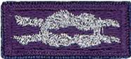 

Cloth, purple on silver, No. 05014, may be worn by adult members presented with the adult recognition of a faith, above the left pocket. Adults may wear both knots. (See the *Insignia Guide,* No. 33066D.)

***NOTE: - Since the programs are similar or the same (as in the case of the PRAY Awards) for girls and boys in Boy Scouting, 4H, Girl Scouting, Campfire, etc., a Venturer or Adult Leader who as a youth earned a religious award may wear the purple square knot on the uniform though it was not earned as a member of the BSA. (My Philmont staffer daughter Dr. Darby does this!!)***

***Per Mike Walton of*** [***www.USScouts.org***](http://www.USScouts.org)***, this applies to males and females, youth and adult.  If you earned a religious emblem as a youth member, whether as a BSA member or not does not matter. The youth religious emblem square knot represents ANY AWARD youth members earned or received.***

***So yes, a Girl Scout, 4Her, or Royal Ranger has a youth religious emblem from that program and then becomes an adult or youth member of the BSA (includes Venturing/Sea Scouting) may wear that emblem and wear the square knot insignia without device on the uniform shirt.***

The 2015 printing of the ***"Guide to Awards and Insignia,"*** states in the Special regulations section (page 9), "The Boy Scouts of America recognizes the religious emblems programs that belong to each faith group. Anyone (youth or adult) who, as a member of another youth agency (e.g., Girl Scouts of the USA, Camp Fire USA, a Sunday school class, etc.), has earned the religious emblem of their faith is eligible to wear the approved religious emblem on their respective uniform. Individuals would also be eligible to wear the religious square knot, without any device."

## Adult Religious Recognitions

*Baloo's Archives*

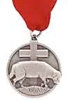 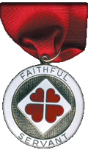



**What is the adult religious recognition program?**   
An adult religious recognition award is presented by nomination only. The recognition is presented to worthy adults for their outstanding service to youth both through their religious institution and one of the national youth agencies. Recipients of these awards are sometimes unaware that they are being nominated. They are nominated to receive an award by submitting the required application, letters of recommendation, and resume. Please check eligibility requirements for specific awards. Self and spousal nominations are usually not allowed.

Essentially every denomination that has Youth Awards has at least one Adult Award. The award on the left is **the** [**Lutheran Lamb Award**](https://www.praypub.org/pdf_docs/lamb2014.PDF). Presented to acknowledge at least 10 years of distinguished service of a Lutheran adult in fostering the spiritual growth of youth through church and civic youth serving agency programs and to increase the use and quality of the civic agency programs in Lutheran congregations as a part of their ministries with youth. (Commissioner Dave has been presented this honor). The recipient may wear the Adult Religious Emblem Square Knot. The Lutherans also have the [**Servant of Youth**](https://www.praypub.org/pdf_docs/youth2014.pdf) Award to acknowledge distinguished volunteer service by adults in ministry to young people through one or more civic youth agency programs. This award may be presented to a non-Lutheran SM of a troop chartered to a Lutheran Church. (or vice versa – a Lutheran Scoutmaster of a troop at a Baptist (or other) Church)

The award on the right is the [**Churches of Christ Faithful Servant award**.](http://goodservant.org/wp/request-curricula/faithful-servant-information/) There is a minimum ten year tenure requirement for nomination. The recipient may wear the Adult Religious Emblem Square Knot.

For complete listings of Adult Religious Recognitions for BSA Leaders go to National’s site at <http://www.scouting.org/scoutsource/Awards/ReligiousAwards.aspx>

or US Scouts site at <http://www.usscouts.org/awards/religadult.asp>

Many of these awards are coordinated by P.R.A.Y. Check their website for info, too [www.praypub.org](http://www.praypub.org/)

Only one Adult Religious Award square knot is worn regardless of how many awards have been received. It is possible, for example, to receive two or three levels of awards in some faiths or to receive awards from more than one faith.

***So, if you know someone who is deserving of receiving the Adult Award from his faith – check it out and begin the nomination process.***

**Confused??**

***Need help to figure out these awards?? See the***

## Religious Emblems Coordinator

They support the Duty to God (religious Emblems) Program, Promote Growth, & Retention in Units

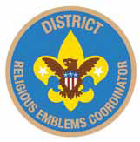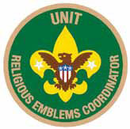

**Purpose:**There are three purposes for having Religious Emblems Coordinators at the council, district, and unit levels:

* Encourage all youth to earn the emblem of their faith
* Promote religious emblems usage the way the BSA promotes other youth advancement
* Establish goals and track the number of religious emblems earned each year

**Why?** Baden-Powell stated, "Religion seems a very simple thing: First, love and serve God. Second, love and serve your neighbor." (*Scouting for Boys*, 1908) Here are three reasons to have Religious Emblems Coordinators:

* Reinforce BSA values through religious emblems
* Improve relationships with religious chartered organizations
* Establish relationships with potential religious chartered organizations

**Responsibilities -   
Unit Religious Emblems Coordinator**

* After appointment by the unit committee chair, serves on the unit committee
* Acquaints all youth with the religious emblems program and emblems available for their faith
* Provides Scout families and clergy with an orientation to the religious emblems program and encourages their involvement
* Urges all youth to earn the religious emblem(s) of their faith
* Disseminates information about any district or council religious emblems activities, retreats, camps, or classes
* Promotes religious emblems usage the way the BSA promotes other youth advancement
* Serves as the unit's liaison to the district religious emblems coordinator

**District Religious Emblems Coordinator**

* After appointment by the district program chair, attends district meetings and with district program chair, sets district goals for religious emblems.
* Encourages every unit to appoint a unit religious emblems coordinator
* Disseminates information to units through charter renewal packets, roundtables, and camporees
* Helps unit religious emblems coordinators recruit presenters to make presentations on religious emblems, including clergy of chartered organizations, unit leaders who promote religious emblems, chaplains, etc.

**Council Religious Emblems Coordinator**

After appointment by the council vice president of program, works with the Religious Relationships Committee. The religious emblems coordinator focuses specifically on raising awareness of religious emblems and increasing usage. The Religious Relationships Committee works directly with the faith community to recruit chaplains, coordinate the council calendar with religious holidays, sponsor religious emblems retreats, identify religious representatives from the various faith groups, and strengthen ties with local congregations and chartered organizations.

Disseminates information to district religious emblems coordinators.

Provides information for dissemination at Trainings (e.g. Colleges of Commissioner Science, Universities of Scouting, New leader trainings) and summer camp (resident and day) programs. Provides information for dissemination to Professional staff and volunteers.

Learns through the Religious Relationships Committee which faith committees are sponsoring religious emblems retreats and which congregations are offering religious emblems classes.

**To learn more:**Go to National's Web Page at <http://www.scouting.org/Home/Commissioners/newsletter/spotlight/10_2013_religious.aspx> and "read all about it."

Then, go to Roundtable and learn who is your District Religious Emblems Coordinator and call for help.

# CUB GRUB

**Cub Grub Cookbook**

This is a really great cookbook for Cubs -

<http://balboaoaks.bsa-la.org/download/blog/Cub%20Grub%20Cookbook.pdf>

You can save a copy on your PC by selecting   
**File, Save As...** in your web browser's menu bar.

**FAITH IDEAS**

*Alice, Golden Empire Council*

**Prayer Pretzels**

You can’t find an easier snack to fit the Value of Faith! Share pretzels in the traditional shape – after you tell the boys the story of how a village priest used the pretzel shape to remind the children to pray! Check it out under AUDIENCE PARTICIPATIONS & STORIES.

***If you want a bigger challenge, pretzels are very easy to make – the trick is doing the twist to make them look like folded arms ready for prayer!***

**Faith Cookies**

Use your favourite cookie recipe. Have all ingredients out and ready, and an easy-to-read copy of the recipe. Go over each step of the recipe with the boys, starting from setting the oven temperature. Let the boys do as much of the measuring and mixing as possible.

To fit the Faith theme, identify each ingredient as an ingredient of Faith -

Knowing what you believe/Scriptures = recipe

Other ingredients could represent hope, prayer, obedience, searching the scriptures, reading a story about faith, knowing a principle of your creed that pertains to faith.

After the cookies are baked, enjoy!



**Scripture Cookies**

To find each ingredient, look up scripture reference and fill in blank. Some clues are subtle, so check list of ingredients on bottom of page before making cookies.

**Ingredients:**

3/4 cup “The words of his mouth were smoother   
than ____” ([Ps. 55:21](http://scriptures.lds.org/ps/55/21#21))

1/3 cup “Come unto me all ye ends of the earth,   
buy ____ and honey” ([2 Ne. 26:25](http://scriptures.lds.org/2_ne/26/25#25))

1 1/2 cups “To what purpose cometh there to me …   
the ____ ____ from a far country?” ([Jer. 6:20](http://scriptures.lds.org/jer/6/20#20))

2 “As one gathereth ____ that are left, have I gathered all the earth” ([Isa. 10:14](http://scriptures.lds.org/isa/10/14#14))

2 cups “And Solomon’s provision for one day was thirty measures of fine ____” ([1 Kgs. 4:22](http://scriptures.lds.org/1_kgs/4/22#22))

1 tsp “Take thou also unto thee principal spices, … and of sweet ____ half so much” ([Ex. 30:23](http://scriptures.lds.org/ex/30/23#23))

1 tsp “Ye are the ____ of the earth” ([Matt. 5:13](http://scriptures.lds.org/matt/5/13#13))

1/2 tsp “The kingdom of heaven is like unto ____   
([Matt. 13:33](http://scriptures.lds.org/matt/13/33#33))

3 cups “Nevertheless, … ____ for the horse”   
([D&C 89:17](http://scriptures.lds.org/dc/89/17#17) or Gen. 1:13-14 –***you will have to explain that oats are a grain and a plant bearing seed- the word oats doesn’t appear in the Bible*)**

1 cup “And they gave him … two clusters of ____”   
([1 Sam. 30:12](http://scriptures.lds.org/1_sam/30/12#12))

**Directions:**

* Beat first four ingredients together.
* Mix in remaining ingredients.
* Drop by teaspoonfuls onto greased cookie sheet.
* Bake at 350° F (175° C) for 15 minutes.

***Answers for Ingredients:  
3/4 cup butter, 1/3 cup milk, 1 1/2 cups sugar (sweet cane), 2 eggs, 2 cups flour, 1 teaspoon cinnamon, 1 teaspoon salt, 1/2 teaspoon baking soda (leaven), 3 cups oats, 1 cup raisins***

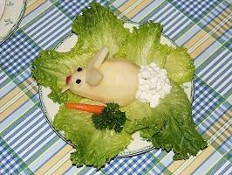

**Bunny Salad**

This is really easy – and tastes good, too!

The Bunny is a chilled pear half, features are made from raisins, dried cranberries, or whatever you like best. Ears can be cut from another pear slice, apple slices, or jicama, or use sliced almonds. The tail is cottage cheese. And be sure to add some carrots for your bunny to enjoy!

**Cashew Chicken Stir Fry**

*Alice, Golden Empire Council*

**[](http://familyfun.go.com/assets/cms/recipes/cashew-chicken-steak-fry-spril-fool-recipe-photo-420-FF0402FOOLA05.jpg)**

**Ingredients:**

2-3 green fruit roll-ups and

2 red fruit roll-ups,

1-1/2 tsp. hulled sunflower seeds,

1-1/2 c. dried apple rings,

3/4 c. dried pineapple chunks,

1/2 c. cashews

**Directions:**

* Make a bunch of pea pods by cutting a 2-1/4 inch square from green fruit roll-up, then arrange 5 or 6 sunflower seeds on the strip in a row, just off center.
* Fold the strip in half over the seeds, then press the edges together to seal them.
* Use kitchen scissors to trim the sealed edges into a rounded pea-pod shape.
* Cut the red fruit roll into thin pepper strips and the apple rings into bite-size “chicken” pieces.
* For the full effect, combine the pea pods, pepper strips, chicken pieces, pineapple chunks and cashews in a frying pan, or serve them on plates with chopsticks
* Makes three cups.

**Main Dish Masquerading as Cupcakes   
or Cake “Meat Loaf”**

*Alice, Golden Empire Council*

**Ingredients:**

1/2 lb. lean ground beef,

1/2 cup seasoned bread crumbs,

1 cup grated Monterey Jack cheese,

3 T. ketchup,

1 egg,

1/2 teaspoon celery salt,

1/4 t. pepper

**“Frosting”**

3 C. mashed potatoes,

Food coloring or beet juice

**Directions:**

* Heat oven to 375 degrees.
* Line 12 muffin tins cups with foil baking cups or use a loaf pan.
* In a large bowl, mix together meat loaf ingredients and divide evenly among cups.
* Bake for about 15 minutes or until cooked through, with the filled muffin tins on cookie sheets. Adjust time for a meat “loaf.”
* Spread a generous amount of “frosting.”
* If you make a loaf, use a decorating tube for your “cake.”

**Appealing New Treat**

*Alice, Golden Empire Council*



The latest scientific breakthrough from Family Fun magazine: pre-sliced bananas! When they peel one, they'll find the fruit inside is already cut into bite-size pieces.

**Ingredients**: Ripe banana (one with a few dark spots)

**Directions:**

1. For each slice, insert the threaded needle through one of the fruit's "corners" (where the edges of the peel meet) and out an adjacent corner, leaving a small tail of thread dangling for later.
2. Insert the needle back through the exit hole you just made and push it through to the next corner, pulling all but a small loop of thread along with it (see diagram). Continue from corner to corner until you return to the beginning, then push the needle out through the first hole you made.
3. Gather the 2 thread ends and carefully pull them out simultaneously; the thread will slice through the banana. Repeat the threading for as many slices as you'd like, then get ready to wow your family with this new breed of snack food.

**Peanut Butter Play Dough Bugs**

*Alice, Golden Empire Council*

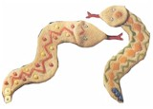

* Make a recipe of peanut butter play dough.
* Boys can use straight pretzels, small regular shaped pretzels, thin licorice, raisins, M & M’s , etc. to add antennae, eyes, legs, spots, and stripes, to their bugs.
* Play dough recipes can be found here: <http://www.makingfriends.com/pro_edible.htm>

**Jell-O Snakes (or worms)**

*Alice, Golden Empire Council*

**Ingredients:**

1 ½ cup apple juice**,**

3 oz. package flavored gelatin**,**

1 envelope unflavored gelatin**,**

5 ice cubes**,** small Ziploc bags

**Directions:**

Pour half the juice into saucepan. Heat until boiling; Remove from heat. Add gelatin, and stir until dissolved.

Pour remaining apple juice into mixing bowl. Add unflavored gelatin, and stir until dissolved.

Add mixture to hot apple juice. Add ice cubes, and stir until melted. Refrigerate until the consistency of pudding, about 10-15 minutes.

Spoon gelatin into Ziploc bags. Cut ¼ inch off the corner of the bag. Squeeze a wavy line of gelatin onto a foiled cookie sheet.

Chill in refrigerator about 2 hours.

To keep snakes firm while serving, place them on a plate over ice cubes.

**Ants on a Log:**

*Alice, Golden Empire Council*

* Spread peanut butter or cream cheese on celery sticks.
* Add raisins or cranberries for “ants.”

**Ants on a tire (or toilet seat) (eew!):**

*Alice, Golden Empire Council*

* Core apples, and slice into rings.
* Spread peanut butter or cream cheese on the rings.
* Add raisins or dried cranberries for “ants”.

**FUN FOODS**

**Note: Be aware of food allergies and diet restrictions.**

**Golden Stars**

*2011-2012 CS RT Planning Guide*

**Ingredients:**

* 1/3 cup melted butter
* 1 package yellow dry gelatin dessert mix
* 8 cups popped popcorn, unflavored

**Directions:**

* Put popcorn in a clean paper sack.
* Pour butter over popcorn, close sack, and shake well.
* Sprinkle dry gelatin dessert over popcorn, close sack, and shake well again.

**Kids Upside Down Umbrella Cakes**

*Alice, Golden Empire Council*

Celebrate National Upside Down Cake Day (April 20th) and also remember that familiar phrase “April Showers Bring May Flowers” – make this tasty Spring Umbrella treat.

**Ingredients:**

1 egg ,

3 tablespoons melted margarine or butter,

1 teaspoon vanilla,

1 16-oz. can of pineapple slices,

2/3 cup brown sugar,

1/3 cup shortening,

1 1/4 cups flour,

1 teaspoon baking powder,

1 teaspoon salt,

1 cup sugar,

licorice for umbrella handles

**Directions:**

* Preheat oven to 350 degrees F.
* Evenly divide melted margarine into a 12-cup muffin tin.
* Drain pineapple slices, save 1 cup drained syrup.
* Put pineapple slices into the melted butter on the bottom of each muffin section.
* Place crumbled brown sugar on top of each pineapple slice.
* In a bowl, mix together sugar and shortening.
* Add egg and vanilla.
* Beat together.
* In another bowl, mix the flour, salt, and baking powder.
* Add this mixture to the first bowl of ingredients.
* Stir well, while adding one cup of the extra pineapple juice.
* Spread this mixture over the pineapple slices in the muffin tin.
* Bake for 30 to 40 minutes.
* Remove from oven and let cupcakes cool for five to ten minutes.
* Flip upside down on serving plate, and
* add a licorice “handle” to your Spring Umbrellas

**Save the earth.....**It's the only planet with chocolate!!!



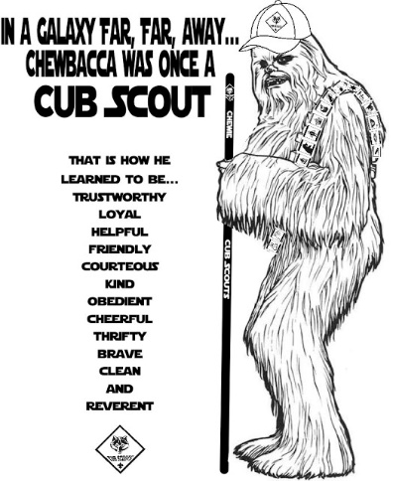

# LAST THINGS

## A LESSON IN SHARING & GIVING THANKS

*Alice, Golden Empire Council*

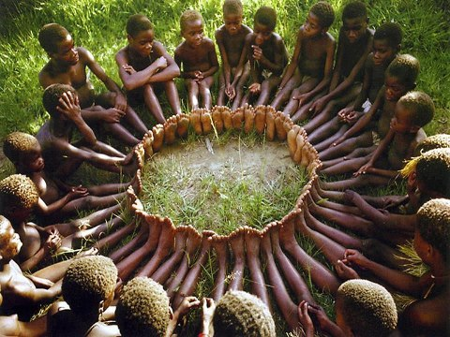

Here’s a great story and picture of children who really understand faith in their group and in each other – and who demonstrate giving thanks for what they have by sharing it willingly:

An anthropologist proposed a game to children in an African tribe - He put a basket full of fruit near a tree and told the kids that whoever got there first won the sweet fruits. When he told them to run they all took each other's hands and ran together, then sat together enjoying their treats.

When he asked them why they had run like that as one could have had all the fruits for himself they said: ''Ubuntu, how can one of us be happy if all the other ones are sad?'' 'Ubuntu' in the Xhosa culture means: "I am because we are"

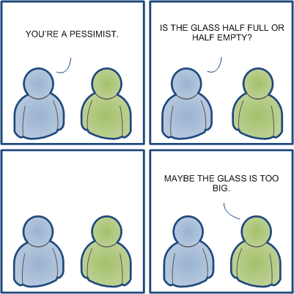

# Stress Management 101

*Wayne from Thrivent****Look at the cartoon above***

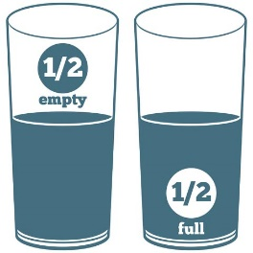A young lady confidently walked around the room while leading and explaining stress management to an audience; with a raised glass of water, and everyone knew she was going to ask the ultimate question, 'half empty or half full?'..... she fooled them all... "How heavy is this glass of water?", she inquired with a smile.

Answers called out ranged from 8 oz. to 20 oz.

She replied, "The absolute weight doesn't matter. It depends on how long I hold it. If I hold it for a minute, that's not a problem. If I hold it for an hour, I'll have an ache in my right arm. If I hold it for a day, you'll have to call an ambulance. In each case it's the same weight, but the longer I hold it, the heavier it becomes."

She continued, "and that's the way it is with stress. If we carry our burdens all the time, sooner or later, as the burden becomes increasingly heavy, we won't be able to carry on."

"As with the glass of water, we have to put it down for a while and rest before holding it again. When we're refreshed, we can carry on with the burden - holding stress longer and better each time practiced. So, as early in the evening as you can, put all your burdens down. Don't carry them through the evening and into the night... pick them up tomorrow.

Whatever burdens you're carrying now, let them down for a moment. Relax, pick them up later after you've rested. Life is short. Enjoy it and the now 'supposed' stress that you've conquered!"

**And here are more Stress Management Hints -**

* Accept the fact that some days you're the pigeon, and some days you're the statue!
* Always keep your words soft and sweet, just in case you have to eat them.
* Always read stuff that will make you look good if you die in the middle of it.
* Drive carefully... It's not only cars that can be recalled by their Maker.
* If you can't be kind, at least have the decency to be vague.
* If you lend someone $20 and never see that person again, it was probably worth it.
* It may be that your sole purpose in life is simply to serve as a warning to others.
* Never buy a car you can't push.
* Never put both feet in your mouth at the same time, because then you won't have a leg on which to stand.
* Nobody cares if you can't dance well. Just get up and dance.
* Since it's the early worm that gets eaten by the bird, sleep late.
* The second mouse gets the cheese.
* When everything's coming your way, you're in the wrong lane.
* Birthdays are good for you. The more you have, the longer you live.
* You may be only one person in the world, but you may also be the world to one person.
* Some mistakes are too much fun to make only once.
* We could learn a lot from crayons. Some are sharp, some are pretty and some are dull. Some have weird names and all are different colors, but they all have to live in the same box.
* A truly happy person is one who can enjoy the scenery on a detour.
* Have an awesome day and know that someone has thought about you today.
* It was me, your friend!