# TABLE OF CONTENTS

TABLE OF CONTENTS 1

CUB SCOUT ADVENTURE PLAN MODIFICATIONS 1

ADMIN HELPS 3

Outdoors With Kids 3

BE UP TO DATE 4

ROUNDTABLE HINTS 5

LIONS 6

WHAT’S NEW FOR LIONS FOR 2017-2018 6

BRYAN’S BLOG ON 2017-2018 LION PROGRAM 7

WHY SHARED LEADERSHIP? 7

LION ORIENTATION VIDEO 7

ORGANIZING FOR LIONS 7

HIGHLIGHTS 7

LION HUB 8

THE CHIEF SCOUT EXECUTIVE ON LIONS 8

MORE LION INFORMATION 9

CUB SCOUT LEARNING LIBRARY 10

The NEW https://cubscouts.org/ !!! 10

ADVENTURE PLAN TRACKERS 14

TRACKING BOYS’ PROGRESS 14

CUB SCOUT LEADER TRAINING 15

IN-PERSON TRAINING 15

ON-LINE TRAINING 15

# CUB SCOUT ADVENTURE PLAN MODIFICATIONS

Last year on November 30, 2016, the BSA announced modifications to Adventure requirements in response to feedback from Den Leader feedback. Dens started using the modified requirements as soon as they began their next Adventure.

There is a PDF of the changes at [www.scouting.org/programupdates](http://www.scouting.org/programupdates).

National Council has supplied book sized printouts of the PDF to Scout Shops to distribute for . So tell your parents to ask for the update when they pick up their son’s new book. It is the same as the PDF on line, but printed to fit in the Cub Scout Handbooks.

 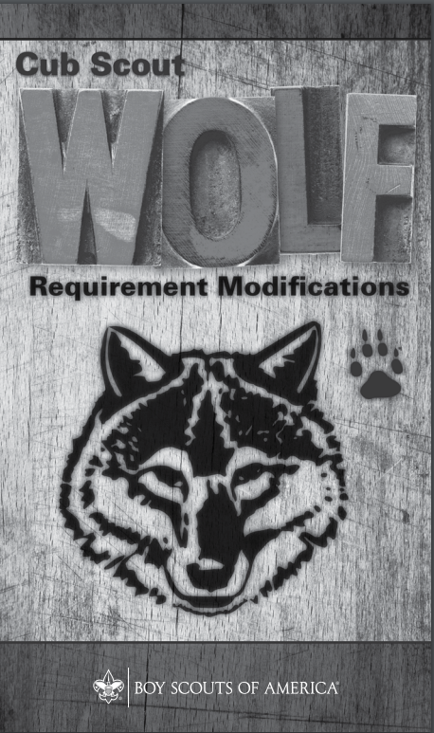 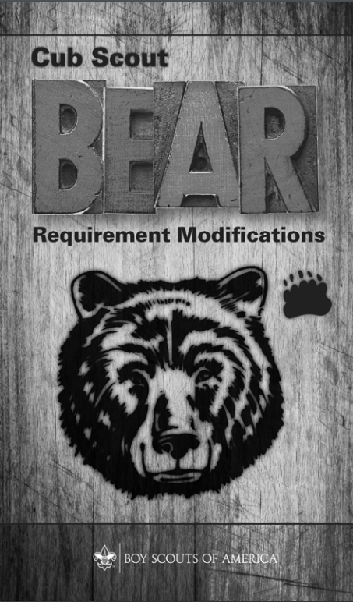 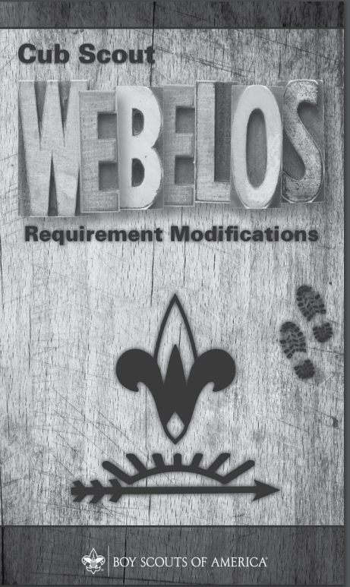BSA ROUNDTABLE COMMISSIONERS FACEBOOK PAGE

**Still looking for a 2017-2018 CS RT Planning Guide?** Need more help than Baloo’s Bugle has been able to provide lately?? (I admit, we have not been as reliable as the in the past. But we are trying.)

Join the over 3000 members of the “BSA Roundtable Commissioners” Open Group on Facebook.

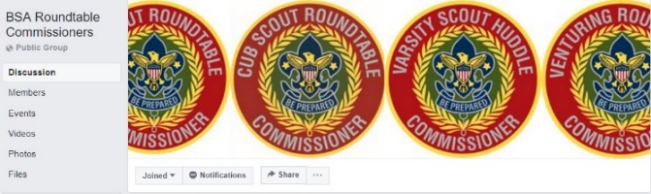

The site admins are my good friends from Philmont, Emily and George. And they do a terrific job.

Two things I found on the page while prepping Baloo’s Bugle –

**Emily is leading a Team prepping “Philmont CS Roundtable Supplements.”** A September Supplement has been posted. The link is on Facebook – not here. Go check the page out!!

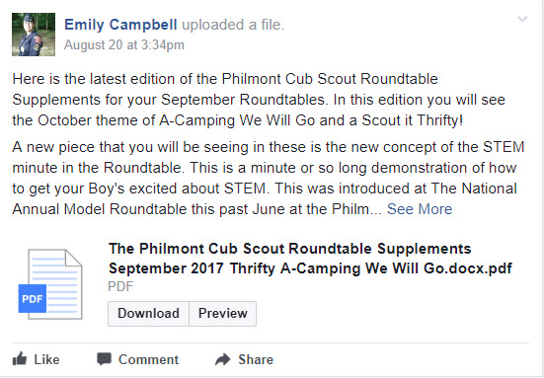

**There is a group working on RT Interest Topics –**

Scott, the National Commissioner Service Team member responsible for Roundtables, has posted “Interim Cub Scout Roundtable Guide Information.”

The attachment includes the following information for use with September and October 2017 Cub Scout Roundtables:

* An Explanation of the new presentation format developed by the National Cub Scout Committee.
* A List of the Draft Cub Scout Interest Topics for 2017-2018 developed by the National Cub Scout Committee.
* A List of the Approved Big Rock Topics for all Roundtables for 2017-2018.
* Two initial Draft Cub Scout Interest Topics for your use. These topics are the draft contents submitted to the publisher by the National Cub Scout Committee which is responsible for the program content of the Cub Scout Roundtable Guide. These topics include, (1) Leader Recruitment and (2) The New Member Coordinator.

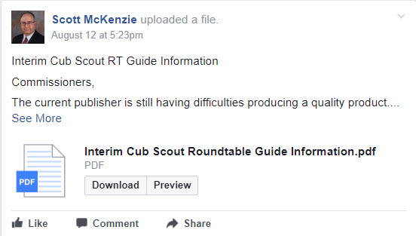

(Again, the link is on Facebook not here!)

To keep current on CS RT PG developments, other RT topics, perhaps pose a question (or several) about things you need to learn, and see what 3000 other RT Commissioners are asking – go the Facebook Page and sign up!! **BUT -**

Please do not add anyone but yourself to the group. **Tell** other Roundtable Commissioners and Assistant Roundtable Commissioners about the group and have them add themselves. The Admins frequently get 50 requests to join in the admin inbox **and the majority of them have not answered the questions.** If they don't answer the questions in 2 days, they are not approved and they have to repeat the process. I (CD) know the Admins and they are very thorough. They vet every person that wants to join the BSA RT Commissioners group to make sure that this continues to be a Roundtable focused group. Please help them by spreading the word with your voice...not by your clicks. And they do thank you for all that you do!

Check out the RT Support page on National’s site - <http://www.scouting.org/scoutsource/Commissioners/roundtable.aspx>

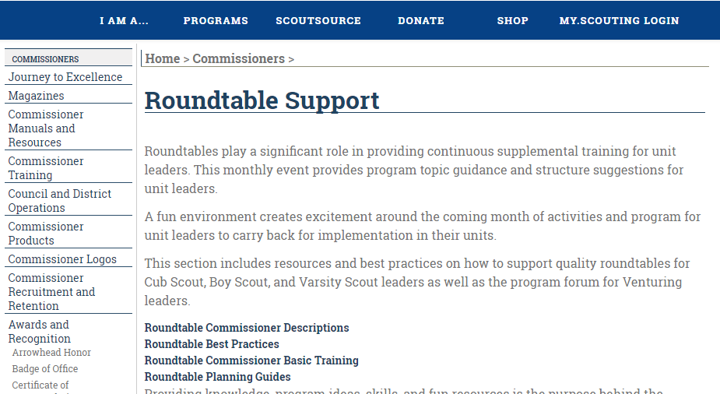

ADMIN HELPS

Outdoors With Kids  
**Ten Camping Commandments to   
Build Excitement Outdoors**

*Sent by Alice @ Golden Empire Council, Source -* <http://gorp.away.com/gorp/publishers/foghorn/camp_kid.htm>

***CDs Note - There are some great ideas here. However, this item was written for families going camping. Not for Packs going Family Camping as Cub Scouts. Some of the items listed are against BSA policy for Packs to do (e,g, shooting activities)***

How do you get a girl or boy excited about the outdoors? How do you compete with the television and remote control? How do you prove to a kid that success comes from persistence, spirit and logic, which the outdoors teaches, and not from pushing buttons?

The answer is in the Ten Camping Commandments for Kids. These are lessons that will get youngsters excited about the outdoors, and will make sure adults help the process along, not kill it. Some are obvious, some are not, but all are important:



1. **Trips with children should be to places where there is a guarantee of action.** A good example is camping in a park where large numbers of wildlife can be viewed, such as squirrels, chipmunks, deer and even bear. Other good choices are fishing at a small pond loaded with bluegill, or hunting in a spot where a kid can shoot a .22 at pine cones all day. Boys and girls want action, not solitude.
2. **Enthusiasm is contagious**. If you aren't excited about an adventure, you can't expect a child to be. Show a genuine zest for life in the outdoors, and point out everything as if it is the first time you have ever seen it.
3. **Always, always, always be seated when talking to someone small**. This allows the adult and child to be on the same level. That is why fishing in a small boat is perfect for adults and kids. Nothing is worse for youngsters than having a big person look down at them and give them orders. What fun is that?
4. **Always show how to do something,** whether it is gathering sticks for a campfire, cleaning a trout or tying a knot. Never tell— always show. A button usually clicks to "off" when a kid is lectured. But they can learn behavior patterns and outdoor skills by watching adults, even when the adults are not aware they are being watched.

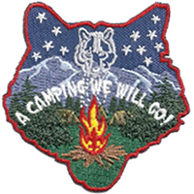

1. **Let kids be kids**. Let the adventure happen, rather than trying to force it within some preconceived plan. If they get sidetracked watching pollywogs, chasing butterflies or sneaking up on chipmunks, let them be. A youngster can have more fun turning over rocks and looking at different kinds of bugs then sitting in one spot, waiting for a fish to bite.
2. **Expect young peoples' attention spans to be short.** Instead of getting frustrated about it, use it to your advantage. How? By bringing along a bag of candy and snacks. Where there is a lull in the camp activity, out comes the bag. Don't let them know what goodies await, so each one becomes a surprise.
3. **Make absolutely certain the child's sleeping bag is clean, dry and warm.** Nothing is worse than discomfort when trying to sleep, but a refreshing sleep makes for a positive attitude the next day. In addition, kids can become quite scared of animals at night. The parent should not wait for any signs of this, but always play the part of the outdoor guardian, the one who will "take care of everything."
4. **Kids quickly relate to outdoor ethics.** They will enjoy eating everything they cook, building a safe campfire and picking up all their litter, and they will develop a sense of pride that goes with it. A good idea is to bring extra plastic garbage bags to pick up any trash you come across. Kids long remember when they do something right that somebody else has done wrong.
5. **If you want youngsters hooked on the outdoors for life, take a close-up photograph** of them holding up fish they have caught, blowing on the campfire or completing other camp tasks. Young children can forget how much fun they had, but they never forget if they have a picture of it
6. ***The least important word you can ever say to a kid is "I."*** Keep track of how often you are saying "Thank you" and "What do you think?" If you don't say them very often, you'll lose out. Finally, the most important words of all are: "I am proud of you."

**What are YOU going to do now?**

***The best gift for a Cub Scout.......  
 ......get his parents involved!***

***The greatest gift you can give your child   
 ..... good self respect!***

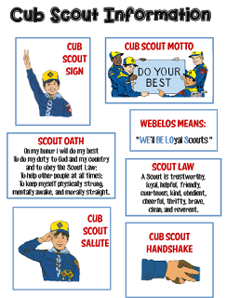

Go to <http://strongarmor.blogspot.com/2015/06/cub-scouts-scout-oath-and-law-helps-and.html> to get full size, full color (or black and white) printable versions



# BE UP TO DATE

[**www.scouting.org/programupdates**](http://www.scouting.org/programupdates)

The Program Updates page has been regrouped. Since the CS Adventure is in full swing, the emphasis on getting ready for it has been reduced. The downloads are still all there.

[**Philmont Training Center**](http://www.philmontscoutranch.org/ptc.aspx)

Get great information about the **Cub Scout Extravaganza** at [**Philmont Training Center**](http://www.philmontscoutranch.org/ptc.aspx) during the summer of 2017. It is being done TWICE, so ore people can have **FUN.**

There is a lot of information now on etting ready and implementing the changes to the Boy Scout program.

**Check it all out – stay current!!**





Same is true for Boy Scout Leaders!!

ROUNDTABLE HINTS



**Make Your Roundtable an EPIC Experience for Participants**

*Jeff McHoul, Assistant Council Commissioner – RTs  
Cradle of Liberty Council*

Last month, we looked at some methods of "Refocusing your Roundtable " to better serve the needs of the Cub Scout Leaders of your District, this month the focus is on some strategies to continue that process, and can help with your planning for your   
2016 - 2017 program year.

As we discussed before, the Cub Scout program has a built in attrition curve of Leaders, which means that each Roundtable may be "the first time" for any single participant of your District Roundtable, and you will only have one opportunity to make a positive first impression.

Leaders who attend Roundtable may all be at different points on the experience curve, but you will still need to be on your game with your program, and your Roundtable Commissioner staff will need to be working together as a high functioning team in order to make an impact.

One approach it to strive to make every Roundtable an ***EPIC*** experience:

* ***E - E***xceptional & ***E***xperiential
* ***P - P***ersonally & ***P***rogram Relevant
* ***I - I***nstructional & ***I***nspiring
* ***C - C***oncrete

***E***xceptional & ***E***xperiential   
You should strive to present an exceptional and experience based program

* know your program level material
* prepare your presentation in advance and rehearse
* make your Roundtable a ***"hands - on"*** event - have the Leaders who attend take part in the program by participating in demonstration ceremonies, try any games presented, and work on any project presented

***P***ersonally & ***P***rogram Relevant  
Make the presentation personally and program level relevant to the Leaders who attend -

* plan for level specific break-out programs that address the specific needs of Den Leaders as well as Cubmasters and Committee members
* provide program ideas that are simple, directly support the program at every level, and are easy to reproduce and use at every level

***I***nstructional & ***I***nspiring  
Structure your program so that it is an instructional experience, providing examples of the method of delivery, that motivates and inspires Leaders

* provide simple directions for games
* example scripts for ceremonies, songs, skits and cheers
* assemble and provide simple kits for each project that you present, and plan for sufficient quantities for all participants and any potential participants
* provide support and coaching to participants while working on projects and tasks to inspire them to take ideas back to their Dens and Packs

***C***oncrete  
Bring all of these components together at one place at one time, with a trained and motivated Roundtable team to deliver a concrete experience that provides Cub Scout Leaders with what they need to deliver a successful program at the Den and Pack level .

A Roundtable experience that is relevant to the level and responsibilities of the leaders who participate in your program; incorporating simple, easy to use hands-on instructions, and providing the inspiration to bring ideas back to their Packs and Dens; will provide an EPIC experience that will better serve the Cub Scout Leaders of your District; and ultimately build a stronger Cub Scout program.

**Remember -**

***EPIC ROUNDTABLES -***

***E - Exceptional & Experiential***Strive to present an **exceptional and experience** based program

***P - Personally & Program Relevant***Make the presentation **personally and program level relevant** to the Leaders who attend.

***I - Instructional & Inspiring***Structure your program so that it is an **instructional** experience, providing examples of the method of delivery, that motivates **and inspires** Leaders

***C - Concrete***Bring all of these components together at one place at one time, to deliver **a concrete experience** that provides Cub Scout Leaders with what they need to deliver a successful program at the Den and Pack level.

# LIONS



## WHAT’S NEW FOR LIONS FOR 2017-2018

There is a new PowerPoint available at <http://scoutingwire.org/lion/> with everthing you need to know about changes to the **still a Pilot** Lion Program.

Highlights include:

* Lots of new recruitment help, for example:   
  A new PDF brochure PDF is on-line.   
  A Recruiter patch is available!  
  And other recruitments hints and materials.
* **A Lion may wear either the Lion Cap and Tee shirt** *(Currently, $3 discount if you buy hat and Tee together!!)* **or,** if he and his parents desire, **the Blue Cub Scout Field Uniform.**
* **Attendance at Pack Meetings is acceptable.** Packs should find ways to actively involve the Lions in PM program, activities, skits, etc
* **Pinewood Derby is a Pack decision** – Lions may participate in Pinewood Derby (Use of wedge car is mentioned to minimize cutting) or hold a “Veggie Derby.”

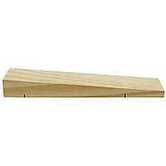

**Pre-Cut Pinewood Derby Wedge Kit, SKU# 614417**

The same top quality pine blocks that are used in the Official Pinewood Derby® Kit pre-shaped into a wedge with pre-cut axle grooves. Eliminates the need for woodworking tools or skills. All you need to do is add wheels, weights, sand and decorate for a car that is ready to race!

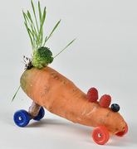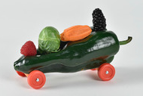

**Veggie Derby Cars**

* **Fundraising participation is the family’s decision.** Fundraising and mandatory levels are not required. Some parents do want to have the individual option to fundraise. If popcorn is sold by Lions then Show and Sell with older boys and parents would be the preference, door to door selling needs the parents at the Lions’ side.

## BRYAN’S BLOG ON 2017-2018 LION PROGRAM

[Lion pilot program for kindergarteners off to a roaring start, with exciting changes coming for 2017-2018](https://blog.scoutingmagazine.org/2017/08/14/bsas-lion-pilot-program-for-kindergarteners-is-off-to-a-roaring-start/" \o "Lion pilot program for kindergarteners off to a roaring start, with exciting changes coming for 2017-2018)

[August 14, 2017](https://blog.scoutingmagazine.org/2017/08/)

Based on feedback from parents, as well as surveys and focus groups, the BSA has some changes to announce to the Lion pilot program for this fall. The link is: <https://blog.scoutingmagazine.org/> Then search for LION ***(singular not plural)***

***Later in this item you will find links to all Bryan’s Blog entries (that I know) on the Lion Program.***

## WHY SHARED LEADERSHIP?

* Engages the families and helps create ownership of program by families.
* Creates a stronger loyalty and connection to the den, families, and Scouting.
* Provides an opportunity to watch potential leaders in action—as a unit or pack considers future leaders.
* Millennial parents want to try things out before committing. They prefer to commit to small roles first.
* **The boys love watching their “parents be the leader**!” (Ask them for their meeting in front of their son. Watch how he encourages them to do it! (Please, Please Mommy! (Daddy!) You can do it!) be sure to tell them, all you need to know is in the “Parent and Leader Guide.”

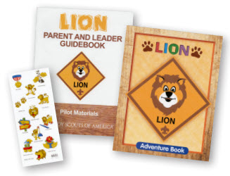

## LION ORIENTATION VIDEO

[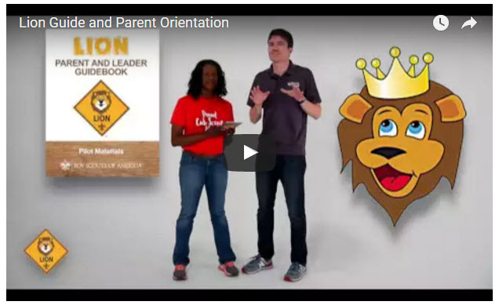](https://youtu.be/YaIBTUO70JA)

*Video URL -* [*https://youtu.be/YaIBTUO70JA*](https://youtu.be/YaIBTUO70JA)

## ORGANIZING FOR LIONS

*From – New Birth of Freedom Council*

For those packs that are thinking ahead about participating in the Lion Scouts program, having the right volunteers involved in delivering the Lion Scouts program will be important.  Research shows that the most important person for a successful Scouting experience is a good leader.  There are two new adult leader positions within the pack that are directly engaged in the delivery of the Lion Scouts program – a Lion Coordinator and a Lion Guide.  Where do these positions fit into the current pack structure? **What is the Lion Coordinator’s job description?**

* Is an experienced and successful den leader
* Understands den and pack operations within the overall structure of Cub Scouting
* Demonstrates excellent communication and organization skills (and will remain in at least monthly contact with the Lion dens)
* Participates as needed in the unit’s School Night with all new Lions and their parents
* Assists the Lion guide in hosting the first orientation meeting for all the individual Lion dens in their pack
* Serves as a coach and mentor for Lion Guide

## HIGHLIGHTS

* **61% of Lion parents indicate they have no other child in Scouting.** We are reaching Families new to Scouting as well as siblings of Scout familie.
* **91% of parents say their Lion will be moving to Tigers** and 82% of Lion Guides say most will stay.
* **Satisfaction is very high 90%.** For the T**-**shirt, shared leadership, age appropriate activities, youth Adventure book, immediate recognition stickers, meeting duration, frequency and content. The Leader Guidebook is not intimidating and is simple and easy for new parents to follow for effective meetings. **Adventures are engaging for the boys.**

## LION HUB

[](http://scoutingwire.org/lion/)

***Big Smiles - Build Bigger Futures***

BSA has launched a new Lion Hub at:  
<http://scoutingwire.org/lion/>

**Available Lion Resources include:**

[LION VEGGIE CAR DERBY FLYER](http://www.scouting.org/filestore/cubscouts/lion/Lion-Veggie-Car-Flyer-02.jpg)

[PARTICIPATING COUNCILS](http://www.scouting.org/filestore/cubscouts/lion/Participating_Councils.pdf)

[PROGRAM OVERVIEW](http://www.scouting.org/filestore/cubscouts/lion/Lion_Overview-2.docx)

[FAQS](http://www.scouting.org/filestore/cubscouts/lion/LION-FAQs-8-8-17.docx)   
*The FAQ PDF is 13 pages long!! Lots of information!!*

[LION GUIDE AND PARENT ORIENTATION VIDEO](javascript:void(0))

[LION GUIDE AND PARENT ORIENTATION POWERPOINT](http://www.scouting.org/filestore/cubscouts/lion/Lion-Guide-and-Parent-Orientation-8-23-2017.pptm)

[LION PRODUCTS NOW AVAILABLE!](http://www.scouting.org/filestore/cubscouts/lion/Lion-Merchandise.pdf)

[NEW LION PROGRAM MATERIALS](http://www.scouting.org/filestore/cubscouts/lion/Lion-Retail-Merch-Sheet.pdf)

[LION RECRUITMENT BROCHURE](http://www.scouting.org/filestore/cubscouts/lion/210-828C-Lion-Brochure-DIGITAL.pdf)

[LION RECRUITMENT BROCHURE, PRINT-READY WITH CROP MARKS](http://www.scouting.org/filestore/cubscouts/lion/210-828C-Lion-Brochure-PRINT.pdf)

[CONTACT US](http://www.scouting.org/filestore/cubscouts/lion/Lion_Contact_Us.pdf)

**For Councils**

[COUNCIL OVERVIEW POWERPOINT](http://www.scouting.org/filestore/cubscouts/lion/LionCouncil_Overview-(2)-8-8-2017.pptx)

[LION PROMOTIONAL MATERIALS (HELP SPREAD THE WORD!)](https://scouting.webdamdb.com/albums.php?albumId=1532537)

[LION PROMOTIONAL VIDEO](https://scouting.webdamdb.com/viewphoto.php?imageId=40278757)

[LION RECRUITMENT BROCHURE](http://www.scouting.org/filestore/cubscouts/lion/210-828C-Lion-Brochure-DIGITAL.pdf)

[LION RECRUITMENT BROCHURE, PRINT-READY WITH CROP MARKS](http://www.scouting.org/filestore/cubscouts/lion/210-828C-Lion-Brochure-PRINT.pdf)

[REGISTRATION PROCESSING](http://www.scouting.org/filestore/cubscouts/lion/Lion_Pilot_Registration_Processing.pdf)



Lion Parents say **developing character is the #1 reason** to join Scouting.



## THE CHIEF SCOUT EXECUTIVE ON LIONS

**What We Know** According to a 2014 [U.S. Census Bureau report](http://www.census.gov/newsroom/press-releases/2014/cb14-224.html), 57 percent of kids ages 6–17 participate in at least one after-school extracurricular activity. This means that by the time they are eligible for Tigers, more than half of them already are engaged in some type of athletic, artistic or other program.

Often, children become attached to lifelong activities at an early age — that is certainly a goal we would have, as we know the long-term benefits of Scouting involvement include strong asset development in the areas of character and leadership. However, we also know that when youth participate in numerous activities at an early age, and miss joining Scouting, they are unlikely to do so at adolescence.

What will be important to learn in the next few years, if the initial entry point works at the kindergarten-age level, is will this cause losses at a different age, or will the program keep the same retention all the way through to Boy Scouting?

What we learn from the pilot Lion format could also help us assess and create a smoother transition from Webelos into Boy Scouting. Too many parents now see a barrier or obstacle, rather than a smoother transition. You will often hear parents say, “We did Cub Scouting, now we’re not sure if we are going to do Boy Scouts.” We do not have a seamless transition into Boy Scouts for a number of reasons. This pilot test will help us think through some of these issues.

We want to be sure that our Lion program delivers the right mix of character and leadership values and that we set the bar high. The program must be sustainable, we must have the right infrastructure to support it, and it needs to meaningfully address the needs of parents who want their kids to join Scouting at an earlier age.

You can rest assured that we will carefully evaluate our progress and keep you apprised of the results. Stay tuned

*Reprinted from "The Chief's Corner" on* [*Scoutingwire.org*](http://www.scoutingwire.org/)

## MORE LION INFORMATION

**Bryan's Blog has written about Lions –**Go to <http://blog.scoutingmagazine.org> and you can look them up. Here are a few -

[*August 14, 2017*](https://blog.scoutingmagazine.org/2017/08/)

 [Lion pilot program for kindergarteners off to a roaring start, with exciting changes coming for 2017-2018](https://blog.scoutingmagazine.org/2017/08/14/bsas-lion-pilot-program-for-kindergarteners-is-off-to-a-roaring-start/) Based on feedback from parents, as well as surveys and focus groups, the BSA has some changes to announce to the Lion pilot program for this fall.

*September 27, 2016*

[](http://blog.scoutingmagazine.org/2016/09/27/lion-pilot-program-brings-scouting-to-kindergartners-in-nearly-200-councils/) [Lion pilot program brings Scouting to kindergartners in nearly 200 councils](http://blog.scoutingmagazine.org/2016/09/27/lion-pilot-program-brings-scouting-to-kindergartners-in-nearly-200-councils/) Answering the call of families who want a Scouting program for kindergarten-age boys, the BSA has expanded its Lion pilot program to nearly 200 councils. 

*April 28, 2016*

[](http://blog.scoutingmagazine.org/2016/04/28/lion-scout-imagery-including-hats-t-shirts/) [In full gear: Here’s your first look at Lion Scouts T-shirts and hats](http://blog.scoutingmagazine.org/2016/04/28/lion-scout-imagery-including-hats-t-shirts/) This week we get our first look at new T-shirts and caps to be worn by Lions — members of the pilot program for kindergarten boys set to roll out this fall. 

*April 15, 2016*

[](http://blog.scoutingmagazine.org/2016/04/15/will-lions-part-pack-answers-questions-youve-asking/) [Will Lions be part of the pack? (And answers to your other Lion questions)](http://blog.scoutingmagazine.org/2016/04/15/will-lions-part-pack-answers-questions-youve-asking/) Will Lions be part of the Cub Scout pack? By adding another year to the program, is the BSA concerned about "burnout"? And why was the Lions name chosen? 

*March 10, 2016*

[](http://blog.scoutingmagazine.org/2016/03/10/new-details-released-about-lions/) [New details released about Lions, the pilot program for kindergarten boys](http://blog.scoutingmagazine.org/2016/03/10/new-details-released-about-lions/) In Lions, the new pilot program for kindergartners, boys wear T-shirts instead of uniforms and earn adventure stickers instead of adventure loops. 



**There are slideshows on the web put up   
by local councils. Some examples are:**

**Be sure to vet these against the 2017-2018 changes!!**

WD Boyce Council has "Lion Cub Pilot Program" at: <http://www.wdboyce.org/document/lion-cub-pilot-program/161325>

Northern Star Council has a training slide show for District Coordinators and others at: <https://www.signup4.net/UPLOAD/NORT26A/LION12E/District%20Lion%20Cub%20Coordinator%20Training.pdf>

**Councils have put up webpages about what their packs need to know to begin a Lions Program. Examples are:**

WD Boyce:<http://www.wdboyce.org/cub-scouts/lion-cub-pilot-program/63360>

Garden State (My Council): <http://www.gardenstatescouting.org/lion-program-0>

Garden State, also, has an FAQ PDF - <http://www.gardenstatescouting.org/sites/default/files/Lion%20Program%20FAQ.pdf>

And we have created a Facebook page for our units with Lions - <https://www.facebook.com/GSCLion/>

**Selected FAQ's**

National has posted a PDF file of FAQs about the LION program at <http://www.scouting.org/filestore/pdf/Lion_FAQs.pdf>



**Cub Hub Blog Lion Posts**

The items listed below are from the [Cub Scout Learning Library](http://www.cubscouts.org) . Check it out frequently for new lion and other new Cub Scout items. You can go to [www.cubscouts.org](http://www.cubscouts.org) and click on the Cub Hub Blog.

[](https://cubscouts.org/a-look-at-the-lion-uniform-and-gear/) [A Look at the Lion Uniform and Gear](https://cubscouts.org/a-look-at-the-lion-uniform-and-gear/) Lion uniform, shirts and hats! In case you’ve missed the Lion uniform images floating around the Digital Pack…

[](https://cubscouts.org/will-lions-join-tigers-and-bears-oh-my-a-lions-faq/) [Will Lions Join Tigers and Bears? Oh My! — A Lions FAQ](https://cubscouts.org/will-lions-join-tigers-and-bears-oh-my-a-lions-faq/) Lions: Answers to your top questions. We have seen a lot of great feedback, comments and questions from…

[](https://cubscouts.org/q-and-a-for-new-lion-program/) [**5 Questions (and Answers) for the New Lion Program**](https://cubscouts.org/q-and-a-for-new-lion-program/)More Information on the New Lion Program As we mentioned earlier on the Cub Hub, Select councils will…

[](https://cubscouts.org/scoutings-lion-program-to-roll-out-in-select-councils/) [**Lion Program will bring Scouting to Kindergarten Boys**](https://cubscouts.org/scoutings-lion-program-to-roll-out-in-select-councils/)Something Roaring in the Jungle There is an exciting new Scouting program called “Lion” for Kindergarten-aged boys…

CUB SCOUT LEARNING LIBRARY

## The NEW <https://cubscouts.org/> !!!



Per my contacts at National Council *(some of which have since moved back to Council assignments or other departments)* , further development of the Cub Scout Learning Library (aka <https://cubscouts.org> ) is currently on hold as BSA assesses its digital strategy.

**BUT, obviously,   
the Cub Scout Blog is still active!!**

Once that assessment is done and plan for moving forward is developed, additional on-line support for CS leaders will be available, either at cubscouts.org or a new site depending on the results.

**The November 30, 2016, Adventure Plan changes will not be on this site until the assessment is done.**

**This is the Cub Scout Learning Library –**Everything you could want to know for Cub Scouts is or will be here. And all within a click or 3 of the home page. National heard the message that although things were at [www.scouting.org](http://www.scouting.org) they were often buried too deep to be found.

This site has admin stuff and practical stuff. The new Den Leader Resource Books are here. You can download some of the pages for **FREE**

This website is a great resource. There are still parts under construction but what is there is

**GREAT!!**



**Yes,**[**https://cubscouts.org**](https://cubscouts.org) **runs on a phone, too!!!**

**There are 3 tabs on top of the home page –**



* Learning Library
* Cub Hub Blog
* Join Scouting

**Plus – a magnifying Glass to start a search and Icons for various Social Media –**



1. [**Learning Library**](https://cubscouts.org/learning-library/)takes you where you can learn about your position and pick up hints. Besides specifics for dens of each rank, other clickable links include – **KEY:**

* All or most of material was placed on site this past month
* All or most of material was in place and listed as such in last month's Baloo's Bugle.
* Site / pages under construction

**Den Leader**

* **Den Meeting Basics**
* [Your First Den Meeting](https://cubscouts.org/library/your-first-den-meeting/)
* [Planning Den Outings](https://cubscouts.org/library/den-outings/)
* [The Parts of a Den Meeting](https://cubscouts.org/library/parts-of-a-den-meeting/)
* [**Getting Started**](https://cubscouts.org/library/welcome-to-wolf-cub-scouting/)

Three Core Adventures for the selected rank are listed here. You see & can download the Leader's Guide info for these 3 Adventures.

* [**Additional Required Adventures**](https://cubscouts.org/library/call-of-the-wild/)

The remaining Core Adventures for the selected rank are listed here. When you click them you get an intro to the Adventure but do not get the Meeting Plans and Resources. You see this note:

MeetingPlansTo get you started in delivering fun and engaging meetings, complete Den Meeting Plans are available here on the Learning Library for the Backyard Jungle and Games Tigers Play adventures. To obtain Den Meeting Plans for all other adventures, Den Leader Guides are available at your local Scout Shop, online at [**scoutstuff.org**](http://www.scoutstuff.org/), or as an eBook through [**Amazon**](http://www.amazon.com/s/ref=nb_sb_noss_2?url=node%3D154606011&field-keywords=den+leader+guides).

* [**Elective Adventures**](https://cubscouts.org/library/adventures-in-coins/)

All the Elective Adventures for the selected rank are listed here. When you click them you get an intro to the Adventure but do not get the Meeting Plans and Resources. You see the same note (above).

* **Building Strong Dens**

**The Basics of Cub Scouts**

* [Advancement](https://cubscouts.org/library/advancement/)
* [BSA Mission and Vision Statements](https://cubscouts.org/library/bsa-mission-and-vision-statements/)
* [Cub Scout Ages and Ranks](https://cubscouts.org/library/cub-scout-ages-and-ranks/)
* [Cub Scout Uniforming](http://cubscouts.org/library/cub-scout-uniforming/)
* [Den Flags](https://cubscouts.org/library/den-flags/)
* [Den Yells](https://cubscouts.org/library/den-yells/)
* [Leader Survival Kit](https://cubscouts.org/library/leader-survival-kit/)
* [Methods of Cub Scouting](https://cubscouts.org/library/methods-of-cub-scouting/)
* [Purpose of Cub Scouting](https://cubscouts.org/library/purpose-of-cub-scouting/)
* [Roles and Responsibilities](https://cubscouts.org/library/roles-and-responsibilities/)
* [Scout Oath and Law](https://cubscouts.org/library/scout-oath-and-law/)
* [What Is Cub Scouting?](https://cubscouts.org/library/what-is-cub-scouting/)
* **Training**
* [The Role of Training](https://cubscouts.org/?post_type=library&p=3419)
* [Youth Protection](https://cubscouts.org/library/youth-protection/)
* **Den Planning And Administration**
* [Advancement Basics](https://cubscouts.org/library/advancement-basics/)
* [Advancement Requirements](https://cubscouts.org/library/advancement-requirements/)
* [Annual Planning For Your Den](https://cubscouts.org/library/annual-planning-for-your-den/)
* [Coordinating Your Den Plan with Pack](https://cubscouts.org/library/coordinating-your-den-plan-with-the-pack/)
* [Tracking and Recognizing Advancement](https://cubscouts.org/library/tracking-and-recognizing-advancement/)
* [Youth Protection Training](http://www.scouting.org/Training/youthprotection.aspx)
* **Positive Youth Development and Working with Boys**
* [Developmental Differences Boys 7-11](https://cubscouts.org/library/developmental-differences-in-boys-7-11/)
* [Behavior and Discipline](https://cubscouts.org/library/behavior-and-discipline/)
* [Positive Youth Development](https://cubscouts.org/library/positive-youth-development/)
* **Working With Special Needs Cub Scouts** *(Advice is specific to each Special Need. Lots of research was done to prep these pages.)*
* [Parents’ Prejoining Conference](https://cubscouts.org/library/parents-prejoining-conference/)
* [Leadership Techniques](https://cubscouts.org/library/leadership-techniques/)
* [Working With Specific Disabilities and Needs](https://cubscouts.org/library/working-with-specific-disabilities-and-needs/)
* **The other positions are still under development:**
* **Cubmaster**
* **Committee Chair/Member**
* **Chartered Org Rep**
* **Parent / Adult Partner**



1. **Cub Hub Blog** takes you to a Cub Scout specific Blog similar to Bryan's Blog. The most recent topics discussed are listed here. There are more at [www.cubscouts.org](http://www.cubscouts.org):

***Here are the posts from August, July, and June (In reverse chronological order).***

August 28, 2017

[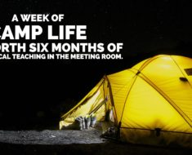](https://cubscouts.org/this-makes-first-time-camping-not-so-scary/) [First Time Camping Guide: Beginner Camping for the Whole Family](https://cubscouts.org/this-makes-first-time-camping-not-so-scary/) Let’s get real – you don’t have to be a “camping person” to camp! I certainly wasn’t,…

August 22, 2017

[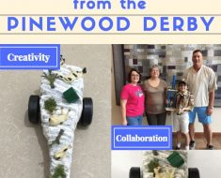This Mom Wasn’t Sure About Her Son’s Pinewood Derby Car Design But Then…](https://cubscouts.org/lessons-moms-pinewood-derby-car/)When Sherry’s son had an ambitious idea for the design of his Pinewood Derby car, she wasn’t enthusiastic about…

August 11, 2017

[These Cub Scouts Talked with an Astronaut in Space (Here’s How Your Pack Can Too!)](https://cubscouts.org/cub-scouts-talk-with-astonauts/) I hope and I wish for all of you that you never stop learning. –  Expedition 52…

August 10, 2017

[How to View the Eclipse Everyone’s Talking About](https://cubscouts.org/how-to-view-the-eclipse-everyones-talking-about/) The countdown to August 21’s total solar eclipse is on. And while we can’t take credit for…

August 8, 2017

[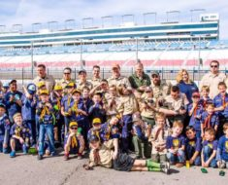What Do You Do in Cub Scouts? Answers From a Real Scout Mom](https://cubscouts.org/what-do-you-do-in-cub-scouts-answers-from-a-real-scout-mom/) When I decided to put my son in Scouting, like many parents,  I was looking for a…

August 4, 2017

[You Need to Know These Three Things When You Start Cub Scouts This Fall](https://cubscouts.org/you-need-to-know-these-three-things-when-you-start-cub-scouts-this-fall/) We’ve got a few insider tips for Cub Scout parents, along with the moms and dads considering…

August 2, 2017

[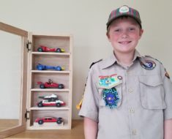This Scout Dad’s Use for Old Pinewood Derby Cars Will Make You Want to Get Crafty](https://cubscouts.org/this-scout-dads-use-for-old-pinewood-derby-cars-will-make-you-want-to-get-crafty/) Love the Scouting memories but need a new use for those fewer-than-five-ounces blocks on wheels? Neil Fern,…

August 2, 2017

[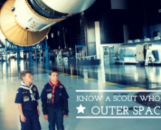Know a Cub Scout Who Loves Outer Space and Astronomy?](https://cubscouts.org/know-cub-scout-loves-outer-space-astronomy/) Is there a Cub Scout in your pack who is counting down the days until the Aug.…

July 14, 2017

[Cub Scout Saves His Brother After He Falls Off Bridge](https://cubscouts.org/cub-scout-saves-brother-falls-bridge/) The next time you picture a hero, remember this story of a Cub Scout who stayed calm…

July 12, 2017

[This is Why Cub Scouts Meet With Their Packs and Dens Each Week](https://cubscouts.org/this-is-why-cub-scouts-meet-with-their-packs-and-dens-each-week/) Cub Scouts don’t just grow as individuals during their years experiencing the Boy Scouts of America’s adventures. They…

July 3, 2017

[](https://cubscouts.org/4-times-cub-scouts-exemplified-duty-to-country/) [4 Times Scouts Showed “Duty to Country” Starts When You’re Young](https://cubscouts.org/4-times-cub-scouts-exemplified-duty-to-country/) Duty to country guides all Scouts to honor the people who serve the land of the free.…

June 30, 2017

[What is Cub Scout Day Camp?](https://cubscouts.org/what-is-cub-scout-day-camp/) Ah, summer camp season. It’s the time when parents shuttle kids from camp to camp to fill their…

June 30, 2017

[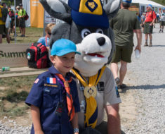This is How a Cub Scout Can Attend Jamboree](https://cubscouts.org/think-jamborees-not-for-cub-scouts-think-again/) Never heard of Jamboree? Or maybe you know all about it, but your kids are still in…

June 22, 2017

[What is a Blue and Gold Banquet?](https://cubscouts.org/what-is-a-blue-and-gold-banquet/) If you’ve heard stories of aptly colorful Cub Scout banquets and never really understood what all the…

**Join Scouting** takes you to

[www.beascout.org](http://www.beascout.org)



This picture on <https://beascout.scouting.org/> home page. Check it out!!

**Also, on the home page –**

[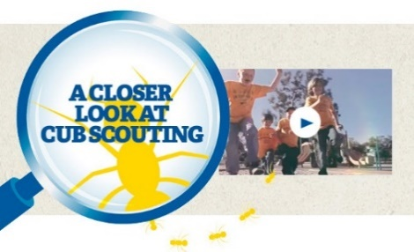](https://www.youtube.com/watch?feature=player_embedded&v=dqKFgk8SJlE)

Click for a YouTube Video on Cub Scouting.  
<https://www.youtube.com/watch?feature=player_embedded&v=dqKFgk8SJlE>

**And 6 picture links -**

**[](http://www.cubscouts.org)**

**These Six Links take you to:**

[**www.scoutstuff.org**](http://www.scoutstuff.org) –The Supply Division site where you can locate your nearest National Scout Shop or other local seller of Scout Stuff or buy your Scouting supplies on-line.

[**http://scoutingwire.org/**](http://scoutingwire.org/) - Where you can get the latest Scouting News from around the country. You can sign up to get notifications when things are posted here...

[**https://cubscouts.org/pinewood-derby-2016-photo-contest**](https://cubscouts.org/pinewood-derby-2016-photo-contest)Apparently they are not going to run this event for 2017 as you get taken to a page that says promotion has ended. Pictures of entries that were received have been removed.

[**https://www.scoutbook.com/**](https://www.scoutbook.com/)Where you can get the Scoutbook APP to track your son's Scouting Experience from Tiger to Eagle Scout.

[**www.boyslife.org**](http://www.boyslife.org)**–** Go directly to the on-line edition of Boys 'Life

[**http://scoutingwire.org/marketing-membership/**](http://scoutingwire.org/marketing-membership/) Get resources and materials to strengthen your unit at BSA's marketing and membership site. Learn the best practices and tips employed by the most successful units.

# ADVENTURE PLAN TRACKERS

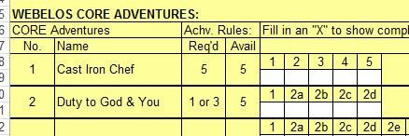

* Tracking Spreadsheets are posted on the USScouts Advancement webpage (<http://usscouts.org/advance/cubscout/intro.asp>). The spreadsheets were tested by a software developer who said they are so good he sees no reason to develop his own!!
* Utah National Parks Council, also, has Excel spreadsheets posted for all the new Adventure Plan requirements on their Akela's Council BlogSpot.   
  <http://akelascouncil.blogspot.com/search/label/Tracking%20Sheet> (The page starts with Arrow of Light scroll down for other ranks)

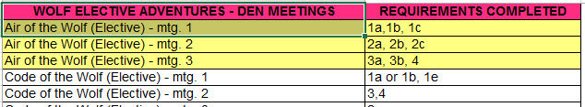

* A spreadsheet that correlates Meetings to Adventure requirements is available on the Utah National Parks' Akela's Council Blogspot at <https://www.dropbox.com/s/yb8fweg7etnhqrt/WOLF%20BEAR%20WEBELOS%20REQUIREMENTS%20-%20MTGS.xlsx?dl=0> . It has all the Wolf, Bear, Webelos and AOL Adventure requirements.

These Advancement Spreadsheet workbooks are **FREE** for Scouters**.** But be **COURTEOUS** and observe the following -

**PLEASE do not download the files from either site to email or send them digitally to others.**They are for your personal / pack use only. If you would like to share these files with others, please copy / send the link to them and send them to the site so they can print off their own. They would love everyone that wants a copy to get their own copy absolutely free. Both USScouts and Utah National Parks receive Ad money based on the number of people visiting the site. That ad money helps keep their websites open. Please help them (us) by encouraging others to visit to obtain files.

# TRACKING BOYS’ PROGRESS

**IN THE MODIFIED CUB SCOUT ADVENTURE PLAN**

Judy and I have found several places on the web where there are aids to use to track boys’ progress in the modified Adventure Plan. Judy is placing a more detail in Baloo’s Bugle, Part IV – Den Meeting Helps.

* **The Bobwhite Bather blog site** (<https://bobwhiteblather.com/mid-year-cub-scout-program-updates/> ) has a discussion of changes.
* **Cubmaster Tom,** responded providing links to documents he formatted to paste into the boys’ books for each modified Adventure. See example below:

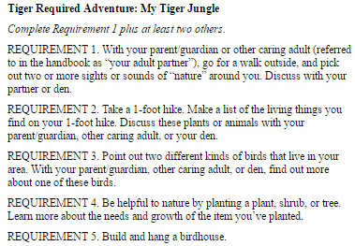

The complete Tiger document is at: <https://docs.google.com/document/d/1ka_AkwxDkKgNjLrAOUHzbQQqCkruDCC8RyxtMFvrFO8/edit?usp=sharing>. The links for the other ranks are in the comment on Bobwhite Blather.

* **Bert Bender, Atlanta Area Council, replied,**  
  Having finished several deep dives through the requirements changes, I’ve updated the page at <http://www.southfultonscouting.com/node/3557> to not only show exactly what got changed and what didn’t change, but now also add comments intended to be a practical guide to whether you need to look at the new 11/30/16 language, and whether when those might be a useful alternative.

Comments after some Adventures encourage (sometimes plead) that dens avoid the “easy button” approach. Doing the June 1, 2015 handbook elements will often result in better outcomes and experience in Cub Scouting.

* **Utah National Parks Council’s Akelas Council Blogspot** has revised paper tracking sheets (<http://akelascouncil.blogspot.com/>) Thanks to Celeste Hunt for creating these.

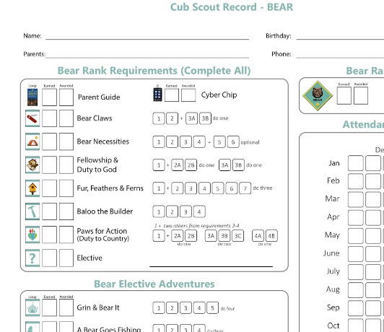

Celeste says, “Tracking, planning, and recognition are so important in Cub Scouts. This new tracking sheet helps you to be able to keep track of where each boy is at towards the Bear, Adventures, and Cyber Chip requirements. I print 2 copies of the tracker on cardstock for each boy. One for his book and one for my leader binder. I place it next to the trackers for the religious and other awards we are doing. I have tab for every boy with all his trackers. Complete information on each boy in one place. Not every boy is there every week. By doing this, I always know what each boy has done. If the parents ever have questions, I have a place to check, and I can always copy each tracking sheet to show them where their boy is.



# CUB SCOUT LEADER TRAINING

## IN-PERSON TRAINING

Position-Specific In-Person Training Guides Available Now! The training guides for

* [Den Leader](http://www.scouting.org/filestore/training/pdf/515-215.pdf) (<http://www.scouting.org/filestore/training/pdf/515-215.pdf> ),
* [Cubmaster/Assistant Cubmaster](http://www.scouting.org/filestore/training/pdf/511-503_WB.pdf) (<http://www.scouting.org/filestore/training/pdf/511-503_WB.pdf> ), and
* [Pack Committee](http://www.scouting.org/filestore/training/pdf/511-504_WB.pdf)  (<http://www.scouting.org/filestore/training/pdf/511-504_WB.pdf> )

Are available on Scouting University. You can access them at <http://www.scouting.org/training/adult.aspx> .



## ON-LINE TRAINING

On-Line Training for all Cub Scout positions has been available since October 25, 2015

The online training for Den Leaders, Cubmasters, Committee Chairs and members, and Chartered Organization Representatives is totally updated with help from volunteers from around the country. The new training is divided into shorter, more targeted modules so leaders can get the training they need, in the order they want, any time they need it. It is organized around the learning needed prior to the first meeting, in the first 30 days, and to be position-specific trained. This training was developed to be implemented in conjunction with the BSA’s new learning management system. Keep an eye on   
my. Scouting Tools (log in at <https://My.Scouting.org>) for more information.

Go to the BSA Volunteer Training Team Facebook page (Link above) andhttp://zamnar.com/data/uploads/17/317782-facebook-like.jpg.   
Then you **automatically** receive the latest news!!

If you are having difficulties with   
the training or system call   
BSA Member Care at 972-580-2489

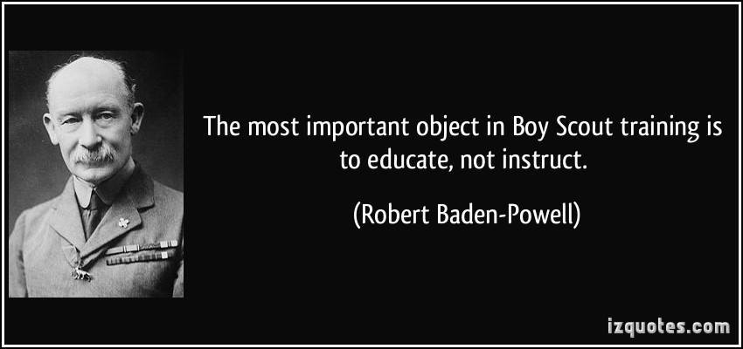

**A Typical Learning Plan has several parts –**

There is no need to complete more than one section at a time. Do what you have time to do.

Here you can see the three parts of the CM Course -

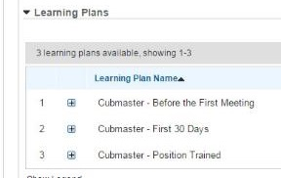

Each of these three parts is broken down into "bite sized" chunks:

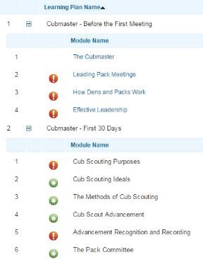

**Go check it out and get your   
people trained!!!**