LIONS
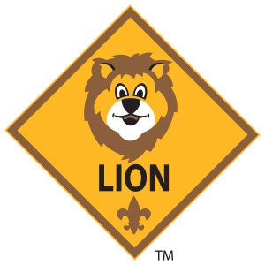

LION GUIDE AND PARENT ORIENTATION VIDEO
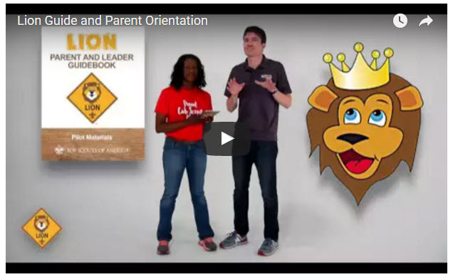
Video URL - https://youtu.be/YaIBTUO70JA

ORGANIZING FOR LIONS
From – New Birth of Freedom Council
For those packs that are thinking ahead about participating in the Lion Scouts program, having the right volunteers involved in delivering the Lion Scouts program will be important. Research shows that the most important person for a successful Scouting experience is a good leader. There are two new adult leader positions within the pack that are directly engaged in the delivery of the Lion Scouts program – a Lion Coordinator and a Lion Guide. Where do these positions fit into the current pack structure? What is the Lion Coordinator’s job description?
- Is an experienced and successful den leader
- Understands den and pack operations within the overall structure of Cub Scouting
- Demonstrates excellent communication and organization skills (and will remain in at least monthly contact with the Lion dens)
- Participates as needed in the unit’s School Night with all new Lions and their parents
- Assists the Lion guide in hosting the first orientation meeting for all the individual Lion dens in their pack
- Serves as a coach and mentor for Lion Guide

NEW LION HUB
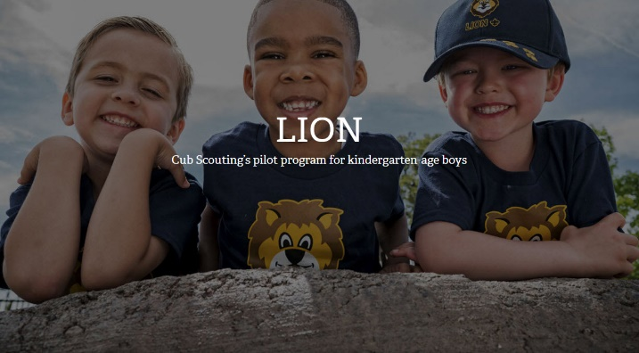
Big Smiles
Build Bigger Futures
BSA has launched a new Lion Hub at:
http://scoutingwire.org/lion/

Available Lion Resources include:
PARTICIPATING COUNCILS
PROGRAM OVERVIEW
FAQS
The FAQ PDF is 13 pages long!!
Lots of great information!!
LION GUIDE AND PARENT ORIENTATION VIDEO
LION GUIDE AND PARENT ORIENTATION POWERPOINT
CONTACT US
LION PROMOTIONAL MATERIALS
(HELP SPREAD THE WORD!)
LION PROMOTIONAL VIDEO
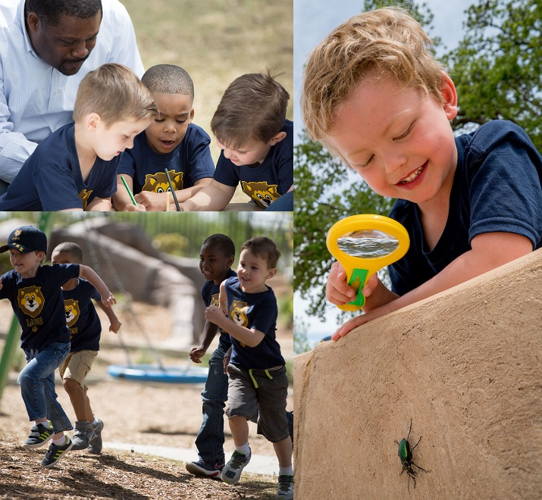

THE CHIEF SCOUT EXECUTIVE ON LIONS
What We Know According to a 2014 U.S. Census Bureau report, 57 percent of kids ages 6–17 participate in at least one after-school extracurricular activity. This means that by the time they are eligible for Tigers, more than half of them already are engaged in some type of athletic, artistic or other program.
Often, children become attached to lifelong activities at an early age — that is certainly a goal we would have, as we know the long-term benefits of Scouting involvement include strong asset development in the areas of character and leadership. However, we also know that when youth participate in numerous activities at an early age, and miss joining Scouting, they are unlikely to do so at adolescence.
What will be important to learn in the next few years, if the initial entry point works at the kindergarten-age level, is will this cause losses at a different age, or will the program keep the same retention all the way through to Boy Scouting?
What we learn from the pilot Lion format could also help us assess and create a smoother transition from Webelos into Boy Scouting. Too many parents now see a barrier or obstacle, rather than a smoother transition. You will often hear parents say, “We did Cub Scouting, now we’re not sure if we are going to do Boy Scouts.” We do not have a seamless transition into Boy Scouts for a number of reasons. This pilot test will help us think through some of these issues.
We want to be sure that our Lion program delivers the right mix of character and leadership values and that we set the bar high. The program must be sustainable, we must have the right infrastructure to support it, and it needs to address in a meaningful way the needs of parents who want their kids to join Scouting at an earlier age.
You can rest assured that we will carefully evaluate our progress and keep you apprised of the results. Stay tuned for more.
Reprinted from "The Chief's Corner" on Scoutingwire.org

MORE LION INFORMATION
Bryan's Blog has written about Lions –
Go to http://blog.scoutingmagazine.org/2016/ and you can look them up. Here are a few -
Lion pilot program brings Scouting to kindergartners in nearly 200 councils
September 27, 2016
Answering the call of families who want a Scouting program for kindergarten-age boys, the BSA has expanded its Lion pilot program to nearly 200 councils.
In full gear: Here’s your first look at Lion Scouts T-shirts and hats
April 28, 2016
This week we get our first look at new T-shirts and caps to be worn by Lions — members of the pilot program for kindergarten boys set to roll out this fall.
Will Lions be part of the pack? (And answers to your other Lion questions)
April 15, 2016
Will Lions be part of the Cub Scout pack? By adding another year to the program, is the BSA concerned about "burnout"? And why was the Lions name chosen?
New details released about Lions, the pilot program for kindergarten boys
March 10, 2016
In Lions, the new pilot program for kindergartners, boys wear T-shirts instead of uniforms and earn adventure stickers instead of adventure loops.

There are slideshows on the web put up
by local councils. Some examples are:
WD Boyce Council has "Lion Cub Pilot Program" at: http://www.wdboyce.org/document/lion-cub-pilot-program/161325
Northern Star Council has a training slide show for District Coordinators and others at: https://www.signup4.net/UPLOAD/NORT26A/LION12E/District%20Lion%20Cub%20Coordinator%20Training.pdf
Councils have put up webpages about what their packs need to know to begin a Lions Program. Examples are:
New Birth of Freedom: http://seb.newbirthoffreedom.org/2016/03/22/were-approved-for-the-lion-scouts-pilot/
WD Boyce:http://www.wdboyce.org/cub-scouts/lion-cub-pilot-program/63360
Garden State (My Council): http://www.gardenstatescouting.org/lion-program-0
Garden State, also, has an FAQ PDF - http://www.gardenstatescouting.org/sites/default/files/Lion%20Program%20FAQ.pdf
And we have created a Facebook page for our units with Lions - https://www.facebook.com/GSCLion/
Selected FAQ's
National has posted a PDF file of FAQs about the LION program at http://www.scouting.org/filestore/pdf/Lion_FAQs.pdf

Cub Hub Blog Lion Posts
The items listed below are from the Cub Scout Learning Library . Check it out frequently for new lion and other new Cub Scout items. You can go to www.cubscouts.org and click on the Cub Hub Blog.

A Look at the Lion Uniform and Gear Lion uniform, shirts and hats! In case you’ve missed the Lion uniform images floating around the Digital Pack…
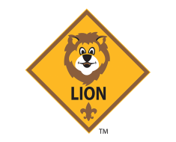 Will Lions Join Tigers and Bears? Oh My! — A Lions FAQ Lions: Answers to your top questions. We have seen a lot of great feedback, comments and questions from…
5 Questions (and Answers) for the New Lion ProgramMore Information on the New Lion Program As we mentioned earlier on the Cub Hub, Select councils will…
Lion Program will bring Scouting to Kindergarten BoysSomething Roaring in the Jungle There is an exciting new Scouting program called “Lion” for Kindergarten-aged boys…

