Arbor Day/Earth Day Ideas

Plan a special service project for Earth Day –
Check for local opportunities on community web sites or at your local library. You can also find great activity ideas at www.earthday.org or at www.apples4theteacher.com

Invite a garden expert to help pack families get started on a simple garden – if you don’t have a resource in your pack family, check with the local Extension Service for a Master Gardener. Nothing teaches Faith better than planting and nourishing a seed – and you will be helping your pack families to eat better and save money!

Plant a tree or trees, to celebrate Arbor Day – The date varies from state to state, based on optimum planting time, but many have chosen a date in April. Check the list in Value Related Ideas.
Trees are available from several sources. In Sacramento and many other places, a local Tree Foundation will provide trees and planting tips. Also Disney has a program to provide trees to plant for Earth Day, and check out the Family Activity Program with all kinds of great ideas – they can also be used with your den! Go to: www.arborday.org/explore/families

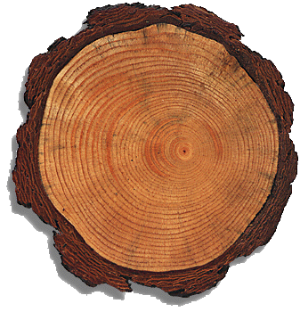
Have some fun with tree “cookies” – Cut slices from small tree branches – these cross-sections are great to explore the history of a tree. Discuss tree rings in general, then give each boy or person their own “cookie” to explore. Challenge them to find: a time when the tree was stressed; several years when sun, water and nutrients were just right, an example of some damage from fire, insects or other factor. Note: You can connect the changes in the tree rings with ways in which a boy’s faith is strengthened or tested, such as temptations, falling out with friends, or when faith is nourished by religious teachers or family service projects.
Play Hug A Tree Game – Learn to recognize “your” tree - In an area with many trees, boys take turns being blindfolded, led to a tree (for touch and feel) and then lead away. After removing the blindfold, the tree hugger tries to locate his tree. Talk about the differences in trees, and how those differences affect where they grow, how much water, sun, etc. they need, how animals and people (and even other plants) make use of different trees.

