Wolf Elective Adventure: Code of the Wolf
- Do one of the following:
  - With the members of your den or family, make a game with simple materials that requires math to keep score.
  - Play a game of “Go Fish for 10s.”
  - Do five activities at home, at school, or in your den that use mathematics, and then explain to your den how you used everyday math.
  - Make a rekenrek with two rows, and show Akela how you would represent the numbers 4, 6, 9, and 14.
  - Make a rain gauge or some other measuring device, and use it.
- Do one of the following:
  - With other members of your den or family, identify three different types of shapes that you see in nature.
  - With other members of your den or family, identify two shapes you can see in the construction of bridges.
  - Select a single shape or figure. Observe the world around you for at least a week, and write down where you see this shape or figure and how it is used.
- Do one of the following:
  - With your den, find something that comes with many small, colored items in one package. Count the number of items of each color in your package. Keep track of each color. Then:
    - Draw a graph showing the number of items of each color.
    - Determine what the most common color is.
    - Compare your results to the other boys'.
    - Predict how many items of each color you will find in one more package.
    - Decide if your prediction was close.
  - With your den or family, measure the height of everyone in the group and see who takes more steps to walk 100 feet.
  - Have each member in your den shoot a basketball. Count the number of shots it takes to make five baskets. Graph the number of shots it takes for each boy using 5, 6–10, 11–15, 16–20, or more than 20.
- Do one of the following:
  - Use a secret code using numbers to send a message to one of your den members or your den leader. Have that person send a message back to you. Be sure you both use the same code numbers.
  - Send a message to another member of your den or your den leader using the pig pen code or another code that changes letters into special shapes.
  - Practice using a code stick to create and decode a message.
Workbook for use with these requirements: PDF Format DOCX Format

Block Cipher
https://sites.google.com/site/codesforscouts/block-cipher

We write the message in a rectangular block, one row at a t time, and then read off the columns.

Example:

To encode the message THIS IS VERY EASY!, write it in a block like this:

THISI
SVERY
EASY!
The coded message is read by looking at the columns, and writing them out like this: TSE HVA IES SRY IY!

To decode it, just write all the code words in a block again, as columns, and then read the message across the rows.

Here's a code for you to solve:

LKU OHR OIT KGH WHE IER DRA ELF ROI LOE OKL OFD

5 SECRET CODES FOR KIDS TO WRITE A CODED LETTER
July 30, 2013 by Rebecca
http://kidsactivitiesblog.com/27282/secret-codes-to-write-a-coded-letter#_a5y_p=825806

1. Reverse the Words
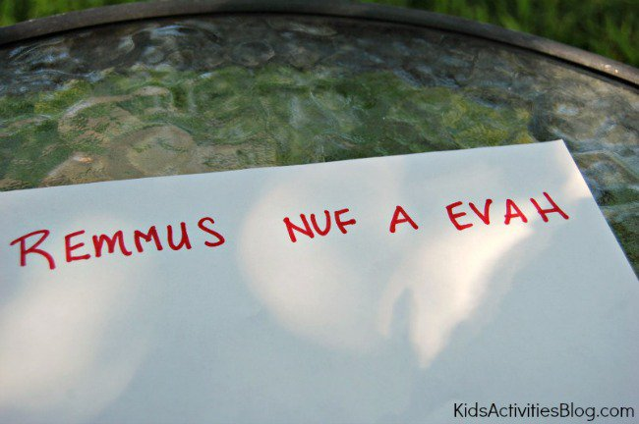
This is a simple code to solve – just read the words backwards! Even though it seems simple once you know the secret, it can be a hard one to figure out when you don’t.
2. Half-Reversed Alphabet
Write out the letters from A to M then write the letters from N to Z directly below them.
3. Block Cipher
Write the message in a rectangular block, one row at a time (we used 5 letters in each row). Then writes down the letters as they appear in the columns.
4. Read Every Second Letter
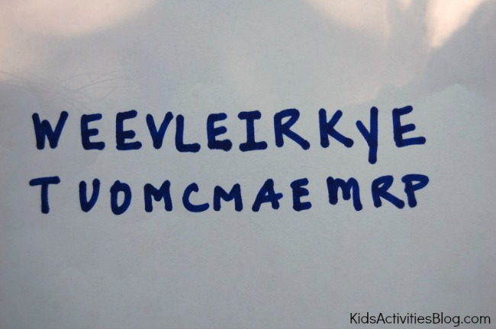
Read every second letter starting at the first letter, and when you finish, start again on the letters you missed.
5. PigPen
The PigPen code is easier than it looks and is my children’s favorite. First, draw out the two grids below and fill in the letters:
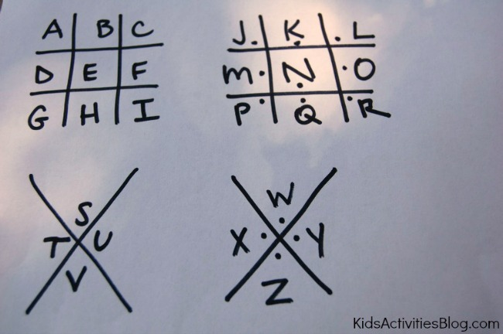
Each letter is represented by the lines around it (or pigpen).
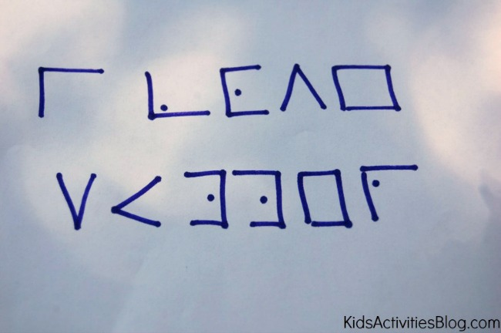

WRITE A CODED LETTER
We practiced writing our names and silly words before moving to coding whole sentences.
The letters and messages you can write can be fun, but make sure you send along a key so the recipient can figure it all out!

CODE ACTIVITY FOR KIDS: MAKE A SPY DECODER
http://frugalfun4boys.com/2014/04/15/code-activity-kids-make-spy-decoder/

April 15, 2014 by Sarah
Aidan (age 10) really enjoys secret codes, and we were thrilled to find this idea on Spoonful for making a spy decoder! The fun part about this decoder is that it provides 27 different codes, making it difficult for someone to crack. If you make two identical decoders, siblings or friends can send encrypted messages to each other.
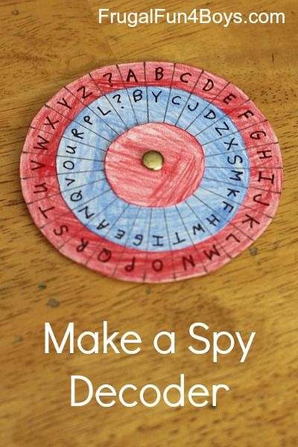
To make a decoder, you will need:
- Posterboard
- Colored pencils
- Scissors
- A compass
- A pencil
- A ruler
- A paper fastener
- A fine tip Sharpie marker
Step 1: Cut out three circles per decoder out of posterboard. You will need one that is 3.25 inches in diameter, one that is 2.5 inches in diameter, and one that is 1.5 inches in diameter.
Note: The size of the circles is very important! If you change the size of the decoder, you will have to change the measurements for marking off the letter sections, which involves higher level math than I felt like using…
Step 2: Color your circles with colored penciles, if desired.
Step 3: On the largest circle, make small pencil marks 3/8″ apart on the outside edge. You should end up with 27 sections.
Detail is important in this step! This was where we got into trouble. We were trying to make three identical decoders. I had 28 sections on my first try, and Aidan had 24. Obviously, those two decoders were not going to be compatible! We figured out what we were doing differently, and we decided that I would make all of the outside pieces so that they would be the same. We had to start over on the large circles, and I made 3 with exactly 27 sections each.
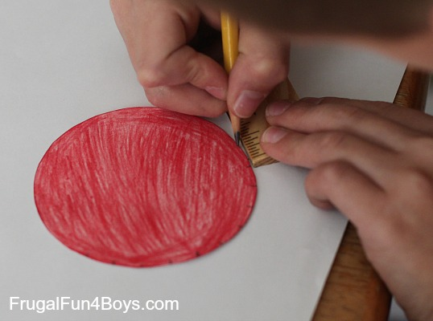
Step 4: Poke a hole through the center of the largest circle and the middle circle. Attach them with the paper fastener. The best way to find the middle of the circle is to use the compass.
Then, use the ruler to draw a straight line from the paper fastener to each edge mark. Again, detail is important. You really want each of the sections to be equal in size, or your decoder will be difficult to use.
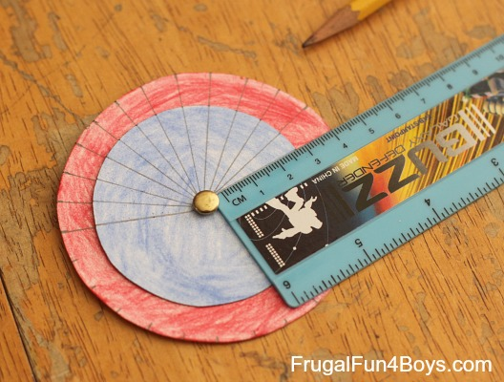
Step 5: Write the alphabet on the outside circle and put a ? in the 27th section. For the middle circle, you can either write the alphabet in order or mix it up. Aidan wanted a random alphabet in the middle circle – I think it made it feel more secret!
Then add the smallest circle to the decoder.
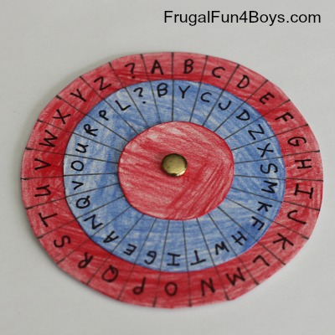
To write a message:
First, set the code. The post on Spoonful suggests setting the decoder where the “A” on the outside circle matches the first letter of the day of the week. Aidan wasn’t wild about that idea. We thought of sending a “code word” along with each message and setting the decoder where “A” on the red circle matches the first letter of the code word. Or, come up with your own system!
To write a message, find the letter you want on the outside (red) circle and write down the corresponding letter on the middle (blue) circle.
To read a message, find the letter on the middle (blue) circle, and write down the corresponding letter from the outside (red) circle.
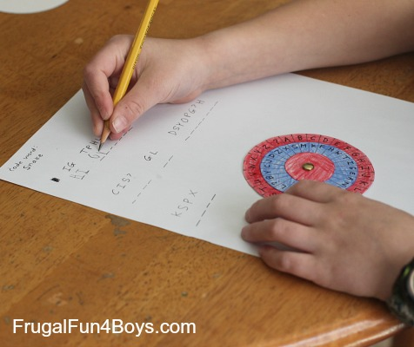

The post on Spoonful has additional directions for making the decoder into something that can be worn around your neck – kind of fun if you want to add that step!
The Thomas Jefferson Cipher Wheel – Here’s an interesting tidbit from history… Thomas Jefferson created a cipher wheel which was used to send encrypted messages in a similar way. The wheel was made from 36 discs on an axle that could be turned to spell out a message. To encrypt the message, the sender would copy down any other row from the cipher wheel other than the intended message (which would appear to be nonsense). The receiver would line up the discs on his (identical) cipher wheel so that they matched the nonsense message and then turn the cipher wheel until they saw a row with the hidden message. Click here to read more about the Jefferson Cipher Wheel – it’s quite interesting! You can also purchase a replica (that really works) from monticello.org.

