Tiger Adventure: Backyard Jungle

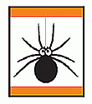
- Take a 1-foot hike. Make a list of the living things you find on your 1-foot hike.
- Point out two different kinds of birds that live in your area.
- Be helpful to plants and animals by planting a tree or other plant in your neighborhood.
- Build and hang a birdhouse.
- With your adult partner, go on a walk, and pick out two sounds you hear in your “jungle.”
Workbook for use with these requirements: PDF Format DOCX Format

Ways to Conduct a 1-Foot Hike
http://cubscoutideas.com/3887/tiger-backyard-jungle-adventure-take-a-1-foot-hike/

There are several ways you can conduct the hike.

1. Make it a Square Foot Hike – Give each boy a 4′ piece of string. Have them pick an area they like and lay out the string to form a square foot. For 10 minutes, they examine their square foot with the magnifying glass. Afterward, they can share what they found with the rest of the group.

2. Play “Do You See What I See?” – For this game, have each boy pick a partner. Partners decide on their one foot area. Have both boys stand behind a line about 10 feet away from the area they’ve chosen. Give the first boy a set amount of time (5 or 7 minutes would probably be best) to examine his area. He makes a list of everything he sees. When the time expires, he and his partner trade places. Give the partner the same amount of time to make his list. Have the boys compare lists and see who found the most things. After they compare, have both of them go back to their area to see if they can find more things working as a team.

3. Complete several 1-foot hikes during a regular hike – Since most of us hike in some kind of wooded area, the boys may be able to find things they wouldn’t if they complete the 1-foot hike in their backyards. Many hiking trails weave through different types of terrain. You may hike through a heavily wooded area, by a body of water or near an open field of wildflowers. By selecting more than one spot to have a 1-foot hike, the boys will be able to see different living things.

To add some excitement, tell the boys that they won’t know when you’ll call out for them to do a 1-foot hike. They need to be ready to quickly find the area they want to examine. Like before, give them a set amount of time to examine the area. Talk about what they found when the time is up. Continue your hike until you find another great spot for a 1-foot hike.

“Leave No Trace”

Since we want to “Leave No Trace” of our hike, the boys shouldn’t dig or disturb the surface of the ground too much. My good friend Betsy gave me several good ideas to help with that. She suggested that we find an area with lots of nooks and crannies to explore without digging. Fallen logs in the woods and grass offer lots of possibilities. Or they can look at a garden with mulch that they can gently push aside.

Betsy also shared these great ideas. We can expand the area beyond just looking at the ground. Go up the plants on your 1- foot space because there is lots to observe on a plant too–the colors, shape of the leaves, texture, bugs or other animals that might be there. The boys might also want to look for shadows. They could look for where the sun is and talk about the path it takes through the sky and how that affects what grows on the opposite sides of trees and rocks.

Recording The Findings

There are a few ways that the boys can record what they found:

Make a simple list.
Draw pictures of what they find.
Make a plot by drawing a large square on their paper and have them indicate where in the square they saw the different living things.

While a 1-foot hike doesn’t sound that exciting at first, your Cub Scouts will be amazed at what they can discover.

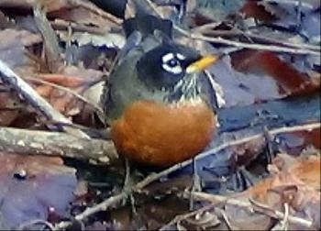

American Robins

The red breasted birds, mark the return of Spring to most folks in the northern states. One of the easiest birds to watch while they go about their nesting and feeding habits since they're in most peoples backyards.
Actually, unknown to a lot of people, these birds spend the winter in much of their breeding range. However, because they spend less time in yards and congregate more in wooded areas you may not see them as often.
During milder winters, it's more common to see them in our backyards.
These birds are often used as the standard to which other birds sizes are compared; one of the most common native birds of the East, and the largest of the Thrush Family.
Hardly a garden in North America has not been visited by this bird. Often referred to as the Red Robin.
Description
American Robins have gray upperparts and the familiar reddish breast, varying from pale rust to a dark brick red. Male and females look nearly identical. The females colors are less vibrant.
Sometimes during nesting season you'll see mud on the breast of a female, since she is the one that lines the nest with mud. The average size of this bird is 9-11 inches long.
Often, you'll see these birds hopping on lawns, meadows, and golf courses looking for earthworms. They also eat insects, fruit, and berries.

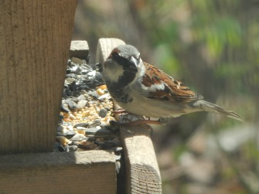

House Sparrows
may or may not be the most loved birds, they certainly are a part of our backyard bird watching experience.

Initially these birds were imported from England. Brought to the US because they were known to eat certain caterpillars that harm shade trees.
One by one, other US cities began importing them for the same purpose. In less than 50 years this small bird has a range that includes the entire U.S. and well into Canada.

Unfortunately, they didn't go after the caterpillars hoped for. While intentions were good, the outcome has been just the opposite. Our native cavity nesters have not evolved fast enough to compete with these highly competitive birds.

Their nesting, feeding, and mating habits can be observed easily due to their long multiple breeding season.

Description
House Sparrows are 5 to 6 inches in length. The male has a gray crown, whitish check, and black throat. The bill and breast are black in summer and in winter the bill is yellow and the breast is gray.
The female has a brown crown and a plain breast with a broad buff line over the eye. Be careful when identifying female House Sparrows because they may look similar to female House Finches. The female House Finch will have a stripped breast.
Although misnamed English Sparrow, and commonly known as the House Sparrow, it is not particularly a native of England and is not a sparrow. It's thought to have its origin in the Mediterranean and actually a member of the Weaver Finch family.

10 Steps to Plant a New Tree and Shrubs
http://www.homedepot.com/c/easy_steps_to_plant_new_tree_HT_PG_OD

Fall is a great time to plant trees and shrubs around your home. By planting in the cooler weather, you're allowing the plants to more easily establish the root growth they will need during the spring growing season and the hot, dry summer. It will also allow the plants to recover from the inevitable stress they experience during transplanting.

Planting a new tree is an investment that can last a lifetime. Position the tree carefully since it will be in place for years. When planting a tree, know its maximum height and spread, information that's usually on the label. Plant it far enough away from houses, outbuildings, power lines, and other permanent structures so that even when mature, the tree won't touch them. Be sure to plant your new tree far enough away from other trees so that it won't grow leaning away from the others, trying to get maximum light.

For tips and helpful information on how to properly fertilize your lawn, visit our Feeding Your Lawn and Overseeding Your Lawn project guides.

Step 1: Things to consider

Here are some things to consider before selecting which trees and shrubs to purchase:

Will the shrubs or trees I have chosen flower?
Do they bear fruit or berries?
Will they attract birds or butterflies?
Are they purely ornamental or will they drop fruit on the ground?
Will this shrub or tree keep its leaves all winter?

Step 2: Tree planting preparation

When selecting the location for your tree, make note of the sun exposure for the area throughout the day. You should also consider the plants, shrubs or trees surrounding the location and try to envision the maximum canopy and height the new tree will eventually reach.

Will it brush up against your house? Are there overhead obstructions such as wires or eaves? What current plants and shrubs will be cast in shade once the tree reaches full height? These are all questions you should ask yourself before heading off to The Home Depot Garden Center. There you will find labeling on the plants and trees indicating their sun needs and expected size at maturity.

This will help you avoid the need to retransplant the tree later because it has outgrown it's space.

Step 3: Location selection

Once you have selected a tree, it’s time to dig the hole. Begin by measuring the tree’s root ball. A common mistake made while planting a tree is to dig the hole too deep and not wide enough.

The hole should be dug at least three times the diameter of the root ball of the tree and no deeper than its root ball. This large diameter of loosened soil will allow the roots to spread and grow more easily.

It’s best to place the soil on a tarp or in a wheelbarrow to avoid killing any surrounding grass and to make back filling the hole easier.

Step 4: Dig the hole

If you’re digging in soil with a high clay content, check the walls and base for glazing. This glazing will form a barrier that blocks water from seeping in. It can also make it more difficult for the roots to spread and grow into the surrounding native soil. Use a gardening tool such as a fork to scratch a few inches deep and break it up.

Dig a slightly deeper ring around the outer edges of the hole, leaving a higher ridge of compacted soil in the center. This will allow the root ball to rest on a pedestal of sorts and keep water from pooling at the base of the root ball.

You want the root ball moist but not soaking in water as this could lead to root rot.

Step 5: Prepare the tree

If the tree you selected comes in a bucket, you’ll need to remove it and gently loosen the root ball with a shovel or by hand. The roots can become pot-bound and will continue to grow in a circular pattern if they aren’t loosened first.

If your tree comes in a burlap wrap, remove any string or twine that may be present. Then cut away the burlap surrounding the roots. If it’s natural burlap, it can be peeled back from the root ball and remain. If it’s a synthetic or plastic burlap it must be removed entirely.

Step 6: Plant the tree

Trees should always be lifted by the root ball, never by the trunk. Lower the tree into the hole and place it on top of the raised center section. Lay the handle of your shovel across the hole to check that the crown of the root ball is level with the surrounding ground.

If the root ball is below the surrounding ground, remove the tree and add more soil. If it’s too high, remove more soil from the hole. It’s best in most regions to not amend the soil. Allow the root system to adjust to the native soil around it and spread.

If your soil is sandy and fast draining, add some peat moss to the excavated soil. Use that mix of native soil and peat to backfill the hole. The peat will act as a sponge and absorb water, keeping it at the level of the root structure.

Step 7: Backfill the hole

Backfill the hole just to the height of the ball or slightly lower to allow for settling. Don’t mound the dirt over the ball and up the trunk, it will prevent air from reaching the roots.

Be careful not to compress the soil too much or it will prevent water from reaching the deeper parts of the root ball. Mound dirt around the tree to form a moat that will help collect water.

Spread two inches of bark or wood chip mulch around the area to help retain water and control weeds. It’s very important that no mulch be touching the trunk of your new tree. Clear mulch back away from the base of the trunk. This will allow enough clear surface area for water, air and light to penetrate the soil.

Step 8: Water and maintain the tree

It’s critical in the early development of the root system to keep the soil moist. Newly planted trees should be watered at the time of planting and you should water it at least once per week during its first growing season. Water it more often during the height of summer as rainfall dictates.

Avoid over watering the tree because it will reduce the oxygen flow to the root system. It’s best to give the tree deep soakings rather than frequent, light waterings. Getting the moisture down deep in the root system will encourage deep root growth.

Soaker hoses work well for deep watering. They release small amounts of water and can be left on for several hours.

Step 9: Planting shrubs

As with tree planting, you should make note of the sun exposure for your planned area. Also note the distance to any surrounding shrubs and flowers. This way, you won’t plant a shrub that will soon crowd out those around it or struggle due to too much or too little sun.

The hole should be dug as deep as the root ball and two or three times as wide. If the roots of the shrub have become pot-bound, loosen the root ball by hand or with a shovel. This will encourage the feeder roots to grow beyond the root ball and help establish the plant sooner.

After digging the hole, place the shrub and again check that the base of the trunk is even with the surrounding ground. Create a moat of soil around the drip line of the plant to allow water to collect around the shrub. The drip line is the distance to the outermost branches. Spread two inches of mulch or pine straw around the shrub, but away from the base of the trunk.

Step 10: Maintaining shrubs

Once planted, give the shrub a long, generous soaking. Repeat the deep watering two or three times per week until the shrub is established.

To help relieve the stress of the transplant, you can apply a plant starter solution to both shrubs and trees immediately after planting. This will help relax the roots and promote growth. Read the product directions for proper application instruction

Flip the Bird Tag
http://scoutermom.com/cubscout/tiger-adventure-backyard-jungle/

This is an active game which is a combination of tag and keep away. In it, a players work together to keep their friends from being tagged. “Flip the Bird” is the traditional name for this game, but if you think it will cause too much of a stir, you can just call it “Bird Tag”.

Materials

You need something to be the “bird”. This can be a rubber chicken, a towel with a knot tied in the middle, a ball, etc. Use your imagination.

Instructions

Choose somebody to be “It”.
Define the boundaries of the play area.
Give the “bird” to somebody who is not it.
“It” tries to tag the other players. “It” can tag anyone except the person currently in possession of the “bird”.
The players work together, throwing the “bird” to the person being chased to prevent “it” from tagging them.
When somebody is tagged, they must sit on the side of the play area.
Last person not to be tagged wins. Hr or she gets to be “It” for the next round

Notes

This game is meant to teach teamwork. However with younger children, some might not want to throw the bird. If this is the case, make the rule that nobody can keep the bird for more than the count of three.

Another option is to have multiple birds and only the people with the birds can be tagged. Know your group and adjust the rules as necessary.

Gourd Birdhouse
http://scoutermom.com/cubscout/tiger-adventure-backyard-jungle/

I dried some gourds we grew, so we can make gourd birdhouses. If you didn’t grow any yourself, you can probably find some in your area at a farmer’s market or even a craft shop.

Because of the number of steps involved and the drying time required between paintings, we will probably start these at a meeting and then they can take them home to paint them. I’m also planning on having them already soaking when the meeting starts. Kids and a 10 percent bleach solution are not a good combination, so they can start at the point where they scrub the gourds with the soapy water.
Gourd Birdhouse

Depending on age and maturity, some of these steps might have to be done by an adult.

Materials:

Dried gourd – “bottle gourd”
bleach solution – one-part bleach and nine parts water
Steel wool
bucket with soapy water
Old towel to dry the gourd
Utility knife
Spoon
Hand drill
Enamel paint or shellac or polyurethane
Paint brush

Directions

Soak the gourd in a bleach solution for 15 minutes. (This might be done by an adult rather than a youth.)
Dry the gourd with the towel.
Immediately clean the outside of the gourd using the steel wool and the soapy water.
Dry the gourd again with the towel.
With the knife, cut a 1 ½ inch diameter hole in the gourd, slightly above the halfway point on the “fat” part of the gourd. (This might also need to be done by an adult.)
Use the spoon to remove any seeds or pith in the gourd.
Drill a few holes in the bottom, for drainage.
Drill two holes at the top of the gourd. Later you will feed the wire through these to make a hanger for the gourd..
Coat the gourd with at least two coats of paint, shellac, or polyurethane, letting it dry 24 hours between applications.
Feed a length of wire through the holes.
Twist the ends of the wire together to form a hanger.
Hang out on a tree and wait for some birds to move in.

Notes

The dried gourds might have some mold spots on them. This happens during the drying process. They can still be used.

You might need to redrill the holes a little after painting.

USE CAUTION WITH THE BLEACH AND THE UTILITY KNIFE!

Cub Scouts Birdhouse Plans
http://cubscoutideas.com/3915/cub-scouts-birdhouse-plans/#more-3915

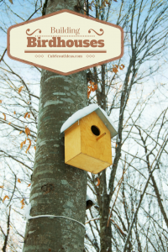
1. Precut a board for each boy following the first diagram.
2. Drill the entrance hole about 2 ½” from the top of the front piece. The hole should be about 1 ½” in diameter. Make sure the hole is centered on the board. Unless you have a manual hand drill and a lot of time for the boys to crank the drill, you’ll probably want to predrill the hole.
3. Attach the front to the sides by using the 1 5/8” deck screws. You might want to predrill holes in the front piece to make it easier for the boys.
4. Attach the back to the sides with the 2” finishing nails. The holes for the nails can also be predrilled.
5. Cut about ½” off each corner of the floor for drainage.
6. Attach the floor about ¼” up from the bottom of the house on the sides and back with the 2” finishing nails. Don’t nail the floor from the front because you won’t be able to open it for cleaning.
7. Attach the roof to the sides with 1-5/8-inch deck screws.
8. Hang your birdhouse outside, and watch for the new occupants to settle in!
Yours in Scouting,
Sherry
DIY Supply List:
5 feet of 1- x 6-inch board cut into the following pieces (see diagram below):
2 – 10” pieces
1 – 7 ¾” pieces
2 – angled pieces 10″ on one side & 8″ on the other
1 – 4” piece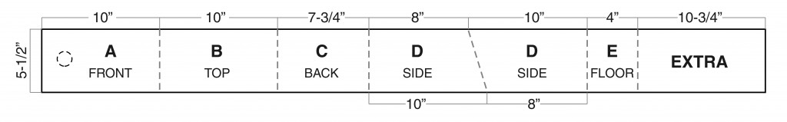 You’ll also need
1 5/8-inch galvanized deck screws
2-inch galvanized finishing nails
Fine sandpaper
Wood glue
Building Instructions:
Assemble the birdhouse as shown in this drawing. Step-by-step instructions are below.
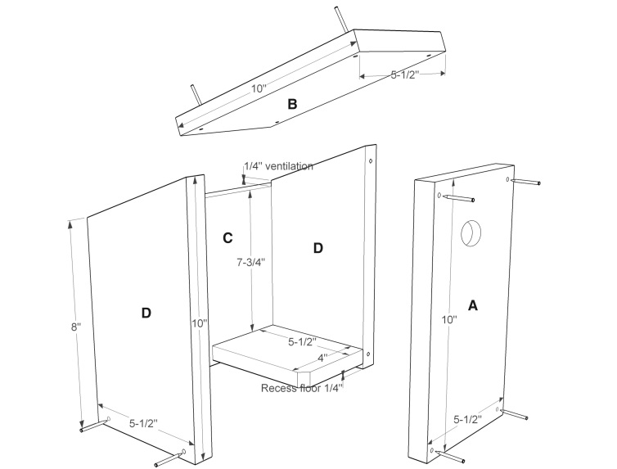
1. Precut a board for each boy following the first diagram.
2. Drill the entrance hole about 2 ½” from the top of the front piece. The hole should be about 1 ½” in diameter. Make sure the hole is centered on the board. Unless you have a manual hand drill and a lot of time for the boys to crank the drill, you’ll probably want to predrill the hole.
3. Attach the front to the sides by using the 1 5/8” deck screws. You might want to predrill holes in the front piece to make it easier for the boys.
4. Attach the back to the sides with the 2” finishing nails. The holes for the nails can also be predrilled.
5. Cut about ½” off each corner of the floor for drainage.
6. Attach the floor about ¼” up from the bottom of the house on the sides and back with the 2” finishing nails. Don’t nail the floor from the front because you won’t be able to open it for cleaning.
7. Attach the roof to the sides with 1-5/8-inch deck screws.
8. Hang your birdhouse outside, and watch for the new occupants to settle in!
Yours in Scouting,
Sherry

