Bear Adventure: Fur, Feathers, and Ferns
- While hiking or walking for one mile, identify six signs that any mammals, birds, insects, reptiles, or plants are living nearby the place where you choose to hike.
- Name one animal that has become extinct in the last 100 years and one animal that is currently endangered Explain what caused their declines.
- Visit one of the following: zoo, wildlife refuge, nature center, aviary, game preserve, local conservation area, wildlife rescue group, or fish hatchery. Describe what you learned during your visit.
- Observe wildlife from a distance. Describe what you saw.
- Use a magnifying glass to examine plants more closely. Describe what you saw through the magnifying glass that you could not see without it.
- Learn about composting and how vegetable waste can be turned into fertilizer for plants.
- Plant a vegetable or herb garden.
Workbook for use with these requirements: PDF Format DOCX Format

Flip the Bird Tag
http://scoutermom.com/16586/flip-bird-tag/
This is an active game which is a combination of tag and keep away. In it, a players work together to keep their friends from being tagged. “Flip the Bird” is the traditional name for this game, but if you think it will cause too much of a stir, you can just call it “Bird Tag”.
Materials
You need something to be the “bird”. This can be a rubber chicken, a towel with a knot tied in the middle, a ball, etc. Use your imagination.
Instructions
- Choose somebody to be “It”.
- Define the boundaries of the play area.
- Give the “bird” to somebody who is not it.
- “It” tries to tag the other players. “It” can tag anyone except the person currently in possession of the “bird”.
- The players work together, throwing the “bird” to the person being chased to prevent “it” from tagging them.
- When somebody is tagged, they must sit on the side of the play area.
- Last person not to be tagged wins. Hr or she gets to be “It” for the next round
Notes
This game is meant to teach teamwork. However with younger children, some might not want to throw the bird. If this is the case, make the rule that nobody can keep the bird for more than the count of three.
Another option is to have multiple birds and only the people with the birds can be tagged. Know your group and adjust the rules as necessary.

Finding Out About Endangered Species in Your Area
http://scoutermom.com/5903/finding-endangered-species-area/
Conservation and Scouting go hand in hand. Since getting outdoors is a big part of the Cub Scout and Boy Scout programs, it makes sense that we should teach Scouts about protecting our natural resources.
The US Fish and Wildlife Service has an Endangered Species Page where you can look up endangered species in your state or even your county. There is also a Weird and Wonderful Wildlife Page on the site where kids can learn about 14 different endagered species and play some games to find out even more.
o if your unit is studying endangered species for requirements or just to learn more about conservation, check out those pages from the US Fish and Wildlife Service.
Ideas for Adventure Requirements:
http://www.boyscouttrail.com/cub-scouts/bear-fur-feathers-ferns-adventure.php
- Requirements 1 through 5 could all be done on one den outing if scouts researched extinct animals beforehand. Signs could be sound, tracks, scat, fur, feathers, or visual sighting.
- Visit IUCN.org and check out the Red List of threatened species (the Photos page would be most interesting).
- At a den meeting, offer as many of these different places as possible in your area and let the scouts choose which sounds most interesting.
- Binoculars and a camera with telephoto lens helps us keep our distance. Staying on the trail and being observant for unusual animal behavior is a good idea.
- Take time to view a fresh, green leaf and a leaf that has begun to decompose. What differences are there? color, disintegrating material, crunchy or soggy.
- Visit EPA.gov Composting for information about composting.
- Have a selection of vegetable seeds on a white sheet of paper and have scouts try to identify them. Help them figure out how long various vegetables will take to grow and how much space they will need. Then, let them choose a few to plant in egg cartons, paper cups, or other personal, portable growing containers.
Den Meeting Ideas for Fur, Feathers, and Ferns Adventure:
http://www.boyscouttrail.com/cub-scouts/bear-fur-feathers-ferns-adventure.php
- Play Group Morph.
- Create Wacky Animals.
- Play Vegetable Olympics.
- Perform Cubmaster In the Wild skit.
- Sing LIttle Green Frog song.
- Sing Tom the Toad song.
- The LNT Principles for Kids are listed in the back of the Bear Handbook. Read details of the principles and implementing them atLNT.org and Outdoor Ethics.
- Learn more about Leave No Trace from Leave No Trace Dude.
- Learn more about Hiking from Hiking Dude.

messages to each other.
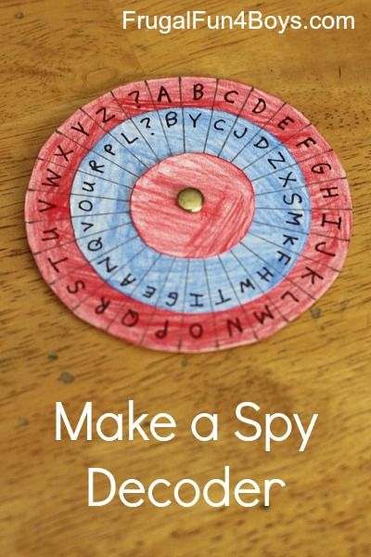
To make a decoder, you will need:
- Posterboard
- Colored pencils
- Scissors
- A compass
- A pencil
- A ruler
- A paper fastener
- A fine tip Sharpie marker
Step 1: Cut out three circles per decoder out of posterboard. You will need one that is 3.25 inches in diameter, one that is 2.5 inches in diameter, and one that is 1.5 inches in diameter.
Note: The size of the circles is very important! If you change the size of the decoder, you will have to change the measurements for marking off the letter sections, which involves higher level math than I felt like using…
Step 2: Color your circles with colored penciles, if desired.
Step 3: On the largest circle, make small pencil marks 3/8″ apart on the outside edge. You should end up with 27 sections.
Detail is important in this step! This was where we got into trouble. We were trying to make three identical decoders. I had 28 sections on my first try, and Aidan had 24. Obviously, those two decoders were not going to be compatible! We figured out what we were doing differently, and we decided that I would make all of the outside pieces so that they would be the same. We had to start over on the large circles, and I made 3 with exactly 27 sections each.
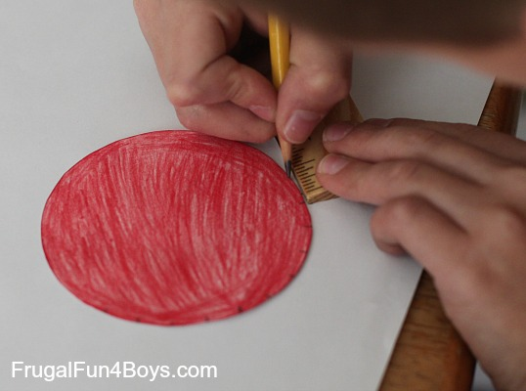
Step 4: Poke a hole through the center of the largest circle and the middle circle. Attach them with the paper fastener. The best way to find the middle of the circle is to use the compass.
Then, use the ruler to draw a straight line from the paper fastener to each edge mark. Again, detail is important. You really want each of the sections to be equal in size, or your decoder will be difficult to use.
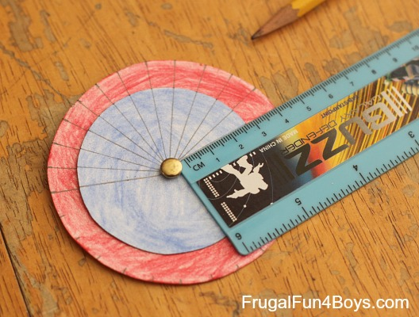
Step 5: Write the alphabet on the outside circle and put a ? in the 27th section. For the middle circle, you can either write the alphabet in order or mix it up. Aidan wanted a random alphabet in the middle circle – I think it made it feel more secret!
Then add the smallest circle to the decoder.
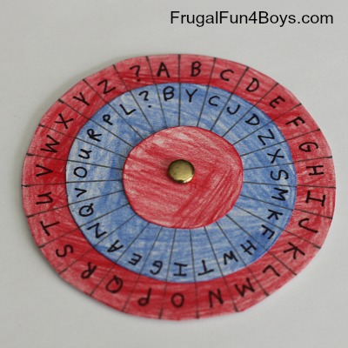
To write a message:
First, set the code. The post on Spoonful suggests setting the decoder where the “A” on the outside circle matches the first letter of the day of the week. Aidan wasn’t wild about that idea. We thought of sending a “code word” along with each message and setting the decoder where “A” on the red circle matches the first letter of the code word. Or, come up with your own system!
To write a message, find the letter you want on the outside (red) circle and write down the corresponding letter on the middle (blue) circle.
To read a message, find the letter on the middle (blue) circle, and write down the corresponding letter from the outside (red) circle.
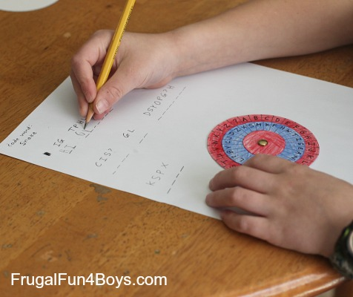

The post on Spoonful has additional directions for making the decoder into something that can be worn around your neck – kind of fun if you want to add that step!
The Thomas Jefferson Cipher Wheel – Here’s an interesting tidbit from history… Thomas Jefferson created a cipher wheel which was used to send encrypted messages in a similar way. The wheel was made from 36 discs on an axle that could be turned to spell out a message. To encrypt the message, the sender would copy down any other row from the cipher wheel other than the intended message (which would appear to be nonsense). The receiver would line up the discs on his (identical) cipher wheel so that they matched the nonsense message and then turn the cipher wheel until they saw a row with the hidden message. Click here to read more about the Jefferson Cipher Wheel – it’s quite interesting! You can also purchase a replica (that really works) from monticello.org.

HOMEMADE RAIN GAUGE
http://theimaginationtree.com/2012/04/homemade-rain-gauge.html

Here’s how to make a really simple rain gauge using recycled materials, for some rainy day fun! There are plenty of opportunities for learning about measuring, number recognition, capacity and weather along the way too!

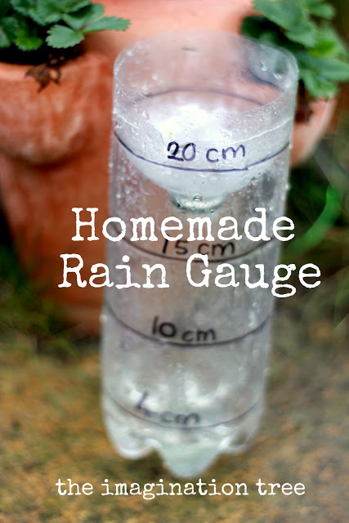
We have had the most incredible, persistent rainfall for the past 10 days here in the Southern UK, and it has inhibited a lot of our outdoor play ideas. But then I came up with a really easy way to embrace the rain and throw in a bit of playful learning too, by measuring the rainfall!
All you need is an empty plastic bottle, the larger the better!

I cut around the body of the bottle, about 5cm down from the top. We simply turned it upside-down and placed it inside the bottle, making sure it was pushed down and flush with the edges.
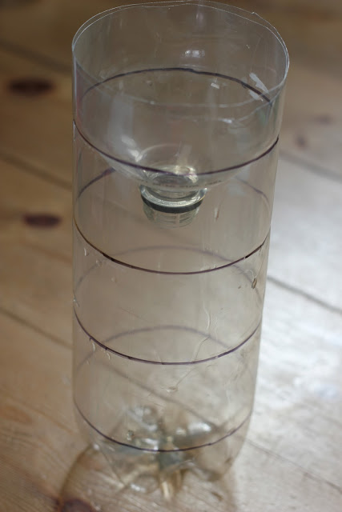
Our bottle had grooves on it already and I just drew around them using a permanent marker. Just make sure your lines are at regular intervals, ready for measuring! Cakie got her ruler and held it up to the lines I had drawn, making a good attempt to read the numbers back. I wrote on the measurements in centimetres.
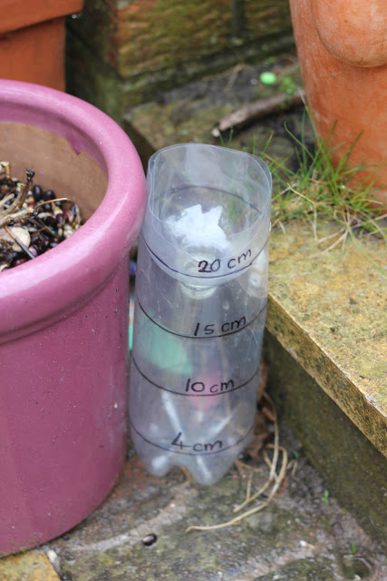
24 hours later, Cakie rushed out to check out the water level in her rain gauge and it was already up to our first marker level of 4cm!!
The rain continues to fall and we are checking every day. The level is rising by at least 2-4cm per day…wow!
With older children I would consider making a line graph to chart the increase in rain and investigate the average monthly rainfall in Britain compared to the rest of the world.

